LA County MOU Regarding School Stability Transportation for Foster Youth
Process

This one-pager provides a high-level overview of processes outlined in the Every Student Succeeds Act (ESSA) School Stability Transportation Long-Term Plan:
- What is School of Origin (SOO)?
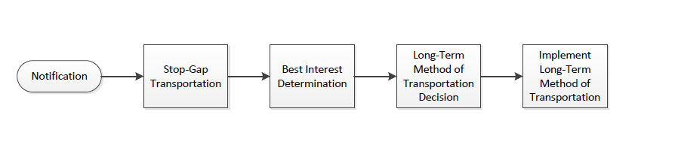
  - The SOO is the school that the foster child attended when permanently housed or the school in which the foster child was last enrolled. The SOO may also be a school that the foster youth attended where he/she is connected and that he/she attended within the immediately preceding 15 months.
Process Overview

- Notification and Identification of Foster Youth Placed in Out-of-Home Care
  - DCFS CSWs will utilize the DCFS 1399 form to notify the school a following a determination that the youth will be or has been placed into out-of-home care or is moving to a new out-of-home care placement.
  - If the youth has an active IEP, any local education agencies involved should receive notice at least 10 days in advance of the school change.

- Stop-Gap Transportation
  - Stop-Gap transportation helps ensure that youth can stay in their school of origin immediately following their removal from home or from a current foster care placement until a best interest determination (see below) can occur. The youth must be transported to their SOO until a BID has occurred, and if the youth is staying in their SOO, until the long-term method of transportation is established.
  - After DCFS has been notified that a youth will need SOO transportation, the DCFS CSW will immediately work with the DCFS Education Specialist to evaluate transportation options:
    - This may include reaching out to the school district to see if the youth has an IEP or a bus route is available.
    - The CSW will also look to see if public transportation or education travel reimbursement is available.
    - If no options are quickly available, the DCFS Education Specialist will submit an electronic referral to the private vendor, HopSkipDrive for stop-gap transportation.

- Best Interest Determination (BID)
  - The SOO is the default placement. Youth may not be unenrolled from school until and unless the BID occurs and finds it is in the youth’s best interest to change school placements.
  - The Education Rights Holder (ERH), youth, and Independent Charter Organization Foster Youth Liaison are required to have a meeting (in person or by phone) to determine whether or not it is in a child’s best interest to remain in her school of origin. Input from the CSW, DCFS Education Specialist, and caregiver may also be considered but they are not the decisionmaker.
  - The ERH determines whether the child should remain in their school of origin.
  - The role of the Independent Charter Organization Foster Youth Liaison is to advise and if the liaison wishes to recommend that the child’s best interest is to move schools, the liaison must provide the ERH with a written explanation.
  - The Independent Charter Organization Foster Youth Liaison should reach out to the ERH and youth to convene a BID as soon as possible after they receive a notification that a youth may be removed from their home. The Liaison may also include the CSW in this meeting or to help reach out to the ERH and youth.
  - Once a BID has occurred, the Liaison should email the results to the DCFS Education Specialist, CSW, and any other parties involved with the BID or entitled to know.

- Long-Term Method of Transportation Decision
  - If it is determined that a youth shall remain in their school of origin, DCFS and the Independent Charter Organization shall then have a conversation to determine the method of transportation. Caregivers and ERH may consult, and DCFS and the Independent Charter Organization are the final decision makers on the method.
  - DCFS CSW and Independent Charter Organization Foster Youth Liaisons will work to exhaust all resources prior to requesting private transportation (see below for flowchart):
    - CSW will determine whether education travel reimbursement or public transit can be utilized.
    - The Independent Charter Organization will assess whether the child is eligible for transportation services under another entitlement, a related service is included in the student’s IEP, or the district is able to use or modify an existing bus route.
    - If multiple options are available, DCFS and the Independent Charter Organization should select the most cost-effective and reasonable option, which means considering the cost, distance, length, and developmental appropriates of transportation.
    - If none of the above options are available, only then can the private vendor (currently HopSkipDrive) be chosen as the long-term method of transportation. If this method is chosen, the DCFS Education Specialists should be contacted and they will work with HopSkipDrive to set up the rides.
  - If the stop-gap transportation method is chosen as the long-term plan, Independent Charter Organization Foster Youth Liaison and DCFS CSW and Education Specialist should confirm this by e-mail.
  - DCFS and Independent Charter Organization have five school days after the BID to implement the long-term method of transportation
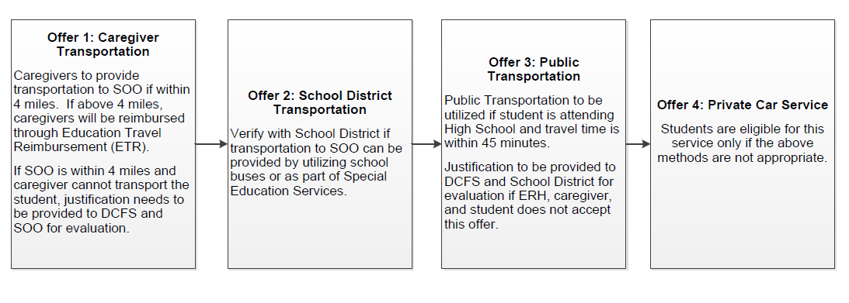

For questions about process or facilitating transportation please reach out to the DCFS Education YES box youth.education.support@dcfs.lacounty.gov

The process outlined below will be utilized once the school district also signs on to the MOU
California Education Code Section 48853.5 (g)
CA Rule of Ct. 5.651(e)(1)(B).).
Education Code § 48853.5
EC § 48853.5(c).
Non-Regulatory Guidance: Ensuring Educational Stability for Children in Foster Care issued by the U.S. Department of Education and the U.S. Department of Health and Human Services on June 23, 2016.

