TEACH ACADEMY OF TECHNOLOGIES DECEMBER CAASPP (F)IAB

Standards were selected as the focus area of instruction for the second administration of the CAASPP Interim Assessment Benchmark. Standards will vary from administration to administration. Teachers can choose to re-test an area if scores were not satisfactory.

5TH GRADE:
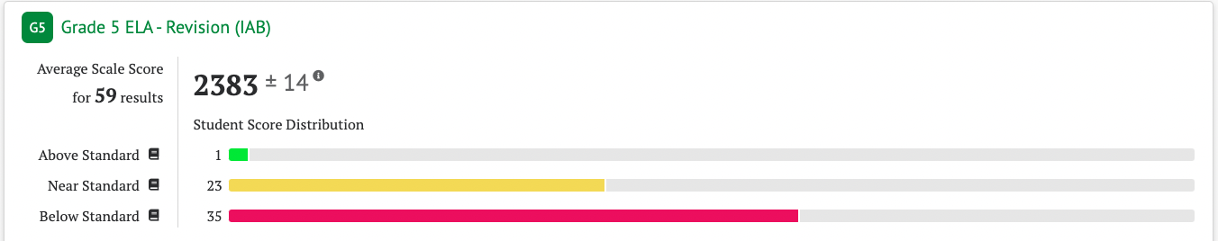

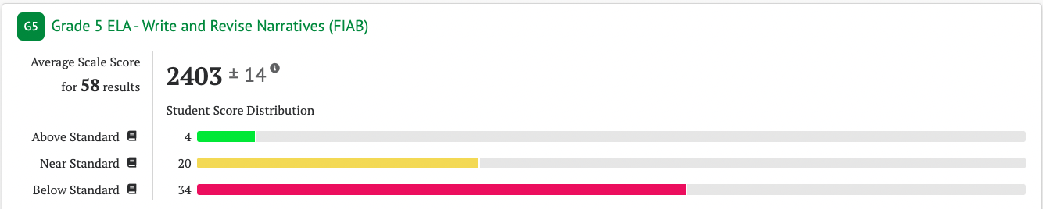

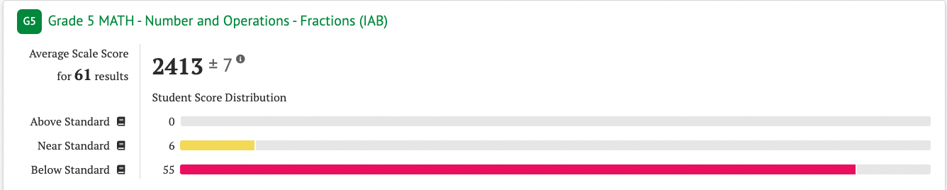

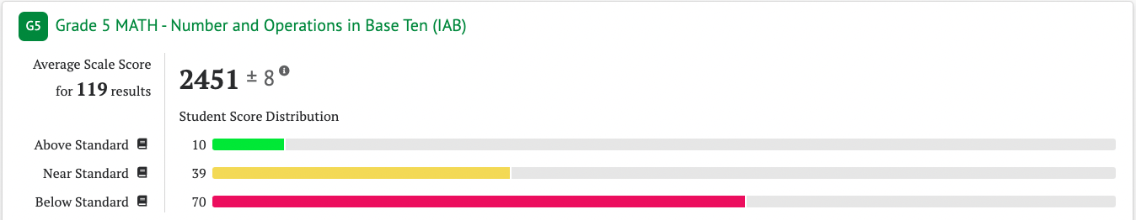
Above Standard October: 4
Above Standard December: 6 (same 4 +2 new)
Near Standard October: 19
Near Standard December: 20 (7 were not in band in October; Overall 13 remained in band)

6TH GRADE:
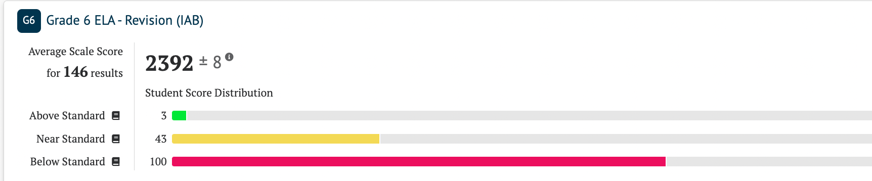

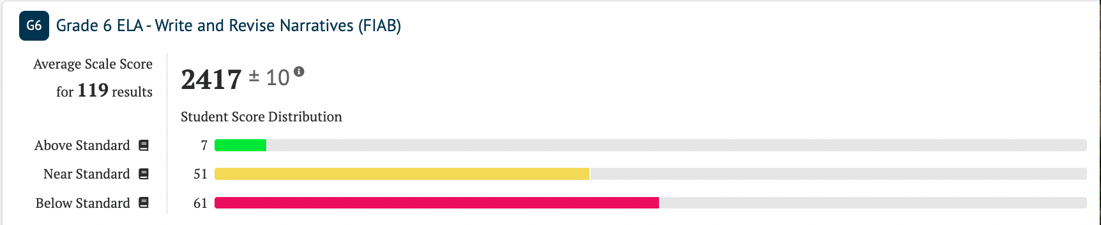

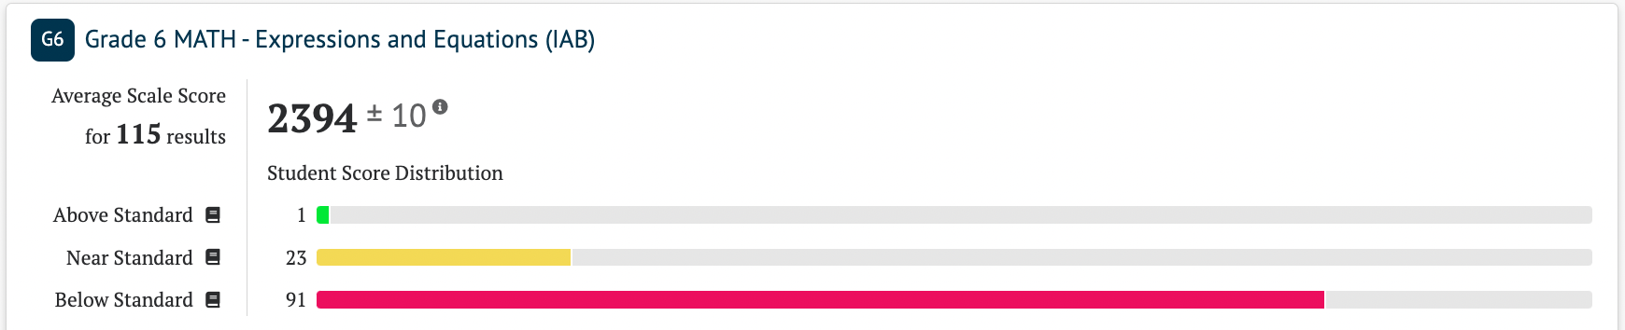

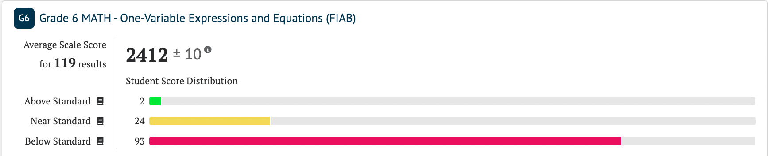

7TH GRADE:
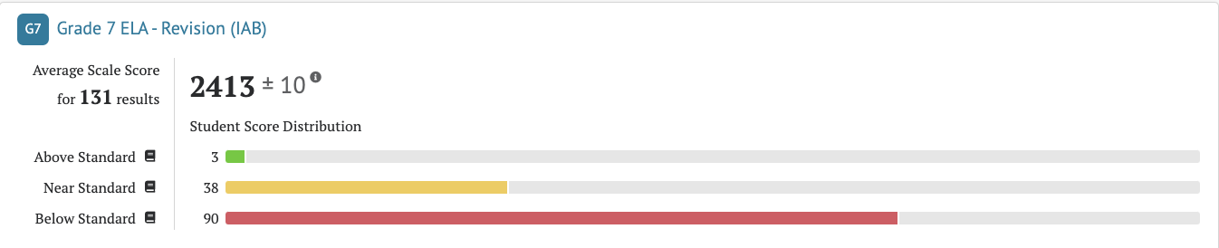

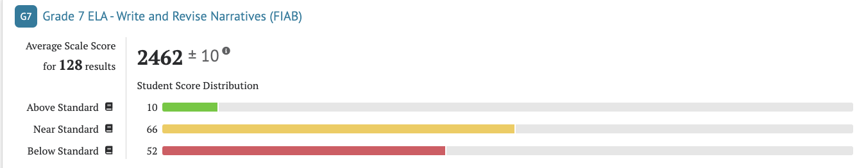

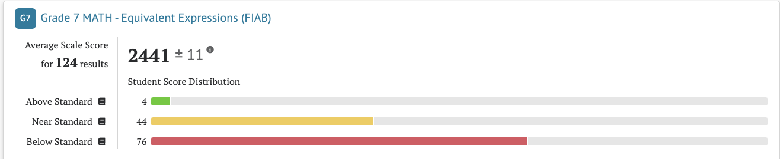

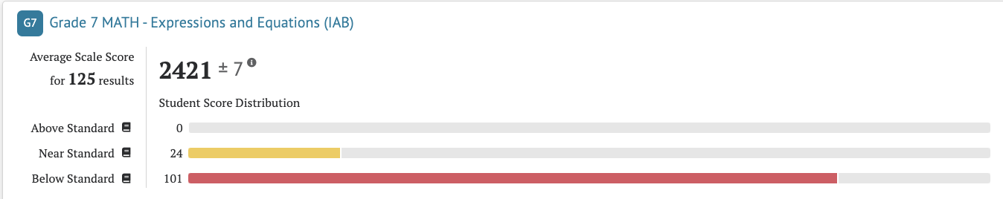

8TH GRADE:
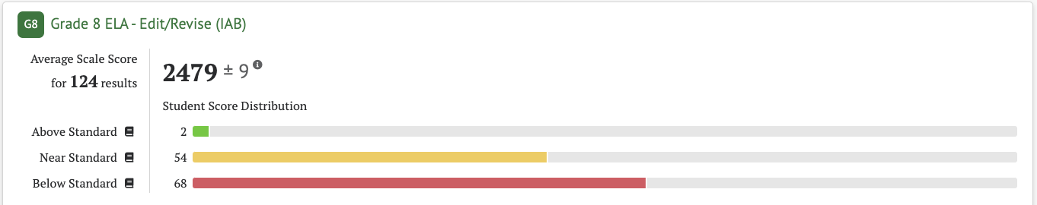

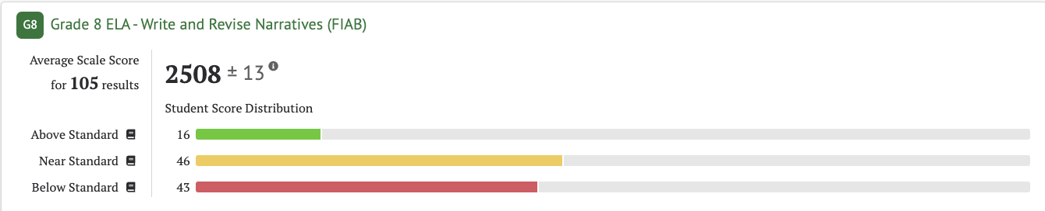

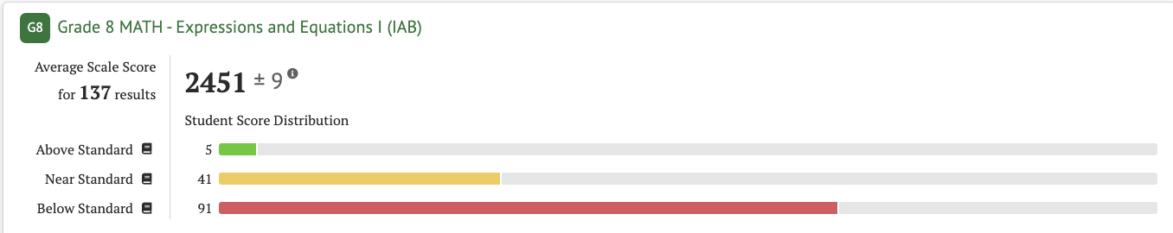

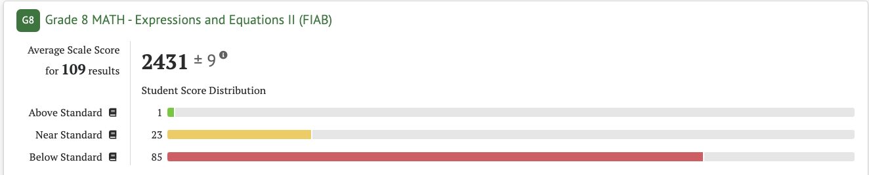

TEACH ACADEMY OF TECHNOLOGIES OCTOBER CAASPP (F)IAB

Standards were selected as the focus area of instruction for the first administration of the CAASPP Interim Assessment Benchmark. Standards will vary from administration to administration. Teachers can choose to re-test an area if scores were not satisfactory.

5TH GRADE:
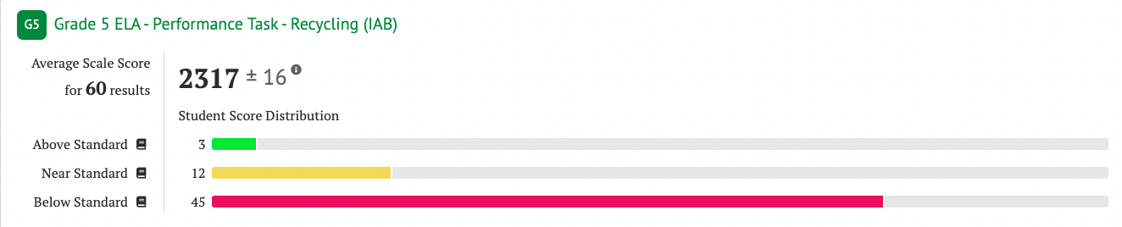

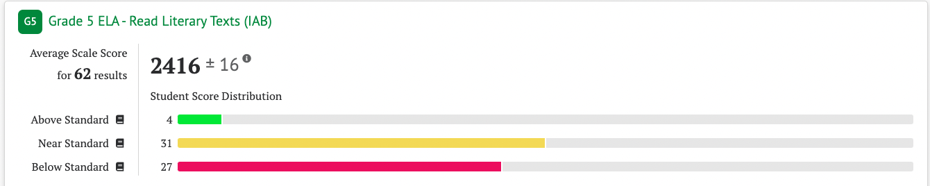
Above Standard October: 4
Above Standard December: 6 (same 4 +2 new)
Near Standard October: 19
Near Standard December: 20 (7 were not in band in October; Overall 13 remained in band)

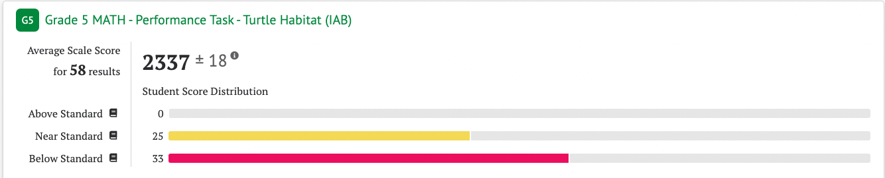

6TH GRADE:
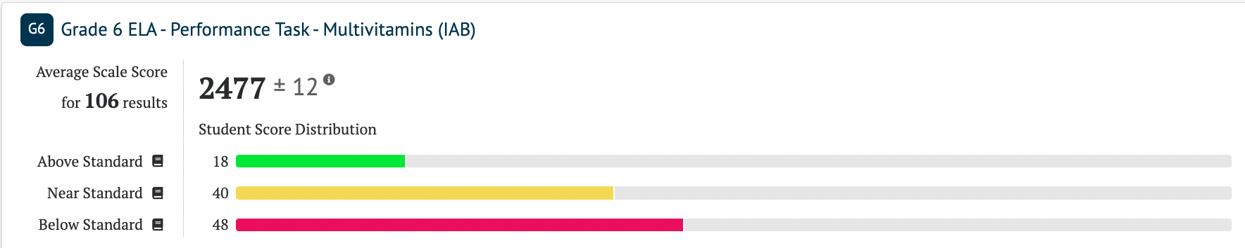

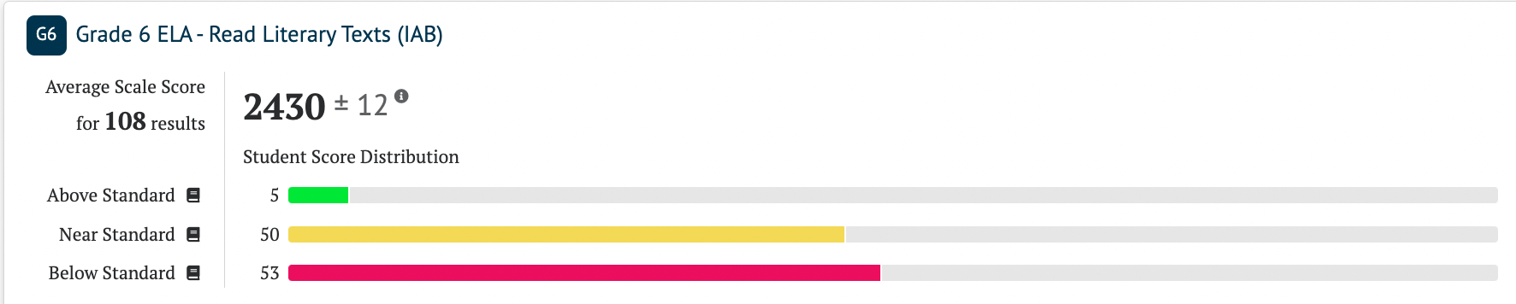

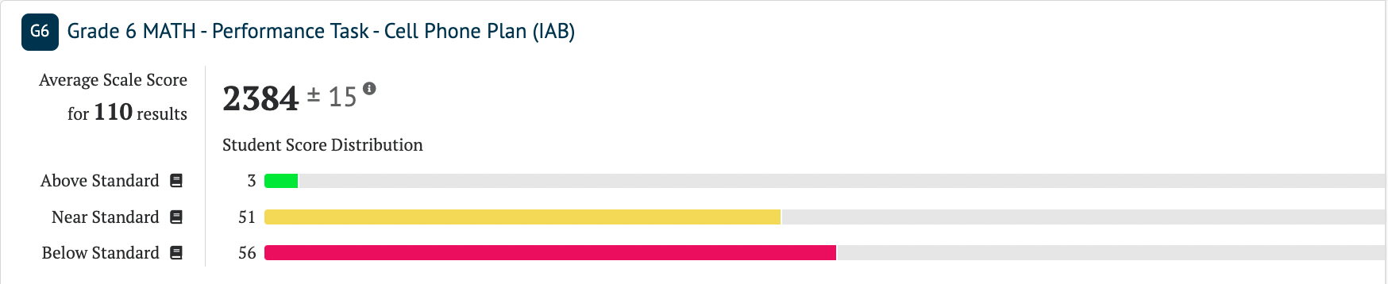

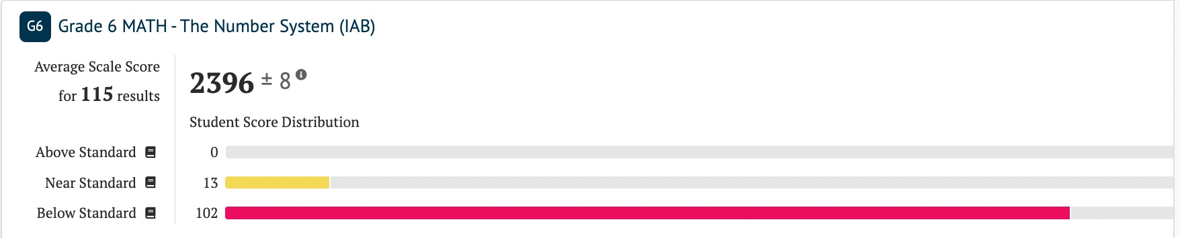

7TH GRADE:
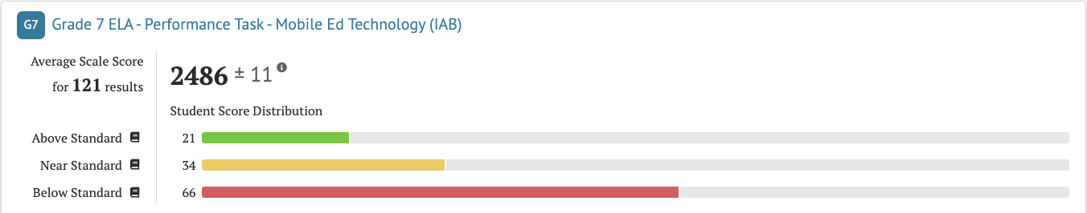

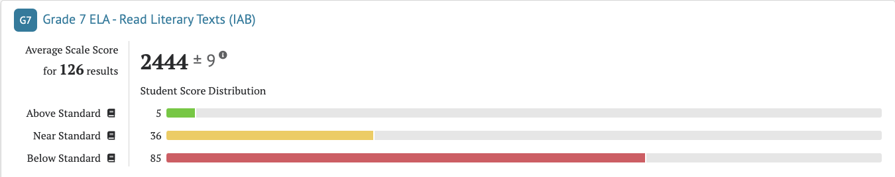

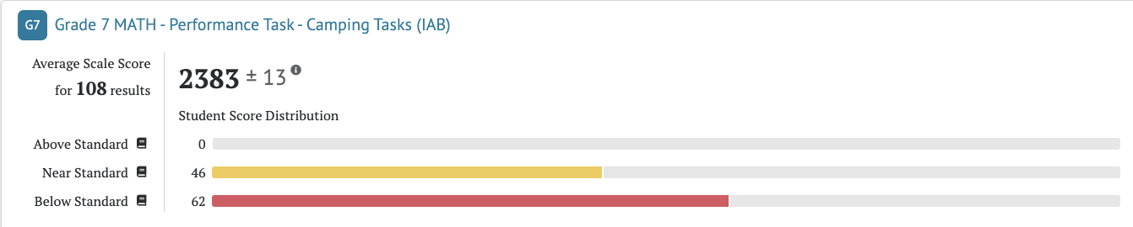

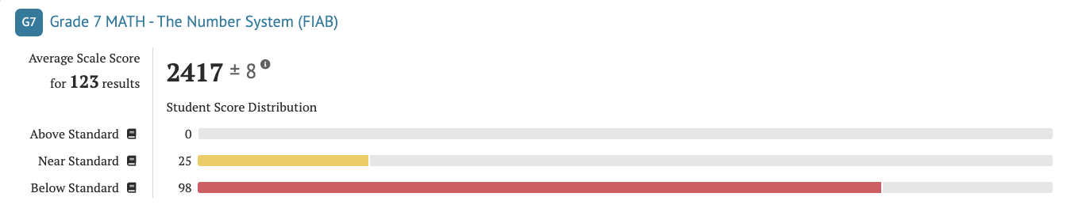

8TH GRADE:
