TEACH TECH CHARTER HIGH SCHOOL DECEMBER CAASPP (F)IAB

Standards were selected as the focus area of instruction for the second administration of the CAASPP Interim Assessment Benchmark. Standards will vary from administration to administration. Teachers can choose to re-test an area if scores were not satisfactory.

ALL STUDENTS:
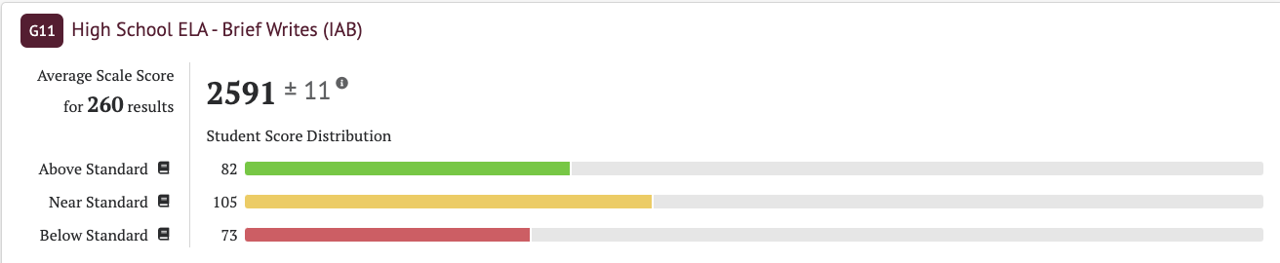

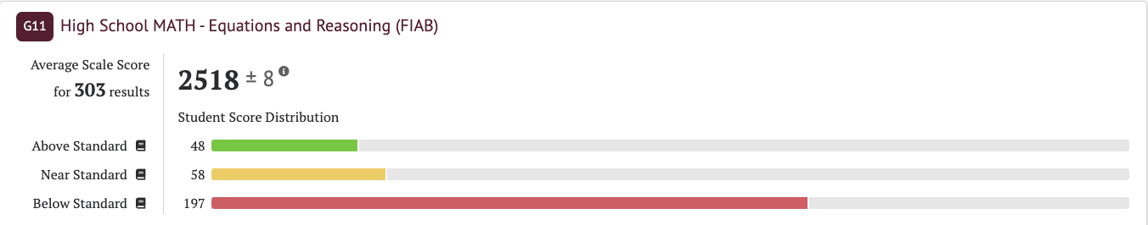

TEACH TECH CHARTER HIGH SCHOOL OCTOBER CAASPP (F)IAB

Standards were selected as the focus area of instruction for the first administration of the CAASPP Interim Assessment Benchmark. Standards will vary from administration to administration. Teachers can choose to re-test an area if scores were not satisfactory.

