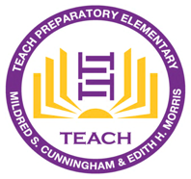

TEACH Prep Elementary

Principal’s Report

May 2021

- Enrollment Update:
- Currently we are maintaining a total of 196 students.
- We passed out Returning Next Year Survey. We have received about 145 responses and in the process of getting the rest of our parents’ responses by resending the message to them and calling them.

- Summer School/Extended Learning
- We have responses from our teachers as to who will be teaching summer school
- Official start of day will be June 21- July 8th. Monday-Thursday 8:30-12:00pm.
- We are first inviting any scholars that teachers are requesting them to attend summer school based on their performance in class (scores of 1 and 2) and then we will invite other scholars who are interested.

- SBAC
- We are starting testing starting tomorrow, Tuesday, May 18th. We are anticipating at least 2-3 weeks of testing which includes make- ups. Teachers have sent messages out and have a plan set for students to come on campus to test during this time.

- Kindergarten Culmination
- We will have a walk-through Kinder Culmination Station on our campus outside.
- Parents will be given a set time to come get their Culmination gift back and walk over to the picture station to take pictures with their teacher.

