TEACH Public Schools Re(Open) Tentative Plan Fall 2020
Underlying Assumption
TEACH Public Schools must formulate a plan for reopening campuses based upon the current prevailing information about COVID-19. The global ramifications of the health crisis require formulating and implementing a plan capable of evolving as science and realities improve. The TEACH Plan must be developed while factoring information available from public health officials and it must account for modifications based upon changing guidelines from national and state health officials. In summary the main three components of reopening: physical distancing, temperature screenings, and frequent disinfecting of surfaces and classrooms must be addressed within the framework of constantly changing circumstances.

Phase I Staff Training
Train all staff in COVID-19 protocol.
Prevention- insure that all staff are knowledgeable in preventative hygiene measures including: hand washing, face covering, social distancing, proper cleaning of both student and staff areas, high touch surface treatment, food service, avoidance of sharing items, eliminating traditional high risk transmission activity (hugging, shaking hands, holding hands, kissing, etc)
Potential Outbreak- endow all staff with a working knowledge of how to respond when it is suspected that a student or staff member becomes symptomatic. Educate all adults in protocol when isolation and contact tracing become necessary. Establish and teach procedures for safe transportation, housing, and removal of anyone who becomes symptomatic.
Resource- provide each site with a specific contact person who has received advanced training and or certification to act as the final decision maker in cases of potential closure. Ensure that each site has a designated person with the requisite knowledge and information to successfully navigate any issues that may arise requiring superior training.

Phase II Physical Site Specific Preparation
In the creation of a comprehensive plan to safely re-open TEACH Public Schools District Office, Tech CHS, TEACH Academy of Technologies, no one plan can be created and implemented. Each site must be outfitted with the necessary equipment to establish and maintain a safe, clean, and sustainable environment. Along with daily instruction, facilities must accommodate: food delivery and consumption, changing of classrooms, sanitizing recreational areas, and constant restroom navigation. Campus specific systems must be designed and implemented to maximize safety for staff and students at each location. This must all be accomplished while adhering to safety guidelines such as wearing facial masks and maintaining social distancing.

Classrooms must be outfitted with plexiglass barriers, desks and tables separated; student and staff movement must flow successfully in one direction and there must be separate locations for entrance and exiting.

Focus areas: food service, student movement, limit learning modalities, constant cleaning of high touch surfaces, physical prep (masks, gloves, thermometers, etc.), creative use of outside space for instruction.
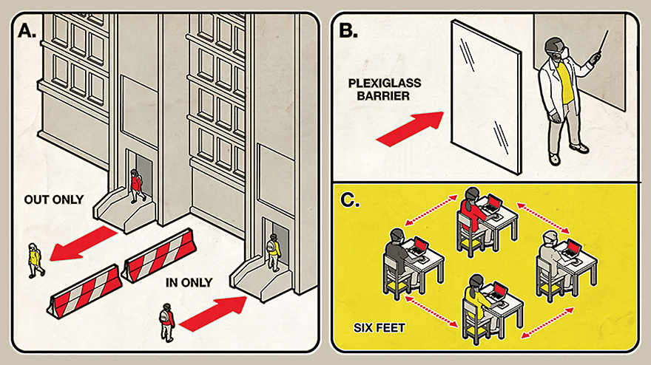
Proposed entrance/exit, and classroom design.

Phase III Promote Healthy Practices & Routines
1. Establish an Ongoing Intense Cleaning Regiment
a. Clean, sanitize, and disinfect frequently touched surfaces (for example, playground equipment, door handles, counter tops, sink handles, drinking fountains) multiple times per day. and shared objects between usages.
b. Avoid use of items that are not easily cleaned, sanitized, or disinfected.
c. Ensure safe and correct application of disinfectants and keep products away from children.
d. Ensure that ventilation systems operate properly and increase circulation of outdoor air as much as possible by opening windows and doors, using fans, and other methods. Do not open windows and doors if doing so poses a safety or health risk (for example, allowing pollens in or exacerbating asthma symptoms) to children using the facility.
e. Take steps to ensure that all water systems and features (for example, drinking fountains, faucets) are safe to use.
f. Establish a “Constant Cleaning Team” who circulate the campus to constantly clean, disinfect, and sanitize the entire campus including classrooms, hallways, desks, chairs, walls, floors, plexiglass dividers, etc.
2. Social Distancing
a. Create and maintain a culture wherein adults practice, model and enforce strict policies of six foot human separation at all times. Promote the proper wearing of face coverings along with the hygiene practices listed below.
b. Ensure that classes include the same groups of children each day and that the same teachers remain with the same group each day. Teachers are suggested to change classes and children should remain stationary when practical.
c. Restrict both individual movement of members of particular clusters and mixing between groups.
d. Refrain from field trips, inter group events, and extra-curricular activities. Limit gatherings, activities, and events to those that can maintain social distancing, support proper hygiene practices, and restrict mixing of groups.
e. Close communal spaces if possible, if not possible stagger use with required distancing and disinfect between usages.
f. Restrict all nonessential visitors, volunteers, and activities involving mixture of external persons with groups of students and staff.
g. Space out seating and work spaces to at least six feet apart and emphasize the importance of keeping this distance.
h. Serve meals in classrooms where practical, and serve each student a prepackaged meal with disposable, sealed, packaged, plastic utensils for each child.
i. Stagger arrival and drop off times to limit direct contact among students and parents as much as possible.
j. Keep each child’s belongings separated, eliminate sharing of supplies and equipment including electronic devises, books, games, learning aids.

Healthy individual hygiene practices
Wash hands frequently
Cover coughs & sneezes
Reinforce use of cloth face coverings Proper use, removal, & washing of face covering
Provide soap, hand sanitizer, alcohol wipes, disinfecting moist towels, tissues
Post signage on how to stop the spread of COVID-19

Phase IV Safe Daily Operations
Each TEACH site must redesign its daily operation routine and adhere to public health and safety guidelines. This includes adherence to public health accommodations ranging from classroom spaces and meal service class schedules to meal service and transportation, schools will need to devise plans that conform with physical distancing protocols. Newly created operation systems will have obvious implications for staffing and costs.

Establish Protocol For Students & Staff
Screening
Screen all children and staff upon arrival at school. These daily health checks should take place in an area and at a time wherein social distancing is applicable. Encourage staff and students to remain at home if they feel ill or otherwise show signs of illness.

Displaying Signs of Illness
Identify an area to separate anyone who exhibits COVID-like symptoms during hours of operation, and ensure that children are not left without adult supervision. Employees with symptoms (fever, cough, or shortness of breath) at work should immediately be separated and sent home. Establish procedures for safely transporting anyone sick home or to a healthcare facility, as appropriate. Notify local health officials, staff, and families immediately of any possible case of COVID-19 while maintaining confidentiality as required by the Americans with Disabilities Act (ADA). Close off areas used by any sick person and do not use them until they have been cleaned. Wait 24 hours before cleaning or disinfect to reduce risk to individuals cleaning. If it is not possible to wait 24 hours, wait as long as possible. Ensure safe and correct application of disinfectants and keep disinfectant products away from children Advise sick staff members not to return until they have met applicable criteria to discontinue home isolation. Inform anyone exposed to a person diagnosed with COVID-19 to stay home for a fixed period of time and self-monitor for symptoms.

Contact Tracing
Schools must develop protocols and partnerships with public health authorities to effectuate “contact tracing” strategies—with the aim of knowing at any given point which students or teachers warrant special distancing protections or testing.

Closure
In the event that a person diagnosed with COVID-19 is determined to have been in the building and poses a risk to the community, schools may consider closing for a few days for cleaning and disinfection. (See attached chart)

Temperature Scans
Establish facial recognition software to monitor student temperature throughout the day. After a student is scanned entering the school, their face is recorded. If during the day this student has a significant rise in their temperature, the monitoring machine will identify the student provided the student is detected by monitors placed in high traffic areas or classrooms.

Phase V Assign Learning & Support Models
Student Schedules
Students will receive instruction in one of two formats. All students will receive at least one half of their instruction in the virtual format. Surveys were generated and will be circulated to accommodate the greatest number of families in selecting the appropriate format. Prioritization strategies will be discussed and families with a greater number of students will be given higher priority.

Virtual/Distance Learning Model
Students will receive all of their instruction in a virtual format and will never be required to come to campus. These students will not be allowed to freely enter campus for tutoring, instruction, or any other reason. Students in the exclusive virtual platform can be placed there by school administration or their parents can opt to have them placed in this format. Within the virtual instruction arena two forms of instruction will take place
1. synchronous – teacher instructs all students live at a designated time
2. asynchronous- student signs on at their optimal time for pre-recorded lecture, power point, video, etc.

Hybrid Model
Certain students will receive a mixture of in class learning and virtual learning. These students will attend school two days per week and will learn from the virtual platform 3 days per week. Cohorts of students will attend school for a full day two days per week and different cohorts will attend school for alternate full days. For example: Cohort A would hypothetically attend school Monday and Wednesday or Monday and Thursday and Cohort B would attend Tuesday and Thursday or Tuesday and Friday. Under this model half of the matriculating students in the hybrid model would attend each school day and the other one half would attend on alternate days. Logistical considerations include placing siblings in the same cohorts and considering the needs of students in specific categories: EL, SPED, etc.,

Social Emotions Support
Serving students of South Los Angeles during a global pandemic can cause added psychological trauma and produce extremely stressful conditions for a particularly vulnerable population. Plans for reopening TEACH schools must necessarily include a plan for emotional wellness.
1. Recognizing potential trauma
a. school closures
b. loss of friends and family members
c. isolation caused by social distancing (depression, anxiety)
d. insecurity created from parents losing jobs.
e. loss of life, abuse violence, neglect
f. uncertainty of limited resources
g. needs assessment
i. staff and students
ii. school and community resources (health providers

2. Mental Health & Wellness Supports
a. open discussion
b. supportive relationships and nurturing learning environments
c. whole child support mindset that guides reopening and interaction
d. state, federal, local/community resources: counseling

Stage VI. Procurement
Beginning immediately TEACH Public Schools must make every effort to purchase necessary supplies for Fall operation. Items in high demand will likely be unavailable if there is any delay in ordering them. The essential items for operation are:
Alcohol, facial coverings, hand sanitizer, soap, gloves, industrial cleaning and sanitizing supplies, temperature measurement instruments, tissue, signage,
.

Centers for Disease Control and Prevention Recommendations for School Closure Decisions

All Schools Regardless
Of Community Spread
- Confirmed person with COVID-19 in building? of Community Spread
- Assess risk
- Short (potentially two to five days) building dismissal to clean, disinfect, and contact trace in consultation with local health officials

No Community Spread
- Prepare
- Teach and reinforce healthy hygiene
- Develop information sharing systems
- Intensify cleaning and disinfection
- Monitor for absenteeism
- Assess group gatherings and events
- Require sick students and staff to stay at home
- Establish procedures for someone becoming sick at school

Minimal to Moderate
Community Spread
Coordinate
- Coordinate with local health officials
- Implement multiple social distancing strategies for gatherings, classrooms, and movement through the building
- Consider ways to accommodate needs of children and families at high risk

Substantial Community
Spread
- Coordinate with local health officials
- Implement multiple social distancing strategies for gatherings, classrooms, and movement through the building with extended school dismissals
- Consider ways to accommodate needs of children and families at high risk

80% alcohol based FDA approved
sodium hypochlorite at 0.5% (equivalent 5000ppm) for disinfecting surfaces
70% ethyl alcohol for disinfection of small items,

