Re-Opening Plan Fall 2020
TEACH Tech Charter High

Signage 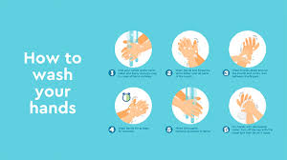
The entire campus must be adorned with appropriate signage to instruct students of where and when to travel as well as establishing health and safety requirements. Signs should include but not be limited to: requiring masks, encouraging safe practices for coughing and sneezing, remind students and staff about frequent and thorough handwashing, identifying direction for travel, marking supply locations, instructing visitors where to go.

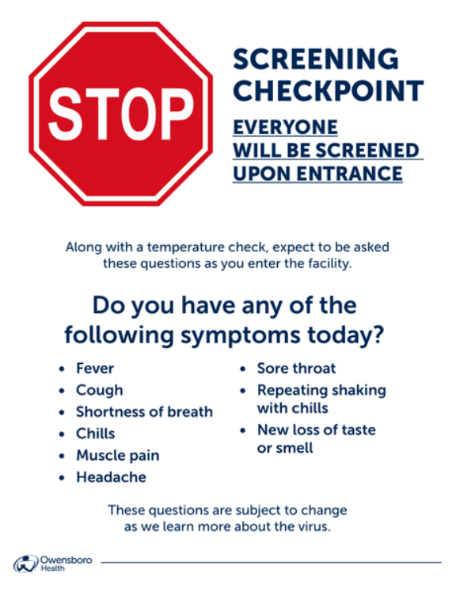

Campus Entrance Protocol
Students and staff entering campus will be checked for and provided with cloth face masks when necessary. Upon entrance, all students will have their temperature taken and will be provided with tissue and hand sanitizer. Any student or staff member who has a temperature higher than the normal range will not be allowed to enter campus. This student or staff member will need to be tested for Covid-19 before being allowed to enter campus. When practical, those students and staff members with elevated temperature should be tested immediately and should enter the quarantine protocol upon receipt of positive results. If any student or staff member exhibits any objective signs or symptoms of any illness, they should be encourage to leave and get tested immediately. When possible parents or family members dropping students off at school should remain at the site until students have been cleared for entrance.

Ingress
Students enter through the gates located at the far North part of campus and the southernmost sliding gate located on 108th Street. One half of students enter through each gate depending upon either grade or gender. All students will have temperature checked upon entrance and will remain 6 feet apart during the entrance process. Students will form a line with each entering student standing 6 feet behind the person in front of them. As the students’ temperatures are checked, those within normal range will proceed to a designated area of the outside/playground behind the school building. Students will enter the building on a staggered basis, as each group will remain seated until called to enter. As students enter, they will remain six linear feet from each other and will proceed directly to class. Six foot distance will remain in effect at all times including when students exit and have exited the school grounds.

Egress
Students will be dismissed on a staggered basis beginning at 1:10pm each instructional day. Students will be dismissed from the two gates used in the morning for ingress. Students will not be permitted to remain in the area of the school or on campus to socialize or wait for other students and or rides. All students must be off campus by 1:25 each day. Students are to leave campus and the immediate area of the school upon dismissal and the campus will officially close at 1:30 each day. No students or staff member will be allowed to enter campus, leave, and re-enter campus. All students must be off campus by 1:25 each day.

Controlled Movement
There should be absolutely no student movement in the last 10 and first 10 minutes of each class period. Students are encouraged to use the restroom at designated times and therefore dissuaded from restroom visitation during class periods. Exceptions will be made when there is urgency but students visiting restrooms must adhere to all Covid-19 regulations (face mask, hall pass, one direction, sole travel)

Hallways & Restroom
A campus aid will be stationed on each floor at all times to insure that student foot traffic proceeds in one direction. Students entering the hallways must be in possession of a visible pass at all times. Students may never travel accompanied by another student and teachers should make every effort to keep ALL students in class.

Contact Tracing
Every effort will be made to keep students within a specific group of approximately 16 students. These cohorts of students should have at best no contact and at least minimal contact with other students. When practical, teachers should travel to classrooms for instruction. Students should remain primarily in specific and designated parts of campus to minimize intermingling of individual cohorts.

Movement to class
At the appropriate time, students will proceed to class within a time window. Passing to class shall account for 10 minutes and students are to enter the building at the 1st floor, far South rear building entrance. Student movement will proceed in 1 direction and all student’s will travel in one direction. Students arriving late will be ushered to an outside area for temperature taking and then allowed to enter the building through the far South building entrance.

Designated Concern Areas
There should be a specific location clearly marked and exclusively used for “persons of concern” to remain without having contact with other staff members or students.. Persons of concern are those who are either complaining of or demonstrating symptoms of Covid-19 exposure, students or staff who believe they have been exposed to the Covid-19 virus, students, staff or visitors who have recently travelled outside of the US,

Instructional time
Students will be assigned seats 6 feet apart. Efforts will be made to keep students in class during instructional time. There will be no group work or sharing of resources or supplies. Students will

Class Schedules
Students will attend school 2 days per week and learn in the on line platform two days per week. Cohorts will be Monday Wednesday or Tuesday Thursday. Fridays will be reserved for professional development and Advisory classes only. In school classes will be 90 minutes each and there will be a total number of 3 classes per instructional day. There will be a 15 minute break between the first and second period of the day and a 30 minute break between the second and final period of the day. Class times will be 8:00-9:30, 9:45-11:15, and 11:45-1:15.

Constant Campus Cleaning
Throughout the day all surfaces should be constantly wiped with disinfectant. High touch surfaces should be cleaned literally after each use. Each campus leader must create and monitor constant cleaning and wiping of desks, walls, counter tops, chairs, etc. This cleaning schedule is to be maintained and monitored. All staff must participate in the constant cleaning effort but specific employees should be made responsible for specific areas to be cleaned and maintained in a sanitized condition.
Supplies
Students and staff members will be provided masks and hand sanitizer. Students and staff will be encouraged to obtain their own masks, however masks will be provided daily. Each classroom will have hand sanitizer readily available and each student will receive hand sanitizer upon entering the campus and the class for instruction

Lunch Service
Lunches will be provided to students in classrooms in prepackaged containers. Disposable plastic-ware will be provided to students. If students leave classroom for lunch service, two lunch times should be conducted with half of the students in each. During lunch periods students should be allowed to individually attend the restroom.

