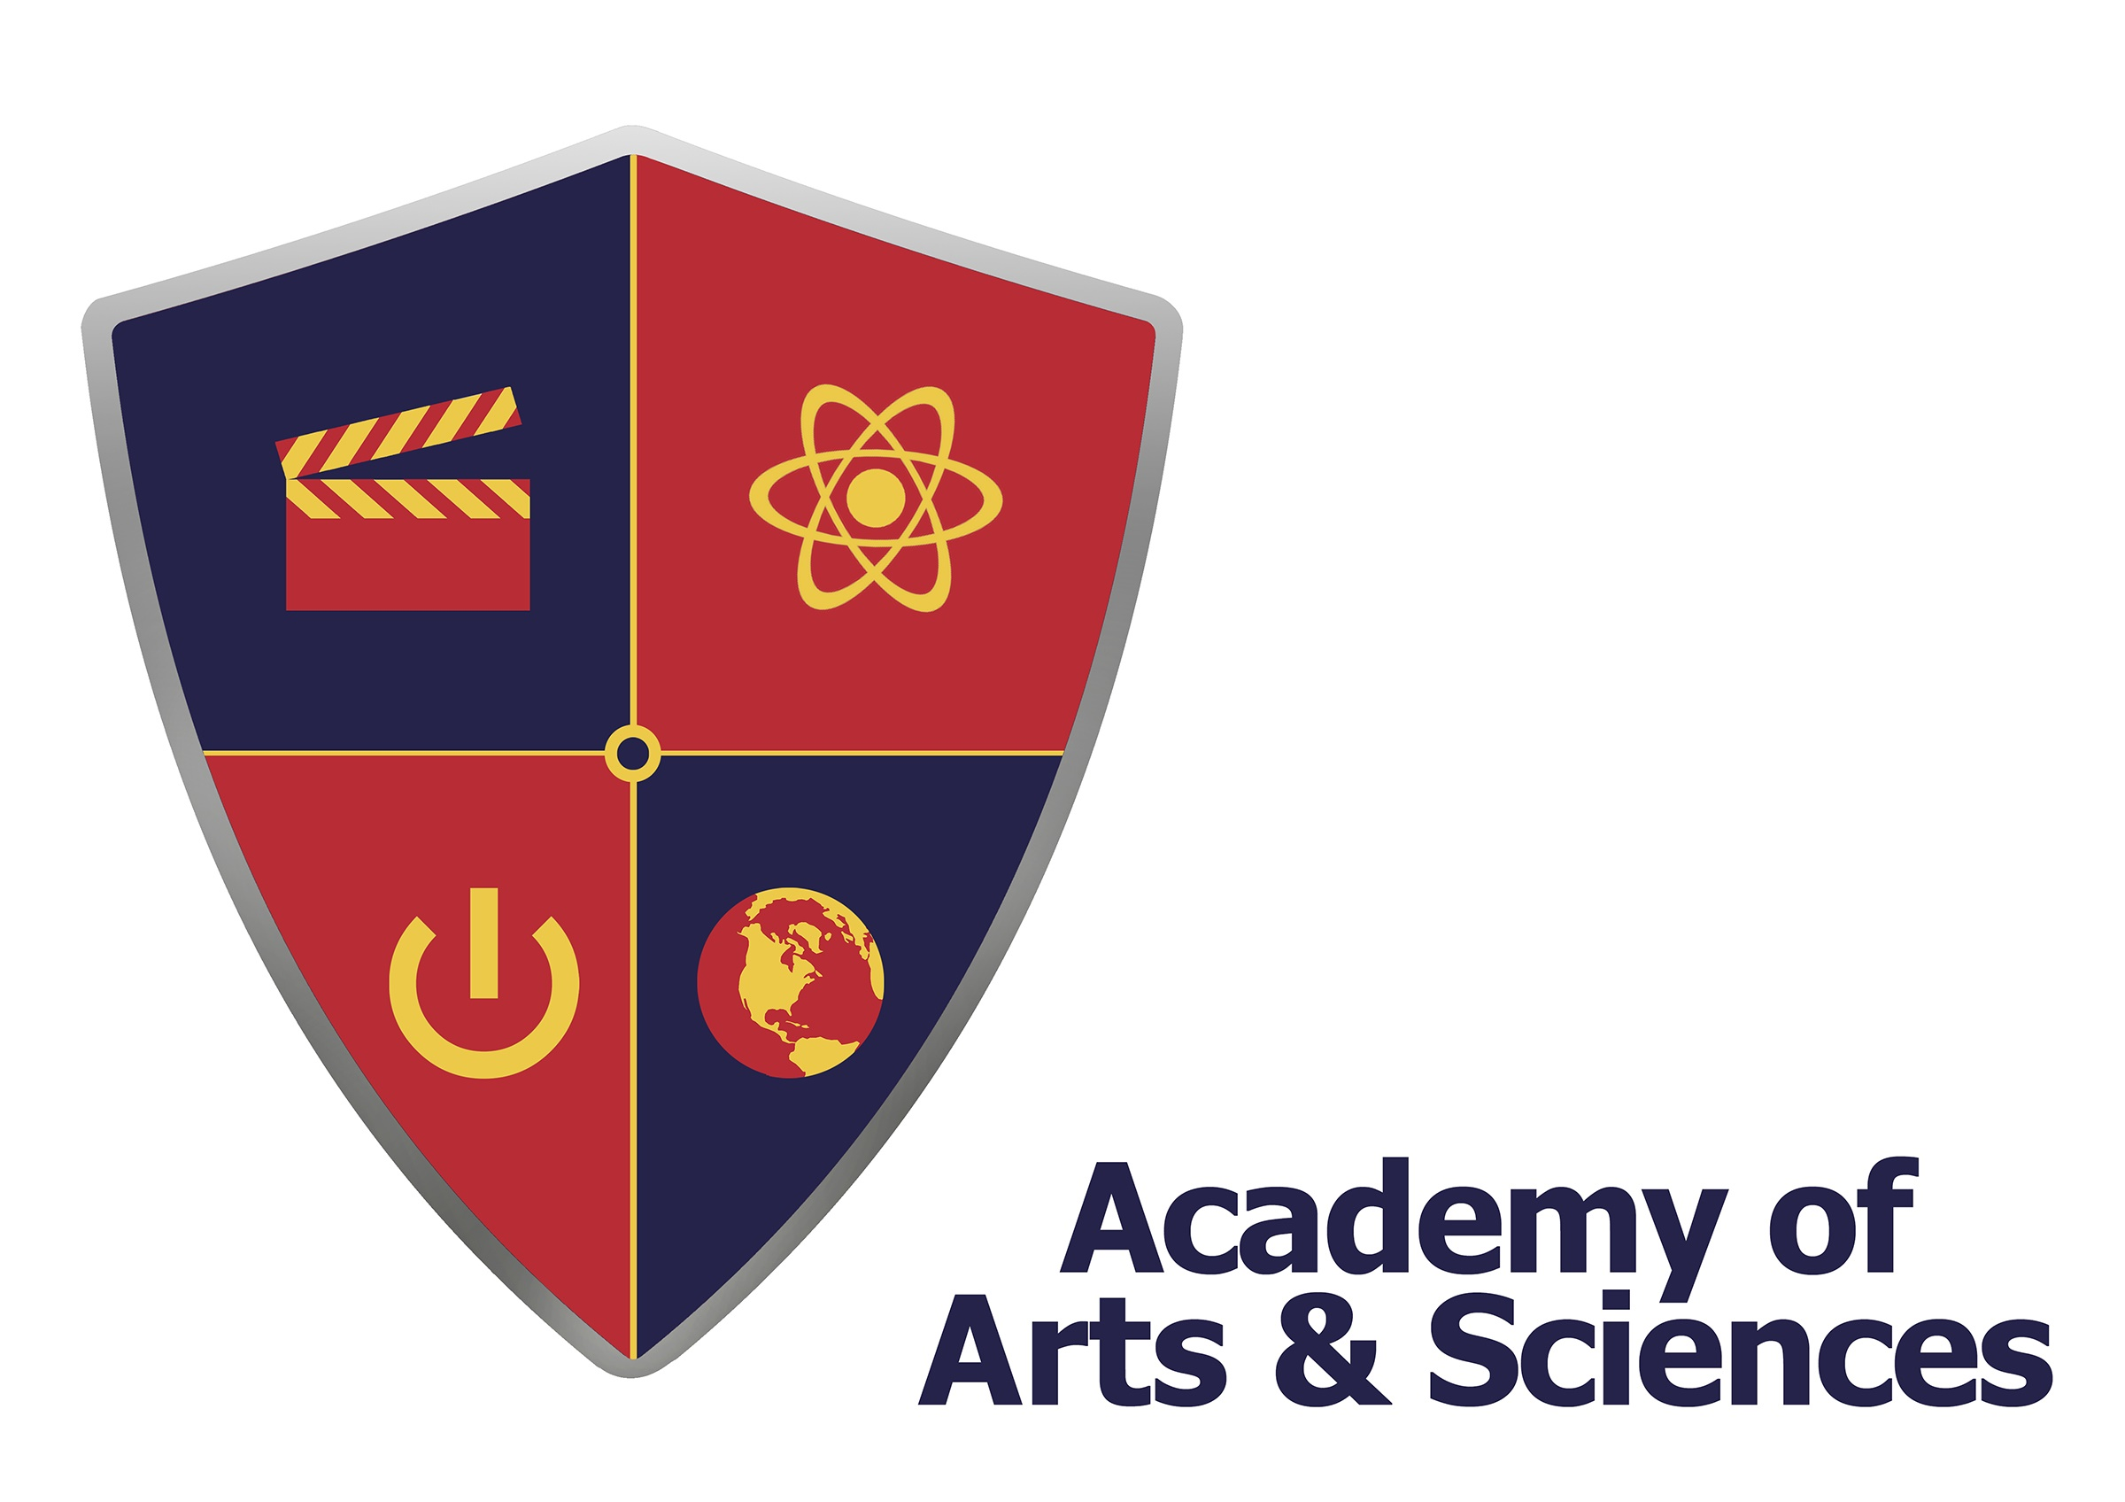

Staff Report
February 15, 2017

This report is meant to provide updates to the Board of Directors Personnel Committee:

Bamboo HR
Bamboo HR is our HRIS system. In addition to tracking credentials for our staff, mandatory training, and leave balances (they also request leave from the system), we have expanded it to include our Performance Planning system. In March, our Self Review will be released for staff through Bamboo. Starting in 2017-18, our entire performance planning process will also run through the system.

Hiring Update
We continue to update our tracking document, which helps us monitor our recruiting process. This tracks when a position is posted, how many applicants we receive, when we make an offer and when the new employee starts. See attached.

S.T.A.F.F. Committee
Our S.T.A.F.F. Committee continues to meet and create opportunities for staff to engage in fellowship in a virtual setting. The January event was #AASGetsFit2017!
We held a 30-day health and fitness challenge, starting Monday, January 9th. The winner of #AASGetsFit2017 will receive a pair of iDeaUSA Bluetooth Headphones Stereo Mega Bass Over Ear Headphones.

Ventura County
We are working with the County of Ventura, Workforce Investment Board (part of America’s Job Center) to recruit and hire potential job seekers in Ventura County. The On-the-Job-Training program is designed to make it more affordable for hiring and training individuals. The program reimburses directly to AAS, up to 50 percent of a trainee’s gross wages, for the duration of the training period.

