2023-24 Education Protection Account (EPA)
Compass Charter Schools
RESOLUTION OF THE GOVERNING BOARD OF
Compass Charter Schools

BE IT RESOLVED that the Education Protection Account funds to be received by Compass Charter Schools for FY 2023-24 in the amount of approximately $2,907,774.08 will be used solely for instructional, non-administrative expenses.
PASSED AND ADOPTED at a meeting of the Board of Directors of Compass Charter Schools.
Dated September 30, 2023.
Board Chair, Compass Charter Schools

BUDGET: Fiscal Year 2023-24 BUDGET (for Board Resolution:
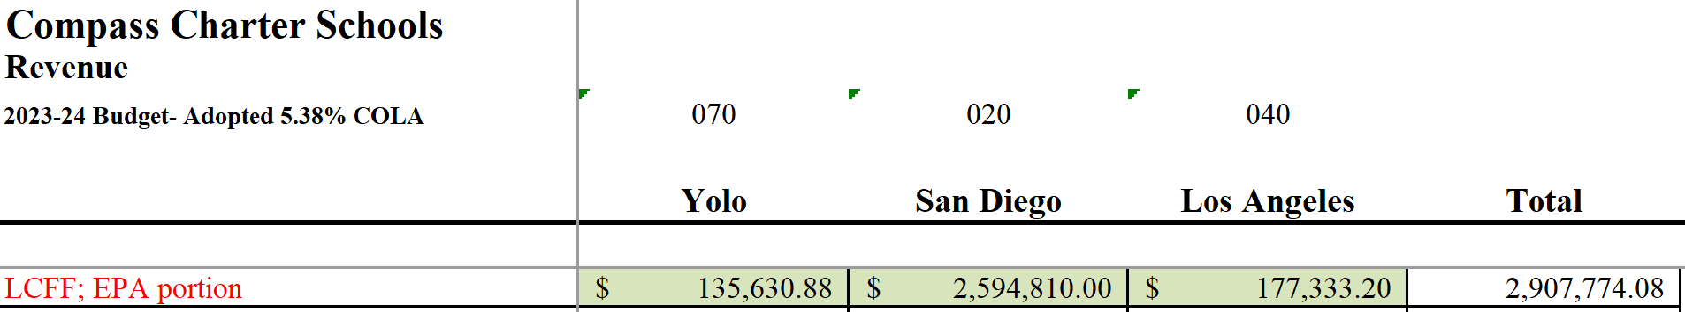

REPORT OUT: Fiscal Year 2022-23 ACTUALS (for website posting):
