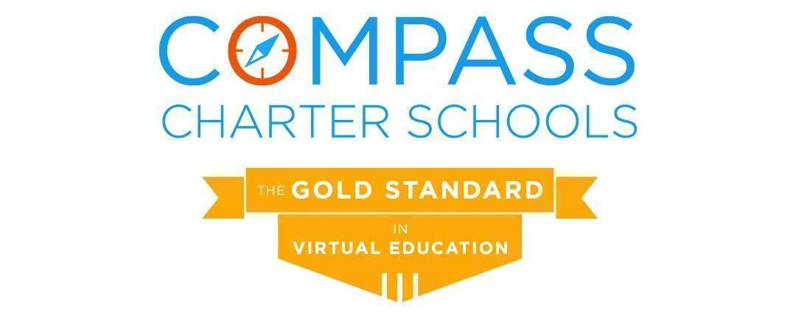

Academic Services Division Report
March 25, 2023

This report highlights areas since the last regular meeting of the Board of Directors:

- Dr. Ebner restarted the Leadership Mentoring program for coordinators.
- The leadership team worked together to write the WASC Action Plan and update the LCAPs.
- Dr. Ebner completed an analysis on the Online and Options A-G course offerings and made recommendations to the Superintendent for A-G offerings moving forward.
- Based on the middle of year (MOY) Star benchmark scores:
  - 30% of scholars receiving intervention from our intervention tutors and/or resource specialists moved from Urgent Intervention or Intervention on the Beginning of the Year (BOY) to either On-Watch (29th - 39th percentile) or At/Above Grade Level (at or above 40th percentile) and no longer need reading intervention for the Spring semester.
  - 29% of scholars receiving intervention moved from Urgent Intervention or Intervention up to On-Watch or At/Above Grade Level and no longer need math intervention for the Spring semester.
  - Scholars who attended ≥50% of their intervention live sessions with tutors outperformed those who attended <50% of sessions.
- For English Language Learners (ELs), MOY benchmark scores reflect:
  - Grades TK-3 Early Literacy:
    - Scholars who attended ≥50% of EL live tutoring sessions outperformed scholars who attended <50% of EL live tutoring sessions.
  - There was significant growth in Lexia Core5 for scholars in grades TK-5 and in Lexia PowerUp in grades 6-12 in word study, grammar, and comprehension.
- 52 current scholars referred to Scholar Support Team (SST), which is an increase of 8% from February 2022
- 71 current scholars with 504s
- 89 scholars with 504s have been supported this year, including scholars who are now withdrawn
  - There was an increase in MOY Reading and Math benchmark scores for scholars who received an initial 504 after the BOY benchmarks.
- High School Credit Status March 2023:
  - 65.8% of high school scholars are on track to graduate within the four-year cohort (-12.6% from October 2022 data).
  - 25.3% of high school scholars are credit deficient in meeting graduation requirements within the four-year cohort (+8.8 from October 2022 data).
  - 6.2% of high school scholars are not eligible to graduate within the four-year cohort (+1.1% from October 2022 data).
  - 2.7% of scholars earned their high school diploma at the end of the Fall 2022 semester.
    - Note: CCS data reflects 59 scholar withdrawals with 38 new scholar enrollments. New scholar enrollments show 28 scholars entered Compass credit deficient; 7 scholars were on track and 3 scholars were pending records (transcript).
- Internal (not CA Dashboard) data of senior scholars meeting A-G requirements 2022-23: 19.4% (+4.4% from 2021-22 school year)
- Internal (not CA Dashboard) College Career Indicator (CCI) 2022-23:
  - Prepared: 27.4% (+9.4 from 2021-22 school year)
  - Approaching Prepared:16.8% (-5.2 from 2021-22 school year)
  - Not prepared: 55.8% (-4.2 from 2021-22 school year)
- Internal (not CA Dashboard) data for high school scholars participating in the Accelerated Course Options Program to recover lost credits or advance in meeting high school graduation requirements for Fall 2022: 91% passing success rate within the 106 (18%) course enrollments.
- The Carson Scholars Fund informed the Counseling Services Department that our nominee has been selected as a 2023 Carson Scholar. Scholar Katelyn Elizabeth Eddins will receive a $1,000 scholarship award that will be invested for her college education. The scholar will also receive a medal and a certificate. The scholar was chosen because she demonstrated the highest standards of academic achievement and integrity, as well as civic and social responsibility.
- 12th Grade Graduation and 8th Grade Promotion locations have been confirmed for CCS of San Diego, CCS of Los Angeles, and CCS of Yolo. Invitations were sent out and RSVPs are being processed for the six ceremonies that will be held the week of June 19, 2023.
- There have been 43 Field Trips, 19 Learning Coach Academy sessions, 38 Orientation sessions, 114 Scholar Club Meetings, and 29 Virtual Scholar Workshops offered to scholars and learning coaches during this school year.
- Current Engagement satisfaction rates are 93% for in-person offerings and 98% for virtual offerings.
- Scholar Recognition - Core Values (ARTIC) Awards breakdown for Semester 1:
  - Recipients by Program
    - (25) Online Learning scholar recipients
    - (33) Options Learning scholar recipients
  - Recipients by Charter
    - (24) Compass of Los Angeles scholar recipients
    - (18) Compass of San Diego scholar recipients
    - (16) Compass of Yolo scholar recipients.
- Over 90% of the Online teachers reported that they have an increase in professional satisfaction and increased cohesiveness throughout semester 1 WIG lead measure reporting.
- Over 80% of Online scholars identified as “on-watch” through STAR benchmark assessments and had targeted Tier 1 intervention data collected during semester 1 showed academic success as indicated by their semester 1 grades.
- The Online teachers continue to utilize research-based strategies aligned with universal design for learning (UDL) assignments and assessments.
- The Online Learning Department participated in several data discussions during semester 1 to create targeted plans for scholars identified as “On Watch” through STAR benchmark assessments, using course progress, engagement, connection meetings, and Tier 1 support data; they worked cross-departmentally to create these plans and report effectiveness throughout the semester.
- Weekly progress reports for Online scholars were revised to ensure learning coaches and scholars receive accurate course progress and “average grade” information throughout the semester.
  - 90%+ open rate for these progress reports sent through Yet Another Mail Merge; increasing support for and collaboration between learning coaches and Online supervising teachers.
- Semester 1 Online Learning Department Data
  - See supplemental data slide deck
  - Connection Meetings
    - 58% of scholars attended all connection meetings for each learning period during semester 1, however, 80% of Online learning coaches and scholars attended at least 2 connection meetings during semester 1.
  - Tiered Re-Engagement
    - Of those scholars who received a tier 1 re-engagement notice, only about half needed to continue in this process and received a tier 2 re-engagement notice.
    - Only 2% or less of scholars who were identified as needing tier 2 re-engagement support through the independent study evaluation process were involuntarily withdrawn.
      - Of these 2% or less, the cause for the involuntary withdrawal was due to the learning coach not requesting a hearing to appeal this evaluation.
- Semester 1 Options Learning Department Data
  - See supplemental data slide deck.
- Connection Meeting Attendance
  - The connection meeting data shows that supervising teachers and coordinators are making concerted efforts to engage scholars of our special population subgroups.
- Tiered Reengagement
  - Less than 2% of scholars in tiered reengagement proceeded to withdrawal.
  - A majority of the tier 1 notices stemmed from STAR testing refusal or missing STAR examinations
- A five-part series of training for Learning Coaches of special education scholars began on March 8, 2023, arranged by our Director of Special Education.
- Planning for Extended School Year (ESY) is commencing. Currently, we have 96 scholars eligible for ESY beginning July 3, 2023.
- The percentage of scholars with IEPs out of the total CCS enrollment rose from 12% Census day 2021-22 to 15% on Census Day 2022-23; we continue to enroll new scholars with IEPs and have continuing scholars who went through the SST process and are currently awaiting their initial IEPs.
- The Director of Staff Support surveyed all program coordinators on the effectiveness of the Staff Support’s communication, initiatives, and offerings. On a likert scale of 1-5, 100% of coordinators indicated that adding information in the weekly updates is effective, 73% of coordinators indicated that communication from the Staff Support is very clear, 91% of coordinators indicated that the Staff Support Team always exhibits ARTIC values, and 82% indicated that the professional learning opportunities this year have been effective.
- In partnership with the Training and Development Manager, an asynchronous professional learning session was launched this month, in addition to the March in-service day offerings. 111 staff members have responded to the post session feedback survey, and 82% found it very effective (4.09/5), 83% found it engaging despite the workshop being asynchronous (4.17/5) and 89% found the presenter to be well rehearsed and energized (4.47/5). Data about the in-service day will be shared at a future meeting.

Respectfully Submitted,

Aviva Ebner, Ph.D.
Assistant Superintendent & Chief Academic Officer

