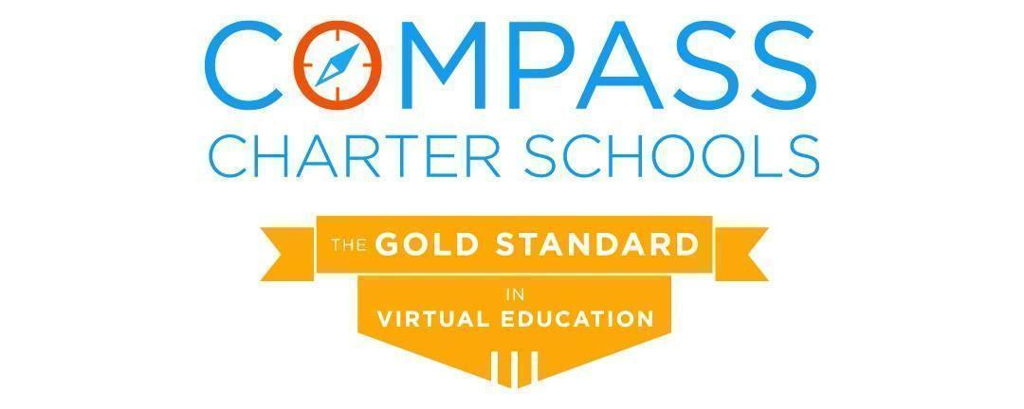

Academic Services Division Report
January 28, 2023

This report highlights areas on which the Academic Services Division team has worked since the last regular meeting of the Board of Directors:

- Dr. Ebner has been working with the Academic Services Division’s administrative assistant on identifying potential grants that can support Compass academic initiatives
- Dr. Ebner is now serving as leadership liaison for the Diversity, Equity, and Inclusion (DEI) committee.
- Planning for Summer session 2023 and for the 2023-24 school year has started.
- Preparation has started for obtaining training and support for collection of “street data.”
- The Academic Support department noted that, of the 148 K-3 scholars that scored at the Intervention or Urgent Intervention levels on the beginning of the year (BOY) Early Literacy assessment, 44% have moved up to On Watch or At/Above Grade Level. Of the 469 MTSS Math scholars tested by 1/3/23, 29.6% moved up to On Watch or At/Above Grade Level. Of the 547 MTSS Reading scholars tested by 1/2/23, 30.4% moved up to On Watch or At/Above Grade Level. The Academic Support team will disaggregate this mid-year data to determine trends in the supports that the team provides for intervention and within resource groups.
- Regarding English Learner (EL) progress, of the TK-5 EL scholars who used Lexia Core5, 13% moved into In or Above Grade Level Material. Of the 6-12 grade EL scholars using PowerUp, 23% moved into Intermediate or Advanced for Word Study, 9% moved into Intermediate or Advanced for Grammar, and 12% moved into Intermediate or Advanced for Comprehension.
- The Counseling Services department is anticipating fourteen (14) scholars to meet graduation requirements at the close of the fall semester.
- Across all three charters, 85 high school scholars participated in the Accelerated Course Options Program (ACOP) to complete a total of 108 additional courses during the fall term to recover lost credit or accelerate towards meeting graduation requirements.
- Mini-”Weeks of Welcome” (Mini-WOW) this Spring will be offered as a flipped model, with recordings shared that include helpful information and tips for learning coaches (LCs) as they enter the second semester. Recordings will be prepared by Assessment, Counseling, English Learner Support (EL), Engagement, IT, Online, Options, Scholar Success, and Special Education (SPED). A cumulative live Q&A will be held for LCs in February.
- Spring Semester Club Rush will be held in February to highlight the 21 scholar clubs available to scholars for the Spring semester.
- The Online Learning Department evaluated the effectiveness of the cross-departmental action plans for the on-watch scholars, the tier 1 interventions, and the STAR MOY benchmark scores.
  - Teachers compared and analyzed scholar assessment results to determine growth; they also collaborated on use of the benchmark data to further customize courses.
  - 94% of the On-Watch Online Elementary scholars who had an action plan created, tier 1 interventions provided, and assignment/assessment choice showed growth on one or both STAR diagnostic assessments and/or increased engagement during learning labs or Accelerate Education courses.
  - 67% of the On-Watch Online Middle School scholars, with the same criteria, showed growth on one or both STAR diagnostic assessments and/or increased engagement during learning labs or Accelerate Education courses.
  - 69% of the On-Watch Online High School scholars who had an action plan created, tier 1 interventions provided, and assignment/assessment choice showed growth on one or both STAR diagnostic assessments and/or increased engagement during learning labs or Accelerate Education courses.
- The Director of Online Learning audited the Accelerate Education electives to determine additional software needed to offer additional elective choices for the 2023-24 school year. The Director of Online Learning is collaborating with the Director of Counseling Services to determine the feasibility of providing courses in which scholars can earn a certificate upon completion (ex: Microsoft Office certification).
- The Director of Online Learning is analyzing the cost for AE A-G courses for Options scholars (amount of instructional support funds to adequately cover the cost of the course, course management, and additional support from an Online teacher). A recommendation will be made and shared with the cabinet to discuss with their respective divisions.
- Options Leadership completed a review of the grading guidelines and rubric to support scholar centered learning. The findings reflected a need to structure these guidelines for improved usage in planning with supervising teachers and learning coaches. The review included researching best practices to align language and usage of the document to enhance the learning experience of the scholar as well as the teaching/planning experience of the learning coach. The draft of the recommendations is currently under review by Options Advisory before being formally presented to the Assistant Superintendent & Chief Academic Officer and then shared with the department.
  - The Options Learning Department is also currently reviewing live synchronous observation rubrics and aligning with updated grading rubric guidelines. This will ensure that the standards for the teaching profession and key observable actions expected of scholars will be reflected in supervising teacher expectations
- Options Advisory and the Director have begun discussions on potential departmental changes. The Options Advisory Chair developed a system to gather feedback, questions, and ideation regarding the impact of, for example, potentially shifting the Options program toward reflect grade span alignment to better serve scholars. Future meetings with Options Advisory and educational partners will be held throughout the semester.
- Biweekly meetings with academic directors and academic support include planning for the 2023-24 school year for special education supplemental materials and program design.
- The Director of Special Education is analyzing the costs for related services contracted with nonpublic agencies (NPA) to determine ways to reduce costs and improve communication and services to scholars.
- Education specialists with moderate/severe credentials are meeting to identify supplemental materials to support scholars with functional needs.
- Course offerings for the new Alternative Diploma will be developed in conjunction with the Director of Counseling Services.
- Compass has 355 scholars with Individualized Education Plans (IEPs) and an additional 29 scholars in the initial assessment process, as of January 13, 2023
- Biweekly meetings with the academic directors were instituted to identify trends and equity gaps in the mid-year (MOY) benchmark data.
  - Trends reflect that Compass Latinx and Black scholars are not performing as highly as their counterparts, so further systems are needed to support their growth; the team will work toward obtaining “street data” for alternate ways of evaluating these trends, as well as reviewing current strategies for scholar subgroups.
  - Although the midyear benchmarks were administered two months earlier this year than last year, the data reflects a nearly 2% improvement in overall growth from 2022-23 Fall to Winter compared to 2021-22 growth from beginning of the year (BOY) to MOY.
  - The scholar population as a whole exceeded the Compass-wide goal of 65% at or above benchmark in reading; 67% of scholars are at or above the reading benchmark.

These efforts of the Compass academic staff to support improvement of the educational experience for Compass scholars are appreciated.

Respectfully Submitted,

Aviva Ebner, Ph.D.
Assistant Superintendent & Chief Academic Officer

