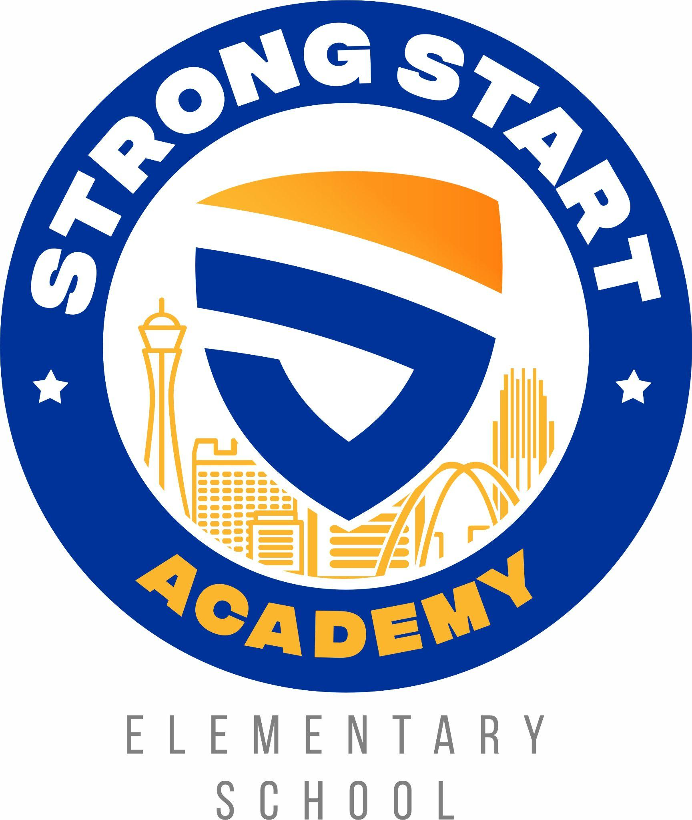
Registration Process--Lottery
Open Enrollment
December 1, 2023 - January 14, 2024
For the 2024-2025 school year, SSAES will offer a Kindergarten through Fourth grade program. In accordance with Nevada law, the 45-day open enrollment period will be from December 1, 2023 to January 14, 2024. All incoming students must complete an interest form which will be used for selection through a lottery process. The interest form is the first step in the registration process and all parents who are interested in having their child attend SSAES must follow this process to enter the lottery. Please be aware of the following enrollment preferences (NRS 388A.456(1)(e)):
★ Siblings of current students
★ Children of employees or board members
★ Children of military personnel

These enrollment preferences mean that siblings of current students, children of employees, board members or military personnel will be accepted first, before other students. Additionally, there is a Home Language Survey (HLS) that is an optional questionnaire, consisting of four questions on the interest form. These questions will help the school identify which incoming Kindergarten students are potential English Learners (ELs) who may require assessment of their English Language Proficiency (Title VI of the Civil Rights Act of 1964). Incoming 1st and 2nd grade students may submit WIDA scores to potentially qualify for this additional weight. Students confirmed as ELs prior to the Strong Start Academy lottery will qualify for an additional weight in the school lottery. The weighted lottery is a mechanism to provide increased opportunities for Spanish speaking students. One of the basic principles of a 50/50 dual language program is a balance of both target languages. Since the dual language program at SSAES will be taught in Spanish and English, our goal is to have half the total classroom enrollment be Spanish dominant speakers and half English dominant speakers. This balance creates a culture of language and provides strong role models of the native language in both the English and Spanish classrooms.
Additionally, Strong Start Academy aims to support the communities within 2 miles of SSAES, which are communities that have been traditionally and significantly underserved populations with students attending one- and two-star schools. Therefore, a weighted lottery will also be implemented for students confirmed to have attended a one- or two-star school. These students will also qualify for an additional weight in the school lottery. The weighted lottery distribution will award three tickets to EL students, two tickets to students whose most recent enrollment was in a one- or two-star school, and all other students will receive one ticket. This weighted lottery will create additional opportunities for educationally disadvantaged students to be accepted to the school and contribute to the program's success (NAC 388A.536(1)(b)(4)).

Weights are optional, and students and families are not required to submit documentation to enter the lottery with a traditional weight of 1.0.
The maximum enrollment per grade level is 60 students in each grade level except for third grade, which is 20 students. The number of students drawn via lottery will be determined once students with preference are enrolled. Students enrolling in Kindergarten must have turned 5 by August 1, 2024.
The lottery will be held on Monday, January 15, 2024. A letter will be emailed to the child’s parent/guardian to announce if the child was selected in the lottery to register at SSAES for the upcoming school year OR if the child was placed on the waitlist. This letter will also provide details about the next steps in the registration process. Parents must respond by email or a phone call to the school to confirm that their child will be attending. Parents must confirm attendance within 5 business days after the email was sent. An email will also be sent to the children who were placed on the waitlist.
All interest forms submitted during open enrollment will remain on file the entire school year of that application period. Any student not selected during the lottery process will be placed on a numbered waitlist. Should an opening occur during the school year, the numbered waitlist system will be utilized. However, enrolled students' siblings will be given preference. If there are no siblings, the numbered waitlist will be utilized to fill vacant seats. In the event that there is not a waitlist for the grade with the vacancy, students who apply will be enrolled upon completion of the interest form.
In order to be eligible for the lottery, a complete interest form must be submitted for new students during the established 45-day open enrollment period. Students with incomplete interest forms will not be eligible for the lottery.
If a child is drawn in the lottery and the parent accepts enrollment into Strong Start Academy Elementary School, a complete enrollment packet must be submitted. A complete enrollment packet includes Online Registration through Infinite Campus, which requires the uploading of the following documents:
● Authorization for Release of Records (if child has attended a previous school)
● Family Commitment Form
● Student’s Birth Certificate
● Student’s Immunization Record
● Documentation of County of Residence
○ (utility bill with your name/home address on it.,i.e., NV Energy, Southwest Gas, signed lease agreement or mortgage statement)
● Parent/Guardian driver's license or other valid form of identification

