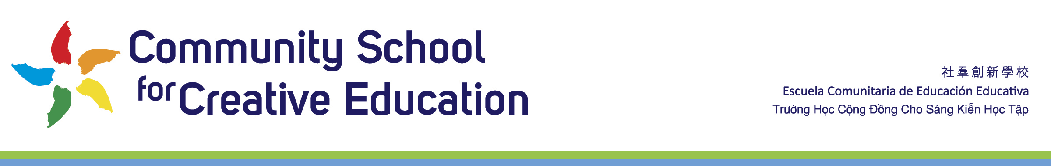
Community School for Creative Education
Board Meeting Calendar 2022-2023
For Board Review and Approval 6 12 2022

Location:
Community School for Creative Education
2111 International Blvd
Oakland, CA 94606

ZOOM Link
For ZOOM Link Go To
https://app2.boardontrack.com/public/maUTAb/nextAgenda

Times:
All meetings are held from 6pm – 8pm, unless otherwise posted
All meetings are held on ZOOM, until otherwise posted.

Dates:
Monday, August 1, 2022

Monday, September 12, 2022

Monday, October 3, 2022

Monday November 7, 2022

Monday December 5, 2022

Monday, January 9, 2023

Monday, February 6, 2023

Monday, March 6, 2023

Monday, April 17, 2023

Monday, May 8, 2023

Saturday, June 10th, 2023, 10am – 1pm Board Retreat

