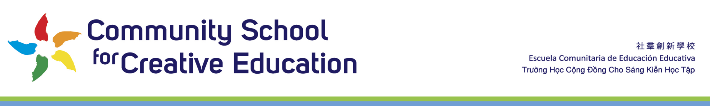
Board Docket Memo
6p-8p May 9 2022

From: CSCE Staff
To: CSCE Board
Re: Agenda Item:21-22 Supplemental LCAP

This Item Will Be Deferred In Consultation with Our Authorizer

Staff Will Update Board on Status at May 9 2022 Board Meeting At This Point in Agenda

