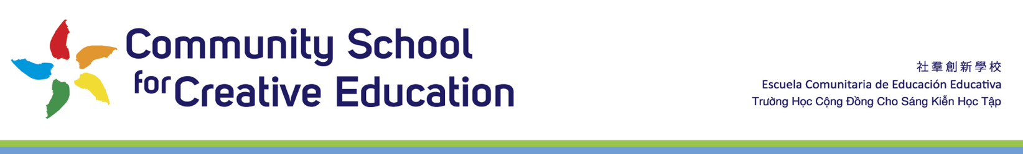
Cover memo CSCE Board Agenda Meeting 4/18/22 Item V.D “ED At Will Agreement ’22-23’
To CSCE Board
From Dr Ida Oberman, ED and Founder
During this transition it is critical that all of our current stakeholders feel that this transition is seamless. The transition is high opportunity and high stakes. We are returning from COVID, we are building up our Upper Grades and the Founding Executive Director, myself, is succeeding.

The demands of a head of school for CSCE are large and when this is coupled with also trying to learn all the people, processes and execute it can make lead to a dip in performance or initial success. Any dip in successful execution can be viewed by our stakeholder as a result of the transition as opposed to a period of transition. This dip can then lead to the momentum of greater problems and concerns. To ensure this does not happen and that the new Head of Schools and the school is positioned for success, I outline below the role I will play during the transition period.

- Onboarding –
  - During the first 6.5 months the new HS will primarily focus on a combination of learning and training
- Family and Community Introductions
- Grant Writing Support
  - I will also maintain full focus on grant writing during this time so that the new HS can focus on teaching and learning and on parent and community engagement key for our full service intercultural Waldorf school
- Strengthening and handing off the systems and processes for mission-critical braid of Waldorf with other tested best practices and standards to advance equity for further implementation and growth of our singular model

As shared in our March 22 board meeting, I will stay on full time till mid-January, 2023

I ask that in April 18 2022 meeting the Board approve the following: extending my annual contract with the 3% raise through mid-January 2023 and add 5 consulting days if deemed needed by the CSCE Board between February 2023-June 2023.

Dr Ida Oberman, ED and Founder

