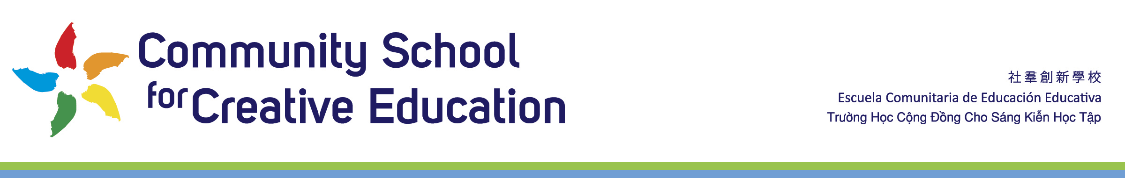

Community School for Creative Education
Board Calendar 2020-2021

DRAFT for Board Executive Team & Board Approval

Location:
Community School for Creative Education
2111 International Blvd
Oakland, CA 94606

ZOOM Link
For ZOOM Link Go To
https://app2.boardontrack.com/public/maUTAb/nextAgenda
Conference Line: 1 351 888 7445

Times:
All meetings re held 6pm – 8pm

Dates:
Wednesday, August 5, 2020

Wednesday, September 2, 2020

Wednesday, October 7, 2020

Wednesday, November 4, 2020

Wednesday, December 2, 2020

Wednesday, January 6, 2021

Wednesday February 3, 2021

Wednesday, March 3, 2021

Wednesday, April 7, 2021

Wednesday, May 5, 2021

Wednesday, June 2, 2021

Saturday, June 12th, 2020, 9am – 12pm Board Retreat

