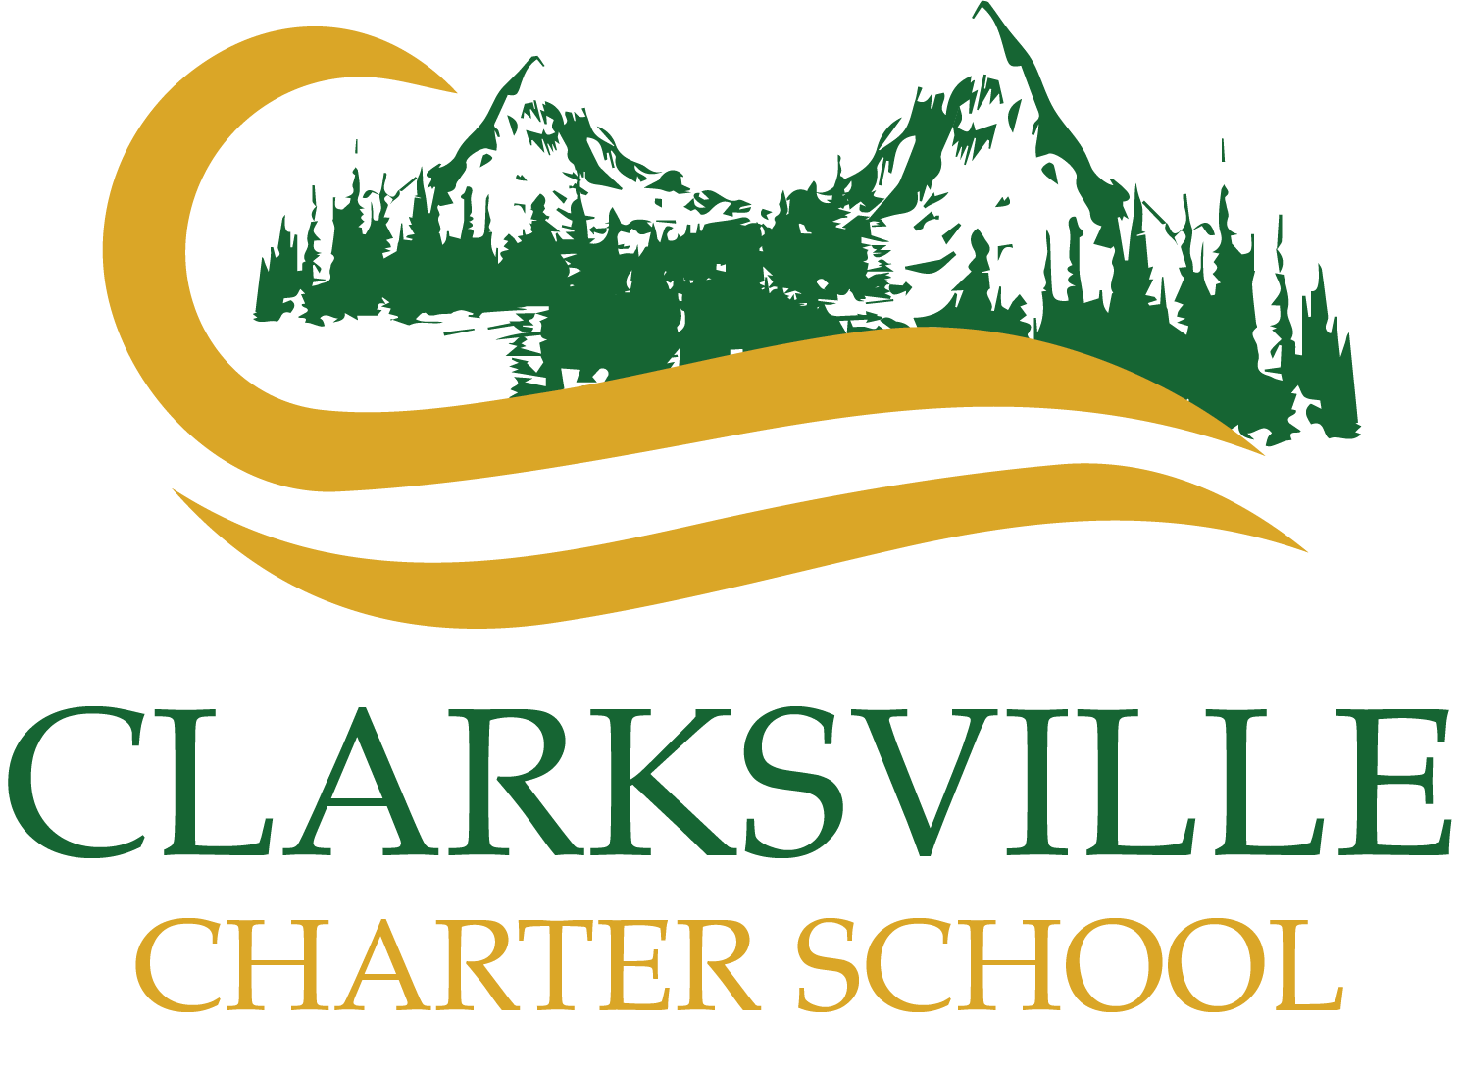Introduction
COVID-19 Schoolwide Health & Safety Policy 2021-2022

It is the policy of Clarksville Charter School (“Charter School”) to take all reasonable measures necessary to prevent the spread of the novel coronavirus disease (“COVID-19”) among students and staff in school-sponsored activities. In accordance with this COVID-19 Schoolwide Health & Safety Policy (“Policy”), the Charter School is implementing health and safety measures to mitigate the spread of COVID-19 at school-sponsored and staffed in-person activities consistent with federal, state, and local guidance.

Although Charter School is a non-classroom-based program, the school recognizes that there are circumstances when staff, students, and parents/guardians may interact in-person as part of the educational program. This can include in-person instruction between staff and students, parent-teacher meetings, field trips, park days, and individualized services (“in-person activities”).

This Policy recognizes that these safety measures are each designed to provide some protection against COVID-19. While there may be times when one measure may not be feasible, implementing alternative measures can provide backup layers of safety. This Policy includes both mandatory measures (using terms “shall” or “will”) as well as recommended measures intended to guide decisions in light of practical limitations.

This Policy is based on guidance provided by the U.S. Centers for Disease Control and Prevention (“CDC”), the California Division of Occupational Safety and Health Administration (“Cal/OSHA”), the California Department of Education (“CDE”), and the California Department of Public Health (“CDPH”). Charter School will, as necessary, consult with the respective county health officer, or designated staff, to monitor and provide advice on local conditions to individually determine whether more or less stringent measures are necessary to align with the applicable public health guidelines.

Charter School will fully cooperate with county public health officials regarding the screening, monitoring, and documentation that will be required to permit careful scrutiny of health outcomes associated with conducting in-person activities. To the extent any mandatory public health guidance is revised to materially conflict with this Policy, Charter School will follow such guidance and not this Policy.

COVID-19 Compliance Officer

State and local public health orders require that schools designate a liaison to be responsible for receiving and sharing information on COVID-19 policies, positive cases, and exposures.

The following individual is designated as the Charter School’s COVID-19 Compliance Officer:

Name: Darcy Belleza Email: darcy.belleza@sequoiagrove.org

The COVID-19 Compliance Officer acts as a liaison between the local county public health department and the Charter School. The COVID-19 Compliance Officer shall be the point of contact responsible for sharing information on positive cases and exposures to relevant state and local health departments. If you have any questions about this Policy, please use the contact information above.

COVID-19 Testing

Pursuant to the CDPH Order mandating that all public and private schools serving students in transitional kindergarten through grade 12 verify the vaccination status of school workers and establish diagnostic screening testing of unvaccinated workers to minimize the risk that they will transmit COVID-19 while on school facilities (“CDPH Order”), Charter School has adopted the COVID-19 employee testing policy (“Testing Policy”) which is included as Appendix A. Per the Charter School’s COVID-19 Testing policy, Charter School will provide diagnostic screening testing to workers who are not fully vaccinated.

Per Cal/OSHA Emergency Temporary Standards, the Charter School will also provide testing at no cost to employees during paid time for:

- Symptomatic unvaccinated employees, regardless of whether there is a known exposure

- Unvaccinated employees after an exposure

- Vaccinated employees after an exposure if they develop symptoms

- Unvaccinated employees in an outbreak (three or more employee cases)

- All employees in a major outbreak (20 or more employee cases) Requests for Accommodations
Employees who are unable to comply with the testing requirement under the Testing Policy due to a qualifying disability or sincerely held religious belief must contact HR Department (shelli.ninke@sequoiagrove.org) to request a reasonable accommodation in writing. If requested, Charter School will engage in an interactive process with that individual, and work to identify any possible accommodations as appropriate (e.g., unpaid leave of absence). Charter School cannot guarantee the availability of either remote work as an accommodation and will process all requests for accommodation consistent with its policies and applicable law. Charter School may not provide an accommodation should it result in a direct threat to health and safety of others or to the individual, and/or if the accommodation will cause an undue hardship for the Charter School.

General Rules of Attendance for In-Person Activities

Charter School recognizes that participation in in-person activities provides various benefits, including engagement in the educational program.

When engaging in in-person activities, the Charter School wants to promote the health and safety of its students, staff, and accompanying family members. As such, any staff member, student, or accompanying family member must not participate in an in-person activity or must leave an in-person activity if any of the following occur:

- The individual exhibits COVID-19 symptoms within 10 days of in-person activity or at an in-person activity;

- The individual was in “close contact” with an individual who tested positive for COVID-19 and has not completed the required quarantine/isolation requirements; OR

- The individual has tested positive for COVID-19 and has not completed the required isolation requirements.

Reporting symptoms, close contact status, COVID-19 positive tests, and similar information is critical to promote health and safety and reduce risk of COVID-19 transmission. Guidance about family and staff reporting is provided below.

Charter School encourages families and staff to contact their healthcare provider if they have health care questions regarding COVID-19 or otherwise.

COVID-19 Symptom Screening
All staff, students, and/or accompanying family members who will be participating in in-person activities must conduct a symptom self-screening for COVID-19 before participating in any in-person activity (e.g., conduct temperature check). An individual must not attend any in-person activity if they are experiencing any of the following symptoms within 10 days of the in-person activity: If a student has a medical condition or alternate diagnosis or chronic illness that would exhibit COVID-19 like symptoms, please refer to the Medical Letter (Appendix B) for medical conditions for alternate diagnosis/chronic illness. Once completed, please submit the letter to the COVID-19 Compliance Officer.
This list does not include all possible symptoms. CDC regularly updates this list, so please visit the following website to confirm whether your symptoms may be symptoms of COVID-19
- Fever over 100 degrees
- Chills
- Persistent cough
- Shortness of breath or difficulty breathing
- Fatigue
- Muscle or body aches
- Headache
- New loss of taste or smell
- Sore throat
- Congestion or runny nose
- Nausea or vomiting
- Diarrhea

https://www.cdc.gov/coronavirus/2019-ncov/symptoms-testing/symptoms.html.

Staff, students, or accompanying family members who exhibit COVID-19 symptoms must not attend an in-person activity unless all of the following criteria are met:

- At least 24 hours have passed since resolution of fever without the use of fever-reducing medications;

- Other symptoms have improved; AND

- One of the following is true:

  - The individual has a negative test for COVID-19;
  - At least 10 days have passed since symptom onset;
  - A healthcare provider has provided documentation that the symptoms are typical of their underlying chronic condition (e.g., allergies or asthma); OR
  - A healthcare provider has confirmed an alternative named diagnosis (e.g., Streptococcal pharyngitis, Coxsackie virus).

Charter School encourages individuals to get tested for COVID-19 when they exhibit symptoms consistent with COVID-19. COVID-19 testing is available for free at multiple locations throughout California. Please contact your healthcare provider, local county public health department, or the Charter School for more information.

Reporting COVID-19 Symptoms

- If a student or accompanying family member cannot attend an in-person activity due to experiencing the symptoms described above within 10 days of the in-person activity, please contact your Homeschool Teacher. Charter School may be able to help determine if the individual can attend the in-person activity (e.g., student provides proof of negative test as described above).

- Staff members who are scheduled to participate in an in-person activity, but have symptoms on the day of the activity or within 10 days of the activity must contact their direct supervisor, complete the Covid Exposure Report, and then await further instruction.

Exposure to COVID-19 (Close Contacts)

An individual who is a “close contact” of an individual who tested positive for COVID-19, regardless of whether the individual has COVID-19 symptoms or not, generally must not attend any in-person activity until at least 14 days have passed since the last contact with the positive COVID-19 case and the individual is fever-free and symptom free. There are some exemptions to this rule, described below.

A person is considered a “close contact” if he/she was within 6 feet of someone who has COVID-19 for a total of 15 minutes or more over a 24-hour period.

Quarantine Requirements for Close Contacts: Quarantine requirements for close contacts will depend on whether the individual is fully vaccinated. An individual may participate in an
in-person activity if the requirements below are met:

- Vaccinated Individuals: If the individual who is a close contact is fully vaccinated OR has recovered from COVID-19 within the last 90 days with evidence of lab-confirmed diagnosis, the individual may participate in in-person activities and does not need to quarantine. These individuals are recommended to get a COVID-19 test on Day 3, 4, OR 5 following the last contact with the COVID-19 positive case.

- Unvaccinated Individuals (Individual and Close Contact Were Not Both Wearing Masks): Individuals who are unvaccinated and asymptomatic may return to in-person activities only if ALL of the following criteria are met:

  - The individual is asymptomatic (i.e., is fever-free and does not exhibit any COVID-19 symptoms);

  - The individual completes:
    - 10 days of quarantine from the date of last exposure; OR
    - 7 days of quarantine if the individual receives a negative COVID-19 test collected after Day 5 from the date of last exposure. Charter School would need to see this negative test to allow an individual to join
in-person activities.

  - The individual:

    - Continues daily self-monitoring for symptoms through Day 14 from last known exposure; AND
    - Follows all recommended non-pharmaceutical interventions (e.g., wearing a mask when around others, hand washing, avoiding crowds) through Day 14 from last known exposure.

If, at any time during the 14-day period, the individual exhibits COVID-19 symptoms, the individual must not attend in-person activities and should consider contacting their healthcare provider.

- Unvaccinated Individuals (Individual and Close Contact Both Wore Masks): If the close contact individual is unvaccinated, but both the close contact and the COVID-19 positive individual were both wearing a mask during last contact, the individual may attend
in-person activities and under a modified quarantine if the individual:
Modified Quarantine:
  - Is asymptomatic
  - Continues to appropriately wear a mask, as required;
  - Undergoes at least twice weekly testing for 10 days after exposure; and
  - Continues to quarantine for all other school sponsored activities.eporting Close Contacts

- If an asymptomatic student or accompanying family member was a close contact within 14 days of a scheduled in-person activity and they wish to attend the in-person activity, please contact the Home School Teacher. Charter School will help determine if the individual can attend the in-person activity.

- If a staff member was a close contact within 14 days of a scheduled in-person activity, they must contact their direct supervisor, complete the Covid Exposure Report, and then await further instruction.

Exposure Management for Positive COVID-19 Cases

If individuals test positive for COVID-19:

- Symptomatic: Individuals who test positive for COVID-19 and exhibit COVID-19 symptoms must self-isolate in their homes and not attend in-person activities until ALL of the following criteria are met:

- At least 10 days have passed since the symptom onset;

- At least 24 hours have passed since resolution of fever without the use of fever-reducing medications; AND

- Other symptoms improved.

- Asymptomatic: Individuals who test positive for COVID-19 and do not exhibit COVID-19 symptoms must self-isolate in their homes until the at least 10 days have passed since the date of the first COVID-19 test. If the individual develops symptoms, then the individual must self-isolate as described above for symptomatic individuals.

Reporting COVID-19 Case to Charter School

- Students/family members who received a positive test for COVID-19 and were considered infectious (defined below) when participating in a Charter School activity must contact their Homeschool Teacher so the Charter School can appropriately notify close contacts and local public health departments for support.

  - Definition of Infectious for Asymptomatic Individual: An asymptomatic individual with a positive test is considered infectious from two days before their test was taken until 10 days after their test.

  - Definition of Infectious for Symptomatic Individual: A symptomatic individual with a positive test is infectious from two days before their symptoms first appeared until the time they are longer required to be isolated (i.e., no fever for at least 24 hours, without the use of medicine that reduce fevers AND other symptoms have improved AND at least 10 days have passed since symptoms first appeared).

- Staff who interact with staff and/or students at any point during the school year must

report COVID-19 positive tests to their direct supervisor, complete the Covid Exposure Report, and then await further instruction..

Reporting COVID-19 Cases to Public Health Department

Upon learning that an individual (employee, student, or accompanying family member) has tested positive for COVID-19 and that individual was participating in Charter School-related in-person activities while infectious (see definition above), the Charter School will notify the local public health department about the positive case no later than 24 hours after learning of the positive case.

The notification to the local public health department will include (as may be required by local public health department):

- The full name, address, telephone number, and date of birth of the individual who tested positive;

- The date the individual tested positive, the location/event/facility at which the individual was present when participating in in-person activity, and the date the individual was last present at any relevant school activity; and

- The full name, address, and telephone number of the person making the report.

Charter School’s COVID-19 Compliance Officer will work with the local public health department to ensure appropriate contact tracing, investigation, and notifications to the community.

To the extent required by local public health guidelines, the Charter School will notify staff and families in the school community of any positive COVID-19 case while maintaining confidentiality as required by state and federal laws.

Charter School will provide information to employees regarding paid and unpaid time off, including sick leave and extended family and medical leave pursuant to federal and state laws to if an employee may need to take time off due to COVID-19 related illness or exposure.

Use of Face Coverings

Individuals can help minimize the exposure and transmission of COVID-19 when cloth face coverings (“face coverings” or “masks”) are worn properly (covering both nose and mouth). Charter School will follow CDPH, CDE, and CDC guidance and applicable public health orders regarding the use of face coverings. All staff and family members are encouraged to review the CDPH guidance on face coverings. Face coverings must be used in accordance with CDPH guidance and this Policy unless a person qualifies for an exemption.

Proper use of face coverings will be strictly enforced. Individuals who refuse to wear a proper face covering may be excluded from participating in in-person activities. If public health guidelines change from what is prescribed below, the Charter School will follow the public

health guidelines.

- Indoor settings: All individuals participating in in-person activities must wear a face covering when meeting indoors, regardless of vaccination status.

- Outdoor settings: Individuals are not required to wear a face covering in outdoor settings, but wearing a face covering is recommended, particularly for unvaccinated individuals.

All individuals must comply with the applicable face covering and other health and safety requirements of the venue (e.g., museum, park, etc.). Staff will have extra face coverings if a student or accompanying family member forgets to bring a face covering.

Charter School will evaluate any student or employee’s request for accommodation from the Charter School’s face covering requirement consistent with applicable law.

Employees requesting an accommodation from the face covering policy/requirement must provide appropriate documentation and contact the HR department (shelli.ninke@sequoiagrove.org).

The following individuals are exempt from wearing a face covering: o Children under the age of two.
  - Persons with a medical condition, mental health condition, or disability that prevents wearing a mask. This includes persons with a medical condition for whom wearing a mask could obstruct breathing or who are unconscious, incapacitated, or otherwise unable to remove a mask without assistance.

  - Persons who are hearing impaired, or communicating with a person who is hearing impaired, where the ability to see the mouth is essential for communication.

  - Persons for whom wearing a mask would create a risk to the person related to their work, as determined by local, state, or federal regulators or workplace safety guidelines.

Persons exempted from wearing a face covering due to a medical condition, must wear a non-restrictive alternative, such as a face shield with a drape on the bottom edge, as long as their condition permits it.

In limited situations where a face covering cannot be used for pedagogical or developmental reasons (e.g., communicating or assisting young children or those with special needs), a face shield with a drape (per CDPH guidelines) can be used instead of a face covering as long as the wearer maintains physical distance from others. Staff must return to wearing a face covering once the activity has ceased.

Accommodations for Students

If a student cannot wear a mask due to a medical condition, mental health condition, or disability, the student should wear the next most effective alternative that can be tolerated, such

as a transparent face shield with a cloth draping sealing the bottom.

Parents/guardians who believe their child may need an accommodation or is otherwise exempt from the Charter School’s face covering policy and requirement should contact their Homeschool Teacher. Upon receipt of appropriate documentation, the Charter School will evaluate requests for accommodation and determine what, if any accommodations the Charter School can provide.

For students with an individualized education program (“IEP”) or Section 504 Plans, the Charter School will ensure that determinations are made by an IEP/504 Team as appropriate and as may be necessary or required by law.

Students exempted from wearing a mask or face shield are strongly encouraged to be vaccinated against COVID-19. If a student is exempt from wearing any type of face covering, the Charter School will implement appropriate health and safety mitigation strategies, including appropriate physical distancing, use of personal protective equipment, and other health and safety measures to the greatest degree feasible, to mitigate the risk of exposure to COVID-19.

Physical Distancing

Recent evidence indicates that instruction/in-person interaction can occur safely without six feet of physical distancing when other mitigation strategies (e.g., masking) are implemented. As such, students and staff are not required to maintain physical distancing if interacting individuals are fully vaccinated.

If interacting individuals are not fully vaccinated, then three (3) feet of physical distancing should be maintained at all times to the extent possible and both individuals must wear a mask indoors and are recommended to wear a mask outdoors. If three (3) feet of physical distancing is not possible, individuals should try to keep as far apart as possible and continue to wear masks as discussed above.

Healthy Hygiene and Personal Protective Equipment

To help minimize the transmission of COVID-19, staff, students, and accompanying family members who are participating in in-person activities should implement the following hygiene and cleaning practices:

  - Frequently wash hands (at least 20 seconds) throughout the day, especially before and after eating, after using the restroom, after handling garbage, or after removing gloves.

  - Avoid contacting with one’s eyes, nose, and mouth.

  - Cover coughs and sneezes.

  - Limit sharing of supplies. Staff and students should have their own supplies to the extent possible.

  - Charter School appropriately and routinely disinfects and cleans administrative office(s)

and similar spaces.

  - Staff will endeavor to clean surfaces with sanitizing wipes if such surfaces (e.g., tables, chairs, desks, computers) will be used when participating in in-person activities.

The Charter School will evaluate the need for personal protective equipment (“PPE”), including, but not limited to, gloves, eye protection, and respiratory protection as required by Cal/OSHA standards. PPE may be used by a staff member when working with sick children or providing instruction to any students with a face covering exemption.

Resource Center Guidelines

Staff, students, and visitors to a Charter School’s Resource Center must comply with all health and safety protocols, including following the Policy’s face covering requirements while inside the building. Signage shall be posted at all public entrances to the Resource Center reminding visitors of mask requirements and warning visitors not to enter if they have COVID-19 symptoms.

Reminder: If an individual exhibits COVID-19 symptom within last 10 days, was in “close contact” with an individual who tested positive for COVID-19 and has not completed the required quarantine/isolation requirements, or the individual has tested positive for COVID-19 and has not completed the required isolation requirements – the individual must not enter the Resource Center and participate in Charter School activities. These individuals may continue to participate in in-person activities once they complete the required quarantine/isolation described above.

Sanitizing/hygiene materials and practices

  - Charter School will develop plans and routines to ensure that students and staff using the Resource Center will wash or sanitize hands frequently.

  - Charter School will make soap, tissues, no-touch trashcans, face coverings, and water and paper towels or dryers for hand washing available.

  - Charter School shall make available fragrance-free alcohol-based hand sanitizer at strategic locations throughout the Resource Center.

  - Charter School will provide face coverings for students and staff who do not have face coverings.

  - Routine cleaning and disinfecting: Charter School will maintain a high level of cleanliness throughout the year at the Resource Center to help reduce the risk of exposure to and spread of COVID-19. In general, cleaning once a day is usually enough to sufficiently remove potential virus that may be on surfaces.

  - Charter School will optimize ventilation in indoor spaces, to the extent possible.

Communications to the Charter School Community

Charter School will provide staff and parents/guardians with a copy of this Policy (e.g., distributing by email, posting on website, etc.). In addition, the Charter School will provide training to staff on the Policy to ensure appropriate and consistent implementation. Charter School will frequently communicate with parents/guardians regarding the Charter School’s COVID-19 health and safety guidelines and provide supports and resources, as appropriate and necessary.

Amendments to this Policy

The Executive Director or designee is authorized to revise this Policy in order to ensure compliance or consistency with new or revised orders or guidance from local, county, state or federal authorities (“Agencies”), to take any and all actions consistent with orders and guidance from the Agencies that is not specifically addressed by this Policy, and to ensure compliance with the Charter School’s charter petition. The Executive Director or designee will provide the Charter School’s Governing Board with updates as to actions taken pursuant to this section.

The Clarksville Charter School (“Charter School”) adopts this COVID-19 Testing Policy (“Policy”) in accordance with the California Department of Public Health Order “Vaccine Verification for Workers in Schools” issued on August 11, 2021 (“Order”). The Order requires all schools to:
APPENDIX A: COVID-19 Testing Policy
Prioritizing Safety of Staff & Students

- Verify vaccine status of all workers; and

- Conduct diagnostic screening testing for workers who are not fully vaccinated starting October 15, 2021.

Consistent with the Order, and for purposes of this Policy, “workers” are paid or unpaid adults who physically interact with Charter School students or staff in furtherance of Charter School functions (e.g., teachers who meet with students, staff interacting in administrative offices, etc.). Fully vaccinated workers do not have to undergo COVID-19 diagnostic screening testing.

Vaccination Status Survey:

- Charter School will survey all workers asking if they are fully vaccinated.

- An individual is considered “fully vaccinated” two weeks or more after they have received the second dose in a 2-dose series (Pfizer-BioNTech or Moderna or vaccine authorized by the World Health Organization), or two weeks or more after they have received a single-dose vaccine (Johnson and Johnson [J&J]/Janssen).

Access to COVID-19 Vaccine:

- Charter School is not requiring workers to become vaccinated. If you are interested in more information about the COVID-19 vaccine, locations of walk-in clinics, and opportunities to book an appointment for the COVID-19 vaccine, please visit https://myturn.ca.gov/ website.

Acceptable Evidence of Full Vaccination:

- A worker must provide acceptable evidence of vaccination to Charter School in order to be considered fully vaccinated. Per the Order, Charter School can accept one of the following as acceptable evidence of full vaccination:

o COVID-19 Vaccination Record Card (issued by the Department of Health and Human Services Centers for Disease Control & Prevention or WHO Yellow Card)

- which includes name of person vaccinated, type of vaccine provided and date last dose administered; OR

- a photo of a Vaccination Record Card as a separate document; OR
- a photo of the individual’s Vaccination Record Card stored on a phone or electronic device; OR

- documentation of COVID-19 vaccination from a health care provider; OR
- digital record that includes a QR code that when scanned by a SMART Health Card reader displays to the reader client name, date of birth, vaccine dates and vaccine type; OR

- documentation of vaccination from other contracted employers who follow CDPH vaccination records guidelines and standards.

- Workers can submit evidence of full vaccination through the secure jot form survey.

- When providing proof of vaccination, workers must not provide any other medical or genetic information to Charter School, including but not limited to underlying conditions or a diagnosis of a medical condition.

COVID-19 Diagnostic Screening Testing for Workers Who Are Not Fully Vaccinated :

- Consistent with the Order, and for purposes of this Policy, workers who are not fully vaccinated must undergo diagnostic screening testing for the weeks they physically interact with Charter School students or staff. For workers who physically interact with Charter School students or staff less frequently than once per week, they must undergo diagnostic screening testing no greater than one week in advance to obtain a test result before the interaction (preferably within 72 hours) or during the week of the interaction.

- This testing will be provided at no cost using a PCR or antigen test that has Emergency Use Authorization by the U.S. Food and Drug Administration or is operating per the Laboratory Developed Test requirements by the U.S. Centers for Medicare and Medicaid Services. Charter School will share information with workers regarding the specifics of testing administration.

- Fully remote employees or volunteers are not required to undergo diagnostic screening testing.

- Unvaccinated employees are not exempted from the testing requirement even if they have a medical contraindication to vaccination.

- Previous history of COVID-19 from which the individual recovered more than 90 days earlier, or a previous positive antibody test for COVID-19, does not waive this requirement.

- Consistent with the Order, if you have a confirmed diagnosis of COVID-19 within the last 90 days and recovered, Charter School may not require you to conduct diagnostic screening testing for the 90-day period after the diagnosis. Please contact the Human Resources Department if you are interested in seeking this limited exemption.

- Charter School will not discriminate, harass, or retaliate against any employee for receiving the COVID- 19 vaccine or for electing not to receive the COVID-19 vaccine.

- Charter School will establish a method for tracking weekly diagnostic testing results and will report any positive results to local public health departments.

- Employees with any questions regarding the Charter School’s Testing Policy may contact the Human Resources Department.

Enforcement:

- Workers who do not comply with this Policy or who are not otherwise eligible for a reasonable accommodation to the testing requirement consistent with applicable law and this Policy may, depending on their position, be placed on unpaid/inactive status until compliance.

- If a worker believes they may be entitled to an accommodation consistent with applicable law and this Policy, they can contact the HR department (shelli.ninke@sequoiagrove.org). If requested, Charter School will engage in an interactive process with that individual, and work to identify any possible accommodations as appropriate (e.g., unpaid leave of absence). Charter School may not provide an accommodation should it result in a direct threat to health and safety of others or to the individual, and/or if the accommodation will cause an undue hardship for Charter School.

- Charter School may modify enforcement options based on the specific circumstances.

Future Revisions:

- The Charter School drafted this policy in compliance with all applicable federal and state laws, including guidance from the Equal Employment Opportunity Commission (“EEOC”), Centers for Disease Control and Prevention (“CDC”), the California Department of Public Health (“CDPH”), and local health authorities.

- As public health and legal guidance regarding COVID-19 testing at schools evolves, Charter School administrative staff may revise this Policy accordingly. Upon any

revision to this Policy, Charter School will provide notice in writing to workers. This Policy shall be implemented in a manner that is consistent with current federal, state, and local law.

Please refer to APPENDIX C: Quarantine Decision Forest
APPENDIX B: Medical Letter for Alternative Diagnosis or Chronic Condition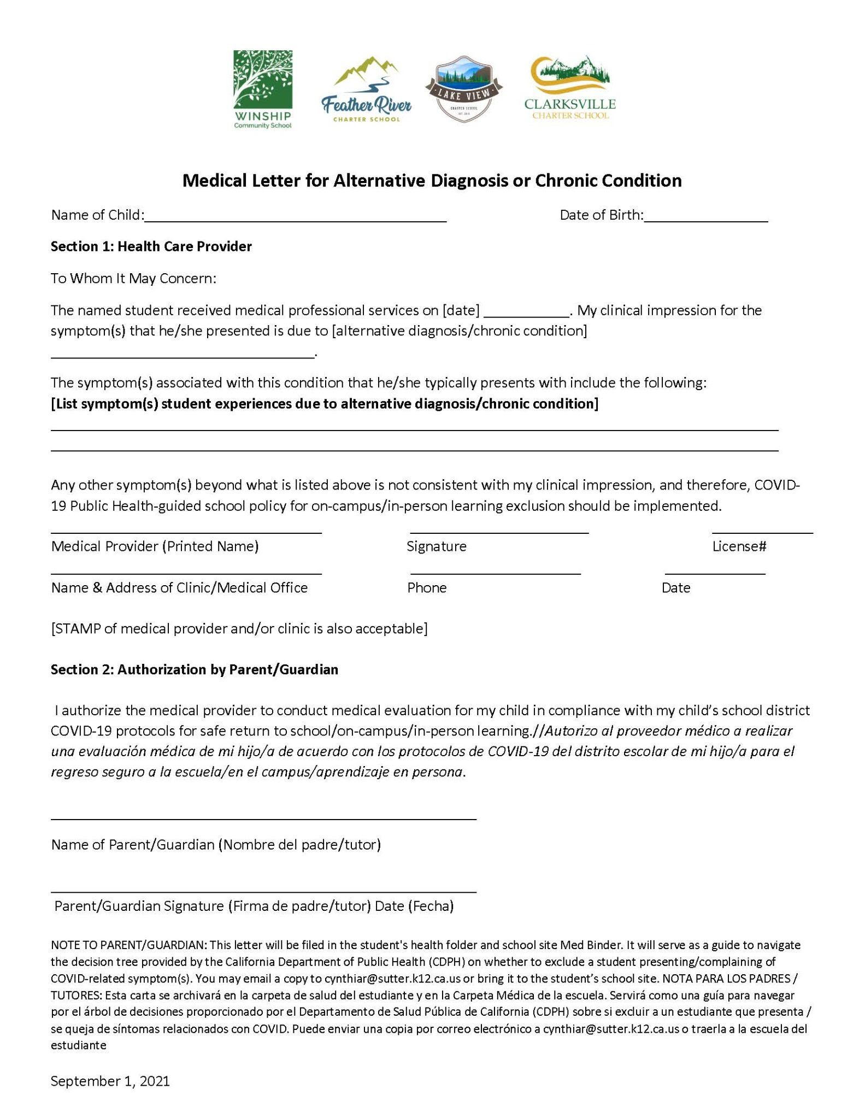

APPENDIX C: Decision Forest
