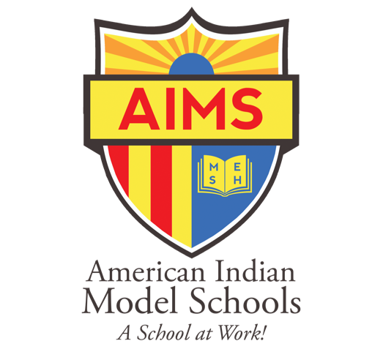

|  |
| --- |
| **American Indian Model Schools**  171 12th Street  Oakland, CA 94607-4900  510.893.8701  www.aimschools.org |

REQUEST FOR PROPOSAL

FOR AN INSURANCE BROKER

MARCH 20, 2018

American Indian Model School (AIMS) is a public charter school within the Oakland Unified School District serving student from grade K-12. The school operates two (2) elementary schools and one (1) high school. The school operates under a Board of Directors who have authority over the governance of the schools.

American Indian Model School (AIMS) is requesting proposals from qualified proposers to serve as an Insurance Broker for their three (3) charter schools consisting of American Indian Public Charter School, American Indian Public Charter School II, and American Indian Public High School.

Proposals are due no later than 4:00 P.M. Pacific Time, Monday, April 16, 2018 to the Finance Office, American Indian Model School, 171 12th Street, Oakland, CA 94607. Proposals will be accepted by electronic media to the email address: finance@aimschools.org.

Proposer also certifies the it does not discriminate against any employee or applicant for employment on the grounds of race, age, color, national origin, religion, sex, gender, disability, genetic information, or any other classification protected by federal, California state constitutional, or statutory law; and does not and will not maintain or provide its employees any segregated facilities at any of its establishments.

American Indian Model School offers educational and employment opportunities without regard to race, age, color, national origin, religion, sex, gender, disability or genetic information.

_____________________________________

COMPANY NAME

_____________________________________ _____________________________________

ADDRESS PHONE FAX

_____________________________________ _____________________________________

CITY STATE ZIP E-MAIL ADDRESS

Names and signatures below certify that you understand and agree to all information in this Request for Proposal.

_____________________________________ _____________________________________

AUTHORIZED REPRESENTATIVE (Print) Signature Date

GENERAL CONDITIONS:

1. Proposals are due to the Finance Office, American Indian Model School, 171 12th Street, Oakland, CA 94607 no later than 4:00 P.M., Pacific Time, Monday, April 16th, 2018.
2. Initial contract period will run July 1, 2018 to June 31, 2019 with the option to extend annually for up to four (4) additional consecutive one (1) year periods if agreeable to all parties.
3. Proposals should provide a straightforward and concise presentation, adequate to satisfy the ,requirements of the Request for Proposal (RFP). Emphasis should be on completeness, clarity of contents and responsiveness to the RFP. Proposals should be structured to respond to the RFP specifications. Format of Request for Proposal response should be as follows:
   1. Executive summary, company organization, primary contact for this proposal.
   2. Provide a brief description of the history and organization of the firm and of any proposed subcontractor.
   3. Describe your firm’s internal organization and the way Services will be furnished. Provide an example of the structure of servicing a current account like American Indian Model School.
   4. Must be licensed in the State of California. Copies of business licenses, professional certifications or other credentials, together with evidence that the firm and its principals are in good standing and qualified to conduct business in California. Proof of Errors and Omissions coverage is required.
   5. Minimum of five (5) years in business as a firm.
   6. Company background and qualifications referenced: Five (5) clients from whom you have currently provided comparable services for K-12 or higher education within the last two (2) to three (3) years. Please include contact name, address, telephone number, and email address.
   7. A qualified principal with five (5) years’ experience in commercial lines insurance brokerage in California.
   8. Experience providing insurance brokerage services to Government entities in California.
   9. Safety and Loss Control experience
   10. Identify the account team structure your firm would use with American Indian Model school. List the names of the proposed account service team and describe each member’s service role. Include at least two qualified individuals from your firm having a minimum of five years’ experience. Provide the Number of full time employees.
   11. Describe the steps you would take in reviewing the School’s current insurance program and designing changes to the program. Include specific techniques and procedures your firm may use to assist in identifying current and anticipated new exposures to loss.
   12. A detailed cost proposal, including any travel costs and other expenses. As the School may award a contract based on the initial offer, the initial offer should be made on the most favorable terms available. Include broker service compensation on the basis of, one (1) fee for service or two (2) commission. If compensation is commission based, provide detailed commission structure in the proposal.
   13. Emergency contact. 24-Hour Emergency Name and Telephone Number.
   14. Must have an A.M. Best Rating of A- or better. If not A.M. Best, then a copy of most recent financial statement filed with the California Department of Insurance. It should include the most recent year’s annual reports, or comparable document, including detailed current profit and loss, assets and liabilities, and other relevant data.
   15. Proposal plan.
   16. Support services and training. Provide the company name, address, telephone number, fax number and E-mail address of the branch that will directly serve the school.
   17. Fee schedule
   18. Completed and Signed Certificate of Non-Discrimination Form
   19. Completed and Signed Request for Proposal Agreement
   20. Exceptions
4. Insurance coverage for this request includes:
   1. Commercial Property and Liability
   2. Umbrella/Excess Liability
   3. General Liability
   4. Commercial Crime
   5. Automobile
   6. Directors and Officers Legal Liability
   7. Student Accident Liability
   8. Volunteers Liability
   9. Worker’s Compensation
   10. Employment Practices Liability
5. The Proposal should reflect a Comprehensive package for all the insurance coverage required and requested.
6. Proposer to submit five (5) complete hardcopy sets (original and 4 copies). Time, date and name of RFP must be clearly marked on face of sealed envelope. All price quotations and related materials must be in a sealed envelope.
7. Estimated proposal timing:
   1. RFP Issued March 20, 2018
   2. Deadline for Questions April 15, 2018
   3. RFP Due April 16, 2018
   4. RFP Evaluation Begins April 16, 2018
   5. Presentations April 17, 2018
   6. Board Approval April 17, 2018
   7. Implementation April 18, 2018
8. The proposals will be evaluated, and a vendor selected using the following criteria:
   1. Project Plan
   2. Firm Experience, Qualifications, and Personnel
   3. Cost
   4. References related to K-12 Schools