**AIMS 2018-2019 Short-Term & Long-Term Goals**

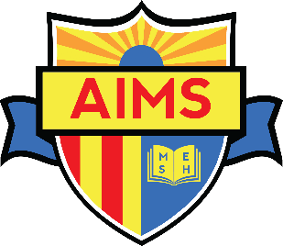

Short term: Within 90 days

1. Procopio settlement
2. Establish governance committee
3. Dissolve legal committee to Ad Hoc
4. Visit other charter schools and private schools in wealthy areas
5. Use BoarOnTrack methodologies

Long-Term: Within 1 year

1. CMO development
2. Name change from American Indian to AIMS K12
3. Expansion of the AIMS Board
4. Control AIMS narrative – Tell Our story – Develop Presentations about AIMS
5. Board should go out and make the ask – fundraising, tours for students, access to job boards, etc.
6. Create development committee
7. Create Academic Committee
8. Update ByLaws

More than 1 year:

1. Replication of School model – tied to expansion of board goal and governance
2. Question – Does the board want to expand revenue base other than state funds?

* If so, what form should it take?

Goals for governance committee:

1. Creating board welcome packet for onboarding and training
2. Develop Board Recruitment Plan