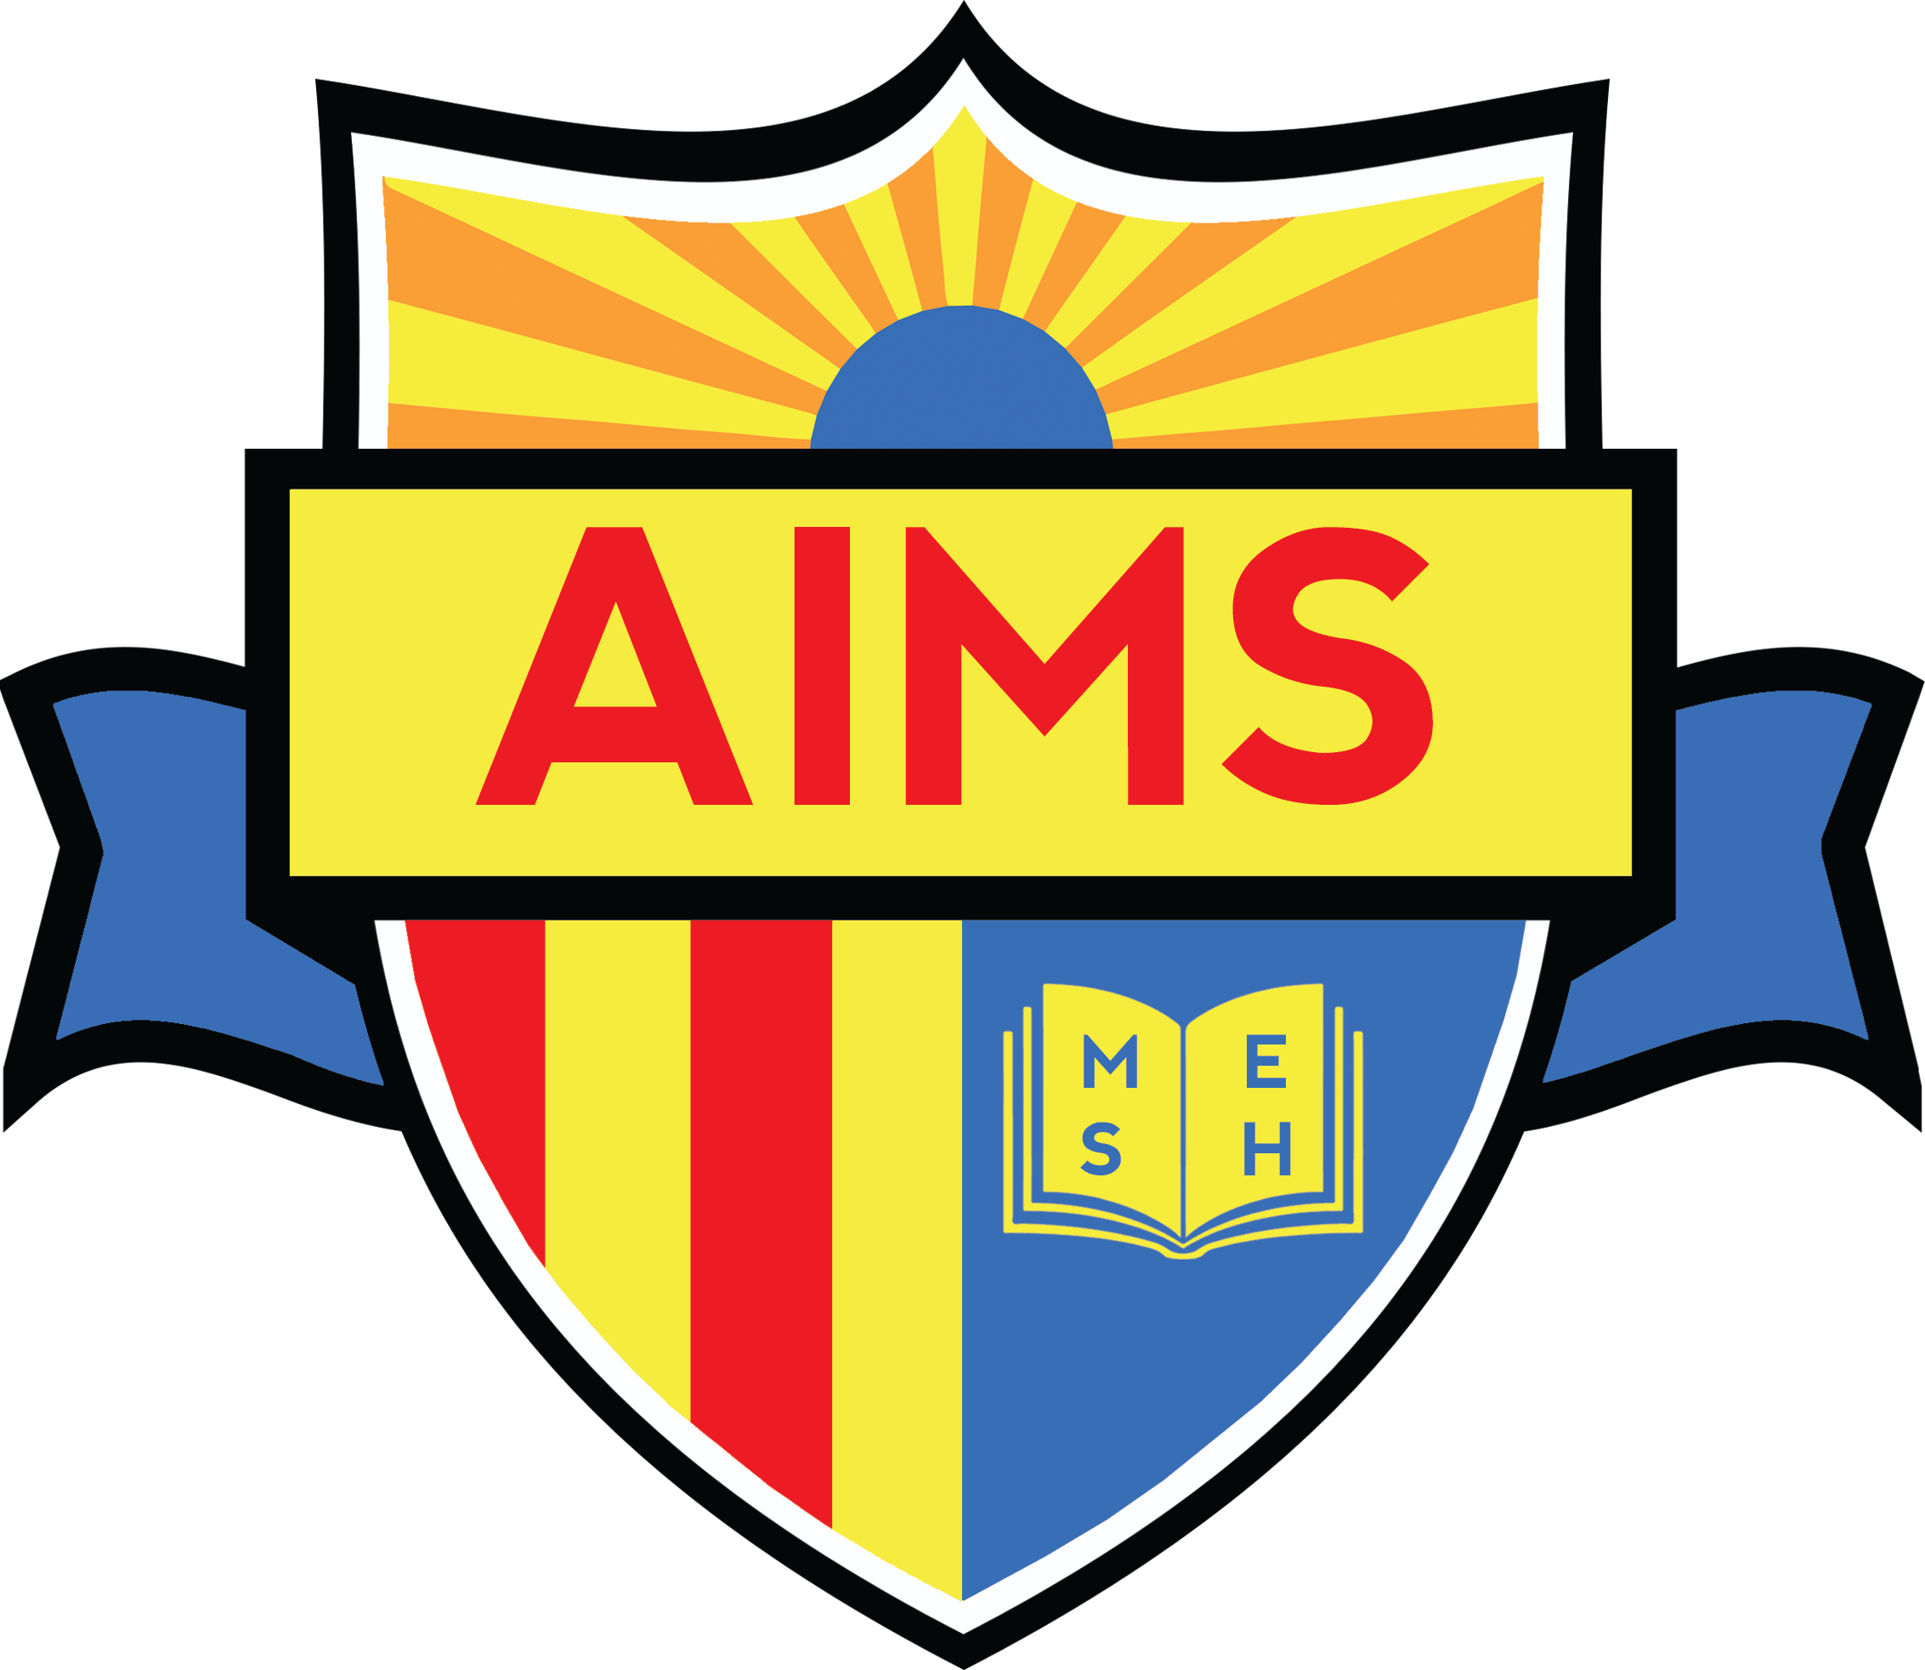

**AIMS**

**Finance Committee Lunch/Nutrition Report**

**Thursday August 15, 2018**

|  |  |
| --- | --- |
| **Revenue** | **Aug 2017-June 2018** |
| Federal | $ 206,299 |
| State | $ 14,382 |
| Collections | $ 45,582 |
| **Total Revenue** | **$ 266,263** |
|  |  |
| **Expenses AIPCS/AIPCS II** |  |
| Lunch Master (vendor) | $ 247,017 |
| School Food Solutions  (Back office Support) | $ 14,009 |
| Meal Time  (Eligibility Database) | $ 898 |
| **Total Expenses** | **$ 261,924** |
|  |  |
| **Net Income** | **$ 4,340** |

**2017-2018 Ending Balance AIPCS/AIPCS II**

Ending Balance in Mealtime ($1390.00)

2016-2017 Balance ($2339.00 after continued collection)

**2018-2019 FREE/REDUCED/PAID Student Eligibility**

**Free AIPCS - 83 Reduced- 23 Paid-69**

**Free AIPCS II- 431 Reduced-114 Paid-273**

**Free AIPHS - 223 Reduced-41 Paid- 196**

**2018-2019**

Implementation of New Programming (AIPHS 746 Grand Ave)

Monday August 20th- TBD

**2018-2019**

Implementation of New Programming (K-1st Satellite Site 1926 E. 19th St.)

Monday August 13th- Average of 75 students participating Total Enrollment- 150

**K-12th District Lunch Payments (Paid Families)**

All meal payments are accepted at the 171 12th St. campus (Cash, Money Order, Check) or www. Mymealtime.com. Parents can set up automatic bill pay, or make online payments for the entire school year.