**AIMS K-12 COLLEGE PREP**

2023-2024 2nd Interim Budget Executive Summary

AIMS K-12 College Prep, formerly known as, American Indian Model Schools, is a Charter District comprised of 3 schools. AIMS College Prep Middle School was initially established in 1996, celebrating its’ 25th Anniversary in June 2022. The AIMS K-12 College Prep Charter District was formed in 2006 with the expansion of schools, adding AIMS College Prep High School and American Indian Public Charter II, (K-8). The Charter is located in the city of Oakland in Alameda County.

AIMS K-12 College Prep 2023-2024 2nd Interim projects enrollment of 1222 students in 3 schools; One K-8, One Middle School (6-8) and One High School. AIMS K-12 currently employs 6 part-time and 121 full-time staff to serve our students.

**Governance**

The Charters are governed by a volunteer Board of Directors. There are five members of the board, each volunteering their term. The school board meets every other month on the third Tuesday. The Board of Directors are supported by a several other committees such as the Governance, Finance, Facility and LCAP Advisory Committees’ that also meet monthly. Charter operations are led by Superintendent Maya Woods-Cadiz.

**Enrollment**

In accordance to the Charter Agreement with Oakland Unified School District, AIMS K12 has nearly reached its full enrollment capacity. AIMS College Prep Middle School is capped at 250 students, American Indian Public Charter II (AIPCS II) 675, and AIMS College Prep High School at 450. The report below reflects enrollment numbers, the Average Daily Attendance (ADA) number and the Average Daily Attendance (ADA) percentages used in projecting the budgets.

These numbers have had an impact on the LCFF General Fund allocations however other State and Federal supports have been fundamental in maintaining AIMS K 12 standards. For the 2023-2024 2nd Interim Budget enrollment numbers remain flat.





***2023-2024 State Budget***

***INTRODUCTION MAY REVISION — 2023-24***

*The May Revision includes total funding of $127.2 billion for K-12 education ($79.1 billion General Fund and $48.1 billion other funds). Because available Proposition 98 resources have declined between the Governor’s Budget and the May Revision, the May Revision adjusts and repurposes prior one-time allocations to continue supporting and maintaining critical ongoing education investments. The May Revision repurposes modest portions of the funding previously provided to support the Arts, Music, and Instructional Materials Block Grant and the Learning Recovery Emergency Block Grant to support the Local Control Funding Formula. With these changes, the state is reasonably positioned to sustain the continued multi-year implementation of the California for All Kids plan—a whole child framework to close opportunity gaps by accelerating learning and investing in the educator workforce while providing universal access to early learning, before and after school care, comprehensive nutrition services, and increasing the number of community schools in high-needs communities. Further, the May Revision does not reflect a discretionary withdrawal from the Public-School System Stabilization Account.*

*The decrease in revenues projected for fiscal years 2021-22, 2022-23, and 2023-24 results in a corresponding decrease in resources for K-14 schools. Proposition 98 is estimated to be $110.6 billion in 2021-22, $106.8 billion in 2022-23, and $106.8 billion in 2023-24, representing a three-year decrease in the minimum Guarantee of $2 billion below the level estimated in the Governor’s Budget. These funding levels include property tax increases of $15 million in 2021-22, $767 million in 2022-23, and $201 million in 2023-24.*

*What does the Governor’s May Revise mean for AIMS K-12?*

1. *State tax revenue is lower than projected and there is more risk than usual of the state’s fiscal situation getting worse*
2. *8.22% COLA to just about all programs, which is great news (and slightly higher than January’s 8.13%)*
3. *But to do the above despite the state’s worsening fiscal outlook, the governor proposed to cut the already-published Arts and Music Instructional Block Grant and Learning Recovery block grant amounts by roughly 25% and 32% respectively*

**Budget**

AIMS K-12 College Prep fiscal year is from July 1 to June 30, as prescribed for all governmental agencies in the state. AIMS K-12 2023-2024 2nd Interim Budget is projected as a $24,534,794 a 1% increase from the 2023-2024 1st Interim Budget.



*\*LCFF: Local Control Funding Formula*

The General Fund *(LCFF + Other State Revenue)* is used to record the day-to-day operations of the charter. There are nine special purpose funds to capture the remaining budget.

* GENERAL PURPOSE: State Apportionments include the LCFF calculations based on Average Daily Attendance enrollment and percentages (ADA) and Other State Revenue: State Food Revenue, State Lottery and State Mandated Block Grant

**Special State Funds**

* ASES: Afterschool Program
* A-G Grants (for High School Only)
* Educator Effectiveness Block Grant *(Expired 22-23)*
* Art and Music Block Grant

**Local Funds**

* LOCAL FUNDS (Measure G1, Donations & Grants)
* Special Education Funding

**Federal**

American Indian Model Schools receives direct funding* of federal funds for at risk students:

*\*Direct Funding: Federal allocation is directly provided to Charter. The funds do not “pass-through” the Authorizing District (Oakland Unified School District). These funds are issued at a reimbursement rate, funds must be expended and applied for reimbursement quarterly.*

* Title I, Part A Low Income at Risk
* Professional Development (Title II)
* English Learners (Title III)
* Title VI,
* NSLP/SSO: Funding to provide meals to those students qualifying for free or reduced lunches. *(SSO (Pandemic Support) annual plan expired June 30,2022)*
* Facilities Grant *(Expired June 2022)*
* CARES Act: ESSER Funding (1st and 2nd Round) *(Expired June 2022)*
* ESSER III (3 Year grant 21-22 thru 23-24)
* Expanded Learn Opportunity Plan *(Expired June 2022)*
* Expanded Learning Opportunity Plan -Para-professional *(Expired June 2022)*
* COVID response- In-Person Learning Grant *(Expired June 2022)*
* Extended Learning Opportunity Grant *(Expired June 2023)*
* Pre-K Grant (Planning) *(Revenue recognized in 21-22)*

**Budget Benchmarks – Process timeline**

* AIMS K-12 2023-2024 Budget Adoption: June 15,2023
* State’s 2023-2024 June Budget Adoption: June 30,2023
* 45 Day Budget Revision (not required): Mid-August
* Unaudited Actuals (2022-23 Closing): September 01,2023
* First Interim (Realignment based on July – Oct 31 Activity): December 1, 2023
* January Governors Release (Projections for 2024-2025): January 2024
* **Second Interim (Realignment based on Nov 1, 2023– Jan 31, 2024)- March 1,2024**
* Governors May Revise (Revision to Jan. Gov. Release): May 2024
* 2024-25 Budget Adoption – June 15, 2024

**2nd Interim Budget**

Adopted Budget is the plan of financial operation consisting of an estimate of proposed revenue and expenditures for the upcoming fiscal year. School district budgets are adopted based on estimates of State funding. Once the State adopts their budget, school district budgets are subsequently updated.

The 2nd interim is the report of expenditures reported through the second quarter (through January 31, 2024) of the year.

**Revenues**

AIMS K12 is primarily funded by State and Federal revenues. AIMS receives 87% of its revenue from State resources, 7% from Federal Resources and 6% of revenues are based on grants and/or local revenues. The demographic displays the change in the revenue sources, during the Adoption Budget AIMS K-12 received 84% of resources from State revenues, 11% from Federal Revenues and 6% from Local funds.

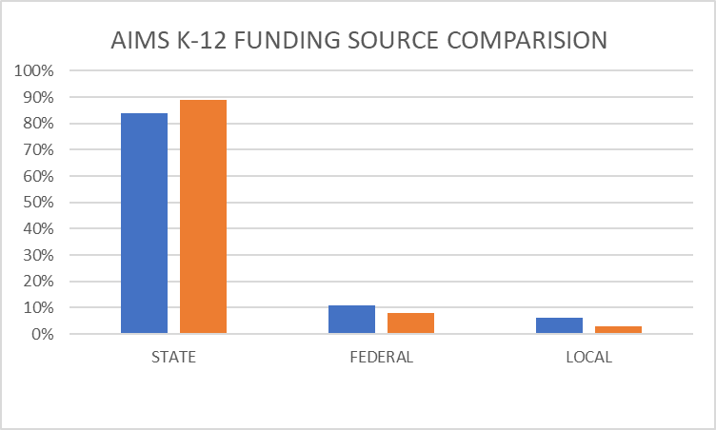

**EXPIRED PROGRAMS**

*COVID RESPONSE FUNDING:*

**SSO Grant:**

On September 17, 2020 AIMS K12 was approved to participate in the SSO Food program and will continue through the 2021-2022 fiscal year. This program was designed to ensure that students and families were provided with meals during the pandemic. The State funded program, reimburses full cost of meals AIMS K12 distributes to its students and surrounding community. The program differs from the NSLP program as it does not require the same level of record maintenance for reimbursement as this program tracks the meals distributed not the child it is distributed to. The language also allows AIMS to provide meals for any community member under the age of 18. The program allows for full reimbursement of cost.

**ESSER I:** ESSER funding was initially outlined in the 2020-21 Governor’s budget. The funds were provided to California through the Federal Coronavirus Aid Relief and Economic Security Act (CARES) and allocated in the Governor’s ESSER budget for schools. ESSER funds are available for expensing until 9/30/2022.These funds are meant to assist schools in preparing for distance or hybrid learning. AIMS approved the application for the ESSER funds during the August 18, 2020 Board Meeting. The total State budget is 1.65B of which AIMS K12 received $304,843 in 2020-2021 These funds will be completely expended in the 2021-2022 school year.

**ESSER II:** California Department of Education has released the new allocations for the second round of ESSER funds in which AIMS K12 has received an additional $1,260,266. The funds are available for use beginning 2020-2021 through the 2021-2022 school year. AIMS began to expense in the 2020-2021 fiscal year and the remaining funds are allocated in the current fiscal year. These funds will be fully expended by June 30, 2022.

**IN-PERSON INSTRUCTION**

The In-Person Instruction grant provides funding to county offices of education (COE), school districts, charter schools and state special schools to assist with offering in-person instruction to the greatest extent possible during the 2020-21 school year; and to expand in-person instructional time and provide academic interventions and pupil supports to address barriers to learning, and accelerate progress to close learning gaps. The In-Person Instruction grant is allowable for use in the 2021-22 and will be fully expended by year end.

**PRE-K GRANT (Planning Year)**

The California Pre-kindergarten Planning and Implementation Grant Program was established as a state initiative with the goal of expanding access to classroom-based prekindergarten program at LEAs and planning for the increased number of teachers needed to fully implement Universal Prekindergarten. American Indian Public Charter II (AIPCS II) was the only school within AIMS K-12 District to qualify for the funding. Funding was received in 2021-2022.

**ROBERTO FAMILY TRUST DONATION**

In 2012 American Indian Public Charter (AIMS MIDDLE) and American Indian Public High School (AIMS HIGH) were named in the Roberto Family Trust each school was granted $127,964. AIMS K-12 Board of trustees recognized these funds during 2020-2021 1st Interim. As of 2021-2022 1st Interim, the final paperwork for the release of funds have been submitted and anticipate receipt by the 2nd Interim.

**EDUCATOR EFFECTIVENESS BLOCK GRANT**

Educator Effectiveness funds may be used to support the professional learning for certificated teachers, administrators, paraprofessional educators, and certificated staff. Coaching and mentoring of staff. Programs that lead to effective, standards-aligned instruction and improve instruction in literacy across all subject areas, including English language arts, history-social science, science, technology, engineering, mathematics, and computer science. Practices and strategies that reengage pupils and lead to accelerated learning. Strategies to implement social-emotional learning, trauma-informed practices, suicide prevention, access to mental health services, and other approaches that improve pupil well-being. Practices to create a positive school climate. Strategies to improve inclusive practices. Instruction and education to support implementing effective language acquisition programs for English learners. Funding was received in 2021-2022.

**EXTENDED LEARNING OPPORTUNITY GRANT (ELO)**

The Extended Learning Opportunity Grant provides funding charter schools to assist with implementing a recovery program, that at a minimum provides supplemental instruction and

emotional well-being. ELO Grants shall be expended only for any of the following purposes: extending instructional learning time, accelerating progress to close learning gaps,

integrated pupil supports, community learning hubs, supports for credit deficient pupils, additional academic services, and training for school staff. An additional requirement of the use of funds, is to allocate 10% of the LCFF portion of the grant to hire/rehire paraprofessionals to provide supplemental education. AIMS K-12 ELO Grant Plans were presented and approved by the Board of Trustees in May 2021 and submitted to the State and OUSD prior to the June 1,2021 deadline. The ELO grant is allowable for use in the 2021-22 and will be fully expended by year end. These funds change distribution methods to federal reimbursement in 2021-2022, revenue is still available for reimbursement.

**NEW PROGRAMS**

**ART & MUSIC INSTRUCTIONAL GRANT:** Funding for local educational agencies to obtain standards-aligned professional development and instructional materials in specified areas, improve school culture, develop diverse and culturally relevant book collections, and other specified uses.

**CONTINUED PROGRAMS *(Revenue recognized in 2023-2024)***

**ESSER III:** California Department of Education has released the new allocations for the third round of ESSER funds in which AIMS K12 has received an additional $2,856,649. The funds are available for use beginning 2021-2022 through the 2023-2024 school year. AIMS has allocated these funds for the duration of the program, allocating 20% in 2021-22 and the remaining balance split between the 22-23 and the 23-24 fiscal years.

**EXPANDED LEARNING OPPORTUNITY PROGRAM (ELOP)**

The intent of the Expanded Learning Opportunities (ELO) Program is to supplement and not supplant services provided under existing ASES and 21st CCLC Elementary/Middle School programs. However, there is shared understanding that LEAs will need to build capacity this first operational year. In addition, ASES, 21st CCLC Elementary/Middle School, and the ELO Program should be considered a single, comprehensive program. In coordinating all these funding streams to move towards a single program, the expectation is that the most stringent requirements will be adopted for program guidance.

**Revenues**



**LCFF SOURCES:**

**2023-24 2nd Interim:** **No Change**

**FEDERAL REVENUES:**

**2023-24 2nd Interim: No change**

**OTHER STATE REVENUES:**

**2023-24 2nd Interim: Recognition of carryover revenue at High School not recognized at 1st interim**

**LOCAL REVENUES:**

**2023-24 2nd Interim: No change**

2023-2024 FCMAT 2nd Interim Budget calculator was used to for the projection for the 2nd Interim Budget. Below highlight the changes in summary and per school:



**LCFF SOURCES:**

**2023-24 2nd Interim:** No Change

**FEDERAL REVENUES:**

**2023-24 2nd Interim:** No Change

**OTHER STATE REVENUES:**

**2023-24 2nd Interim:** No Change

**LOCAL REVENUES:**

**2023-24 2nd Interim:** No Change



**LCFF SOURCES:**

**2023-24 2nd Interim:** No Change

**FEDERAL REVENUES:**

**2023-24 2nd Interim:** No Change

**OTHER STATE REVENUES:**

**2023-24 2nd Interim:** No Change

**LOCAL REVENUES:**

**2023-24 2nd Interim:** No Change



**LCFF SOURCES:**

**2023-24 2nd Interim:** No Change

**FEDERAL REVENUES:**

**2023-24 2nd Interim:** No Change

**OTHER STATE REVENUES:**

**2023-24 2nd Interim:** Recognition of remaining balances from carryover

**LOCAL REVENUES:**

**2023-24 2nd Interim:** No Change

**Expenses**

AIMS K-12 College Prep 2023-24 2nd Interim Budget reflects a 44% investment in Personnel expenses and 56% allocated to the operations of the organization. This investment composition stayed consistent from the 1st interim reporting to the 2nd Interim. The total expenses for the 2023-2024 AIMS K-12 college Prep District are projected at $23,545,992.

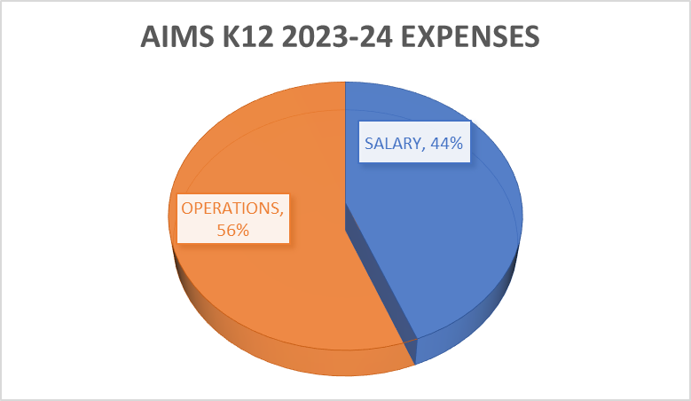



****Expense Allocation for each school is reflected below. Any changes to budget allocation are outlined as well.

55%







**Salaries & Benefits**

Salary compensation represents 44% of expenses across all AIMS K-12 College Prep Schools. AIMS offers a competitive compensation package for both certificated and classified staff. Employee Benefit expense at AIMS averages 23% across all schools. This can vary greatly due to two primary factors: Health and Welfare benefits and PERS. AIMS K-12 covers the employee portion of all AIMS employer-based Health and Welfare options that the employee participates in. Health and welfare benefits (medical/dental/vision insurance premiums), if requested by the employee, can vary due a number of factors, including an employee’s age and number of dependents. AIMS tracks and reports health and welfare benefits as precisely as possible, reflects as a variance in the percentage of benefits for employees at AIMS.

**AIMS MIDDLE**

Compensation for staff at AIMS College Prep Middle School, formerly known as American Indian Public Charter (AIPCS), is split between AIPCS and the Middle school component of American Indian Public Charter School II (6-8). The expenses reflected are split by assignment and student Average Daily Attendance (ADA). All staff, with the exception of 5 teachers are split funded between AIMS Middle and AIPCS II.

**AIPCS II**

American Indian Public Charter II (AIPCS II) is a K – 8. The staff for the K – 5 components are fully funded at AIPCS II and the middle school component reflects the following Full Time Equivalent (FTE) split:

AIMS MIDDLE 51%

AIPCS II/ AIMS ELEMENTARY 49%

100%

**Books and Supplies**

Records expenditures for books and supplies, including any associated sales tax or use tax and freight and handling charges.

The category of Book and Supplies captures more than classroom textbooks and materials, it itemizes Non- Capitalized student equipment such as tables, chairs, computers and software.

**Services and Other Operating Expenses**

Record expenditures for services, rentals, leases, maintenance contracts, dues, travel, insurance, utilities, and legal and other operating expenditures. Expenditures may be authorized by contracts, agreements, purchase orders, and so forth.

**Capital Outlay**

Capital Outlay records expenditures for land, buildings, books, and equipment, including leases with option to purchase. In accordance with the State guidelines for school finance, to capitalize an expense in the individual item must cost $5000 or more.

**Other Outgo**

Other Outgo captures interest, debt service and transfers (payments) to other LEAs (Authorizer)

In 2021-2022 AIMS partnered with Oakland Unified School District to provide the Special Education services for their students. For the 2022-2023, AIMS K-12 began a partnership with the Eldorado Charter SELPA in the 2022-2023 school year. This required the staff and program to be built at the site level. The final payment for settlement with OUSD to depart from their SEPLA in 2022 was paid during the 2023-2024 2nd Interim.

**Summary**

For the 2023-2024 2nd Interim Budget, AIMS K-12 College Prep has projected $24,534,794 in revenue and $23,545,992 in expenses. This provides a $988,802 surplus and represents a 6% contribution to be added to the Ending Fund Balance. Bringing the total Ending Fund Balance $13,655,840 providing approximately 127.59 days of operation. The composition of those funds are as follows:



**Cash Flow Statement**

As of 2nd Interim the cash flow represented is based on the January 31, 2024 closing date. As of January 31, 2024, AIMS K-12 College Prep maintained $15,681,149.10 in cash

