**AIMS K-12 College Prep**

2022-2023 Unaudited Actuals Executive Summary

AIMS K-12 College Prep is a Charter District comprised of 3 schools. AIMS College Prep Middle School, formerly known as, American Indian Public Charter School was initially established in 1996. The AIMS K-12 College Prep Charter District was formed in 2006 with the expansion of schools, adding AIMS College Prep High School, formerly known as American Indian Public High School and AIMS College Prep Elementary School, formerly known as, American Indian Public Charter II, (K-8). The Charter is located in Oakland of Alameda County.

For the 2022-2023 school year, AIMS K-12 College Prep Charter District enrolled 1278 students in 3 schools. AIMS K-12 employed 121 full-time staff to serve our students.

**Governance**

The Charters are governed by a volunteer Board of Trustees. There are five members of the board, each volunteering their term. The school board meets once a month on the third Tuesday of each month. The Board of Trustees are supported by a several other committees such as the Governance, Finance, Facility and LCAP Advisory Committees. Charter operations are led by Superintendent Maya Woods-Cadiz.

**Enrollment**

In accordance to the Charter Agreement with Oakland Unified School District, AIMS has nearly reached its full enrollment capacity AIMS College Prep Middle (AIPCS) is capped at 250 students, AIMS College Prep Elementary 675, and AIMS College Prep High School (AIPHS) at 450.



**Budget**

AIMS college Prep’s fiscal year is from July 1 to June 30, as prescribed for all governmental agencies in the state. The budget for July 1, 2022 to June 30, 2023 totals $26,580,949in revenues.

The General Fund *(LCFF + Other State Revenue)* is used to record the day-to-day operations of the charter. There are nine special purpose funds to capture the remaining budget.

* GENERAL PURPOSE: State Apportionments include the LCFF calculations based on Average Daily Attendance enrollment and percentages (ADA) and Other State Revenue: State Food Revenue, State Lottery and State Mandated Block Grant

**Special State Funds**

* ASES: Afterschool Program
* A-G Grants (for High School Only)
* Educator Effectiveness Block Grant

**Local Funds**

* LOCAL FUNDS (Measure G1, Donations & Grants)
* State Special Education

**Federal**

American Indian Model Schools receives direct funding* of federal funds for at risk students:

*\*Direct Funding: Federal allocation is directly provided to Charter. The funds do not “pass-through” the Authorizing District (Oakland Unified School District). These funds are issued at a reimbursement rate, funds must be expended and applied for reimbursement quarterly.*

* Title I, Part A Low Income at Risk
* Professional Development (Title II)
* English Learners (Title III)
* Title VI,
* NSLP/SSO: Funding to provide meals to those students qualifying for free or reduced lunches.
* NEW: Universal Food Program
* Facilities Grant *(Expired June 2022)*
* CARES Act: ESSER Funding (1st and 2nd Round) *(Expired June 2022)*
* ESSER III (3 Year grant 21-22 thru 23-24)
* Expanded Learn Opportunity Plan
* Expanded Learning Opportunity Plan -Para-professional
* COVID response- In-Person Learning Grant
* Extended Learning Opportunity Grant
* Pre-K Grant (Planning) *(Revenue recognized in 21-22)*

These funds provide necessary services to students in attending AIMS schools.

**Budget Benchmarks – Process timeline**

* AIMS 2023-2024 Budget Adoption: June 15,2023
* State’s 2023-2024 June Budget Adoption: June 30,2023
* 45 Day Budget Revision (not required): Mid-August
* **Unaudited Actuals (2022-23 Closing): September 01,2023**
* First Interim (Realignment based on July – Oct 31 Activity): December 1, 2023
* January Governors Release (Projections for 2024-2025): January 2024
* Second Interim (Realignment based on Nov 1, 2023– Jan 31, 2024)- March 1,2024
* Governors May Revise (Revision to Jan. Gov. Release): May 2024
* 2024-25 Budget Adoption – June 15, 2024

**Unaudited Actuals**

Unaudited Actuals are an annual statement reporting the financial activities of the District in which the data are not yet formally audited. Unaudited Actuals are presented to the Board each September, reflecting the District's final year end closing from the June 2023.

**Revenues**

AIMS K12 is primarily funded by State and Federal revenues. AIMS receives 79% of its revenue from State resources, 7% from Federal Resources and 24% of revenues are based on grants and/or local revenues.

As required by the Measure G1 Parcel tax language, Measure G1 Staff Retention Salary Bonus reimbursement was issued to all schools.



**Expenses**

AIMS K-12 2022-2023 expenses reflects a 44% investment in Personnel expenses and 55% allocated to the operations of the organization. The total expenses for the 2022-2023 school year are $23,823,455.

**52%**

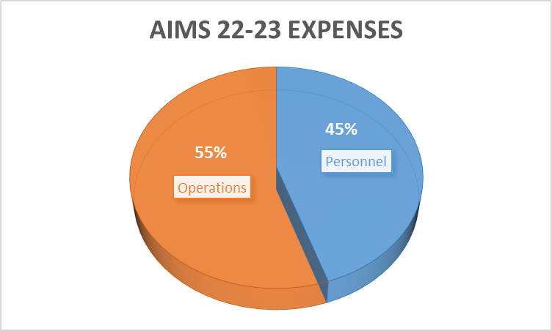

**Salaries & Benefits**

Salary compensation represents 45% of expenses across all AIMS Schools. AIMS offers a competitive compensation package for both certificated and classified staff. Employee Benefit expense at AIMS averages 22% across all schools. This can vary greatly due to two primary factors: health and welfare benefits and PERS. Health and welfare benefits (medical/dental/vision insurance premiums), if requested by the employee, can vary due a number of factors, including an employee’s age and number of dependents. AIMS tracks and reports health and welfare benefits as precisely as possible, reflects as a variance in the percentage of benefits for employees at AIMS. PERS requires an employer contribution of 25.90% of classified salaries. Teachers are offered a 3% match for any voluntary contribution to an 403B retirement plan.

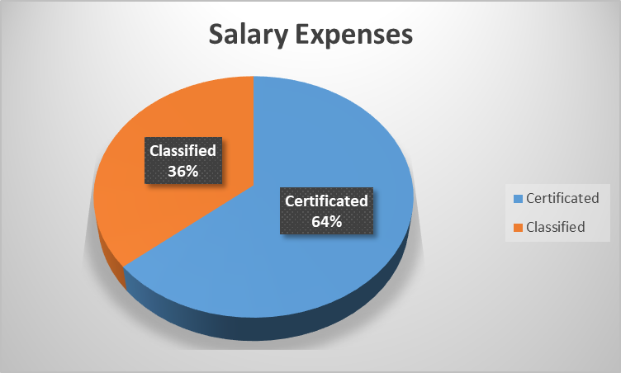

**AIMS MIDDLE**

Compensation for staff at AIMS College Prep Middle School, formerly known as American Indian Public Charter (AIPCS), is split between AIMS Middle and the middle school component of AIMS Elementary (6-8). The expenses reflected are split by assignment and student Average Daily Attendance (ADA). All staff, with the exception of 5 teachers are split funded between AIMS Middle and AIMS Elementary.

**AIMS ELEMENTARY**

AIMS Elementary School is a K – 8. The staff for the K – 5 components are fully funded ate Elementary School II and the Middle school (6-8) component reflects the following Full Time Equivalent (FTE) split:

AIMS MIDDLE 52%

AIMS ELEMENTARY 48%

100%





**Books and Supplies**

Records expenditures for books and supplies, including any associated sales tax or use tax and freight and handling charges.



The category of Book and Supplies captures more than classroom textbooks and materials, it itemizes Non- Capitalized student equipment such as tables, chairs, computers and software. The Food services program is also included in this category.

**Services and Other Operating Expenses**

Record expenditures for services, rentals, leases, maintenance contracts, dues, travel, insurance, utilities, and legal and other operating expenditures. Expenditures may be authorized by contracts, agreements, purchase orders, and so forth.



A charter management organization (CMO) is an educational organization that operates [charter schools](https://en.wikipedia.org/wiki/Charter_schools) in the United States. Charter schools are public schools that operate independently of the local government school district.

A CMO controls all elements of the operation of the schools under its control, including holding the charter. By convention, a CMO manages at least three schools.[(wikipedia)](https://en.wikipedia.org/wiki/Charter_management_organization#cite_note-jw2017-1)

AIMS CMO supports functions such as District Leadership, Board, Superintendent, Human Resources, Fiscal Services, Facility and Food Operations, Registration and Enrollment, Marketing and Communications, and the District Sports Program.



**Capital Outlay**

Capital Outlay records expenditures for land, buildings, books, and equipment, including leases with option to purchase.

On September 18, 2018, AIMS Board of Trustees voted to approve the leasing of 3 ten passenger vans to assist in the transportation of AIMS children for sport activities, field trips and other instructional related activities. The vans are on a 60-month lease and impact capital outlay across all schools.





**Other Outgo**

For the 2022-23 school year, AIMS provided settlement funds to Oakland Unified School District for the discontinuance of services for Special Education. This agreement extends through the 2023-2024 fiscal year. The final expenses recorded in the 2022-23 fiscal year reflect a General Fund encroachment of $1,000,000.

Funding to support the in-house Special Education services provided to AIMS K-12 students and the agreement with the El Dorado SELPA are reflected in other areas of the budget.





**Summary**

For the 2022-2023 school year, AIMS K-12 College Prep received $26,580,949 in revenue. The composition of those funds are as follows:

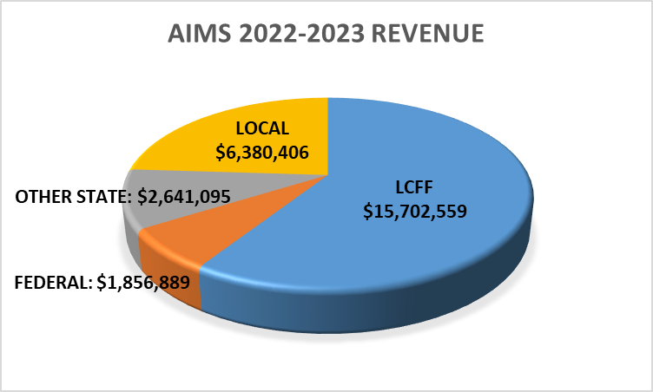





AIMS expensed $23,823,453, during the 2022-2023 resulting in an excess revenue vs expense of in the amount of $2,757,494.

**CASH FLOW STATEMENT**





**CASH FLOW STATEMENT**



CASH AVAILABLE AT JUNE 30, 2023 $12,438,107