|  |  |
| --- | --- |
|  | **OAKLAND ENROLLS**  **MEMORANDUM OF UNDERSTANDING**  **FOR PARTICIPATING CHARTER PARTNERS**  **(2022-2023 School Year)** |

This **Memorandum of Understanding** (“**MOU**”) is entered into by _American Indian Model Schools_ (“**Charter Partner**”) and Oakland Enrolls, a California Nonprofit Public Benefit Corporation, effective August 1, 2022 (“**Effective Date**”) Charter Partner and Oakland Enrolls are sometimes referred to in this MOU individually as “**Party**” and together as “**Parties.**”

**BACKGROUND**

Oakland Enrolls is responsible for the Oakland common charter application project. Prior to the Oakland common charter application project, a fragmented system of school enrollment existed in Oakland, making it difficult for families to navigate the public-school enrollment process. The Oakland common charter application project aims to address this problem, in collaboration with schools and other stakeholders, by providing a simplified enrollment process, where families can use a single platform to fill out one application for charter schools, applying to multiple schools at once. Charter Partner wishes to participate in this Oakland common charter application project, in order to enhance school choice, make the process for families easier, and share data to gain more insight into application and enrollment trends in Oakland. Therefore, in exchange for good and valuable consideration, the Parties agree as follows:

**RIGHTS AND RESPONSIBILITIES**

1. **Description of Oakland common charter application Project.**
   1. ***Timeline*** – Charter Partners participating in the city-wide charter enrollment system will follow the following timeline for the 2022 - 2023 School Year (“**SY**”), in service of preparing for the 2023 - 2024 enrollment year. The timeline is subject to change at the discretion of Oakland Enrolls, and Charter Partner will be required to follow any changes implemented by Oakland Enrolls:
      * September 30, 2022 – Review and finalize lottery preferences for SY 2023-2024
      * November 14, 2022 – On-Time application launch for SY 2023-2024
      * December 9, 2022 - Charter Partner will share their Fall 1 Submission CALPADS 8.1 Student Profile List as of October 2022
      * January 2023 – Lottery verification
      * February 3, 2023 – On-Time applications due
      * February 6, 2023 – Late applications launch
      * March 6-8, 2023 – Schools run lotteries, offers remain in Pre-Offer status
      * March 9, 2023 – All offers made public by Oakland Enrolls
      * March 23, 2023 – On-Time lottery confirmation deadline
      * March 24, 2023 – Bulk rescind of On-Time lottery offers by Oakland Enrolls
      * May 24, 2024 – Application closes for all schools (best guess date)
   2. ***Key System Functionalities of Charter Enrollment Program***
      1. *Multiple Languages*: the common application is available in five languages (English, Spanish, Chinese, Arabic, Vietnamese) .
      2. *School Offer and Acceptances:* A family is only allowed to accept one offer per student in the common charter application system.
      3. *On-Time Lottery Offer Launch:* All Charter Partners will publicize On-Time lottery offers to families on the same date via Oakland Enrolls.
      4. *On-Time Lottery Offer Rescind:* Oakland Enrolls will automatically rescind any outstanding On Time lottery offers on the same date, March 24, 2023. Oakland Enrolls' standard messaging gives families 10 business days to accept an offer, but schools may choose to use their own messaging and timeline..
   3. ***Data Sharing Features*** *–* The Oakland common charter application project involves and requires data sharing related to applications, enrollments, transfers, waitlists, and accepted offers, as follows:
      1. By the start of December 2022, Charter Partner will share their Fall 1 Submission CALPADS 8.1 Student Profile List as of October 2022;
      2. Oakland Enrolls will use the CALPADS data to assess the full enrollment pipeline, subgroups enrollment information, and pipeline attrition (see [Oakland Enrolls – Spring Enrollment Reports](https://public.tableau.com/views/Oakland_SpringEnrollmentReport_Updated03_2021/PipelineSummary?:language=en&:display_count=y&publish=yes&:origin=viz_share_link)). Oakland Enrolls agrees to handle this data in accordance with the terms set out in **Appendix C**.
      3. Oakland Enrolls will share the CALPADS data with third parties for research purposes.
      4. Shared data will also be used for joint marketing and outreach activities by the Parties and Oakland Enrolls’ individual marketing and outreach activities, in accordance with applicable law.
      5. Select data may be shared with OUSD and/or research partners as part of the Community of Schools work and/or to enhance the family experience.
      6. Charter Partner represents and warrants that in assigning the applicable Student Profile Data to and sharing information with Oakland Enrolls including, but not limited to (Confidential Information as defined in **Appendix C**) that Charter Partner is in compliance with the provisions of FERPA, and any amendments thereto. Oakland Enrolls represents and warrants that it is also in compliance with any applicable provisions of FERPA, if any, and any amendments thereto. Furthermore, Charter Partner represents and warrants that it has the requisite consents and is allowed under FERPA, and other applicable laws, to assign Student Profile Data with Oakland Enrolls that Oakland Enrolls would then share with third parties for research purposes. Nothing in this Agreement may be construed to allow either Party to maintain, use, disclose or share information in a manner not allowed by state or federal law or regulation.
2. **Charter Partner’s Commitments.**
   1. Charter Partner will complete the following Appendixes prior to signing and returning the MOU:
      1. **Appendix A** – Confirmation of Commitments and Services.
      2. **Appendix B** – Key Organization Contacts
   2. Oakland Enrolls implements the charter enrollment program, in part, through an online school enrollment platform. To participate in the charter enrollment program, Charter Partner must create a portal and give Oakland Enrolls access to Charter Partner’s portal. Charter Partner agrees and understands that in order to maintain the health and efficiency of the common application, Oakland Enrolls will have certain access to data and the permission to alter data on Charter Partner’s portal.
   3. Charter Partner will be responsible for ensuring that the applications are accurate and updated in accordance with parent and/or legal guardian wishes.
   4. Charter Partner will only accept applications to its school(s) through the Oakland Enrolls common charter application project. All applicants to Charter Partner’s school(s) must submit an Oakland Enrolls common charter application during the On-Time (Open Enrollment) and/or Late (Post Enrollment) Application periods during the common application timeline. Charter Partner will not create or distribute a school-specific application for any grades it serves and will only accept applications per the Oakland Enrolls common application timeline.
   5. Charter Partner will provide information to Oakland Enrolls for school choice collateral in a timely fashion and is responsible for updating its editable online school finder profile and attributes as necessary.
   6. Charter Partner will use Oakland Enrolls’ tools and protocols for lotteries, waitlist management, collecting verification documentation, and communicating offers to families. If the tools provided by Oakland Enrolls cannot accommodate specific lottery configurations, Oakland Enrolls will collaborate with the software vendor and Charter Partner to develop a solution.
   7. Charter Partner will not require verification documentation before running any lottery unless approved by Oakland Enrolls.
   8. Charter Partner will publicly post on each of its schools’ websites links to Oakland Enrolls website and display the common application verbiage and lottery date(s) on or before launch as specified in 1.a.
   9. Charter Partner will have the appropriate people in its organization review Oakland Enrolls’ training materials, best practices, and checklists. Charter Partner will ensure staff attend training session(s) as required.
   10. ***Participation Requirements and Estimated Fees***
       1. *Required - Enrollment System Requirements*: Charter Partner will purchase the following application modules through Oakland Enrolls for a licensing period of September 1, 2022 through August 31, 2023:
          1. Common Application, Communication, Lottery, Waitlist with a cost of $4,200 per school
       2. *Required - Enrollment System Support Service Tier:* Charter Partner must purchase *ONE* of the following Oakland Enrolls tiered support packages for a period of August 1, 2022 through July 31, 2023. Please see **Appendix E** for a more detailed description of service tiers.
          1. *Baseline Support:* Standard Operations Support, Standard Marketing & Recruitment Support, Standard Data & Analysis, Network Benefits, Oakland Enrolls Council Membership. $4,120 per school
          2. *Light Support:* Additional Operations Support, Standard Marketing and Recruitment Support, Additional Data & Analysis, Network Benefits, Oakland Enrolls Council Membership. $6,180 per school
          3. *Medium Support:* Additional Operations Support, Additional Marketing and Recruitment Support, Additional Data and Analysis, Network Benefits, Oakland Enrolls Council Membership. $10,300 per school
          4. *Intensive Support:* Additional Operations Support, Additional Marketing and Recruitment Support, Additional Data and Analysis, Charter Advocacy, Network Benefits, Oakland Enrolls Council Membership. $15,450 per school
       3. *Optional - Oakland Enrolls additional services*: Charter Partner may opt to purchase the following optional Oakland Enrolls services (dates of service). Please see **Appendix F** for a more detailed description of optional services.
          1. On-Time Applications Operations Support (Nov 2022 – Feb 2023). $3,090 per school.
          2. Custom Outreach & Marketing Plan and Support (Sep 2022 – Apr 2023). $2,575 - $8,755 per school depending on level of service.
          3. Graphic Design Support (Sep 2022 - Feb 2023). $3,400 - $5,850 depending on level of service.
          4. Seat Offer Tool and Custom Reports (varies). $2,575 per school
          5. Managing Ongoing Offers (Mar 2023 – Jun 2023). $3,090 per school.
       4. *Optional - Enrollment System components*: Charter Partner may opt to purchase additional modules from the software vendor, including registration and re-enrollment modules, if applicable. Oakland Enrolls recommends the module license(s) start/end dates align with the Common Application license:
   11. ***Summary of Roles and Responsibilities*** 
       1. Oakland Enrolls has summarized roles and responsibilities for Charter Partner, Oakland Enrolls, and the software vendor to help provide clarity around who is responsible for what. This is not meant to be comprehensive, rather a summary to provide guidance. See **Appendix D**.
   12. ***Indemnification*** – Charter Partner agrees that it will defend, indemnify and hold harmless Oakland Enrolls and its officers, directors, employees, and agents (collectively, the “indemnified parties”) against and from any and all claims, actions, demands, losses, causes of action, damages, expenses or liabilities, including attorneys’ fees, to which any Indemnified Party may become subject or which it may suffer as a result of or arising out of any negligent, willful or reckless acts or omissions, breach of this MOU, dishonesty or fraud of or by Charter Partner, its agents, employees or representatives.
   13. ***LIMITATION OF LIABILITY.*** CHARTER PARTNER AGREES AND UNDERSTANDS THAT OAKLAND ENROLLS SHALL NOT BE LIABLE UNDER ANY CIRCUMSTANCES, WHETHER IN CONTRACT, TORT, EQUITY OR OTHERWISE, FOR ANY INDIRECT, INCIDENTAL, CONSEQUENTIAL, SPECIAL, PUNITIVE OR EXEMPLARY DAMAGES (EVEN IF SUCH DAMAGES ARE FORESEEABLE, AND WHETHER OR NOT OAKLAND ENROLLS HAS BEEN ADVISED OF THE POSSIBILITY OF SUCH DAMAGES), INCLUDING DAMAGES FOR LOSS OF PROFITS, ANY OVERHEAD EXPENSES, OR COMMITMENTS TO THIRD PARTIES. OAKLAND ENROLLS’ MAXIMUM AGGREGATE LIABILITY ARISING FROM OR RELATING TO THIS MOU SHALL BE LIMITED TO THE AMOUNTS PAID BY CHARTER PARTNER TO OAKLAND ENROLLS UNDER THIS MOU.
3. **Oakland Enrolls’ Commitments.** In addition to the services described elsewhere in this MOU, Oakland Enrolls commits to the following:
   1. Charter Partner’s participation in the uniform charter enrollment program will be fully supported by Oakland Enrolls, with training and development of school staff, standard operating procedures, communication templates and best practices, direct support provided to families, school and sector-level data analysis, and information sharing including real-time visibility of applications to Charter Partner’s school(s).
   2. Oakland Enrolls may collaborate with Oakland Unified School District on choice collateral, options activities, summary data sharing, and developing a blueprint towards a citywide application system.

Oakland Enrolls is and will continue to explore new policies to enhance the universal enrollment process. In assessing new policies, Oakland Enrolls retains ultimate decision-making authority to decide what policies to implement and how, but it commits to bringing potential policies to the Council for review.

1. **Mutual Commitments, Terms and Conditions.**
   1. ***Term*** *–*The term of this MOU is from August 1, 2022 to July 31, 2023 (“**Term**”), at which point Oakland Enrolls shall have no obligation or duties to Charter Partner to provide services under this MOU. Charter Partner’s obligation to pay any fees due under this MOU shall survive the Term of this MOU. The provisions of section 3(k) and 3(l), all of the provisions of section 4, and any other provision reasonably intended to survive the Term of this MOU will survive the termination or expiration of this MOU.
   2. ***Governing Law*** *–*This MOU is governed by California law, without regard to any conflict of laws rules. Each Party consents to exclusive jurisdiction and venue of state or federal courts located in Oakland, California.
   3. ***Assignment*** *–*Charter Partner may not assign its rights or obligations under this MOU without the express prior written consent of Oakland Enrolls.
   4. ***Integration, Modification, Waiver*** *–*This MOU, and its appendixes, constitute the entire agreement between the Parties and supersedes all prior discussions, negotiations, and agreements whether oral or written relating to Oakland Enrolls and the Oakland common charter application project. This MOU may be amended or modified only in writing, signed by all Parties. No delay or omission by Oakland Enrolls in exercising any right under this MOU will operate as a waiver of that or any other right provided for in this MOU.
   5. ***Counterparts, Electronic Signatures and Delivery*** *–*This MOU may be executed in counterparts, each of which shall be deemed an original, but all of which together shall constitute one and the same instrument. The Parties agree that electronic signatures of the Parties shall have the same force and effect as original signatures. Delivery of a copy of this MOU by facsimile, electronic mail as an attached file (e.g., pdf), or by any other electronic means (e.g., DocuSign) shall be acceptable to bind the Parties and shall not in any way affect this MOU’s validity.

**WITH INTENT TO BE BOUND,** Charter Partner and Oakland Enrolls, by signature of their authorized representatives, have executed this MOU as of the Effective Date.

|  |  |  |  |  |
| --- | --- | --- | --- | --- |
| Accepted and agreed to by: American Indian Model Schools | | | Accepted and agreed to by: Oakland Enrolls | |
| Signature: | ________________________ | Signature: | |  |
| Name: | ________________________ | Name: | | _Lisa Gibes de Gac_________ |
| Title: | ________________________ | Title: | | _Executive Director____ |

**APPENDIX A:**

**Confirmation of Commitments and Services for**

**August 1, 2022 through July 31, 2023**

|  |  |  |
| --- | --- | --- |
| **Charter Partner will purchase:** | **Brief Description** | **Cost Per School** |
| **Required Services** | | |
| **✓ Yes** | Common charter application with modules: application, communication, lottery, and waitlist. Fee includes enhancements and translation costs | **$4,200 per school** |
| **Required Enrollment System Support Service Tier: Charter Partner must purchase ONE of the following Oakland Enrolls tiered support packages for a period of August 1, 2022 through July 31, 2023. (see Appendix E for description of services).**  **Please choose a Tier below by checking the box on the left. We have noted what you Tier you chose last year for your reference.** | | |
| **𝥷** | Baseline Support *(what you chose last year)* | **$4,120 per school** |
| **🙾** | Light Support | **$6,180 per school** |
| **🙾** | Medium Support | **$10,300 per school** |
| **🙾** | Intensive Support | **$15,450 per school** |
| **Optional Services offered by Oakland Enrolls (see Appendix F for description of services).**  **Please choose a service below by checking the box on the left.**  ***Note: the items below are Oakland Enrolls services, not software modules.*** | | |
| **🙾** | On-Time Applications Operations Support | **$3,090 per school (Nov 2022- Feb 2023)** |
| **🙾** | Custom Outreach & Marketing Plan and Support | **$2,575 - $8,755 per school (Sep 2022 – Apr 2023)** |
| **🙾** | Graphic Design Support | **$3,400 - $5,850 per school (varies)** |
| **🙾** | Seat Offer Tool and Custom Reports | **$2,575 per school (varies)** |
| **🙾** | Managing Ongoing Offers | **$3,090 per school (Mar 2023 – Jun 2023)** |
| **Total Cost** | | |

|  |  |  |  |  |
| --- | --- | --- | --- | --- |
| AIMS College Prep Elementary formerly known as American Indian Public Charter School II (AIPCS II), AIMS College Prep Middle School formerly known as American Indian Public Charter School (AIPCS), and American Indian Public High School | **# Schools** | 3 | **TOTAL COST** |  |

|  |
| --- |
| **Accepted and agreed to by: American Indian Model Schools** |
| **Signature: ____________________________**  **Name: _______________________________**  **Title: ________________________________** |

**APPENDIX B:**

**Key Systems & Organization Contacts**

In the spaces provided below please review, update, and/or identify the key systems and contacts in your organization for each of the following roles. If a staff member serves multiple roles, please enter their name and contact information for each role.

**Representative for Oakland Enrolls Council**: Each Charter Partner should have at least one member on the Oakland Enrolls Council.  Ideally, council members have **decision-making authority** at their school and are well-informed about enrollment processes and challenges at their organization. Oakland Enrolls expects a council member to attend quarterly meetings to participate in key decision making.

**School(s) Name Title Email Phone**

AIMS All 3 Marisol Magana Operations Director [marisol.magana@aimsk12.org](mailto:marisol.magana@aimsk12.org) O: 510 893-8701 x.13 C: 510 220-9985

**Lottery Configuration Signatory**: A person with **the authority to** review and approve final lottery preferences, weightings, and quotas prior to the On-Time launch. For a multi-school organization, please list a lottery configuration signatory for each school.

**School(s) Name Title Email Phone**

AIMS All 3 Marisol Magana Operations Director [marisol.magana@aimsk12.org](mailto:marisol.magana@aimsk12.org) O: 510 893-8701 x.13 C: 510 220-9985

**Special Education information**: Each Charter Partner should identify an individual, ideally an individual at each school, who Oakland Enrolls can contact when families have questions about Special Education services.

**School(s) Name Title Email Phone**

AIMS All 3 Tiffany Tung Operations Manager tiffany.tung@aimsk12.org (510) 893-8701 x23

**Website Updates**: Each Charter Partner should identify an individual at each school who Oakland Enrolls can contact when website updates are required. This may be a centralized role for a CMO or each school may have individual contacts.

**School(s) Name Title Email Phone**

AIMS All 3 Marisol Magana Operations Director [marisol.magana@aimsk12.org](mailto:marisol.magana@aimsk12.org) O: 510 893-8701 x.13 C: 510 220-9985

**Operations contact(s)**: Charter Partner may have as many operations contacts as needed, with at least 1 per school. Operations contacts are staff at your organization who deal with applications and enrollment on a regular basis and need to be “in-the-know”. Please clearly identify the lead operations contact for each individual school in your organization (if applicable).

**School(s) Name Title Email Phone**

AIMS Elementary Kevin Ma Clerk [kevin.ma@aimsk12.org](mailto:kevin.ma@aimsk12.org) 510-893-8701

AIMS Elementary Evelin Palacios Clerk [evelin.palacios@aimsk12.org](mailto:evelin.palacios@aimsk12.org) 510-893-8701

AIMS Elementary Bria Wilson Clerk [bria.wilson@aimsk12.org](mailto:bria.wilson@aimsk12.org) 510.893.8701

AIMS All 3 Alexander Lee Administrative Assistantt [alexander.lee@aimsk12.org](mailto:alexander.lee@aimsk12.org) (510) 893-8701 x19

AIMS All 3 Tiffany Tung Operations Manager tiffany.tung@aimsk12.org 510) 893-8701 x23

AIMS All 3 Mayra Contreras Administrative Assistant/Registrar [mayra.contreras@aimsk12.org](mailto:mayra.contreras@aimsk12.org) (510) 893-8701

AIMS All 3 Laila Ahmad Administrative Assistant laila.ahmad@aimsk12.org (510) 893-8701

AIMS All 3 Marisol Magana Operations Director [marisol.magana@aimsk12.org](mailto:marisol.magana@aimsk12.org) O: 510 893-8701 X.3 C: 510 220-9985

AIMS All 3 Chaniel Clark Enrollment Coordinator chaniel.clark@aimsk12.org (708) 238-7699

**Outreach contact(s)**: Oakland Enrolls wants to ensure we have a clear point of contact at each participating school for outreach activities so we can stay in the loop on school level outreach and ensure staff are aware of Oakland common charter application activities. This may be the same person as previously listed or another person (and may vary school-to-school). Our goal is to get a better understanding of how much outreach Oakland Enrolls and school partners do throughout the community.

**School(s) Name Title Email Phone**

AIMS All 3 Laila Ahmad Administrative Assistant laila.ahmad@aimsk12.org (510) 893-8701

**School Information System (SIS): _____________________________________________**

**School Student Registration System (SchoolMint, Aeries, etc):**

**APPENDIX C:**

Policy Regarding Data Shared under the MOU

One of the purposes of the MOU is the sharing of information by Charter Partners with Oakland Enrolls to enable Oakland Enrolls to analyze enrollment data, in a manner that is consistent with the Family Education Records Privacy Act of 1974 (“FERPA”), in order to develop reports regarding application, offer, and acceptance patterns. Oakland Enrolls agrees to abide by the following policies with respect to certain data shared with it under the MOU.

1. In the performance of its services under the MOU, Oakland Enrolls may have access to or receive “Confidential Information,” which shall include: (i) student data comprised of (a) directory information, or (b) aggregate and individual level student information, including information that identifies or could reasonably be used to identify a particular student; and (ii) school level data comprised of information or data not generally known to the public which identifies or could reasonably be used to identify a particular school. Confidential Information does not include any information that (x) is or becomes generally known or available by publication, commercial use or otherwise through no fault of each Party; (y) lawfully obtained by each Party from a third party who has the right to make such disclosure; or (z) is released for publication by another Party in writing.
2. Oakland Enrolls will exercise at least the same degree of care with respect to Confidential Information that it uses with its own data and confidential information, but in no event less than reasonable care, to protect the Confidential Information from unauthorized use or disclosure. For example, Oakland Enrolls agrees to limit internal distribution of Confidential Information only to its employees and agents who have a need to know, and to take reasonable steps to ensure that the dissemination is so limited.
3. When transmitting Confidential Information, Oakland Enrolls will take reasonable steps to ensure that the following things are done:
   1. Confidential Information is encrypted prior to transmitting it electronically.
   2. Descriptions of the Confidential Information are not included with passwords.
   3. Physical copies of Confidential Information are secure under lock and key, or that other sufficient physical access control measures are in place to prevent unauthorized access.
   4. Confidential Information stored on portable or removable electronic media, such electronic CDs, DVDs, or flash drives, is encrypted and that such media is stored under lock and key or in another controlled manner to prevent unauthorized access.
   5. That workstations and laptops are password protected and that enabling screen locks are activated.
4. Within five business days of becoming aware of an unauthorized use or disclosure of Confidential Information, Oakland Enrolls shall promptly provide an impacted Charter Partner with notice of the unauthorized use or disclosure. In the event of an unauthorized use or disclosure, Oakland Enrolls shall cooperate with a remediation that Charter Partner reasonably determines is necessary to fulfill any reporting obligations required by law and to mitigate any effects of such unauthorized use of disclosure of the Confidential Information, including measures necessary to restore good will with teachers, students, or other stakeholders.

**APPENDIX D:**

Purpose: Provide guidance on primary and secondary responsibilities around key Oakland common charter application activities throughout the school year.

|  |  |  |  |
| --- | --- | --- | --- |
|  | Oakland Enrolls | Participating Schools | Software Vendor |
| Gather Info for Application, Lotteries | primary | secondary |  |
| Confirm Lottery Preferences | secondary | primary |  |
| Build Application | secondary |  | primary |
| Manage Application, Provide Translations, Provide Messaging | primary | secondary |  |
| Data Clean Up: Duplicates (no data shared with any party aside from school or applying family)** | only (On-Time) | only (Late) |  |
| Support Lottery Setup | secondary |  | primary |
| Confirm/Approve Lottery Setup |  | only |  |
| Run Lottery |  | only |  |
| Build Registration Packets |  | primary | secondary |
| Setup Online Registration |  | primary | secondary |
| Manage Online Registration |  | primary | secondary |
| Ongoing Operations Support | primary (depending on level) |  | primary (depending on level) |
| Product User Training | primary |  | secondary |
| SchoolFinder Updates | secondary* | primary |  |
| Outreach: School-specific |  | only |  |
| Outreach: General process | primary | secondary |  |

Primary – main party responsible for ensuring completion of the task

Secondary – support the main party with technical support, guidance, implementation support, and/or feedback

Only – sole party responsible for the task

* Oakland Enrolls makes bulk updates to the school finder around key dates and data, schools are responsible for school profile maintenance

** Oakland Enrolls only does Data Cleanup during the On-Time enrollment period

**APPENDIX E: Oakland Enrolls Tiered Services Requirement**

Purpose: Describe the tiered services offered by Oakland Enrolls in more detail. Schools must choose one level of support.

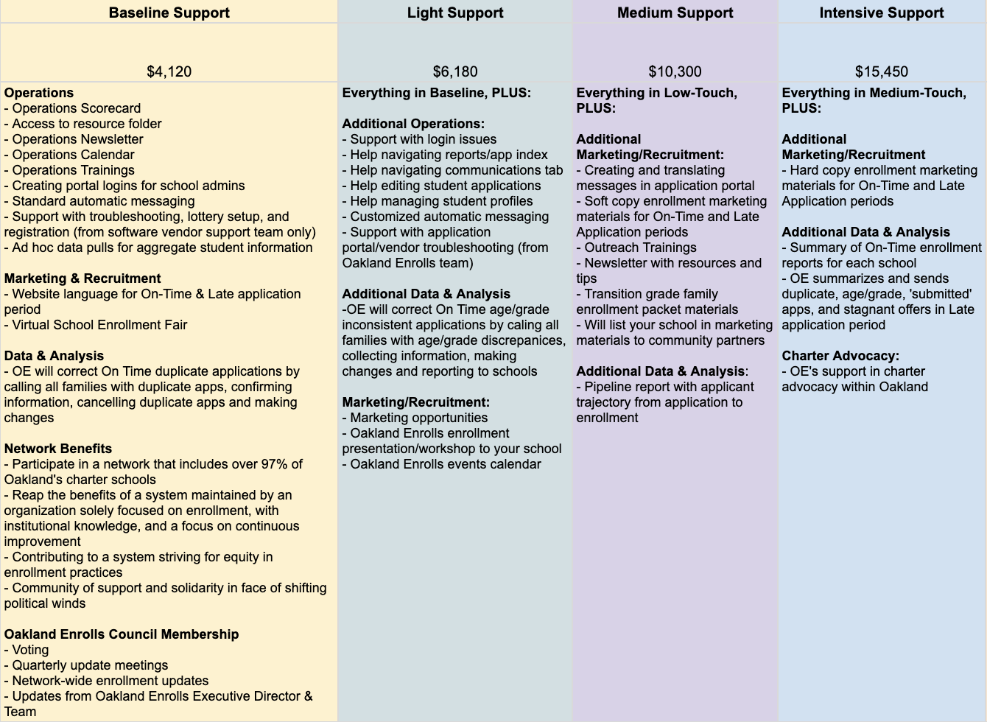

**APPENDIX F: Oakland Enrolls Optional Services**

Purpose: Describe the optional services offered by Oakland Enrolls in more detail

**1. On-Time Applications Operations Support (Nov - Feb)** $3,090

Oakland Enrolls creates an On-Time enrollment operations plan and completes the plan in partnership with school staff. Includes:

* Weekly report to school with summary of: number of new applications, number of canceled applications, aggregated applicant demographics (race/ethnicity and region), analysis of type of priorities of applicants, and analysis of time/date of application
* Suggested messaging content and frequency for applicants
* Sending suggested messaging
* Tracking of success of messages (how many received/bounced, etc.) for follow up
* Phone outreach to families who applied to let them know of upcoming tours, events, etc.
* Phone outreach to follow up with school tour/event attendees to help them apply

Basically, this service would take the day-to-day application management off of your hands up until the lottery. This would also include answering school-specific questions from families (though this shouldn’t take the place of families interacting with the school specifically).

Schools would need to:

* Confirm application questions in accordance with lottery
* Have the ability to help families apply who walk in to their school
* Work with Oakland Enrolls to build timelines around when communications should go out, to whom, what they should say (though OE would execute these)

**2. Custom Outreach & Marketing Plan and Support (Sept - April)** $2,575 - $8,755 depending on level of service.

Oakland Enrolls partners with schools to review and develop a custom outreach and marketing plan that schools will execute.

The most intensive version includes:

* One-on-one strategic planning session with historical school data to help school come up with individualized marketing plan (setting goals, strategies, tactics, and tracking metrics)
* Creation of calendar of social media posts and communications outreach
* Calendar of events throughout Oakland where school can attend
* Template for tracking event attendance
* Template for tracking outreach and marketing metrics and progress
* Graphic design support for marketing materials
* Translation services for marketing materials
* Support planning an options fair or other enrollment event at the school
* Recommended tactical/strategy changes throughout the enrollment season based on tracked metrics

The lighter version includes:

* One-on-one strategic planning session with historical school data to help school come up with individualized marketing plan (setting goals, strategies, tactics, and tracking metrics)
* Creation of calendar of social media posts and communications outreach
* Calendar of events throughout Oakland where school can attend
* Template for tracking event attendance
* Template for tracking outreach and marketing metrics and progress
* Recommended tactical/strategy changes throughout the enrollment season based on tracked metrics

Oakland Enrolls will not be marketing or distributing school-specific collateral during our outreach events or to families who come to Oakland Enrolls support center.

Schools would need to:

* Have an outreach point person with whom Oakland Enrolls can work and who can execute the marketing plan
* Conduct their own outreach activities such as attending school options fairs and community events on behalf of the school
* Track their progress toward goals and metrics
* Manage their own websites, social media channels, etc.
* Send/distribute their own communications to families (emails, text messages, mailers, flyers, etc.)
* Pay for all costs associated with running an event (facility, food, materials, technology, childcare, etc.)
* Pay for printing marketing materials that are produced for the school

**3. Graphic Design Support (Sep - Feb)**  $3,400 - $5,850 depending on level of service.

Oakland Enrolls partners with a graphic design vendor and Charter Partner to aid in Charter Partner’s marketing efforts. Packages are listed below.

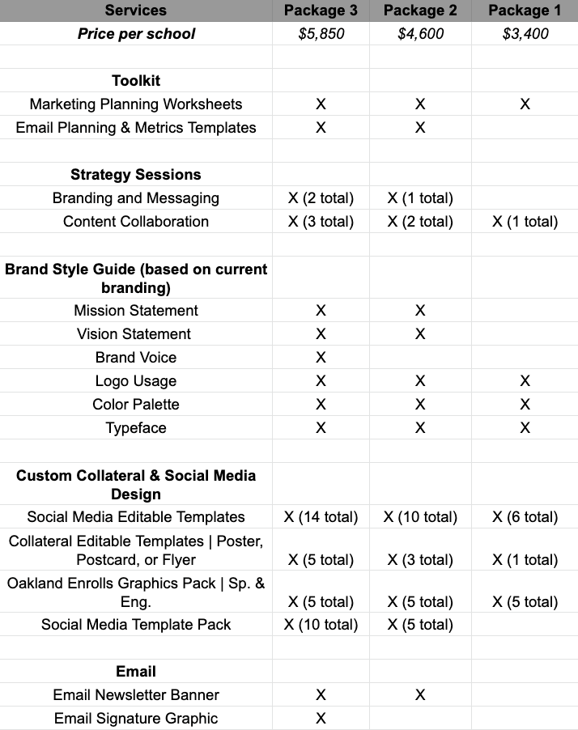

**4. Seat Offer Tool and Custom Reports (varies)** $2,575

Oakland Enrolls creates a more in-depth report to assist schools with analyzing enrollment policies and practices. Oakland Enrolls will also create the Seat Offer tool before lottery season and create custom reports during On Time enrollment, as well as Late enrollment. Oakland Enrolls will partner with schools to determine whether there are additional reports they would like to see that we can produce.

Reports Included:

1. Seat Offer Tool
2. Current Students Activity
3. Enhanced Demand Report

**5. Managing Ongoing Offers (Mar - Jun)** $3,090

Oakland Enrolls partners with a school to set up a process for managing Offers, Rescinds, Waitlist Confirmations, etc. through the end of the school year. Includes:

* Weekly report to school with summary of: number of new applications, number of canceled applications, number of new accepts, status of registering students (if using SM registration), aggregated applicant demographics (race/ethnicity and region), analysis of type of priorities of applicants, and analysis of time/date of application
* Making/rescinding offers based on school’s enrollment strategy
* Suggested messaging content and frequency for applicants in various application statuses, and execution of sending messaging
  + Ex: sending messaging to accepted students to outline registration process, sending messaging to offered students to let them know about orientation/events, etc.
* Tracking of success of messages (how many received/bounced, etc.) for follow up
* Follow up by phone with families with pending offers to make sure they’re aware and help take action

Oakland Enrolls would also field school-specific registration questions (but would not include supporting families over the phone or in person) about the registration process. Oakland Enrolls runs this process, which goes up until the registration process.

Schools would need to:

* Run their lottery
* Work with Oakland Enrolls to build timelines around when communications should go out, to whom, what they should say (though OE would execute these)
* Work with us to determine how many offers should be made (though OE would execute)
* Be able to answer family questions when they call
* Be able to support their families through the entire registration process by phone or in person