**AIMS K-12 COLLEGE PREP**

2021-2022 2ndInterim Executive Summary

AIMS K-12 College Prep, formerly known as, American Indian Model Schools, is a Charter District comprised of 3 schools. AIMS College Prep Middle School was initially established in 1996. The AIMS K-12 College Prep Charter District was formed in 2006 with the expansion of schools, adding AIMS College Prep High School and American Indian Public Charter II, (K-8). The Charter is located in the city of Oakland in Alameda County.

AIMS K-12 College Prep currently enrolls 1335 students in 3 schools; One K-8, One Middle School (6-8) and One High School. AIMS K-12 currently employs 1 part-time and 127 full-time staff to serve our students.

**Governance**

The Charters are governed by a volunteer Board of Directors. There are five members of the board, each volunteering their term. The school board meets once a month on the third Tuesday of each month. The Board of Directors are supported by a several other committees such as the Governance, Finance, Facility and LCAP Advisory Committees’ that also meet monthly. Charter operations are led by Superintendent Maya Woods-Cadiz.

**Enrollment**

In accordance to the Charter Agreement with Oakland Unified School District, AIMS K12 has nearly reached its full enrollment capacity. AIMS College Prep Middle School is capped at 250 students, American Indian Public Charter II (AIPCS II) 675, and AIMS College Prep High School at 450. The report below reflects enrollment numbers, the Average Daily Attendance (ADA) number and the Average Daily Attendance (ADA) percentages used in projecting the budgets.

The return to in-person learning has had a dramatic impact across the country. The transition for parents and students during a pandemic has impacted the attendance numbers seen in our Middle and K-8 populations. With many families relocating due to job loss or to other pandemic related factors, the 1st Interim reflects a loss of students. These numbers have had an impact on the LCFF General Fund allocations however other State and Federal supports have been fundamental in maintaining AIMS K 12 standards. For the 2nd Interim projections enrollment numbers have remained flat.

 

**2021-22 State Budget:**

**Significant Changes Since Budget Adoption**

Assembly Bill 167, the education budget cleanup trailer bill included the following grants:

Confirmed the additional concentration grant to increase 15% (reflected in 1st Interim)

Prekindergarten Planning and Implementation Grant (reflected in 2nd Interim)

A-G Completion Grant: *Coming Soon*

Kitchen Infrastructure Grant: *Coming Soon*

While the Governor has shown a tendency to return to the categorical nature of funding, the logistics of implementation has been slow. Templates and allocations regarding the different grants approved in the budget or through the trailer bill are still being disseminated. This has put schools under tight timelines and there are still unknowns in the amount of several grant allocations.

**Expanded Learning Opportunities Program**

The state budget provided $1.8 billion for access to comprehensive expanded learning for all unduplicated students in elementary schools. The intent is to provide before- and after-school opportunities that, in combination with the instruction day, total nine hours daily, in addition to 30 expanded learning days during intersession periods.

AB 167 delayed conditions of the apportionment until 2022023. Funds received in 2021-22 may be expended through the 2022-23 fiscal year for developing a program.

Beginning in 2022-23, as a condition of apportionment, expanded learning opportunities must be offered to classroom-based K-6 students based on the LEA’s unduplicated count as follows:

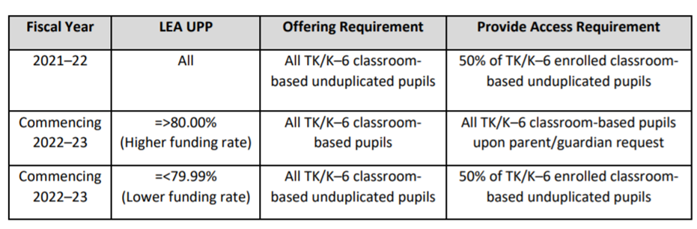

While Ed Code currently provides a three-year guarantee of the higher funding for the LEAs with 80% or greater unduplicated count, the Governor has reaffirmed his investment in this program in his 2022-23 proposed budget.

**COVID-19 Emergency Response Spending**

The administration that COVID expenditures will be $3.2 billion in 2021-22, $1.4 billion higher than budget assumptions. Legislature has been tasked to take immediate or early action to approve additional 2021-22 COVID funding.  It is unknown if schools will be recipients of any of this additional funding.

**LAO Analyzed 2022-23 Proposed Governor’s Budget**

LAO estimates the Governor had a $29 billion surplus to allocate in the 2022-23 budget process.  Approximately $13B of that went to schools. Almost 60% of that is in one-time spending, 30% to the Expanded Learning Opportunities, and the remaining 10% to ongoing increases.

 Substantial Upward Revisions to Estimates of the Minimum Guarantee. The state calculates the minimum guarantee each year using formulas in the State Constitution. The guarantee encompasses state General Fund revenue as well as local property tax revenue. Compared with the estimates in the June 2021 budget plan, the administration revises its estimates of the guarantee up $2.5 billion (2.7 percent) in 2020-21 and $5.3 billion (5.7 percent) in 2021-22. For 2022-23, the guarantee is up $8.2 billion (8.8 percent) relative to the 2021-22 enacted budget level. These increases—combined with nearly $1.6 billion freed up from the expiration of various one-time Proposition 98 costs—make $17.7 billion available for new commitments. Most of the increases in the guarantee are due to state General Fund revenue being significantly above previous estimates. For 2022-23, the higher guarantee also reflects growth in local property tax revenue and an adjustment to “re-bench” the guarantee for the expansion of Transitional Kindergarten. Total Proposition 98 funding for schools and community colleges in 2022-23 is $102 billion—$73.1 billion from state General Fund and $28.9 billion from local property tax revenue.

Provided by Karen Peters, CSMC

**Budget**

AIMS K-12 College Prep fiscal year is from July 1 to June 30, as prescribed for all governmental agencies in the state. AIMS K-12 2021-2022 1st Interim budget was projected as a $19,542,843 budget, for the 2nd Interim the projected budget has increased by $876,117, a 4% increase to total $20,418,960. Recent Federal and State support allocations are widely responsible for the increase.



*\*LCFF: Local Control Funding Formula*

The General Fund *(LCFF + Other State Revenue)* is used to record the day-to-day operations of the charter. There are nine special purpose funds to capture the remaining budget.

* GENERAL PURPOSE: State Apportionments include the LCFF calculations based on Average Daily Attendance enrollment and percentages (ADA) and Other State Revenue: State Food Revenue, State Lottery and State Mandated Block Grant

**Special State Funds**

* ASES: Afterschool Program
* **NEW Educator Effectiveness Block Grant**

**Local Funds**

* LOCAL FUNDS (Measure G1, Donations & Grants)

**Federal**

American Indian Model Schools receives direct funding* of federal funds for at risk students:

*\*Direct Funding: Federal allocation is directly provided to Charter. The funds do not “pass-through” the Authorizing District (Oakland Unified School District). These funds are issued at a reimbursement rate, funds must be expended and applied for reimbursement quarterly.*

* Title I, Part A Low Income at Risk
* Professional Development (Title II)
* English Learners (Title III)
* Title VI,
* NSLP/SSO: Funding to provide meals to those students qualifying for free or reduced lunches.
* Facilities Grant
* COVID response - CARES Act: ESSER Funding (1st and 2nd Round)
* COVID response- New ESSER III (3 Year grant 21-22 thru 23-24)
* COVID response- Expanded Learn Opportunity Plan
* COVID response- Expanded Learning Opportunity Plan -Paraprofessional
* COVID response- In-Person Learning Grant
* **NEW: Extended Learning Opportunity Grant**
* **NEW: Pre-K Grant (Planning)**

**Budget Benchmarks – Process timeline**

* AIMS K-12 2021-2022 Budget Adoption: June 15,2021
* State’s 2021-2022 June Budget Adoption: June 30,2021
* 45 Day Budget Revision (not required): Mid-August
* Unaudited Actuals (2020-21 Closing): September 01,2020
* First Interim (Realignment based on July – Oct 31 Activity): December 1, 2021
* January Governors Release (Projections for 2021-2022): January 2022
* **Second Interim (Realignment based on Nov 1, 2021– Jan 31, 2022)- March 1,2022**
* Governors May Revise (Revision to Jan. Gov. Release): May 2022
* 2022-23 Budget Adoption – June 15, 2022

**2nd INTERIM**

An interim statement is a financial report covering a period of less than a year. The reports are used to convey the performance of AIMS K-12 before the end of the annual reporting cycle. California Public Schools are required to submit Interim reports two time a year. Unlike annual statements, interim reports are not required to be audited. The 2nd Interim report for AIMS K-12 captures activity from November 1, 2021 through January 31, 2021. This report is presented to the Board at the end of February and submitted to our authorizer, OUSD, on March 1st.

**REVENUES**

AIMS K12 is primarily funded by State and Federal revenues. AIMS receives 83% of its revenue from State resources, 14% from Federal Resources and 3% of revenues are based on grants and/or local revenues.

The FCMAT 2nd Interim calculator was used to for the reporting of the 2nd Interim. Below highlight the changes in summary and per school:



**LCFF SOURCES:**

**1st Interim:** *All Schools:* Realignment of program

**2nd Interim:** *All Schools:*No adjustments made to LCFF at 2nd Interim.

**FEDERAL REVENUES:**

**1st Interim 2020-2021:** *All Schools:* Carryover and ESSER III funds reflected.

**2nd Interim:** *AIPCS II and AIMS HIGH:* Projected budget increase for SSO (Food Services Program) to reflect current participation.

**OTHER STATE REVENUES:**

**1st Interim 2020-2021** *All Schools:*In-Person and ELO Grant carryover and Lottery Allocation adjustments reflected.

**2nd Interim:** *All Schools:* Educator Effectiveness reflected. ELOP Grant reflected and ELOG grant reallocated to out years

**LOCAL REVENUES:**

**1st Interim:** *All Schools:*Adjusted revenue projections for Interest and School Site Fundraising.

**2nd Interim:** *AIMS MIDDLE and AIMS HIGH:* Roberto Trust Fund Donation revenue is received and reflected as income. Each were named as grantees of the trust and each received $127,966.14 on January 18, 2022. *AIMS Middle* and *AIPCS II:*  Measure G1 19-20 carryover is reflected



**LCFF SOURCES:**

**1st Interim:** Reflects the loss in projected enrollment

**2nd Interim:** No adjustments made to LCFF at 2nd Interim.

**FEDERAL REVENUES:**

**1st Interim:** ESSER I and II carryover funds totaling $55,810 from 20-21 reflected; (NEW) Year 1 ESSER III funds reflect remaining increase.

**2nd Interim:** Projected Budget Increased for Food Service Program (SSO) to reflect participation

**OTHER STATE REVENUES:**

**1st Interim:** In-Person and ELO Grant carryover funds reflected.

**2nd Interim**: Educator Effectiveness Grant reflected ($41,238); ELOP Grant reflected ($50K); ELOG Grant realigned to 22-23 budget ($50K)

**LOCAL REVENUES:**

**1st Interim:** Reduced revenue projection for Interest and School Site Fundraising.

**2nd Interim:** The Roberto Trust Fund ($127,966.14) donation was received on January 18, 2022. Measure G1 19-20 carryover ($17,861) reflected.



**LCFF SOURCES:**

**1st Interim:** Reflects the loss in projected enrollment

**2nd Interim:** No adjustments made to LCFF at 2nd Interim

**FEDERAL REVENUES:**

**1st Interim:** ***(NEW)*** Year 1 ESSER III funds reflected.

**2nd Interim:** No adjustments to Federal Revenue at 2nd interim

**OTHER STATE REVENUES:**

**1st Interim:** State lottery allocation increased by $45K; In-Person and ELO Grant carryover funds totaling $150,507 from 20-21 reflected.

**2nd Interim:** Educator Effectiveness Grant reflected ($140,648); ELOP Grant reflected ($463,591); ELOG Grant realigned to 22-23 budget ($335,688); Pre-K Grant ($63,146) reflected

**LOCAL REVENUES:**

**1st Interim:** Increased revenue projection for interest; reduced revenue projection for School Site Fundraising.

**2nd Interim:** Measure G1 19-20 Carryover reflected ($52,991)



**LCFF SOURCES:**

**1st Interim:** Reflects an increase in projected enrollment

**2nd Interim:** No adjustments made to LCFF at 2nd Interim.

**FEDERAL REVENUES:**

**1st Interim:** (NEW) Year 1 ESSER III reflected.

**2nd Interim:** Projected Budget Increased for Food Service Program (SSO) to reflect participation

**OTHER STATE REVENUES:**

**1st Interim:**

**2nd Interim:** Educator Effectiveness Grant reflected ($70,034)

**LOCAL REVENUES:**

**1st Interim:** Increased revenue projection for Interest

**2nd Interim:** The Roberto Trust Fund ($127,966.14) donation was received on January 18, 2022.

**COVID RESPONSE FUNDING:**

**SSO Grant:**

On September 17, 2020 AIMS K12 was approved to participate in the SSO Food program and will continue through the 2021-2022 fiscal year. This program was designed to ensure that students and families were provided with meals during the pandemic. The State funded program, reimburses full cost of meals AIMS K12 distributes to its students and surrounding community. The program differs from the NSLP program as it does not require the same level of record maintenance for reimbursement as this program tracks the meals distributed not the child it is distributed to. The language also allows AIMS to provide meals for any community member under the age of 18. The program allows for full reimbursement of cost.

**Elementary & Secondary School Relief Emergency Fund (ESSER)**

**ESSER I:** ESSER funding was initially outlined in the 2020-21 Governor’s budget. The funds were provided to California through the Federal Coronavirus Aid Relief and Economic Security Act (CARES) and allocated in the Governor’s ESSER budget for schools. ESSER funds are available for expensing until 9/30/2022.These funds are meant to assist schools in preparing for distance or hybrid learning. AIMS approved the application for the ESSER funds during the August 18, 2020 Board Meeting. The total State budget is 1.65B of which AIMS K12 received $304,843 in 2020-2021 These funds will be completely expended in the 2021-2022 school year.

**ESSER II:** California Department of Education has released the new allocations for the second round of ESSER funds in which AIMS K12 has received an additional $1,260,266. The funds are available for use beginning 2020-2021 through the 2021-2022 school year. AIMS began to expense in the 2020-2021 fiscal year and the remaining funds are allocated in the current fiscal year. These funds will be fully expended by June 30, 2022.

**ESSER III:** California Department of Education has released the new allocations for the third round of ESSER funds in which AIMS K12 has received an additional $2,856,649. The funds are available for use beginning 2021-2022 through the 2023-2024 school year. AIMS has allocated these funds for the duration of the program, allocating 20% in 2021-22 and the remaining balance split between the 22-23 and the 23-24 fiscal years.

**In-Person Instruction**

The In-Person Instruction grant provides funding to county offices of education (COE), school districts, charter schools and state special schools to assist with offering in-person instruction to the greatest extent possible during the 2020-21 school year; and to expand in-person instructional time and provide academic interventions and pupil supports to address barriers to learning, and accelerate progress to close learning gaps. The In-Person Instruction grant is allowable for use in the 2021-22 and will be fully expended by year end.

**Extended Learning Opportunity Grant (ELO)**

The Extended Learning Opportunity grant provides funding charter schools to assist with implementing a recovery program, that at a minimum provides supplemental instruction and emotional well-being. ELO Grants shall be expended only for any of the following purposes: extending instructional learning time, accelerating progress to close learning gaps, integrated pupil supports, community learning hubs, supports for credit deficient pupils, additional academic services, and training for school staff. An additional requirement of the use of funds, is to allocate 10% of the LCFF portion of the grant to hire/rehire paraprofessionals to provide supplemental education. AIMS K-12 ELO Grant Plans were presented and approved by the Board of Trustees in May 2021 and submitted to the State and OUSD prior to the June 1,2021 deadline. The ELO grant is allowable for use in the 2021-22 and will be fully expended by year end.

**NEW: Educator Effectiveness Block Grant**

Educator Effectiveness funds may be used to support the professional learning for certificated teachers, administrators, paraprofessional educators, and certificated staff. Coaching and mentoring of staff. Programs that lead to effective, standards-aligned instruction and improve instruction in literacy across all subject areas, including English language arts, history-social science, science, technology, engineering, mathematics, and computer science. Practices and strategies that reengage pupils and lead to accelerated learning. Strategies to implement social-emotional learning, trauma-informed practices, suicide prevention, access to mental health services, and other approaches that improve pupil well-being. Practices to create a positive school climate. Strategies to improve inclusive practices. Instruction and education to support implementing effective language acquisition programs for English learners.

**NEW: Expanded Learning Opportunity Program (ELOP)**

The intent of the Expanded Learning Opportunities (ELO) Program is to supplement and not supplant services provided under existing ASES and 21st CCLC Elementary/Middle School programs. However, there is shared understanding that LEAs will need to build capacity this first operational year. In addition, ASES, 21st CCLC Elementary/Middle School, and the ELO Program should be considered a single, comprehensive program. In coordinating all these funding streams to move towards a single program, the expectation is that the most stringent requirements will be adopted for program guidance.

The funding was provided during the 2021-2022 fiscal year, the midyear allocation disbursement has eased the plan requirements for the mandates of funding. The Board Approved plan for the use of funding is not due to the state until June 2022.

**NEW: Pre-K Grant (Planning Year)**

The California Prekindergarten Planning and Implementation Grant Program was established as a state initiative with the goal of expanding access to classroom-based prekindergarten program at LEAs and planning for the increased number of teachers needed to fully implement Universal Prekindergarten. American Indian Public Charter II (AIPCS II) was the only school within AIMS K-12 District to qualify for the funding.

**Roberto Family Trust Donation**

In 2012, AIMS K-12 Middle School (a.k.a. American Indian Public Charter) and AIMS K-12 High School (a.k.a. American Indian Public High School) were named in the Roberto Family Trust. As a part of this Trust, each school was granted $125,000 (and any additional interest). AIMS K-12 Board of trustees recognized these funds during 2020-2021 1st Interim. As of 2021-2022 1st Interim, the final paperwork for the release of funds have been submitted and funds were received in January 2022.

**EXPENSES**

AIMS K-12 College Prep 2021-22 2nd Interim budget reflects a 47% investment in Personnel expenses and 53% allocated to the operations of the organization. This reflects a 2% drop from personnel support into operation expenses from 1st Interim to 2nd Interim. The return to in person learning was the driving force behind this change during 1st Interim. For the second interim, the increase allocation to the SELPA offset this balance even further. Increase cost for utilities, substitute services, increasing insurance rates as well as other maintenance and cleaning factors continue to play a significant role. AIMS expenses increased by 4% from the 1st Interim to the 2nd Interim due to the alignment of operating services throughout all three schools and the adjusted programs allocated through the receipt of Educator Effectiveness and ELOP Grants. The total expenses for the 2021-2022 school year are projected at $19,885.674.

****Expense Allocation for each school is reflected below. Any changes to budget allocation are outlined as well.

55%









|  |
| --- |
| Realignment of program can include: |
| Update Positions (Actual salaries, FTE % etc.) |
| Cover under projected expenses (such as substitutes and other increases to budget) |

**Salaries & Benefits**

Salary compensation represents 47% of expenses across all AIMS K-12 College Prep Schools. AIMS offers a competitive compensation package for both certificated and classified staff. Employee Benefit expense at AIMS averages 21% across all schools. This can vary greatly due to two primary factors: health and welfare benefits and PERS. Health and welfare benefits (medical/dental/vision insurance premiums), if requested by the employee, can vary due a number of factors, including an employee’s age and number of dependents. AIMS tracks and reports health and welfare benefits as precisely as possible, reflects as a variance in the percentage of benefits for employees at AIMS.

**AIMS MIDDLE**

Compensation for staff at AIMS College Prep Middle School, formerly known as American Indian Public Charter (AIPCS), is split between AIPCS and the middle school component of American Indian Public Charter School II (6-8). The expenses reflected are split by assignment and student Average Daily Attendance (ADA). All staff, with the exception of 5 teachers are split funded between AIMS Middle and AIPCS II.

**AIPCS II**

American Indian Public Charter II (AIPCS II) is a K – 8. The staff for the K – 5 components are fully funded at AIPCS II and the middle school component reflects the following Full Time Equivalent (FTE) split:

AIPCS 51%

AIPCS II 49%

100%

**Books and Supplies**

Records expenditures for books and supplies, including any associated sales tax or use tax and freight and handling charges.

The category of Book and Supplies captures more than classroom textbooks and materials, it itemizes Non- Capitalized student equipment such as tables, chairs, computers and software.

**Services and Other Operating Expenses**

Record expenditures for services, rentals, leases, maintenance contracts, dues, travel, insurance, utilities, and legal and other operating expenditures. Expenditures may be authorized by contracts, agreements, purchase orders, and so forth.

**Capital Outlay**

Capital Outlay records expenditures for land, buildings, books, and equipment, including leases with option to purchase. In accordance with the State guidelines for school finance, to capitalize an expense in the individual item must cost $5000 or more.

**Other Outgo**

Other Outgo captures interest, debt service and transfers (payments) to other LEAs (Authorizer)

AIMS partners with Oakland Unified School District to provide the Special Education services for their students. AIMS does not receive revenue for the Special Education program, instead encroaches on the General Fund to pay OUSD to provide the needed services. For 2021-2022 1st Interim the projection assumed $1,600 per ADA. OUSD notified AIMS K-12 the final rate of $2054 and it is reflected in the 2nd interim.

For the past few years OUSD has been charging AIMS 80% of the calculated rate for the services provided. The 2021-2022 fiscal year reflects the full calculated cost for OUSD’s Special Education services. Future years anticipate a 2% to 3% increase on the calculated rate.

**Summary**

For the 2021-2022 2nd Interim, AIMS K-12 has projected $20,418,960 in revenue and $19,885,674 in expenses. This provides a $533,286 surplus and represents a 4% contribution to be added to the Ending Fund Balance. Bringing the total Ending Fund Balance $5,566,423, providing approximately 60.18 days of operation. The composition of those funds are as follows:

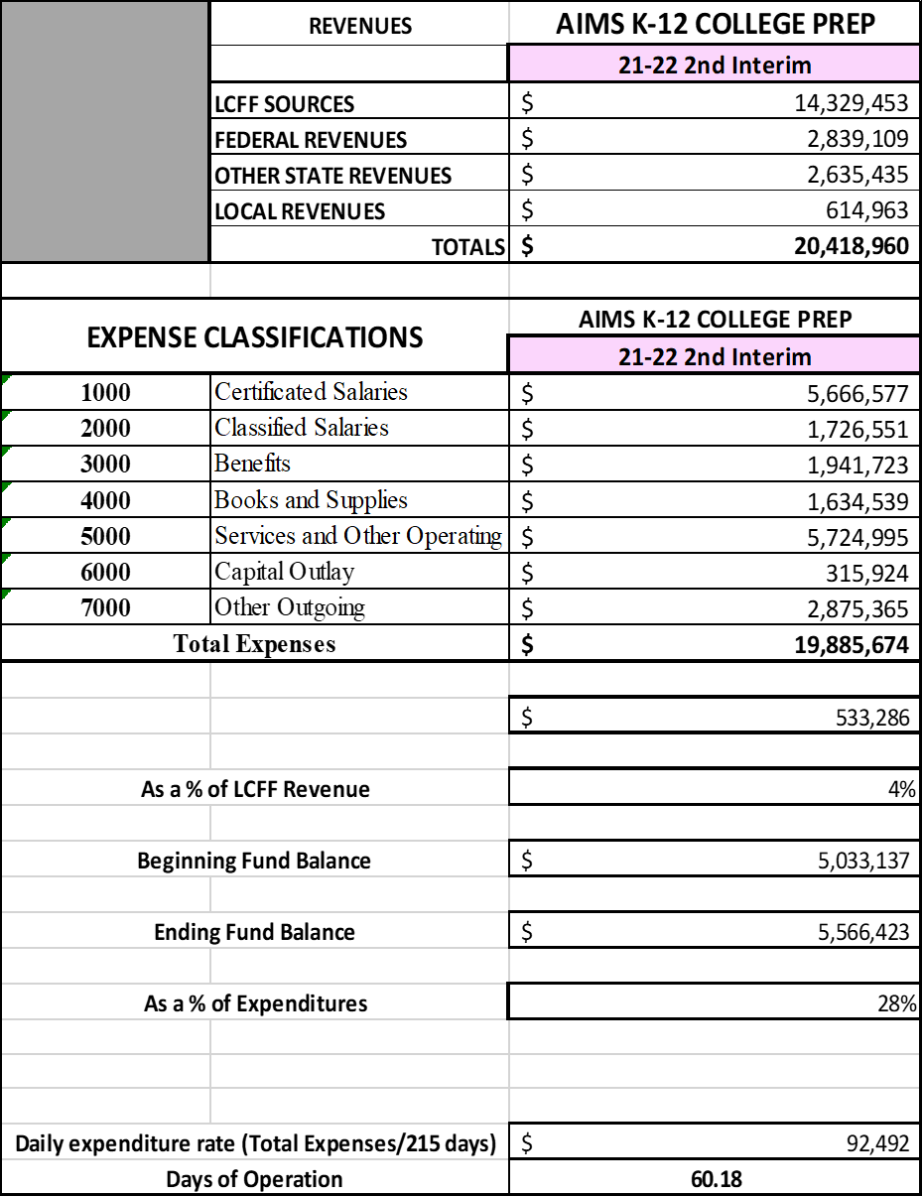

**Cash Flow Statement**

As of January 31, 2022, AIMS K-12 College Prep has $7,035,668 in cash



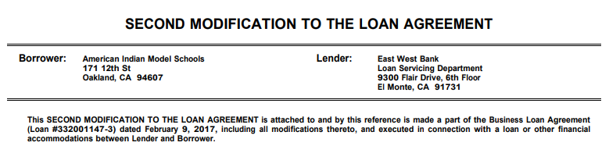





**Multi Year Reports**





