RESTRICTOR 32 RESOURE 3210

ESSER

PROCUREMENT QUOTES



*\*Indicates Quote is funded in two sources*

 

**FURNITURE QUOTE: ELEMENTARY**

**Quote Summary**

**Ship to:**

American Indian Public Charter School Justin Shelmire

171 12th St

Oakland CA 94607-4900 USA

Phone: 1 (510) 867-0324

Fax: N/A

Email: [justin.shelmire@aimschools.org](mailto:justin.shelmire@aimschools.org)

**Bill to:**

American Indian Public Charter School Justin Shelmire

171 12th St

Oakland CA 94607-4900 USA

Phone: 1 (510) 867-0324

Fax: N/A

Email: [justin.shelmire@aimschools.or](mailto:justin.shelmire@aimschools.org)g

**Quote #: QUO11247881**

Valid through: 12/18/2020

**Item SKU# Description Qty. List % Off Price Per Item**

(including options)

**Total Price**

1. VIR-280OPN [280OPN IQ Series Student Des](https://www.schooloutfitters.com/catalog/product_info/pfam_id/PFAM1574/products_id/PRO4768?sc_cid=quote_QUO11247881)k

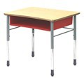**Options:**

Laminate Desk Top – Fusion Maple desktop w/ Clear Lacquer Edge (+ $0.00)

Frame – Silver Mist (+ $0.00)

Book Box – Green Apple Book Box Color (+ $0.00)

**Estimated Delivery:**

37 business days after order confirmation

78 $657.00 61% $259.08 $20,208.24

1. VIR-280OPN [280OPN IQ Series Student Des](https://www.schooloutfitters.com/catalog/product_info/pfam_id/PFAM1574/products_id/PRO4768?sc_cid=quote_QUO11247881)k

**Options:**

Frame – Silver Mist (+ $0.00)

Laminate Desk Top – Fusion Maple desktop w/ Clear Lacquer Edge (+ $0.00)

Book Box – Green Apple Book Box Color (+ $0.00)

**Estimated Delivery:**

|  |  |  |  |  |
| --- | --- | --- | --- | --- |
| **Shipping & Handling Breakdown** | |  | Product SubTotal: | $39,898.32 |
| **Items Shipping From:** | **Shipping Via:** | **Service(s) Included:** | Shipping & Handling: | $1,674.75 |
|  |  |  | Sales Tax: | 3,690.59 |
|  |  |  | **Grand Total:** | **$45,263.66** |
| **Important Shipping Information**   |  | | --- | | COE Distributing REDDAWAY Inside Delivery Lift Gate | |  |  |  |  |

38 business days after order confirmation76 $657.00 61% $259.08 $19,690.08

**FURNITURE QUOTE: HIGH SCHOOL**

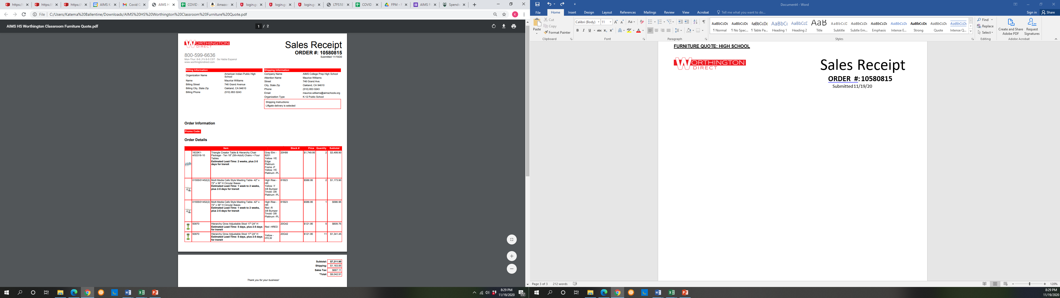

**WINDOW QUOTE: 12th STREET CAMPUS**

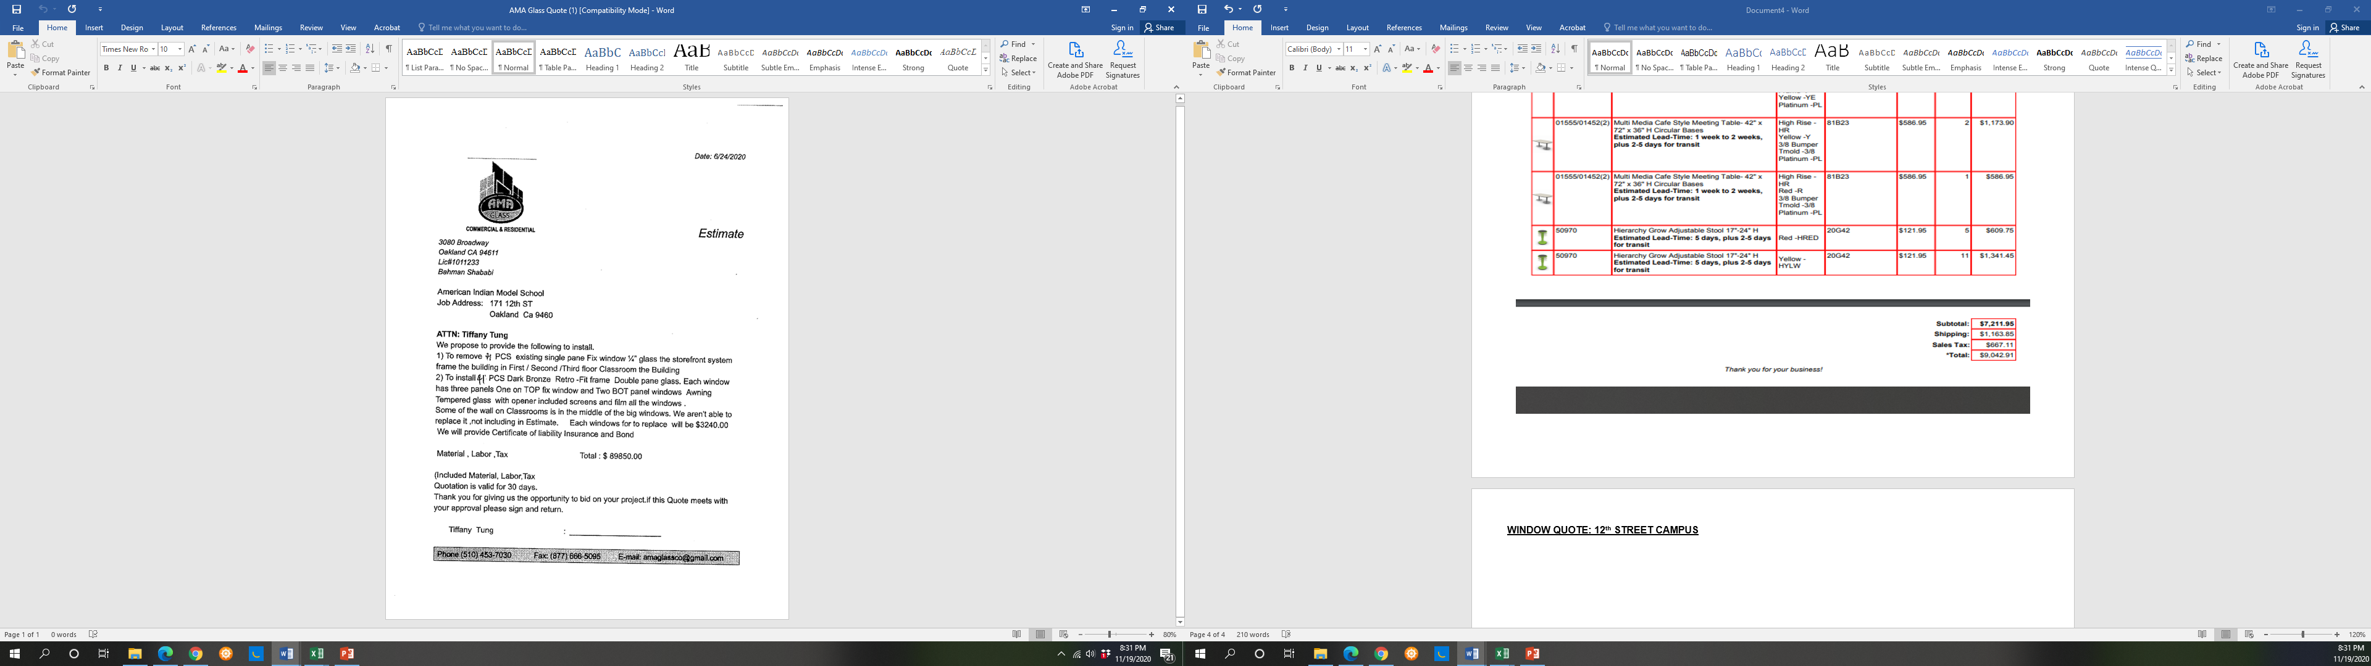

**IMAC COMPUTERS: HIGH SCHOOL**

AIPHS BUDGET: RESTRICTOR 32 $14,000

AIPHS BUDGET: RESTRICTOR 74 $30,000

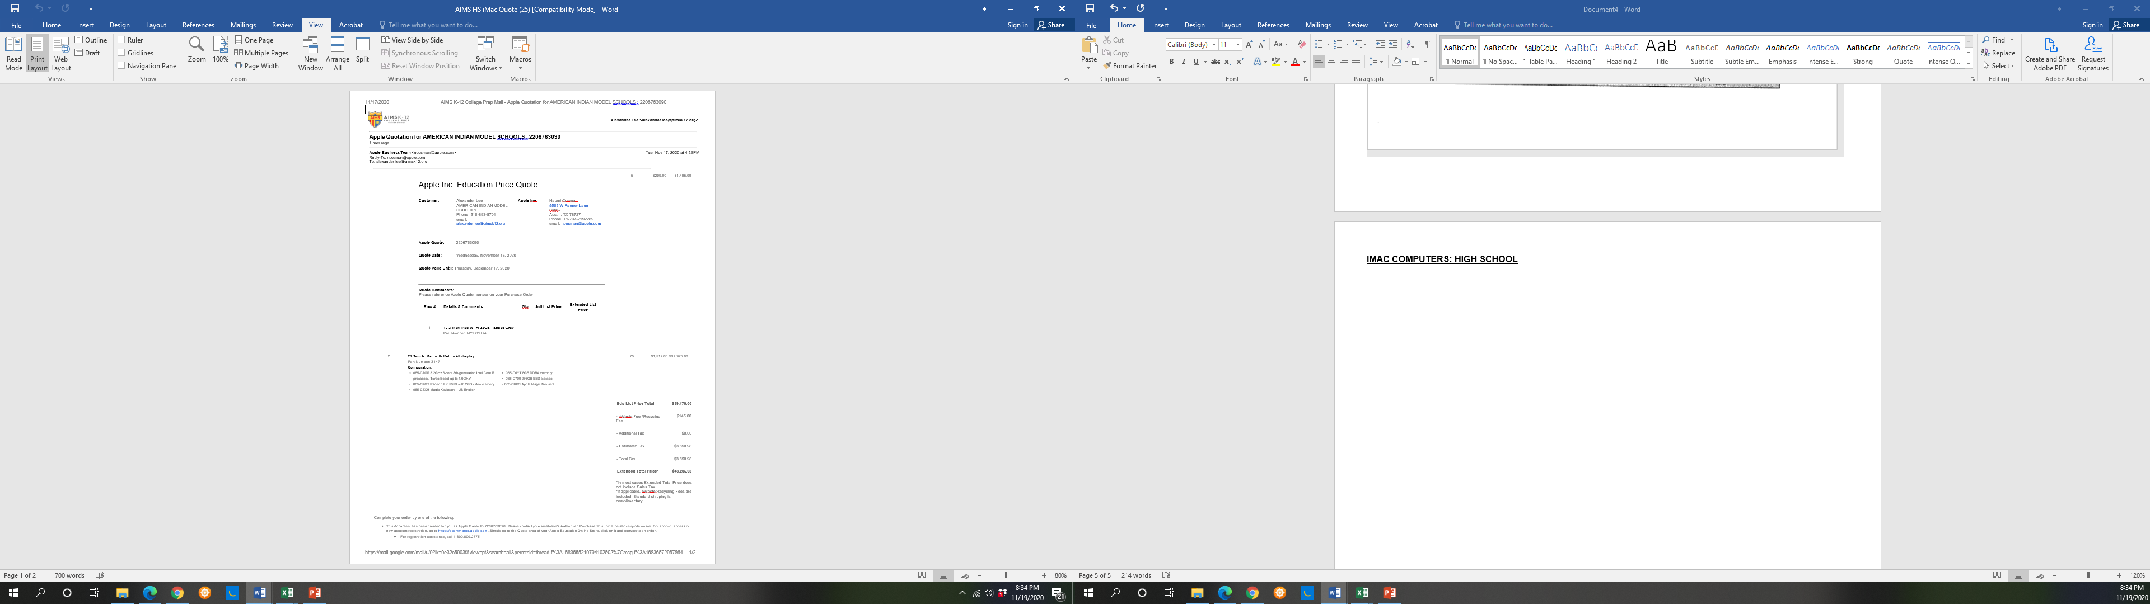

**Trane Condensing Unit Repair: 12th Street Campus**

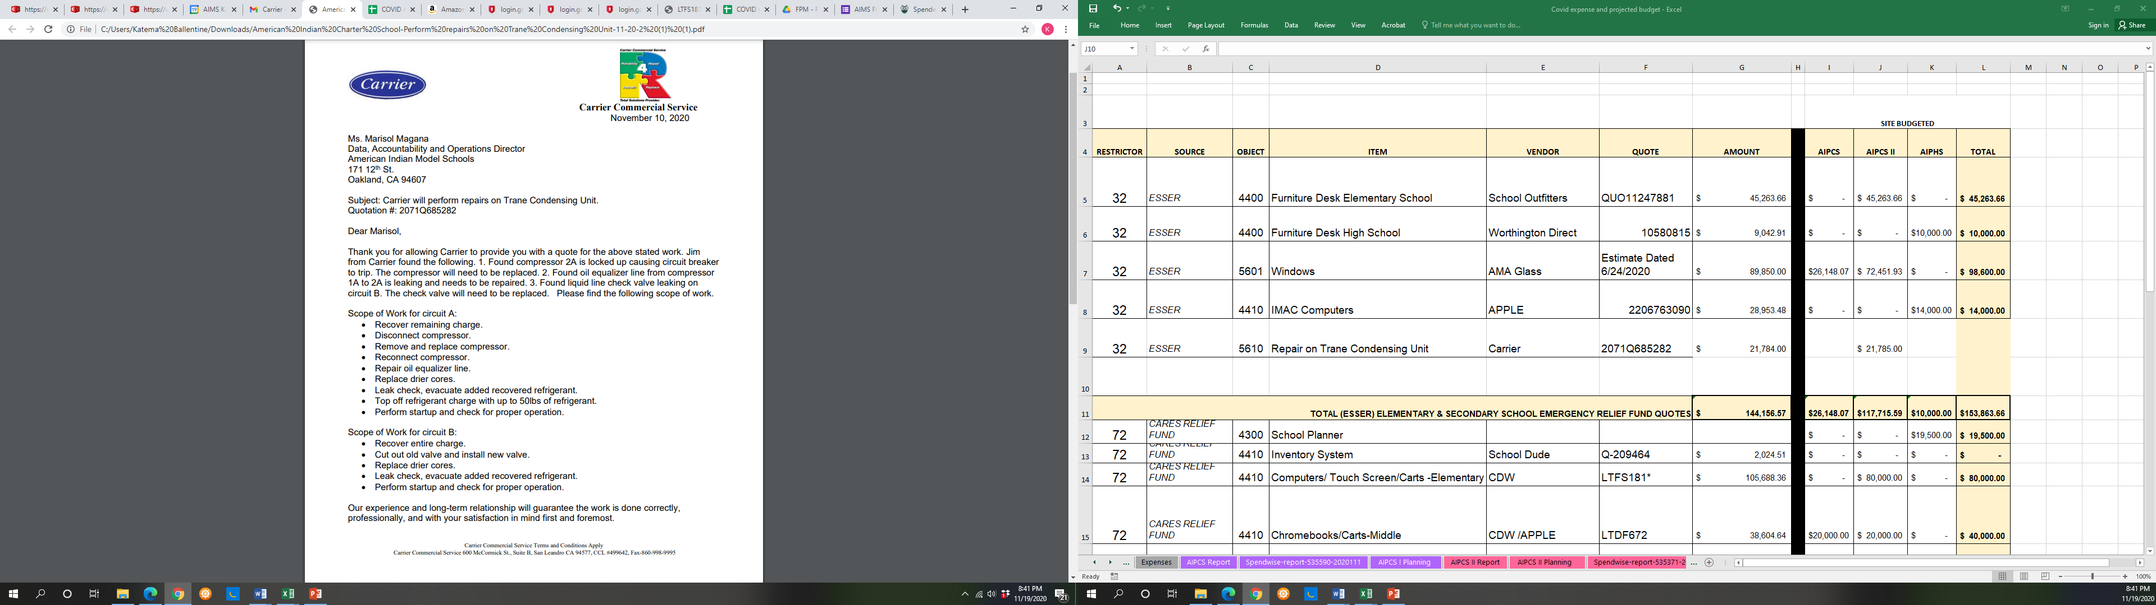

**Trane Condensing Unit Repair: 12th Street Campus**

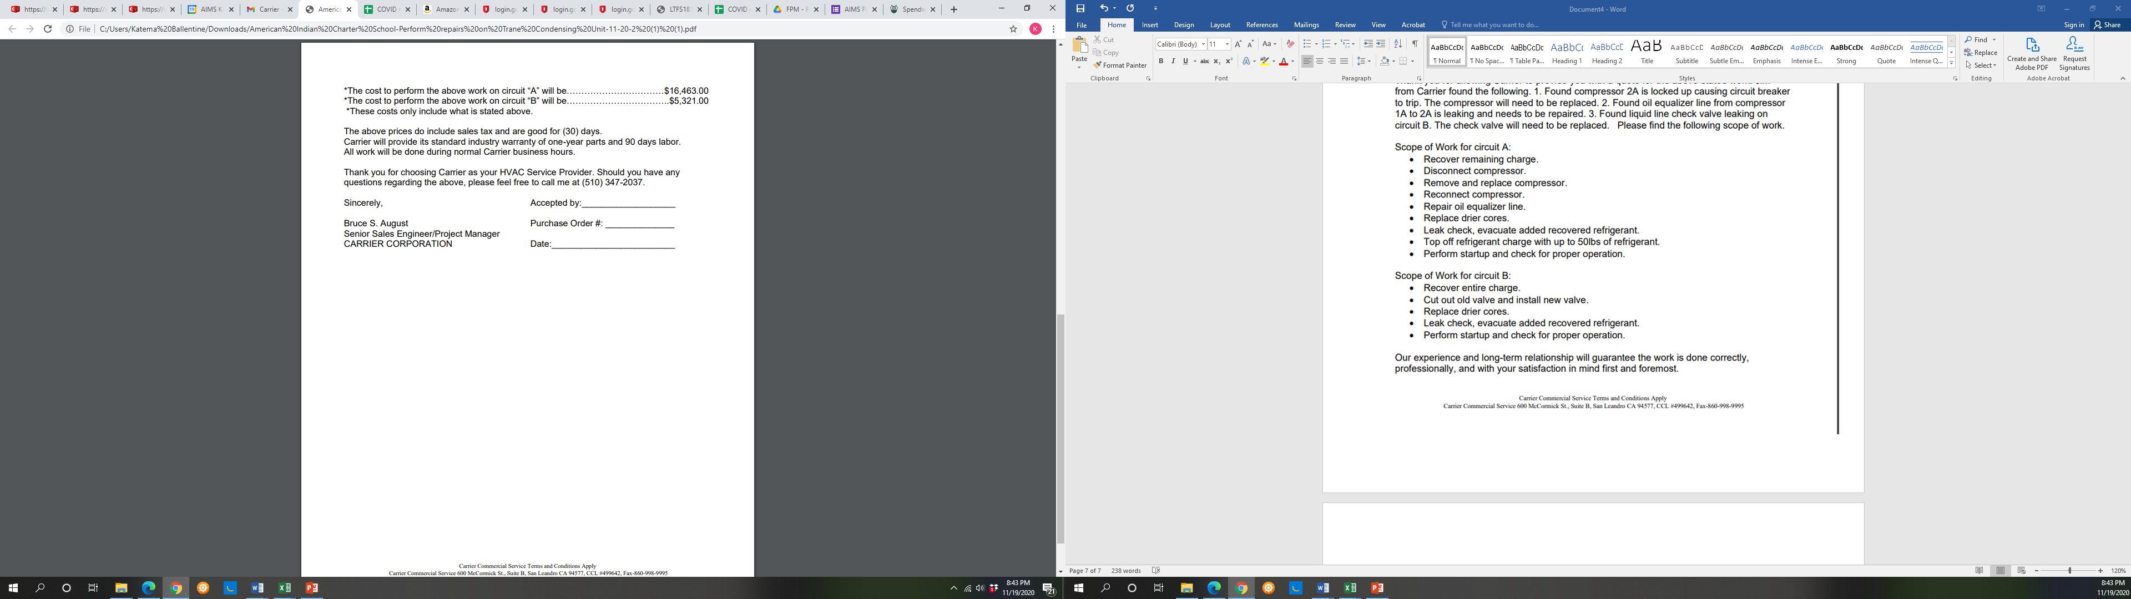

**Install Pressure Transducer: 12th Street Campus**

