AR 315(c) Federal Fund Management Time Accounting

**HEAD OF SCHOOL/SITE MANAGER RESPONSIBILITIES**

Each Head of Schools or designated site manager must ensure that all federally funded employees are familiar with the time documentation guidelines and are complying with these requirements. Please review the Employee Guidelines outlined below.

**FEDERALLY FUNDED EMPLOYEE TIME DOCUMENTATION**

Documentation is required to ensure that the district is properly charging salaries and wages that are reasonable, necessary and allowable in accordance with applicable federal program requirements. The resource codes involved with federal programs reviewed by CDE and that require time accounting forms are Title I Part A & D (Resource 3010 Restrictor 01); Title II Part A Resource 4035 Restrictor 02), Title III EL (Resource 4203 Restrictor 03), and Title IV (if allocated by CDE)

**ESEA**

**Title I Part A (3010)**

• Must be used to supplement the basic program

• Site employees cannot participate in administrative or clerical duties

• Intent is to provide support for low income students to become academically proficient in State Standards

**Title II Part A (4035)**

* to increase the academic achievement of all students by helping schools and district= improve teacher and principal quality through professional development and other activities

**Title III EL (4203)**

• support to ensure English learners in California, attain English proficiency,

• support so that English learners develop high levels of academic attainment in English

• support so that English learners meet the same challenging state academic standards as all other students

**Local Control Funding Formula (LCFF)**

• Considered State “general” funds – not categorical

• Employees funded with only LCFF do not participate in time accounting.

• Time Accounting is ONLY required if LCFF is combined with Title I, II, III, IV)

**Federal Time Accounting**

A requirement for the use of federal funds for salaries, time accounting certification records must be maintained and collected.

If an employee is paid with federal funds, documentation must be completed to reflect that the employee worked on that specific federal program and cost objective.

The following three components must be met for acceptable use of federal funds:

1. Necessary  
2. Reasonable  
3. Allocable (Time spent on compliant duties, proves ability to be allocated)

Types of Time Accounting:

1. Semi-Annual Fully Funded  
2. Semi-Annual / Single Cost Objective  
3. Personnel Activity Report (PAR) Multi-funded

**TIME ACCOUNTING FORMS: SEMI-ANNUAL CERTIFICATION AND PERSONNEL ACTIVITY REPORT**

**SEMI-ANNUAL CERTIFICATION for EMPLOYEES FUNDED WITH 100%, ONE RESOURCE.**

**Title I, Part A&D 3010- Restrictor 01**

**Title II, Part A 4035- Restrictor 02**

**Title III LEP 4203- Restrictor 03**

If an employee works 100% on one activity and is paid through one federal funding source only, they will sign this form twice a year, which is submitted after each six-month work period. Some examples of these employees may be instructional aides or resource teachers at one school site working on one goal area on a set schedule.

**1.) January (July-December) 2.) June/July (January-June)**

All duties must be supplemental and allowable under a Federal Title program.

If position is 100% Title I a Semi-Annual Time Accounting certification is completed twice a year.

* The Job description is embedded in the form.
* Originals are kept at the school site.
* Head of School or Administrative designee submits signed copies to Operations Department after work is completed.

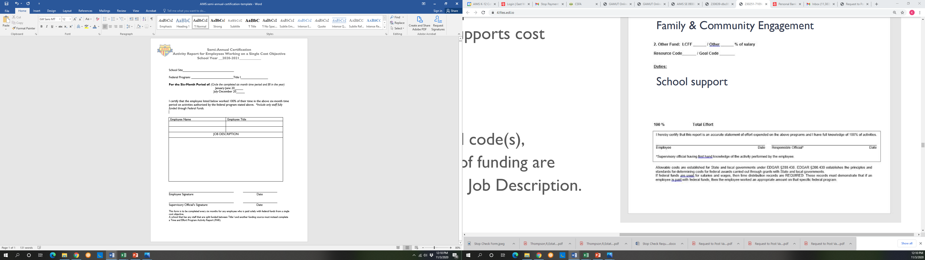

**SEMI-ANNUAL CERTIFICATION with SCHEDULE FOR MULTI-FUNDED SITE BASED EMPLOYEES**

**(Substitute System of Time Accounting)**

If a multi-funded employee works on one goal (or cost objective), their schedule does not change, and they stay in one location, they may complete the SEMI-ANNUAL CERTIFICATION twice a year. In order to use this form, the employee MUST submit one accurate work schedule with each Semi-Annual Certification form. The schedule must include information such as time periods, grades, and subjects.

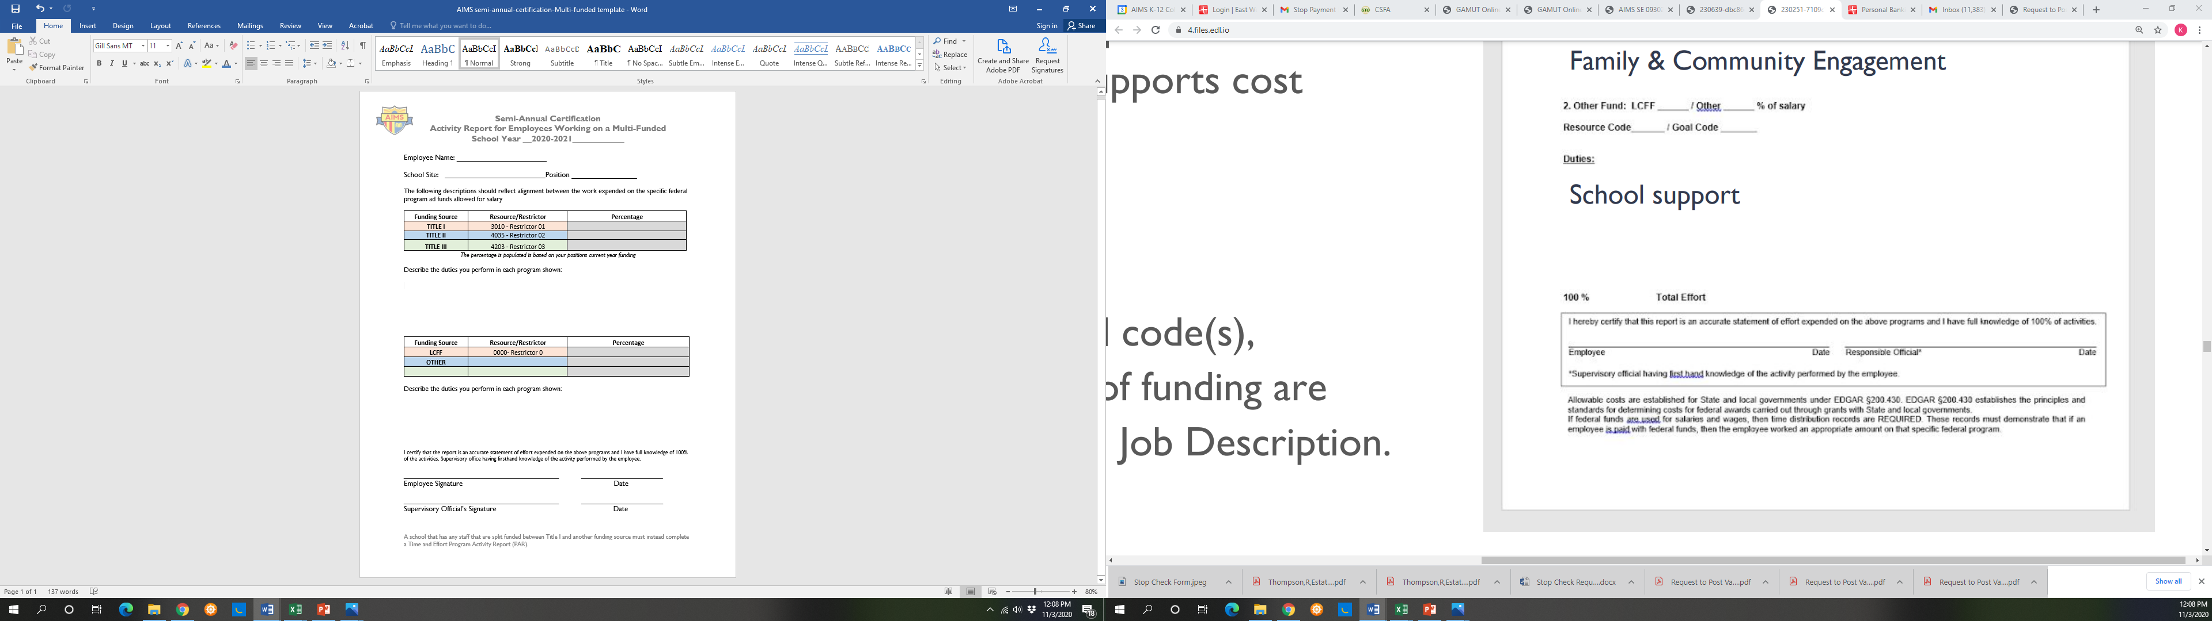

**PERSONNEL ACTIVITY REPORT (PAR)– Calendar for Multiple Funding and Multiple Cost Objectives**

If the employee’s work schedule varies daily or throughout the month, and/or the employee works at multiple sites, the employee should document daily activities, identify each program for which work was performed, and the daily time dedicated to each program. The total documented time for the day should equal to the actual hours worked.

All multi-funded, multiple cost objective employees must complete PARs on a monthly basis.

1. PARS must be submitted after the work month by the 10th of following month.

2. Cannot be submitted or signed after the last day of the following month



**Personnel Activity Report (PAR) Procedures**

All multi-funded personnel responsible for completing a PAR will:

• Complete & submit one description of duties annually to Operations Department.  
• Document their activities, per program, during their contracted hours on the Excel PAR Activity Report  
• Employee Print and sign completed Excel PAR Activity Report after the last working day of each month  
• Submit Excel PAR Activity Report monthly to site designee for Head of Schools to review and sign.  
• Site designee will submit copies all signed Excel PAR Activity Reports to Operations Department ([operations@aimsk12.org](mailto:operations@aimsk12.org)) by the 10th of the following month. (i.e. August PAR forms will be due September 10, 2020).

**All personnel sign time accounting certifications AFTER work is performed.**  
**All original Time Accounting forms, with original signatures must be kept at school site for five years.**

**Procedures to Review Federal Positions:**

A review of each federal funded position will occur annually.

Each Head of School will:

1. Provide evidence of the identified need, alignment to LCAP/SPSA goals, and intent of funding for each position.  
2. Submit an annual job description(Duty Statement) for each multi-funded position.  
3. Submit monthly Personnel Activity Records (PAR) for each multi-funded position.

District (Operations/HR/Finance) will:

1. Review and confirm school steps 1-3.  
2. Conduct a semi-annual fiscal review to determine if funds are allocated appropriately/aligned to work performed.  
3. Make fiscal reconciliations if review results in misalignment.

*If school is retaining the multi-funded position for the next school year, funding must be adjusted and reflected on the Position Action Form (PAF).

**REVIEW AND APPROVAL CYCLE:**

**Personnel Activity Report (PAR**): After the last day of each month, the employee signs and submits their PAR completed, to their supervisor for review. The supervisor must date and sign the PAR after the end of the month and submit by the 10th of the following month. PARS cannot be signed or submitted after the last day of the following month.

**Semi-Annual Certification:** This form must be submitted in January (covering the July-December work period) and June (covering the January – June work period). In June, Semi-annuals can be signed on the last day of work for the employees’ school year.

**FORM SUBMISSION:**

All forms must be sent either hard copy to:

American Indian Models Schools

171 12th Street

Oakland 94607

Attn: Operations Department

OR Scanned and emailed to: operations@aimsk12.org

**EMPLOYEE TRAINING:**

Time Accounting training materials and forms can be found at AIMSK12.org. Time Accounting presentations are given in August of each year and updated throughout the year during Staff Professional Development days.

A PAR Technical Assistance workshop is given each fall. Supervisors and staff that are funded by Federal Programs will be notified prior to training and provided funding percentages.

If you have any questions on compliance or form completion, please contact Human Resources at HR1@aimsk12.org.

**RECONCILIATION PROCESS**

Personnel Activity Report (PAR):

1. Head of Schools or designated assignee collects the PAR form from all employees that are required to complete it. The Pars is reviewed by the Head and signed before submission to the Operations Department. The department ensures that all forms are received, are complete, and provides copies to the Accounting Fiscal Services Executive Assistant.

2. The Accounting Fiscal Services Office Assistant reviews each PAR and compares it to the actual payroll expenditure ledger to confirm reported time activity agrees to the budgeted funding distribution. Managers are notified of discrepancies between resource allocation and time on calendars.

3. Operations, Fiscal Services, Heads of Schools and/or Program Coordinator meet to review any variance in excess of 10% and provide recommendations to the Superintendent

4. Operations, Fiscal Services, Human Resources Heads of Schools and Superintendent (Cabinet) meet to review, discuss, and provide course of action for discrepancies. Budget Services moves expenditures and/or updates the budget to align with the PAR per Cabinets authorization and direction.

5. Reconciliation occurs quarterly in July, October, January and April, to coincide with each budget or actuals reporting period.

Semi Annual Certification:

1. Head of Schools or designated assignee collects the Semi-Annual form from all employees that are required to complete it. The Pars is reviewed by the Head and signed before submission to the Operations Department. The Operations department ensures that all forms are received, are complete, verifies the single cost objective, and provides copies to the Accounting Fiscal Services Executive Assistant.

2. The Accounting Fiscal Services Executive Assistant reviews each semi-annual and compares it to the actual payroll expenditure ledger to confirm semi-annual agrees to the budgeted funding distribution. Managers are notified of discrepancies between resource allocation and time on semi-annual forms.

3. Operations, Fiscal Services, Heads of Schools and/or Program Coordinator meet to review any variance in excess of 10% and provide recommendations to the Superintendent

4. Operations, Fiscal Services, Human Resources Heads of Schools and Superintendent (Cabinet) meet to review, discuss, and provide course of action for discrepancies