RESTRICTOR 72 RESOURE 3320

CRF: LEARNING LOSS MITIGATION (Supp/Concentration) FUND

PROCUREMENT QUOTES





  

**High School: School Planner Quote**

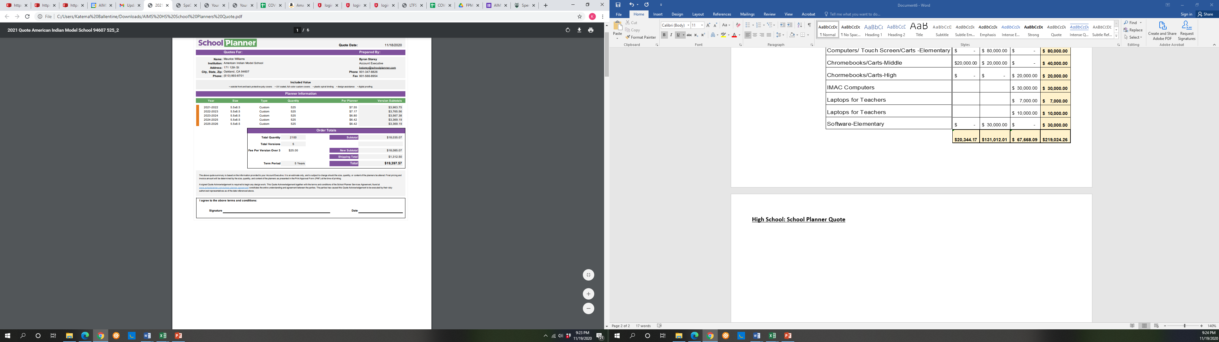

**DISTRICT WIDE: Inventory/Work Order Tracking System**

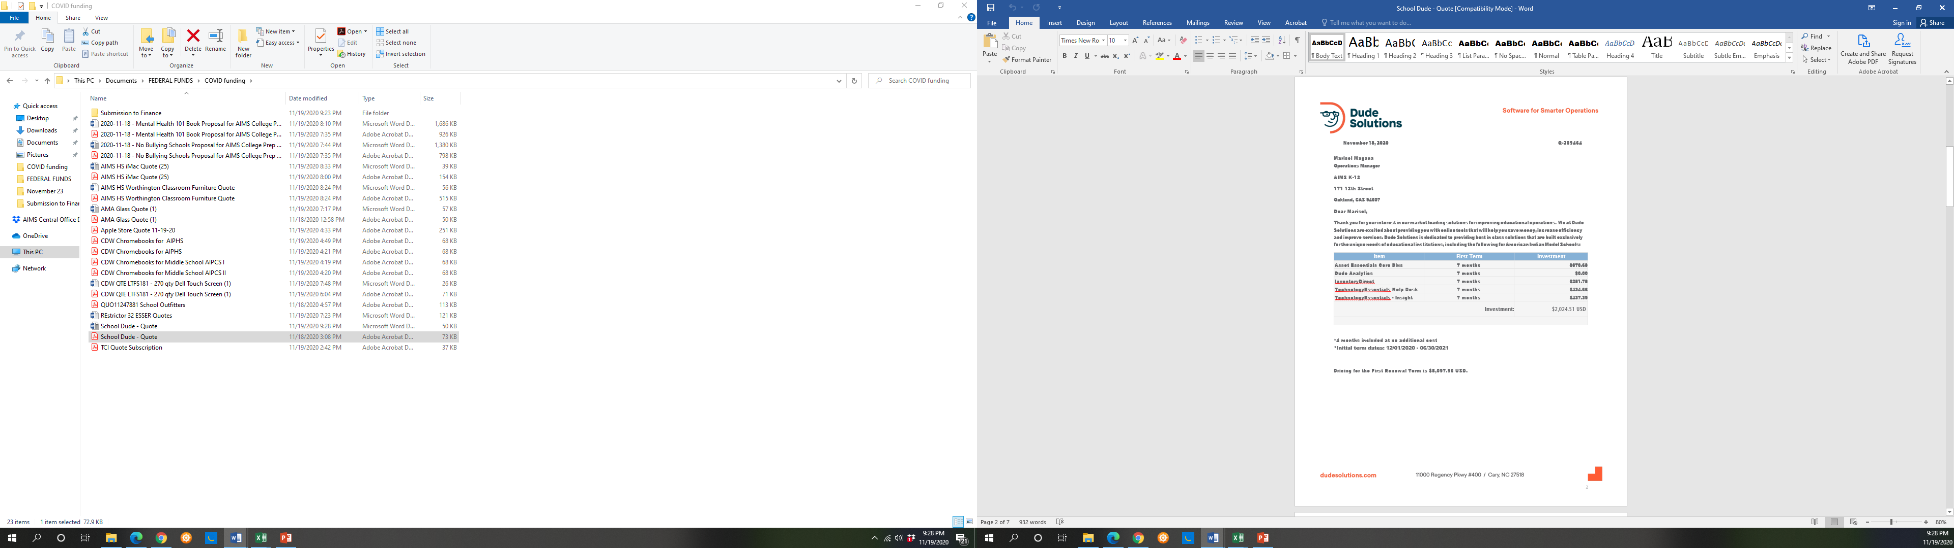

**AIPCS II Elementary: CDW Touch Screen Computers/Licenses**

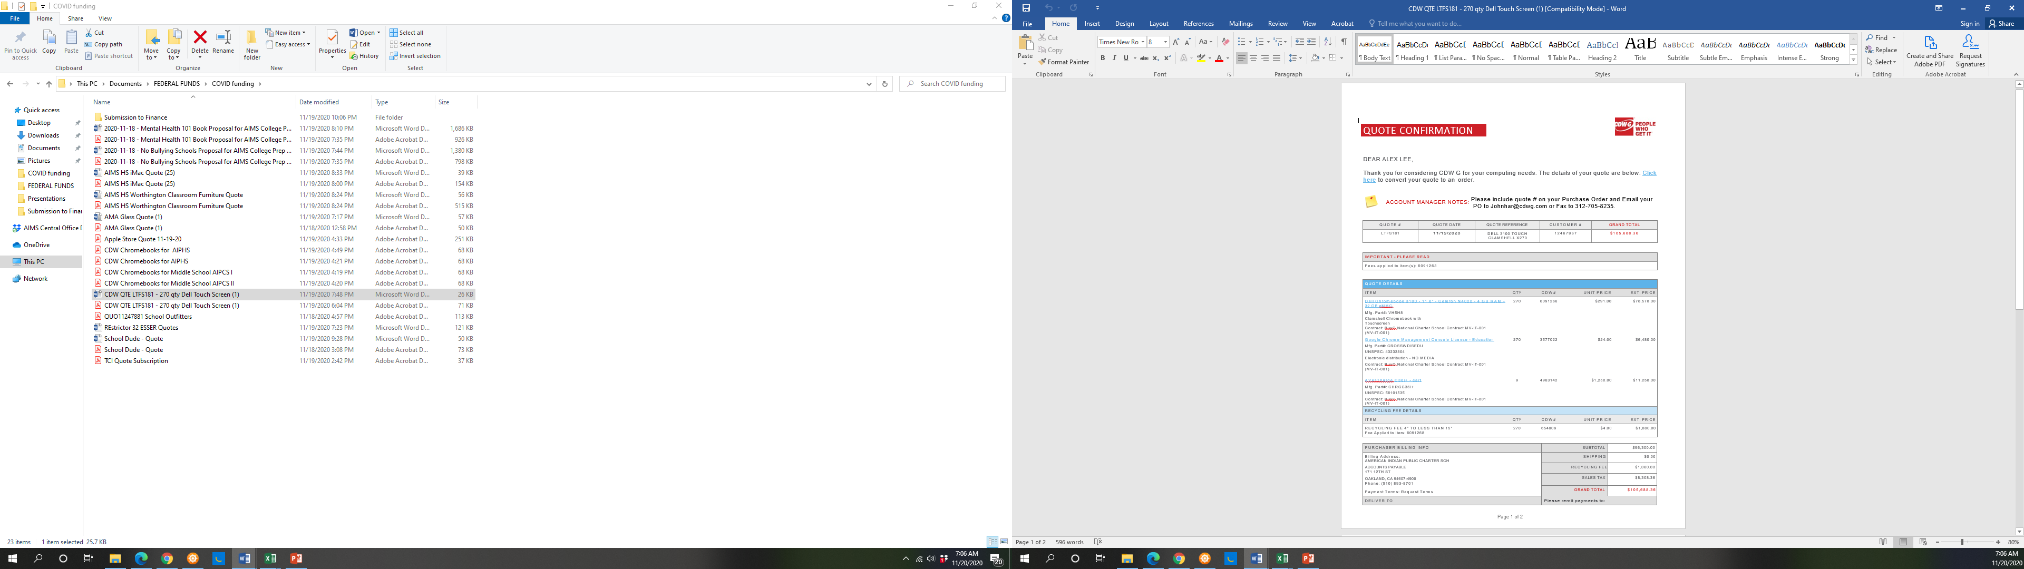

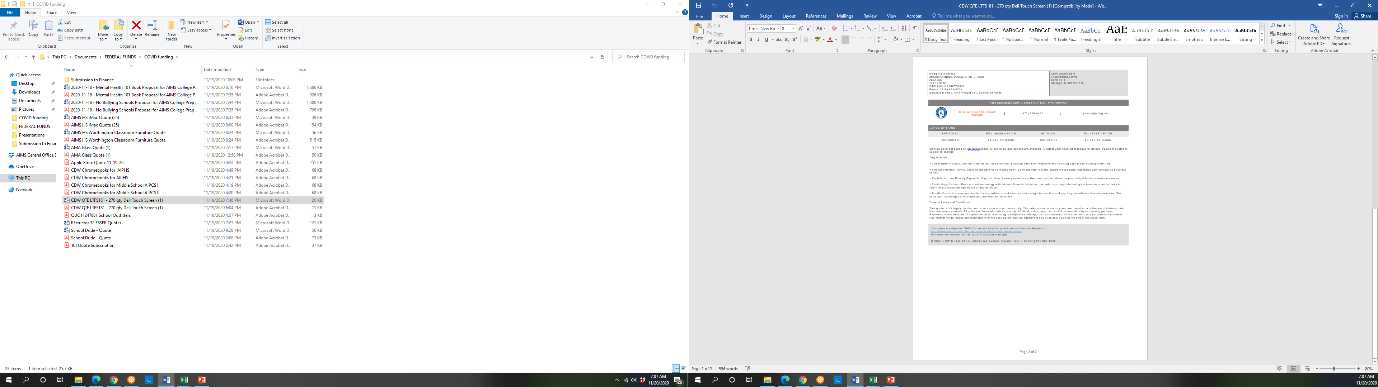

**AIPCS (6-8) : Chromebooks/Carts/Licenses**

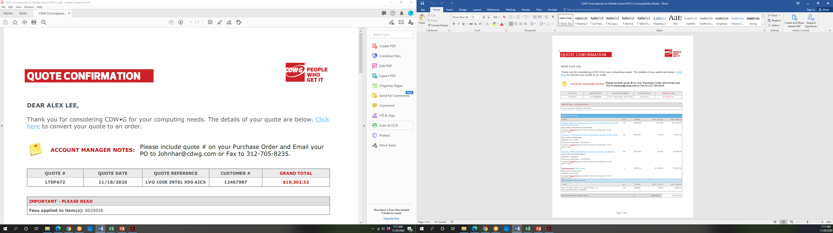

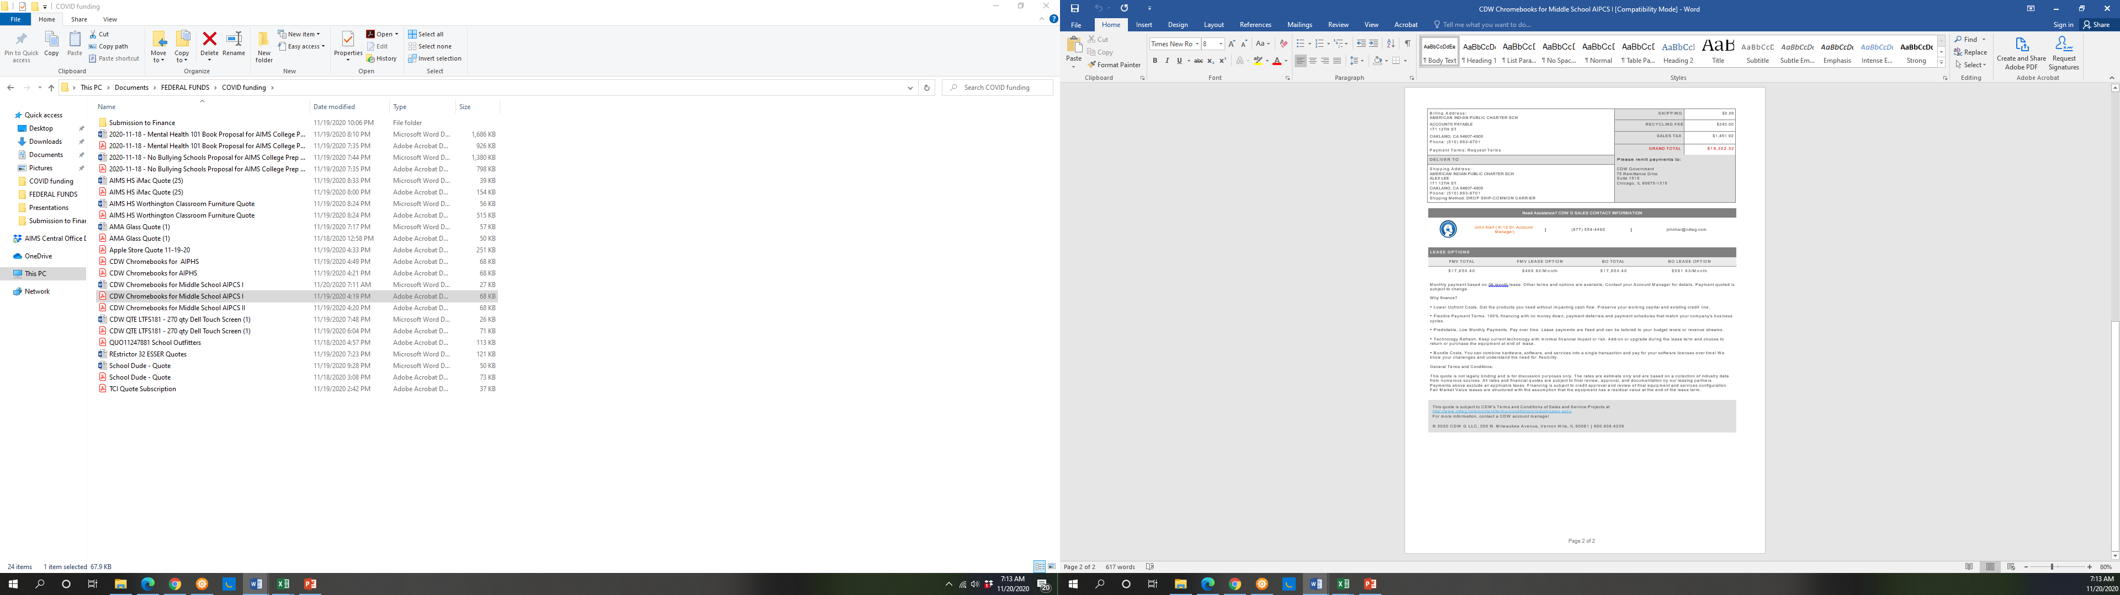

**AIPCS II (6-8) : Chromebooks/Carts/Licenses**





**AIPHS: Chromebooks/Carts/Licenses**

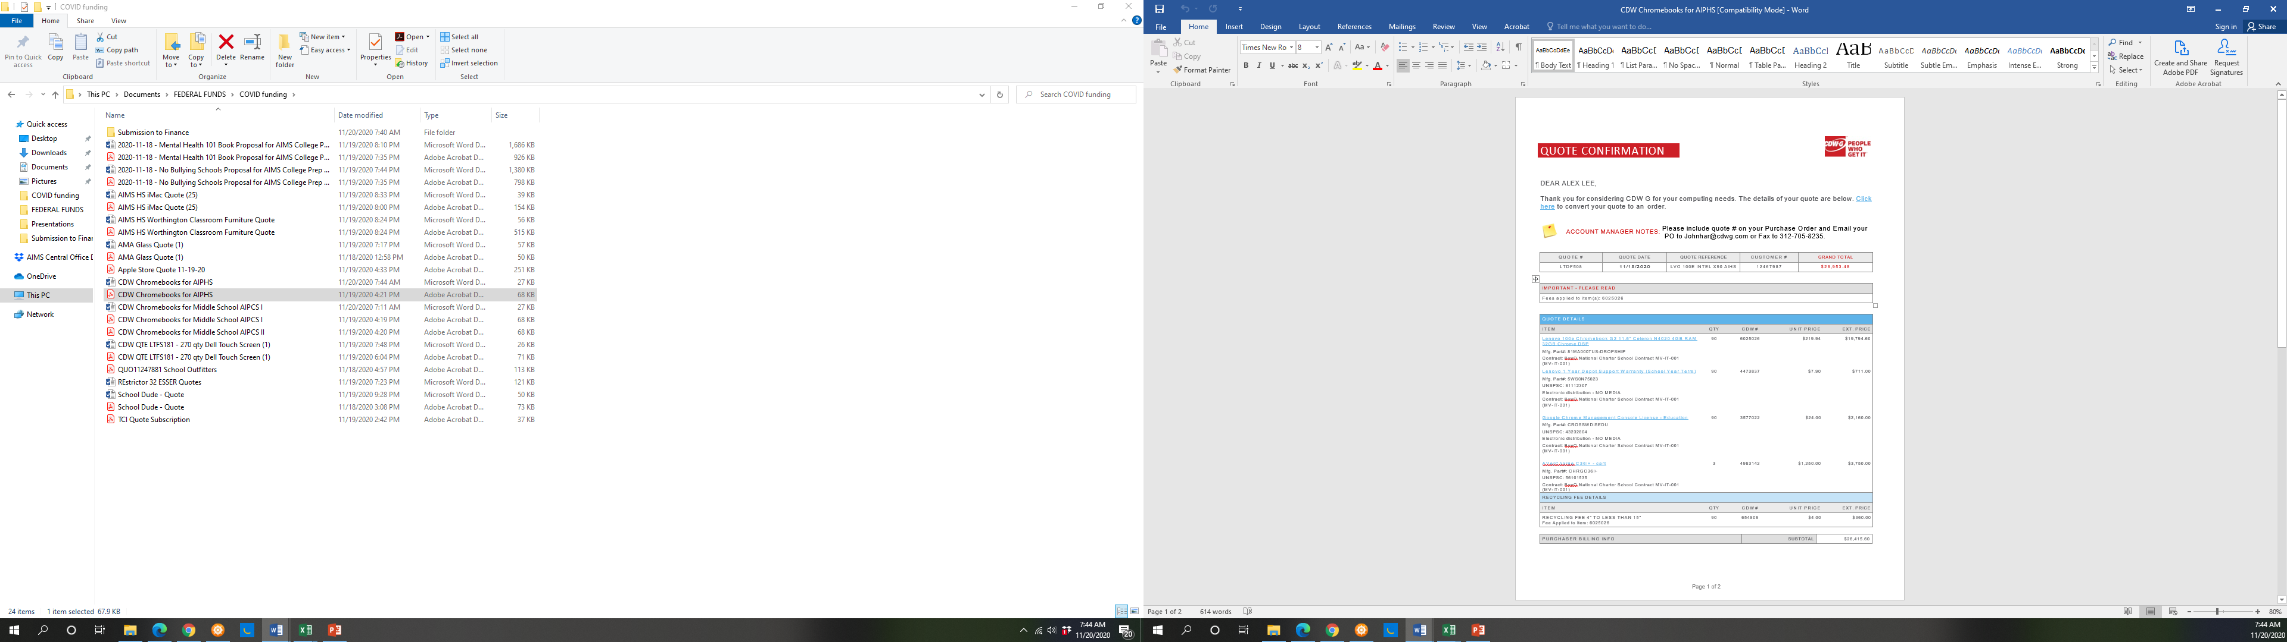

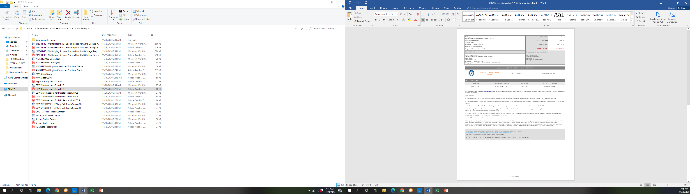

**HIGH SCHOOL: IMAC Computers**

RESTRICTOR 32: $14,000

RESTRICTOR 72: $30,000

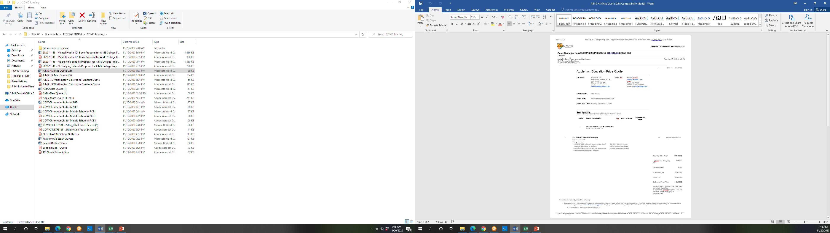

**HIGH SCHOOL: Laptops Quote 1**

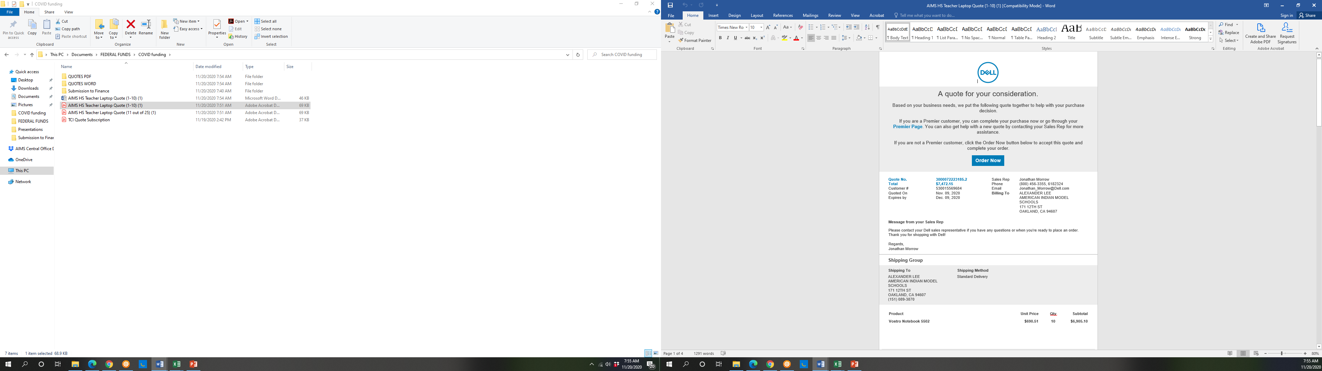

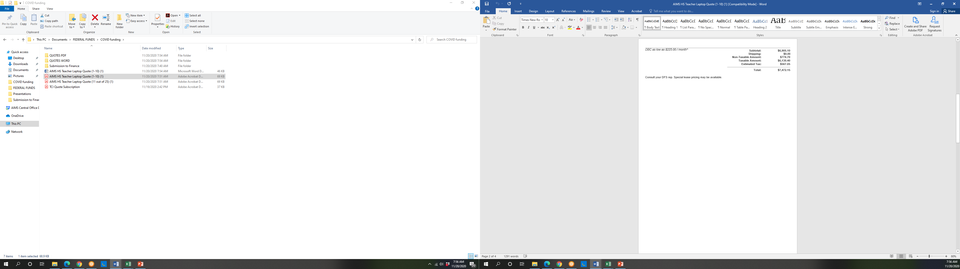

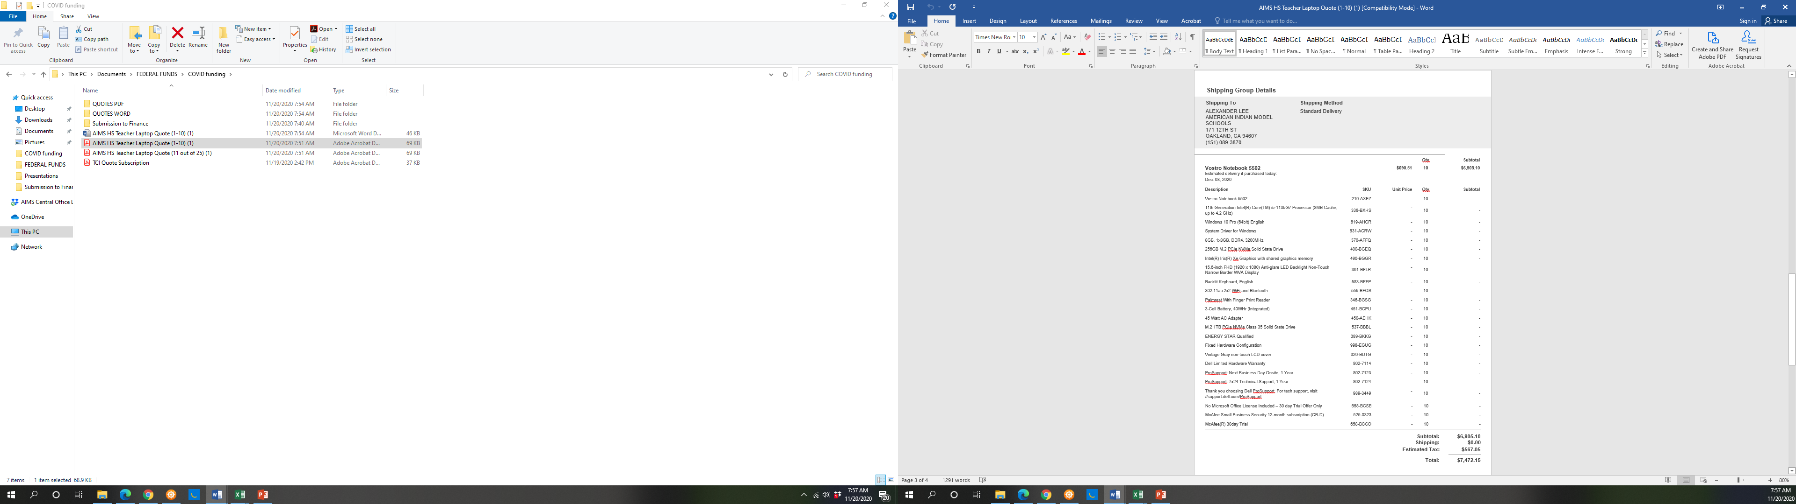

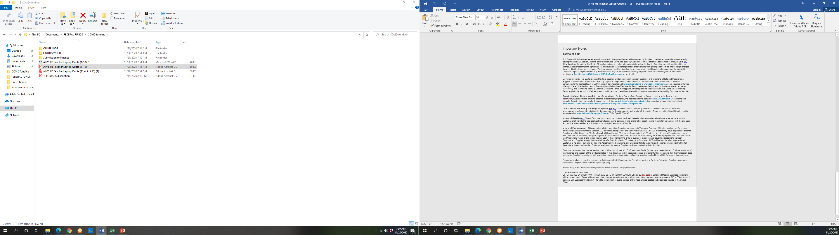

**HIGH SCHOOL: Laptops Quote 2**

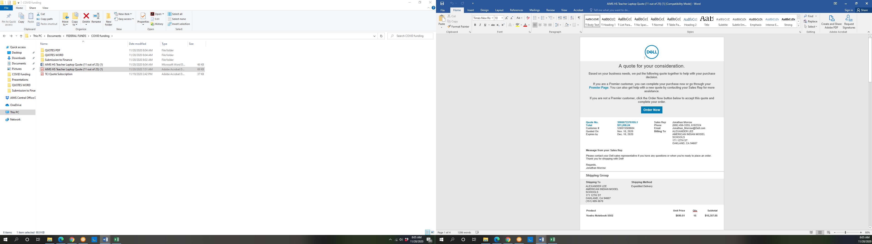

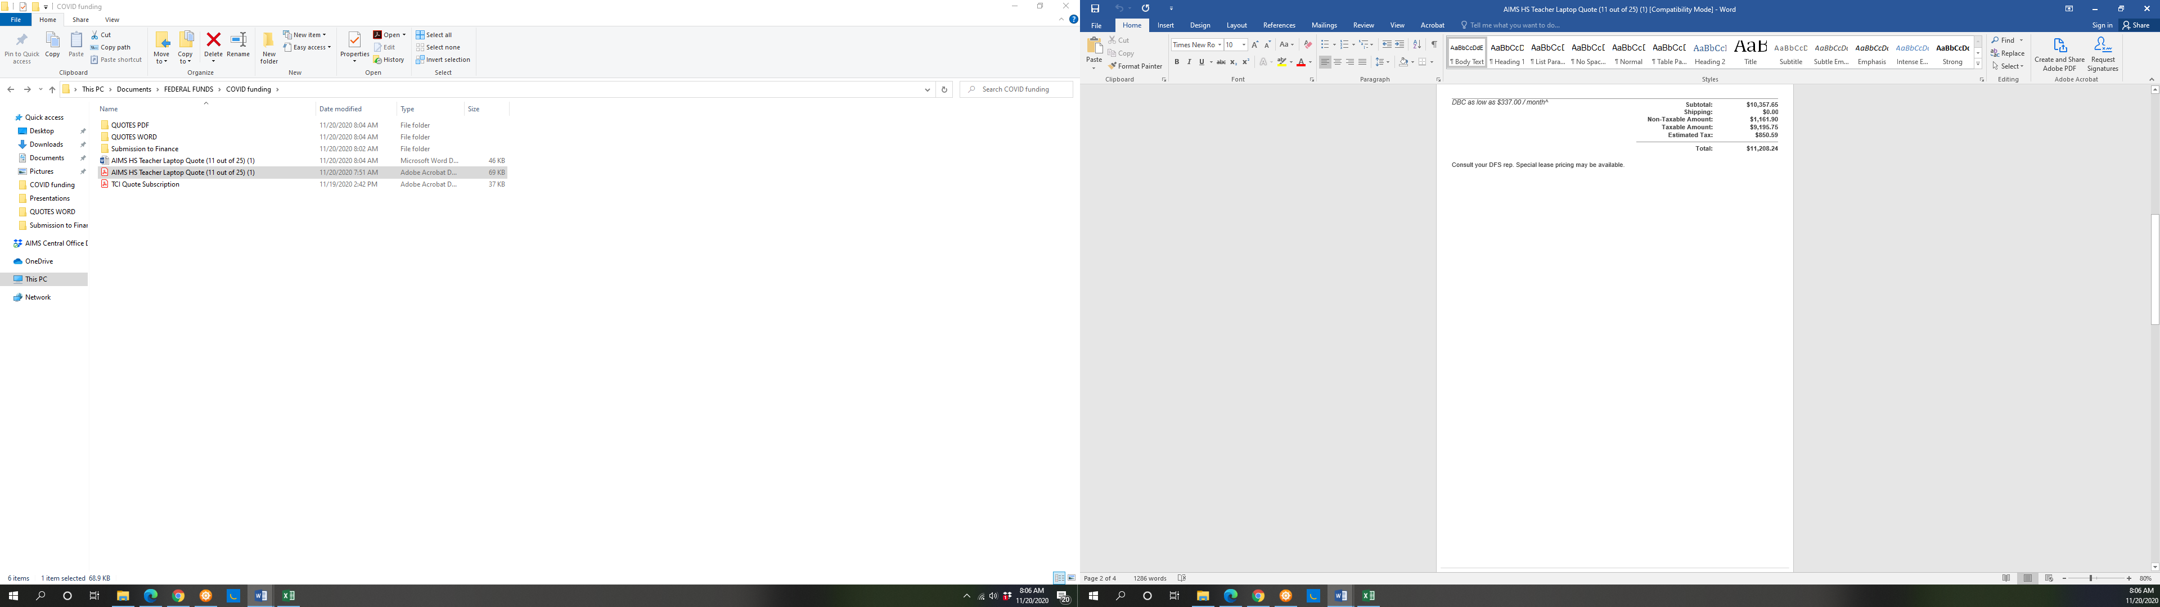

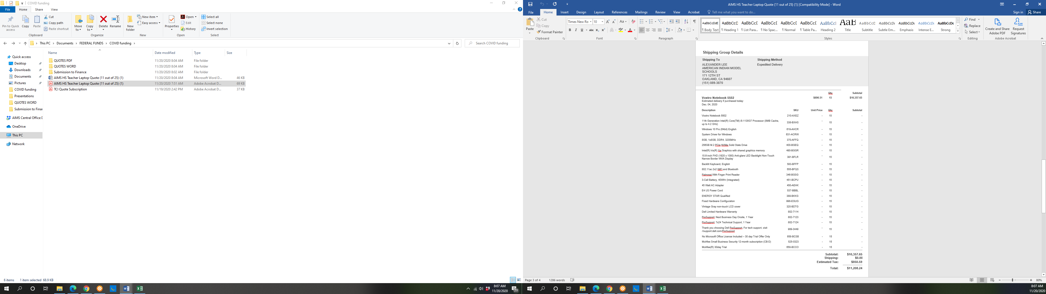

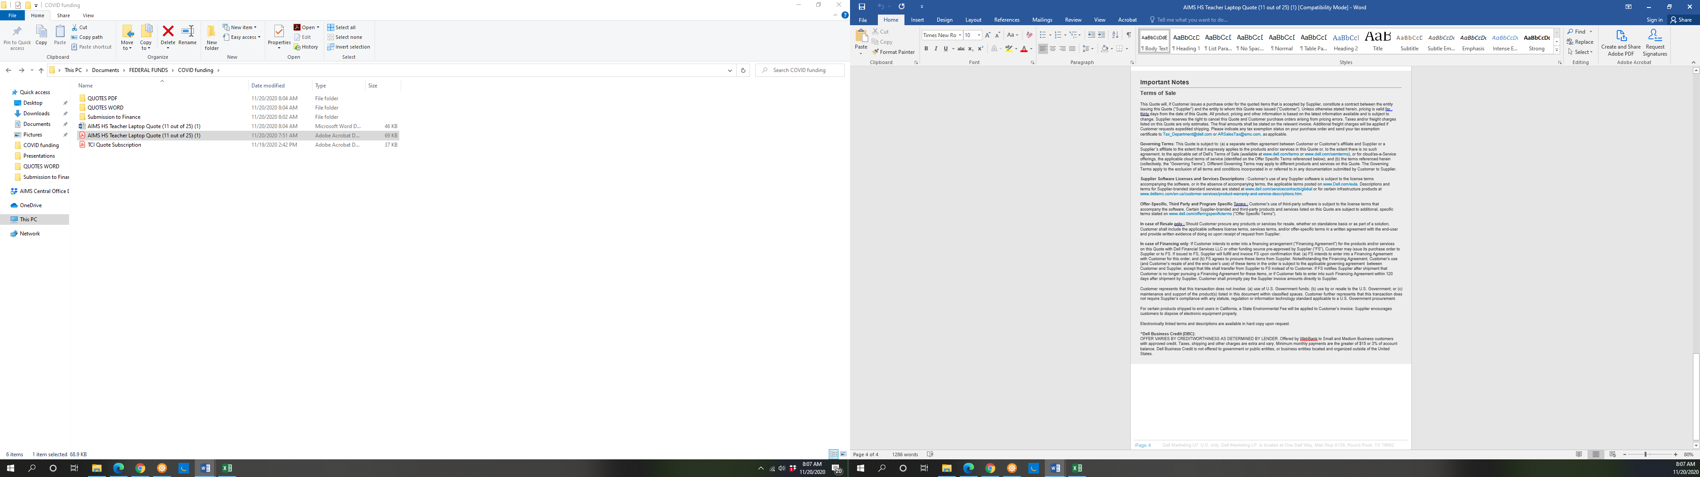

**AIPCS II ELEMENTARY: Software**

