|  |  |
| --- | --- |
|  | **AIMS K-12 College Prep Charter District**  **PPE (Personal protective equipment) Mask and Face Shields for All AIMS Students and Employee Proposal** |

**Number of Masks to Order**

|  |  |  |  |  |  |  |  |  |  |
| --- | --- | --- | --- | --- | --- | --- | --- | --- | --- |
| **Projected Enrollment and Hiring Numbers in School Year 2020-2021** | | | |  | **Number of Masks to Order by Age Group** | | | | |
| **Grade** | **AIPCS I** | **AIPCS II** | **AIPHS** |  | **Age Group** | **Head count** | **# of Masks**  **(6 masks /person)** | **# of Masks Added to Round-up** | **# of mask Round-Up** |
| **K** |  | 71 |  |  | **5-7** | 211 | 1266 | 34 | 1300 |
| **1** |  | 71 |  |  |
| **2** |  | 69 |  |  |
| **3** |  | 72 |  |  | **8-10** | 225 | 1350 | 50 | 1400 |
| **4** |  | 71 |  |  |
| **5** |  | 82 |  |  |
| **6** | 75 | 76 |  |  | **11-14** | 467 | 2814 | 36 | 2850 |
| **7** | 82 | 73 |  |  |
| **8** | 83 | 80 |  |  |
| **9** |  |  | 128 |  | **15-17** | 359 | 2154 | 46 | 2200 |
| **10** |  |  | 123 |  |
| **11** |  |  | 108 |  |
| **12** |  |  | 81 |  | **>18** | 231 | 1386 | 64 | 1450 |
| **Employee** | 130 | | |  |
| **Spare** | 20 | | |  |
|  | | | |  |  | | **Total # of Mask to Order** | | **9200** |

**Mask Vendors Comparison**

|  |  |  |  |  |
| --- | --- | --- | --- | --- |
| **Vendors** |  |  |  |  |
| [**Discount Mugs**](https://www.discountmugs.com/product/slmsrp12-polyblend-athletic-masks/) | [**ePromos**](https://www.epromos.com/product/10011642/full-color-4-ply-polyester-custom-face-mask.html) | [**Signs**](https://www.signs.com/face-masks/) | [**Boat House**](https://www.boathouse.com/products/solid-masks-for-sale?_pos=6&_sid=811d31820&_ss=r) |
| **Material** | PolyBlend | Polyester (outer layer x1) and Cotton (inner layer x3) | Polyester Fabric | Polyester |
| **# of layers** | Unknown | 4-Ply | 2-Ply | 2-Ply |
| **Style** | Earloop | Adjustable Earloop | Fabric Straps | Earloop |
| **Sizes** | 1 Adult Size | 1 size, will fit K-12, and adults with an adjustable earloop | Adult & Youth | Will offer sizes for K-12, and adults |
| **Washable/  Reuseable** | Yes | Yes | Yes | Yes |
| **Customizable** | Front side limited area and colors | Front side full custom | Front side full custom | Front and back full custom |
| **Manufactured in** | Unknown | China | Unknown | PA, USA |
| **Price / Piece** | $6.50 | $6.25 | $11.50 | $5.82 |
| **Estimated Cost for 9,2000 pcs (shipping included)** | $65,000.00 | **$57,500.00** | $115,000.00 | **$53,623.80** |
|  |  |  |  |  |
| **Update** | -No samples  -1 size only  **- will not proceed** | - quotation attached  - Samples received  - [video](https://www.youtube.com/watch?v=4Y0N0TPYi3g) | -No samples  -Will not meet our preferred delivery date: July 15th  - can only produce 500 masks/day  **- will not proceed** | -Able to develop new sizes for us  -Samples received  -waiting for quotation |

**References:**

**ePromos**

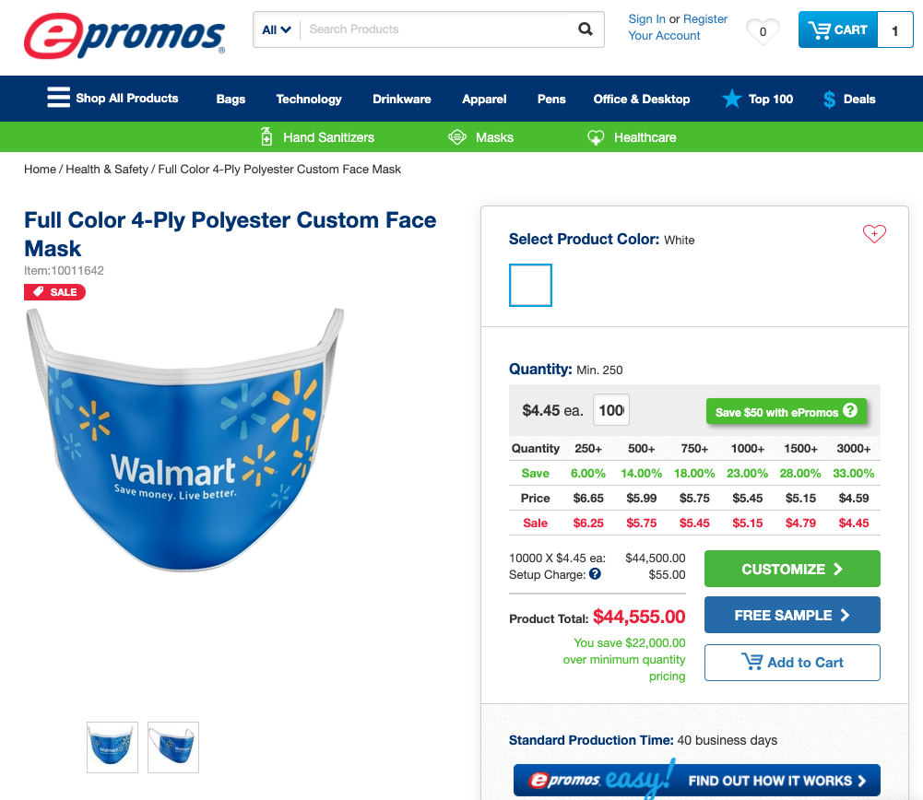

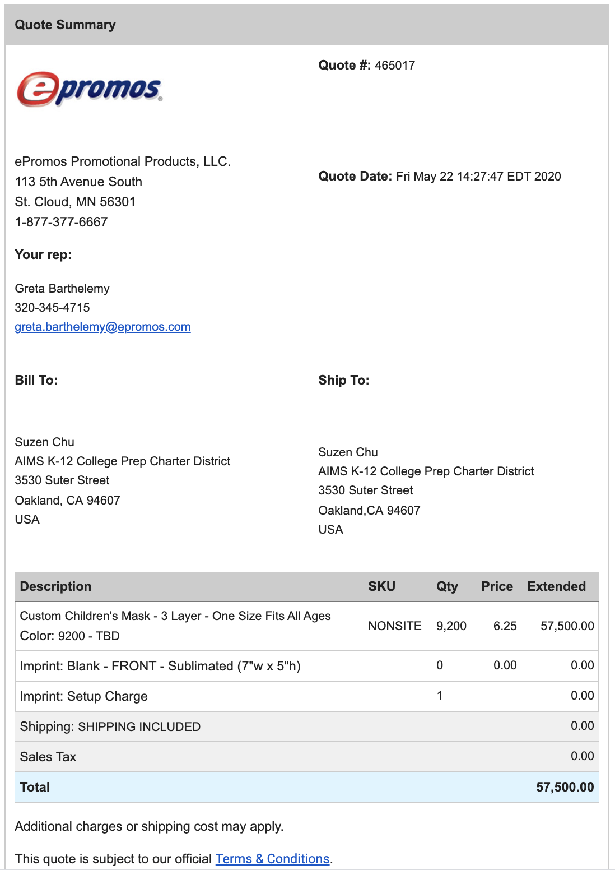

[**VIDEO**](https://www.youtube.com/watch?v=4Y0N0TPYi3g)

[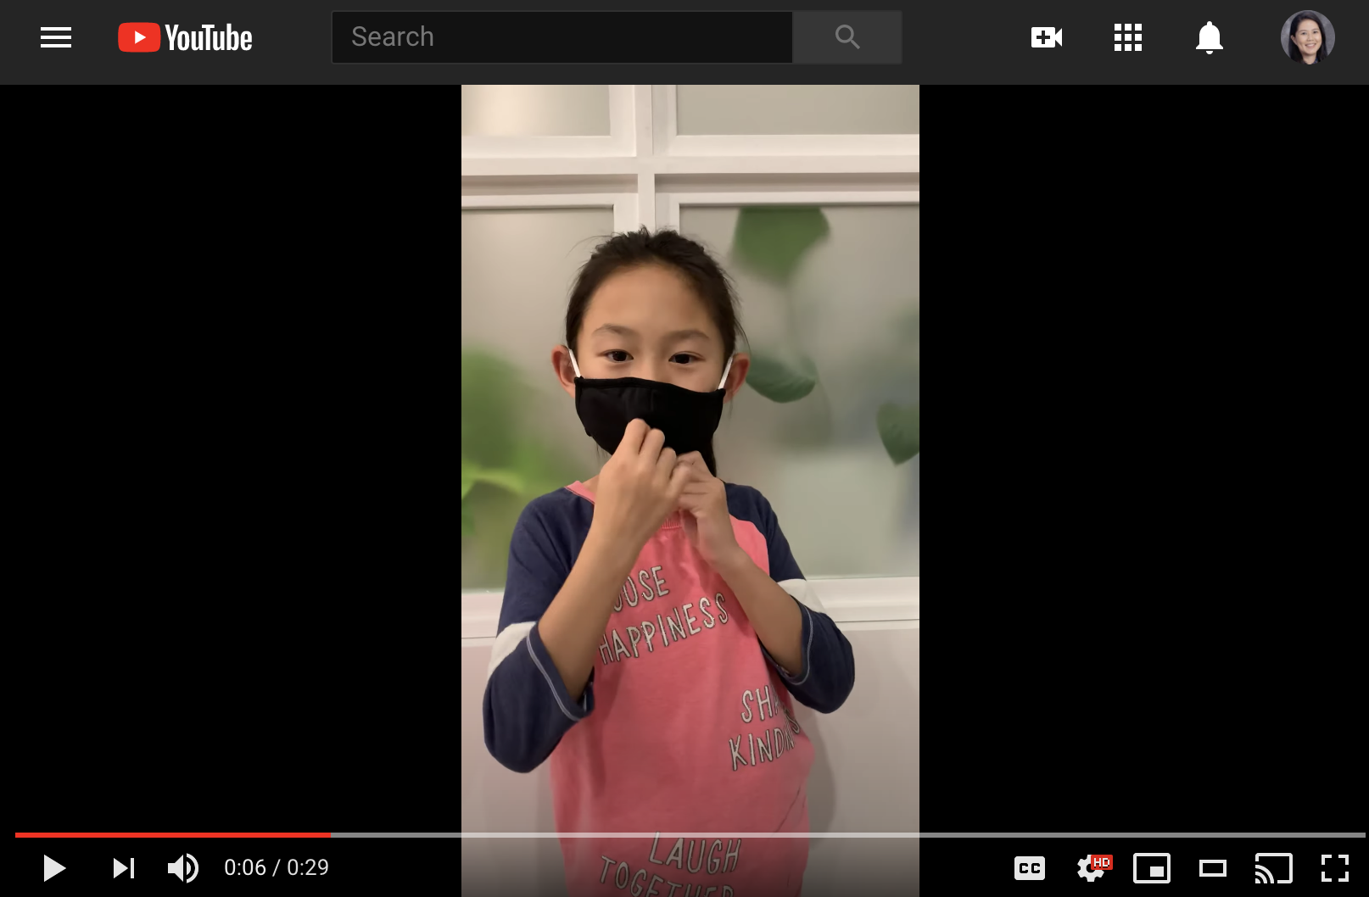](https://www.youtube.com/watch?v=4Y0N0TPYi3g)

**Photos from Vendor**

|  |  |
| --- | --- |
|  |  |
|  |  |

**Photos from actual samples**

|  |  |
| --- | --- |
|  |  |
|  |  |
|  |  |
|  |  |

**Boat House**

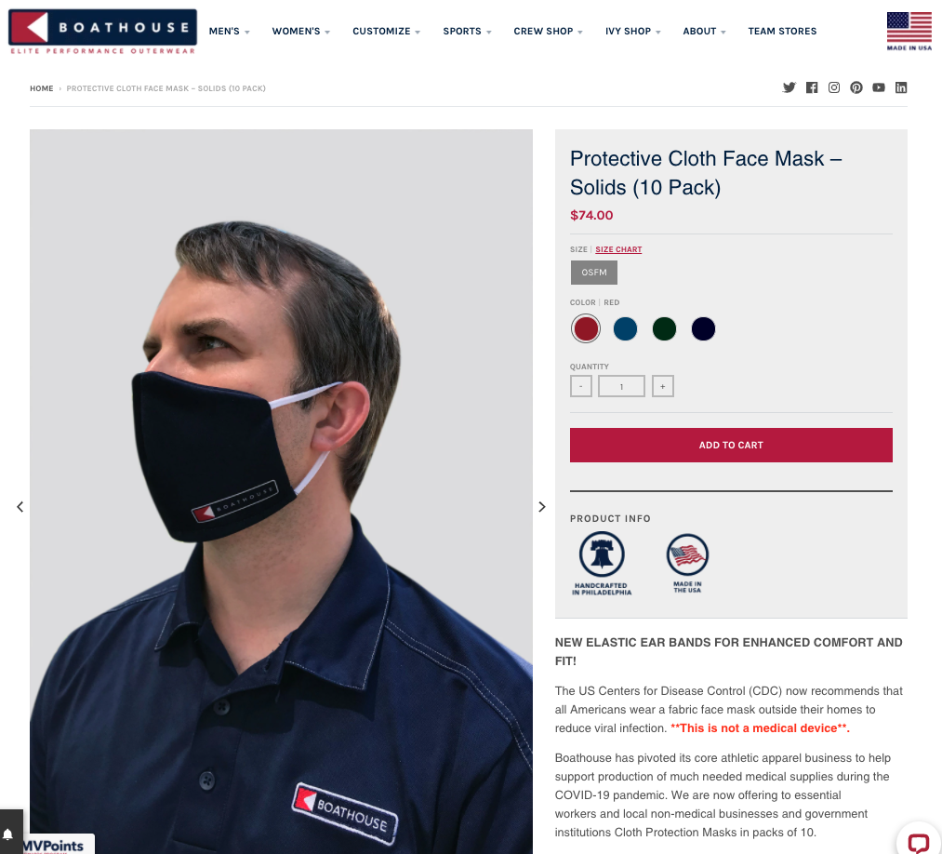

**Photos from actual samples**

|  |  |
| --- | --- |
|  |  |
| Adult and youth size | |
|  |  |

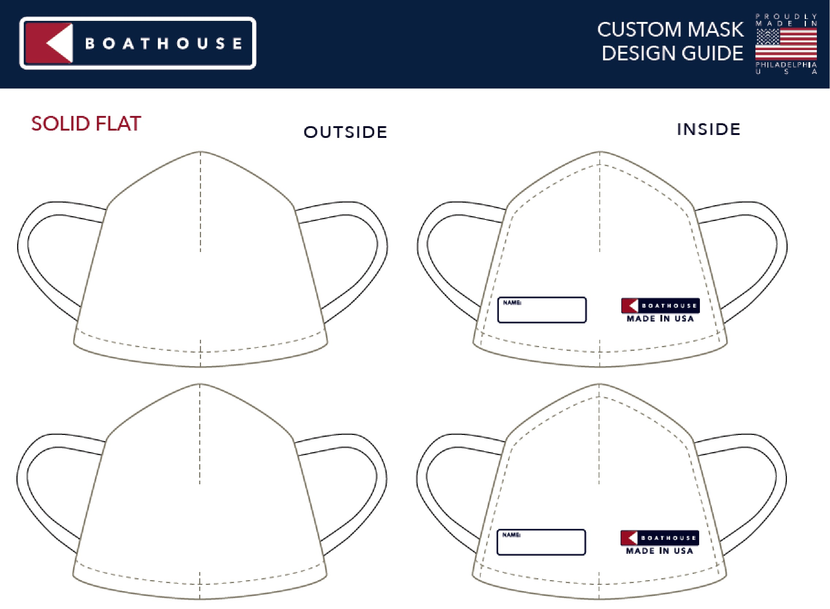

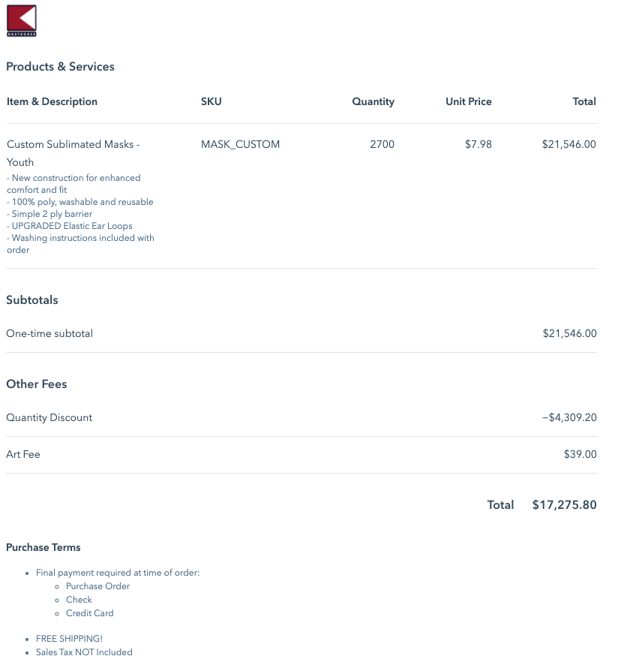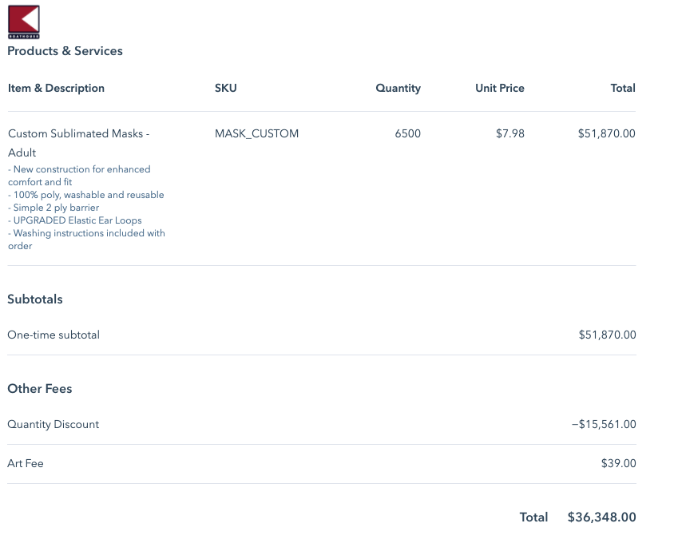

**Number of Face Shields to Order**

|  |  |  |  |  |  |  |  |  |  |
| --- | --- | --- | --- | --- | --- | --- | --- | --- | --- |
| **Projected Enrollment and Hiring Numbers in School Year 2020-2021** | | | |  | **Number of Masks to Order by Age Group** | | | | |
| **Grade** | **AIPCS I** | **AIPCS II** | **AIPHS** |  | **Age Group** | **Head count** | **# of Shields**  **(5 shields /person)** | **# of Masks Added to Round-up** | **# of mask Round-Up** |
| **K** |  | 71 |  |  | **5-10** | 436 | 2180 | 320 | 2500 |
| **1** |  | 71 |  |  |
| **2** |  | 69 |  |  |
| **3** |  | 72 |  |  |
| **4** |  | 71 |  |  |
| **5** |  | 82 |  |  |
| **6** | 75 | 76 |  |  | **11-17** | 828 | 4140 | 160 | 4300 |
| **7** | 82 | 73 |  |  |
| **8** | 83 | 80 |  |  |
| **9** |  |  | 128 |  |
| **10** |  |  | 123 |  |
| **11** |  |  | 108 |  |
| **12** |  |  | 81 |  | **>18** | 231 | 1155 | 45 | 1200 |
| **Employee** | 130 | | |  |
| **Spare** | 20 | | |  |
|  | | | |  |  | | **Total # of Mask to Order** | | **8000** |

**Face Shield Vendors Comparison**

|  |  |  |  |  |
| --- | --- | --- | --- | --- |
| **Vendors** |  |  |  |  |
| [**Disc Makers**](https://www.discmakers.com/faceshields/) | [**Boat House**](https://www.boathouse.com/collections/ppe-custom-protection-masks/products/safety-face-shield-headband-with-3-shields) |  |  |
| **Sold as Single-Use** | Yes | No |  |  |
| **Reuseable** | Yes | Yes |  |  |
| **Can be disinfect** | Yes  by bleach, ammonia or peroxide | Yes |  |  |
| **Features** | Single piece | Headband and shield are detachable and interchangeable |  |  |
| **Manufactured in** | NJ, USA | PA, USA |  |  |
| **Ordering** | 8064 face shields (~5/person) | 1540 headbands  (2/person)  7700 shields  (5/person) |  |  |
| **Estimated Cost** | $24,1920.00 | $39,349.24 |  |  |
| **Update** | In stock, ready to ship | Ready to ship |  |  |

**Reference:** 