Portable Hand Washing
Product | Company (Bids) | Cost Ea. | Total (# of)
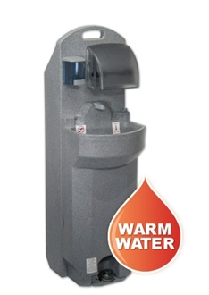  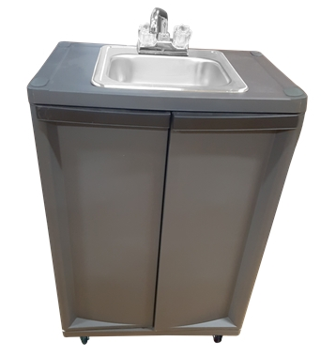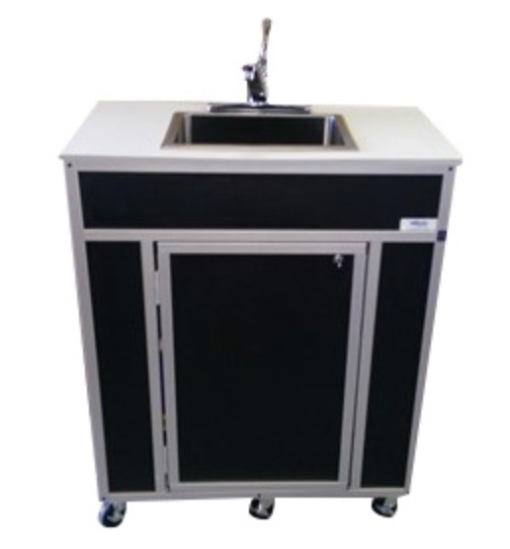 | Portable Handwashing | Low - $998.00  Medium - $1126.67  High - $1938.93 | 58
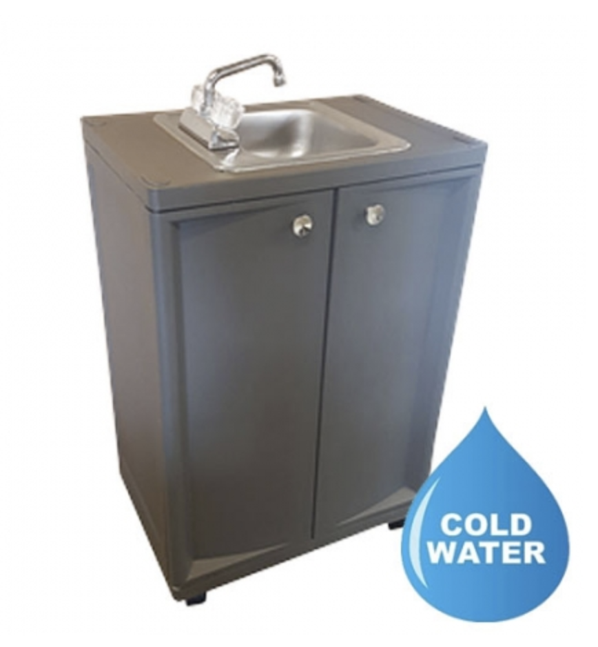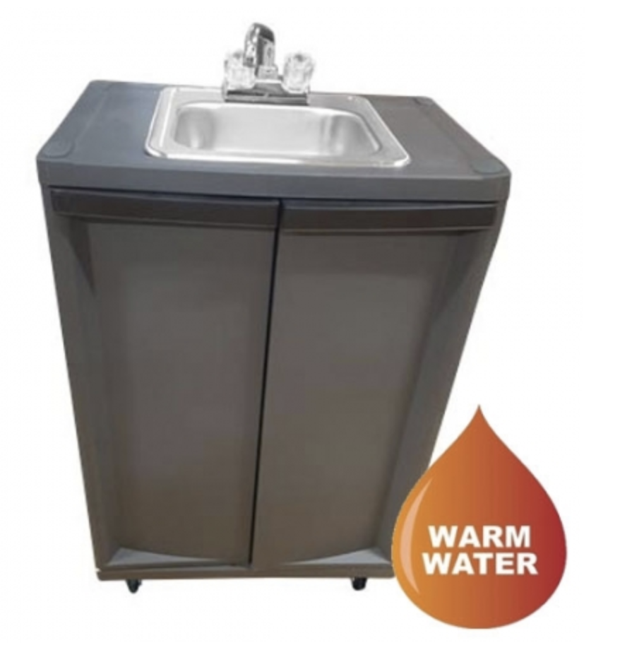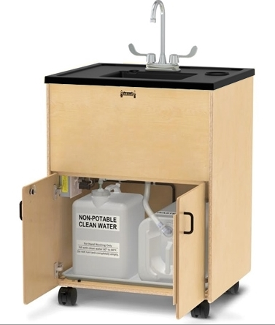 | Sustainable Supply | Low - $833.33  Medium - $1126.67  High - $1,455.63 | 58
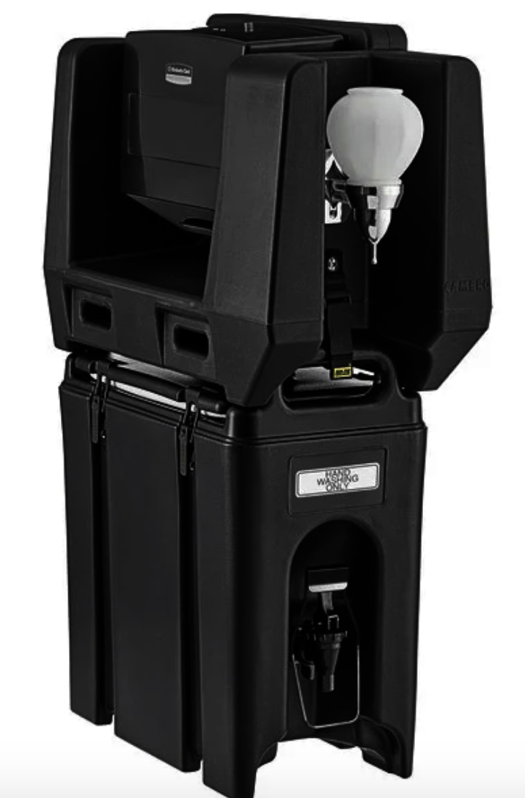  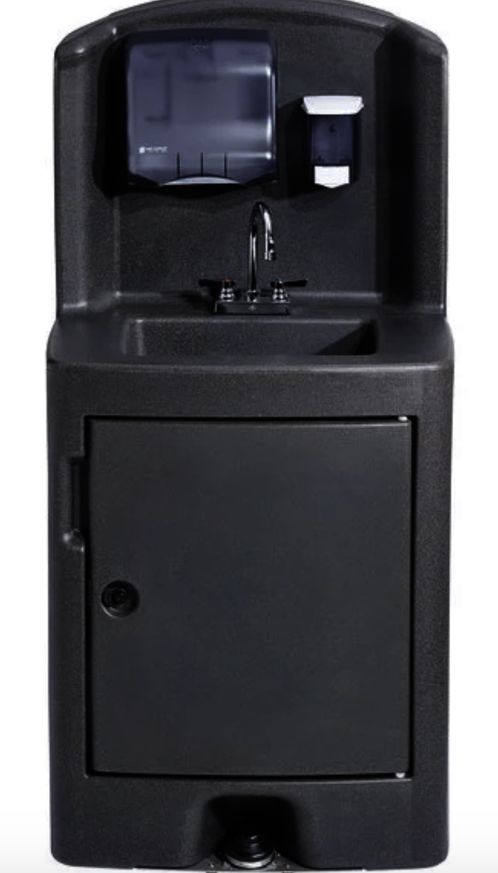  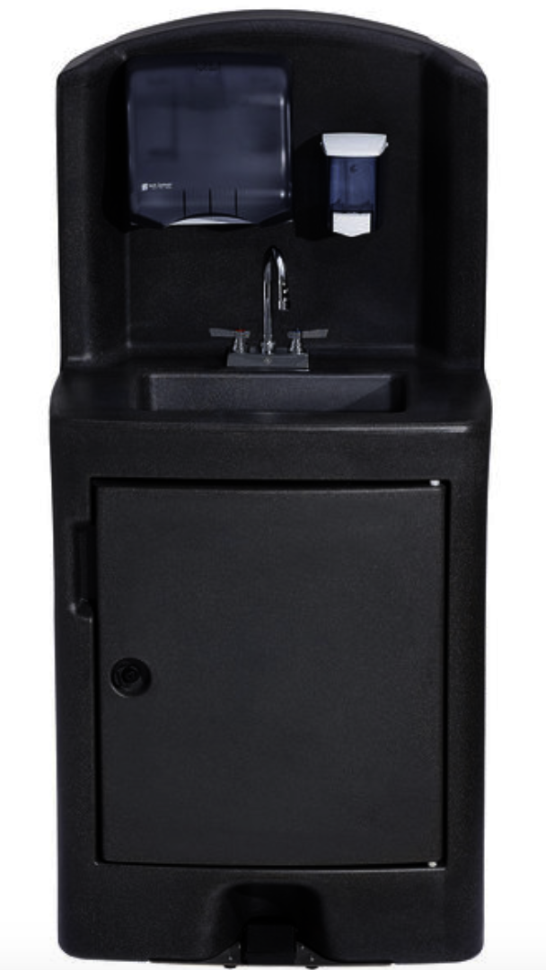 | Webstaurant | Low - $302.49  Medium - $1238  High - $1992.00 | 58

Thermometer Kiosk
Product | Company ( 3 Bids) | Cost Ea. | Total
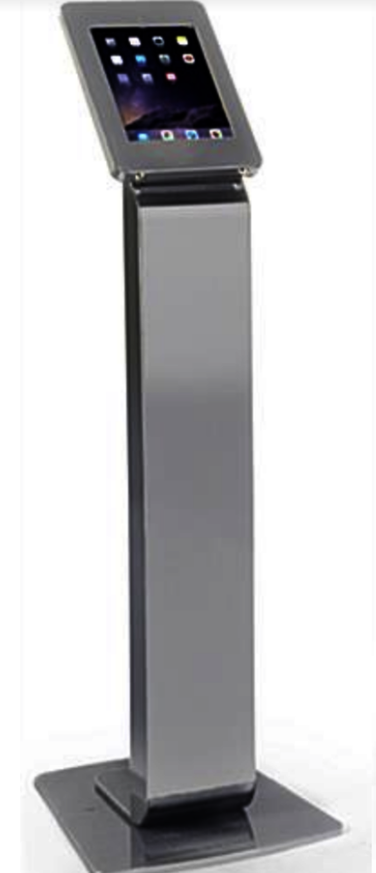 | 22Miles | Low: $900 hardware would need to purchase own tablet (Windows)  Median: $2500 unit  High: $2600 annual: $480 per unit | 20
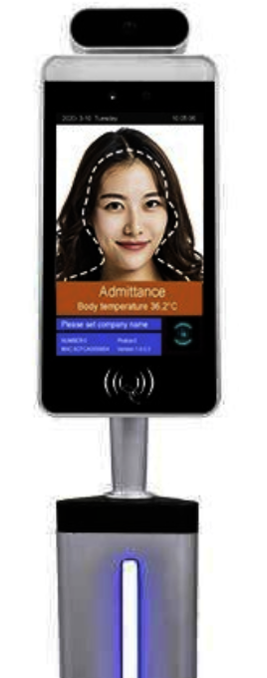 | Lamasa Tech | Low: $2340 Wall Mount  Medium: $2460 Desktop  High: Floor stand $2720 | 20
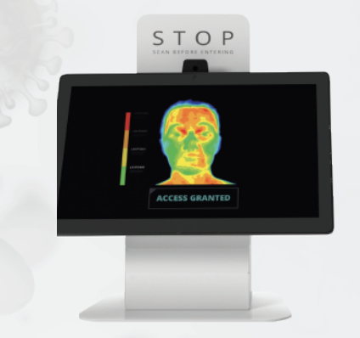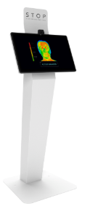 | Olea Kiosk Inc. | $2758  $2798 | 20

Disinfecting Machines

Product | Company ( 3 Bids) | Cost Ea. | Total
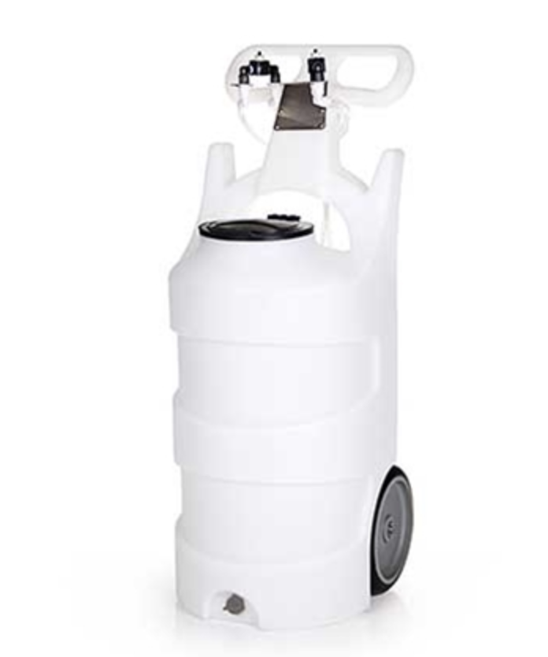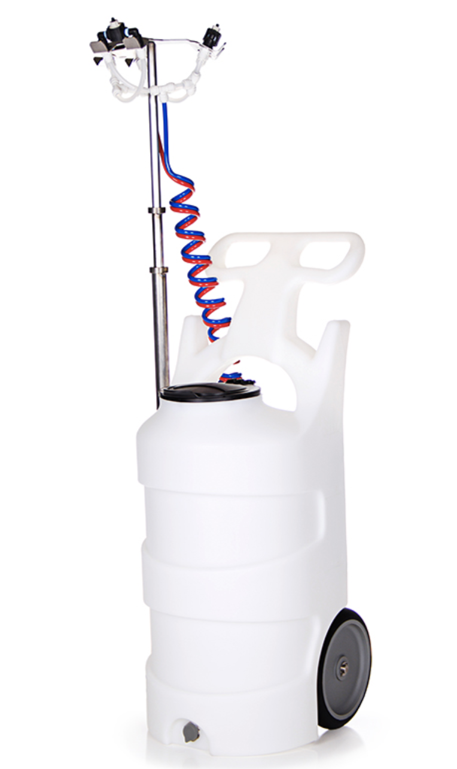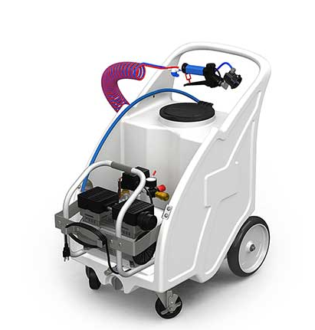 | Wash IQ | Low  $1408.60  Medium  $2101.17  High  $2,590.00 | 10  $25,900
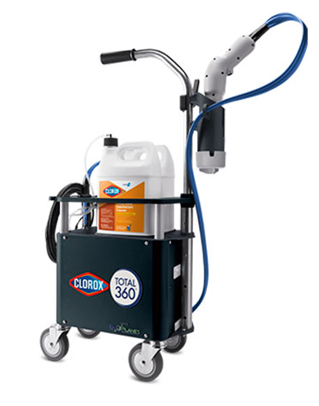 | Clorox 360 | $3999 | 10  $39,999
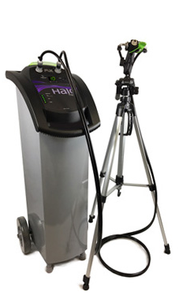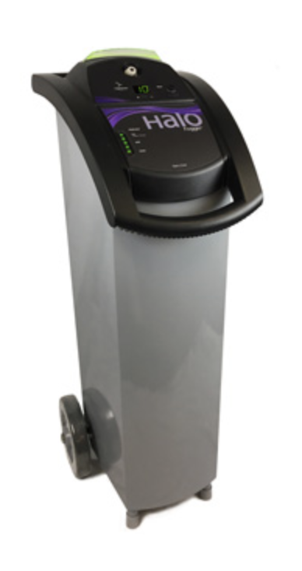 | Halosil International | $10,000  $13,250 | 10  $100,000-$132,500

Hand Sanitizer

Product | Company ( 3 Bids) | Cost Ea. | Total
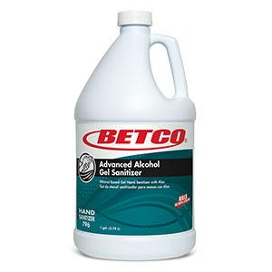 | Central Sanitary Supply | $28.13 per gallon | 275  $7735.75
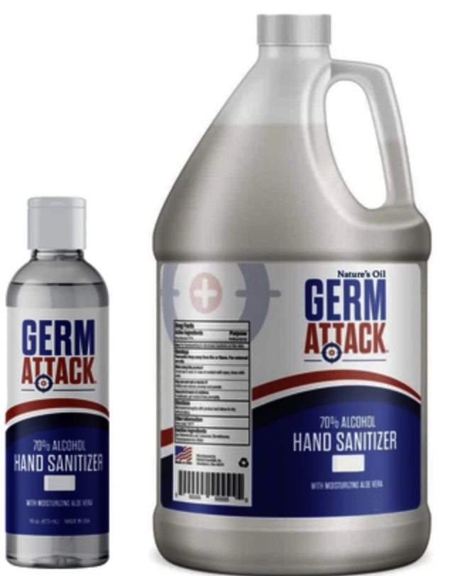 | Bulk Apothecary | $39.95 1 gallon | 275  $9,685.83
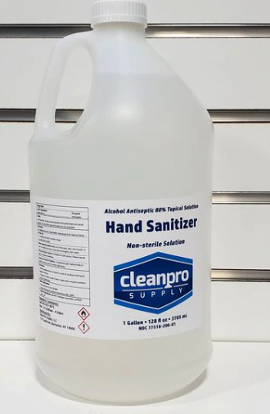 | Clean Pro Supply | $45.00 | 275  $12375

