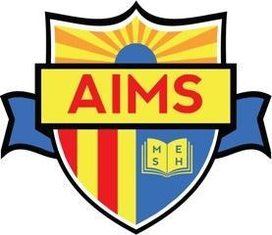 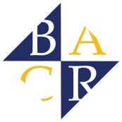

**AMENDMENT OF SECTION IV.**

**AGREEMENT FOR AFTER SCHOOL PROGRAM SERVICES & FUNDING**

**This Agreement for After School Program Services & Funding (“Agreement”) establishes the material terms of the business relationship between Bay Area Community Resources ("BACR") and American Indian Model Schools (“AIMS” or “School”) for American Indian Public Charter and American Indian Public Charter School II for the provision of certain educational services (as further detailed below) at the AIMS school site during the 2019-20 school year. BACR and AIMS are each referred to individually as a “Party,” and collectively as the “Parties.” This Agreement is effective upon execution by representatives of each Party (“Effective Date”).**

**IV. PROGRAM BUDGET AND MANAGEMENT FEE**

**The budget for the Program at AIMS for the 2019-20 year is $354,764 After School Education & Safety Program (ASES). AIMS will contribute School Day funds of $40,000.**

School staff and BACR staff will meet no later than the third Friday of each month in order to review various Program-related matters, including enrollment numbers and Program Fee collections.

At this monthly meeting, BACR will provide AIMS a written report of Program Fees it has collected from the parents of Program participants for the prior month, as well as any overdue Program Fees and late fees for that same month (“Program Fees Report”). In the event that Program Fee collections are below $84,250, AIMS will fund any shortfall, regardless of amount.  In addition, AIMS will fund any related late fees not already paid, as described above in Section (II)(C)(6).  BACR will invoice AIMS for the shortfall, if any, and payment by the School will be made within thirty (30) days of issuance of BACR's invoice.

For the sake of clarity, the Parties expressly agree that the School (not BACR), shall solely fund any shortfall in collections of Program Fees, whether such shortfall is caused by lower than expected enrollment, non-payment by Program participants, or any other reason.  But for this express agreement and commitment by AIMS, BACR would not enter into this Agreement on these terms.

In the event BACR receives payment of any Program Fees after the School has covered the same, e.g., in the event of an exceptionally late payment by Program participant to BACR, then BACR shall report the same to the School as part of the monthly meeting and that amount shall be used to offset any future payment of the Management Fee, so that BACR does not receive double payment at any time.

If enrollment trends over two (2) or more consecutive months indicate more than a 10% change in Program enrollment as compared to the current expected level of 140 participants, then the Parties will meet and confer on proposed changes to Program-related terms, including staffing, student groupings, and the Management Fee on a go-forward basis (i.e., non-retroactive) following execution of any addendum. The Parties will document the results of any such discussions and memorialize any related changes in an addendum to this Agreement.

Effective as of the Date noted above upon signature of both parties.

|  |  |
| --- | --- |
| AMERICAN INDIAN MODEL SCHOOLS  By:______________________________  Its:______________________________  Printed Name:_____________________ | BAY AREA COMMUNITY RESOURCES, INC.  By:______________________________  Its:______________________________  Printed Name:_____________________ |