American Indian Model Schools

Payroll Information

Average Payroll

Bi-Weekly Payroll: $441,165

Monthly Payroll: $882,329

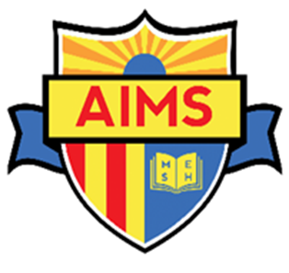

126 AIMS EMPLOYEES

103 Salaried Employees

11 Hourly Employees

12 Student Workers