
The Exploris School

Strategic
Planning
Proposal

Prepared for:
Ellie Schollmeyer
Executive Director, The Exploris School
09 / 28 / 2018

PREPARED BY
Albert P. DuPont, Ed.D.
APD Consulting Group, LLC



Executive Summary
We are pleased to present The Exploris School with a proposal to review the school’s current strategic plan with all stakeholders including board members, administration, teachers, staff, parents, and students. We will bring 30 years of K-12 experience in education and strategic planning to your team. We will lead your community through an in depth study of your strategic plan. As a result of this process, your company will experience increased productivity and results.
OBJECTIVES
As a result of our time together, participants will provide feedback to the current strategic plan through a collaborative process. During the process, our team will provide a gap analysis and reports based on data collected through the process.
By March 31, 2019, we will provide a final copy of a revised strategic plan for publication.
KEY DATES
The schedule will include the following information gathering methods to collect information and provide ongoing feedback:
- Information Gathering Sessions
  - Board of Directors (~1.5 hours) by November 15, 2018
  - Executive Director and other key administrative staff (~1.5 hours) by November 15, 2018
  - Elementary and Middle Schools Staff (~1.5 hours) by December 1, 2018
- Survey Windows for Parents and Students
  - Parents from January 7-25, 2019
  - Students from January 7-25, 2019
- Feedback Sessions
  - Executive Director monthly updates via email or phone
  - Board of Directors by February 15, 2019
- Final Presentation
  - Final presentation to executive director and board of directors by March 31, 2019
PHASES OF DEVELOPMENT
The project will be divided into five phases. The phases are detailed below including a timeline when each phase will be completed.
Phase 1: Background Data
- Review all relevant information (e.g., board minutes, financial statements, annual reports, etc.) that can show documented improvements for each goal identified in the strategic plan
- Summarize key findings from a review of the information above
Phase 2: Data Gathering
- Schedule information gathering sessions with board members and staff
- Meet with board of directors and staff to obtain their feedback on the current strategic plan
- Develop parent and student surveys
- Administer parent and student surveys
Phase 3: Data analysis
- Analyze data collected from all stakeholders
- Discuss the analysis with the executive director and begin process to define priorities
Phase 4: Draft report
- Draft strategic plan goals based on feedback
- Establish a communication approach to share what you learned with stakeholders and continue to solicit input
- Discuss with the executive director the results of your findings
Phase 5: Finalize Report
- Provide final report of final strategic plan to the executive director
- Present final report to the board of directors
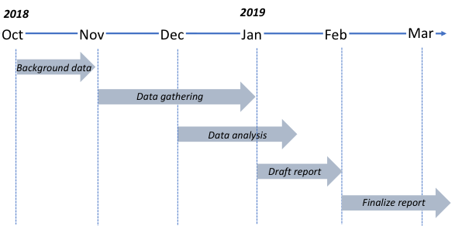

Agreement
This agreement is between APD Consulting Group, LLC, and The Exploris School

The Exploris School wishes to retain the services of APD Consulting Group, LLC to deliver consultative services for strategic planning.

APD Consulting Group, LLC agrees to present the information and material contained in the details described above. APD Consulting Group, LLC also agrees to coordinate the details of this program with Ellie Schollmeyer, executive director, in order to achieve the outcomes that APD Consulting Group, LLC has stated.

The Exploris School agrees to provide the room setup in a manner conducive for small group discussions.
In exchange for the services provided, The Exploris School agrees to compensate APD Consulting Group, LLC as follows:

Professional Fee: $7,500
Deposit: October 2018 - $1000
Balance: November 2018 - $1000
December 2018 - $1000
January 2019 - $1000
February 2019 - $1000
March 2019 – $2500

This constitutes the entire agreement between both parties.

_____________________________ _______________________________
APD Consulting Group, LLC Date The Exploris School Date

