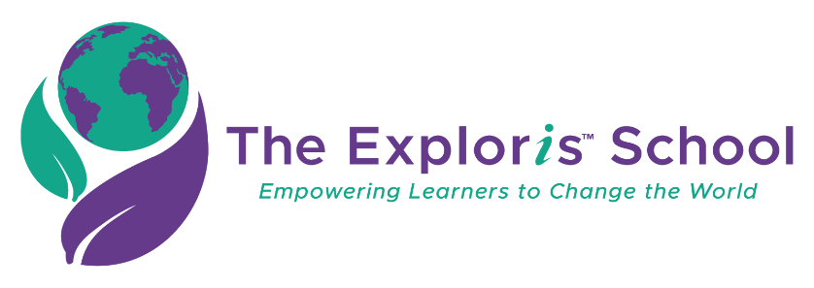

**Conflict of Interest and Anti-Nepotism Statement for The Exploris School**

**Board of Directors**

In accordance with Exploris Board Policies entitled Conflict of Interest and Nepotism, no member of the Board of Directors or any of its Committees shall derive any personal profit or gain, directly or indirectly, by reasons of his or her participation with The Exploris School. Each individual shall disclose to the organization any personal interest, which he or she may have in any matter pending before the organization and shall refrain from participation in any decision on such matter. Additionally, no governing authority or person with supervisory responsibility shall hire or recommend for hire any related person unless made public to the Board of Directors and approved by the Board.

Any member of the Board, any Committee, or Staff who is an officer, board member, a committee member or staff member of a client organization or vendor of The Exploris School non-profit shall identify his or her affiliation with such agency or agencies; further, in connection with any committee or board action specifically directed to that agency, he/she shall not participate in the decision affecting that agency and the decision must be made and/or ratified by the full board.

Any member of the Board, any Committee, Staff and certain Consultants shall refrain from obtaining any list of clients for personal or private solicitation purposes at any time during the term of their affiliation.

At this time, I am a Board member, a committee member, or an employee of the following organizations or am related to the following person, either being recommended for hire or already employed by Exploris:

_______________________________________________________________________________________________________________________________________________________________________________________

Now this is to certify that I except as described below, am not now nor at any time during the past year have been:

1. A participant, directly or indirectly, in any manner, agreement, investment, or other activity with any vendor, supplier, or other party; doing business with The Exploris School non-profit which has resulted or could result in personal benefit to me.
2. A recipient, directly, or indirectly, or any salary payments or loans or gifts of any kind or any free service or discounts or other fees from or on behalf of any person or organization engaged in any transaction with The Exploris School.

Any exceptions to 1 or 2 above are stated below with a full description of the transactions and of the interest, whether direct or indirect, which I have (or have not had during the past year) in the persons or organizations having transactions with The Exploris School non-profit.

Date: __________________ Signature: ____________________________________

Print Name: ____________________________________