**The Exploris School**

**Subcommittee on Equity and Diversity Report:**

**Updates and Recommendations**

**April 24, 2018**

**Introduction and Rationale:**

Research demonstrates that charter schools can contribute to school segregation if they do not take active steps to address diversity and reduce barriers to access for students of all backgrounds. A diverse student body positively impacts all students, increasing their cognitive, social, and emotional skills while preparing them to be engaged citizens in our increasingly diverse society (see Appendix C for related reading). Local and statewide comparison data reveal that (while we do manifest religious and cultural diversity to an extent) Exploris has significant gaps in both socioeconomic and racial diversity relative to traditional and charter schools across the state and in Wake county (see Appendix A - Section 1 for data comparisons). Beginning in 2014, the Exploris Board’s Educational Excellence Committee has worked in partnership with Exploris staff and administration to study and address the lack of diversity at the school. While some progress has been made, the data reveal that that there is still critical work to be done to achieve the goal of making Exploris a more diverse school.

See the full committee r[eport](https://drive.google.com/open?id=1WQFNEXEITEiAKehhrrxZ1LlUshkUlL2A3bD9v0rgiM0) submitted in 2015, for more context on this work. In that report, we identified these five justifications for this work:

1. Strategy 4.4 under the school’s current strategic plan is to: *“Strengthen programming to maximize resources while ensuring a free and appropriate education for ALL students.”*
2. Exploris is the only school recognized as a “Model” STEM school in the state by NCDPI. According to the DPI recognition criteria, Exploris should be focused on *“outreach, support and focus on underserved, especially females, minorities, and economically disadvantaged”* students.
3. A diverse school population prepares students for life in a multicultural society. Research indicates that racial and ethnic diversity in the school environment offers students greater opportunity for cognitive growth and preparation for citizenship. (see for example U. Michigan study, [The Benefits of Diversity in Education for Democratic Citizenship](http://www-personal.umich.edu/~pgurin/benefits.html))
4. Exploris is positioned to be a state and national model of high quality, innovative education that prepares students for high school, college, and life. However, the visible (and statistical) lack of diversity in the school allows naysayers to discredit the success of the school and the powerful model of education it has to share with others.
5. The school has a powerful mission and vision statement. Exploris lives out this mission and vision in its approach to community building and in teaching students to affect change. However, there is a critical opportunity for the school to better model the mission and vision by taking a more proactive approach to recruiting and supporting a more diverse student population.

Since that time, we have made progress on many of the goals set out, including, but not limited to: increasing diversity of staff and board, providing clear solutions to some of the barriers we identified (specifically around providing food), doing targeted recruitment of students/families to apply to the lottery, supporting staff training and events around diversity and inclusion.

**The current policy:**

In October 2015, the board voted to add to Strategic Plan Goal 1.4 [1.2] that by 2021, the student population of The Exploris School community will reflect the demographic composition, racial and socioeconomic, of the general population of Wake County.

Further, we voted to adopt the proposed Lottery Policy to include weighted lottery with the following targets:

* Year 1 (16-17) is 8%
* Year 2 (17-18) is 10%
* Year 3 (18-19) is 15%
* Year 4 (19-20) is 20%
* Year 5 (20-21) is 25%

The percentages in the policy would equate to the total population of students in the school meeting the “Economically Disadvantaged” criteria, defined by meeting national Free and Reduced Lunch (FRL) criteria. According to 2018 data, Exploris currently has 7% (with a 100% response rate).

**Proposed Procedures and Correlating Projections**

The committee recommends that the existing policy be revised in these two ways 1) to not explicitly include five year targets and 2) to push the target of 25% off one additional year (2021-2022). Our rationale in proposing this change is so we can allow the Executive Director more flexibility in the timing of these targets, especially as we may need to tailor enrollment targets with possible changes in the move-in date for our new school. The language of the REVISED POLICY should replace the existing language and should read: *The Exploris School will implement a priority lottery in such as way as to achieve 25% of our students meeting the “Economically Disadvantaged” criteria, defined by meeting national Free and Reduced Lunch (FRL) criteria, by the school year 2021-2022.*

We do, however, strongly recommend it be implemented such that the enrollment targets apply to total enrollment at each grade level rather than applying to total schoolwide enrollment. This will allow the school to add socioeconomic diversity proportionately in all grades instead of any single grade level at a time. (See Appendix A - Section 2 for specific annual enrollment projections/scenarios).

Priority status for faculty, siblings and board members will remain unchanged. The overall enrollment target for a particular year will be applied at each grade level, not to the overall population of incoming students. This means some grade levels, particularly 7th and 8th grades, will take additional years to reach FRL enrollment goals. Please see Appendices A and B for additional information about enrollment projections and illustrations of how the lottery could function, at the discretion of the Executive Director..

While the overall goal is to reflect the socioeconomic diversity of WCPSS (31%), the eventual annual enrollment target of 25% allows room to account for underreporting of self-reported data from already enrolled families. This will also allow the school to study to what extent the lottery policy is succeeding in reaching targets without risking exceeding the overall goal in ways that would have additional implications on the school budget.

Beyond the 2021-2022 school year, administrators should continue to monitor numbers and implement the priority lottery as they see fit to maintain 25% FRL.

**Student Supports and Budget (based on Faculty Enrollment Committee’s research)**

Projected budget impact will depend on the timing of the opening of the school and the rate at which class sizes grow. The following tracks a likely scenario of how many students would qualify for meal and scholarship support based on current projections. *The following chart is offered only for purposes of developing possible projected costs associated with possible new student populations:*

|  |  |  |  |  |
| --- | --- | --- | --- | --- |
|  | **Total Enrollment** | **FRL Target** | **FRL Actual** | **Total FRL Students** |
| 2017-18 | 421 | 8% | 8.0% | 34 |
| 2018-19 | 460 | 8% | 8.0% | 37 |
| 2019-20 | 570 | 20% | 16.8% | 96 |
| 2020-21 | 684 | 25% | 22.8% | 156 |
| 2021-22 | 684 | 25% | 24.7% | 169 |
| 2022-23 | 684 | 25% | 25.0% | 171 |

Food Program

* Costs: 1-2 additional hours/week for an administrator to work with vendor and get meals to classrooms.
* Solutions: Elementary School Lunch Program Pilot Program (see details below)

Student Trips/Field Experiences:

* Cost (per student): K/1: $100; ⅔: $100; ⅘: $825; 6: $500; 7: $1000; 8: $4330
* Solutions: Explicitly asking parents who can to donate $5-$10 extra into trips slush fund; for Outward Bound, apply for John Huie fund (up to $10,000 annually); look into corporate partnerships like [Spark Communities Program](http://giving.walmart.com/apply-for-grants/spark-communities), [Target Field Trip Grants](https://corporate.target.com/corporate-responsibility/grants/field-trip-grants); set up family savings accounts to save ahead for big trips like OB. Continue to ask faculty to review ways to reduce costs without lessening growth experiences.

Before and After-school care

* Costs: FT before and after care: $235/month
* Solutions: Create something similar to the “Monarch Fund” at Central Park School.

Backpack buddy/Pantry

* Costs: $500-$1000/year to keep stocked
* Solutions: Incorporate into Expedition and Service Learning Projects, partner with Inter-Faith Food Shuttle, request budget line for this from PTO.

Clothes and Hygiene Items Pantry

* Costs: $500-$1000/year to keep stocked
* Solutions: Incorporate into Expedition and Service Learning Projects to stock pantry, partner with Inter-Faith Food Shuttle, request budget line for this from PTO.

Transportation

* Costs: Public transit is $1.50 - 2.00/year. Children under 12 ride free
* Solutions: Continue to pay/budget for bus passes. Target areas with walk and/or short bus ride zone, identified the following (some already targeting in recruiting efforts): [Chavis Heights](http://www.cadcommunities.com/chavisheights/): under 1 mile from Kindley, no major streets to cross; [Walnut Terrace](http://www.cadcommunities.com/walnutterrace/): closer, but across MLK; [Capitol Park](http://www.cadcommunities.com/capitolpark/): Right at 1.5 miles, but on bus route. Create stronger network of families who live nearby for carpooling.

Volunteer Hours

* Costs: Some families, especially single parents, may not have flexibility to volunteer.
* Solutions: Revise volunteer requirement language in Handbook to read “suggested” or hours rather than “expected.” Also, additional volunteer opportunities might be made available that don’t require being present at the school during the day.

School Supplies, including tablets:

* Costs: $100-$200
* Solutions: Apply for a grant: <http://www.ncpublicschools.org/dtl/grants/>. Also apply for [Digital Learning Initiative Planning Gran](http://www.ncpublicschools.org/dtl/grants/)t (proposals due each Spring). Set up supply pantry, see solutions under Pantry (above). Establish Service LEarning Project for students to stock a school supply pantry.

Parent Education

* Costs: Administrative Time in developing additions or revised Parent University programming
* Solutions: Offer two Parent Universities per year on topics specifically geared toward equity.

Staff and Board Education

* Costs: Teacher time, replace or add programs to professional development time in these areas.
* Solutions: Implement workshops using these models: [Let’s Talk Racism](http://www.nccu.edu/calendar/eventDetails.cfm?id=1663), [Teaching Tolerance Workshops](https://www.tolerance.org/professional-development/teaching-tolerance-workshops), Choice Not Chance.

School Counselor and Other Student Support:

* Costs: Additional time/salary for additional school counselor and interventionist, and increased instructional coaching position to full time.
* Solutions: In upcoming school year, add to budget funding for one more FT School Counselor who specializes in Equity-Based Social work. (See these [guidelines](https://www.schoolcounselor.org/asca/media/asca/Careers-Roles/RoleStatement.pdf) for school counselor caseload numbers). In subsequent years, add Interventionist position, and increase Instructional Coach to FT. Partner with Fletcher Academy to share resources for additional academic supports for students.

**Recommendations re: Recruitment**

* Continue to make recruitment of staff from underrepresented populations a priority. School leadership has already made this a priority in new hires this year.
* Track student data to determine if student recruitment this year preceding lottery was effective. (Committee led recruitment efforts in surrounding neighborhoods this year, but we cannot track application data due to the way the lottery currently is run.)
* Publicize change in lottery process, this committee’s work, which will improve public perception of charters and improve targeted recruiting effort.

**Recommendations re: Parent Communication**

* Based on results (50+), we have identified key areas where parents need more information, and we are planning a Town Hall meeting with administration in August or September 2018.
* It will be important to continue gathering parent and student input on diversity efforts annually to inform the school’s efforts.

**Recommendations re: Administration**

* Make minor revisions to language of School Mission and Values on school website to include language around inclusion and diversity.
* Revise Handbook to make language around school trips (availability of scholarships), transportation and food, volunteer hours, etc. clearer.
* Ensure equity and diversity goals (staff and student level) are included in upcoming strategic planning process with board and staff.
* Adopt a new food program:
  + Spicy Green Gourmet Pilot (ES)
    - $4-$5 lunches with cost ($0.25-0.50) rolled in for cover FRL lunch fund.
    - Current cost with My Hot Lunch is $6-$7/meal.
    - Biodegradable packaging
    - Award Winning Food Service: http://www.pcrm.org/health/healthy-school-lunches/carrot/2016-golden-carrot-award-winners
    - In Accordance with National Guidelines
    - Would require on-site staff member to coordinate with vendor to transfer “scholarship” funding, but this is minimal (1 hour/week at most).

**Immediate Next Steps**

* Lottery policy:
  + School administration to vet proposed policy with the NC Office of Charter.schools and the attorney for the State Board of Education prior to Exploris board meeting in June.
  + Submit policy to SBE in July in time for review and approval at the October 2-4, 2018 SBE meeting.
  + Update the Exploris application form by November 1, 2018.
  + Publicize New Lottery Policy in August 2018 on social media, professional and social networks, and in neighborhood outreach.
* Lunch program:
  + Work with and support as needed the administration as they finalize agreement with new vendor.
* Student supports
  + School administration and faculty continue work to implement short term solutions to address existing need in the school.
  + School administration and faculty work to develop long term solutions to address projected need.

**Appendix A: Data**

**Section 1 - Comparison Data**

Racial Demographic Percentages of Total Students:

|  |  |  |  |  |
| --- | --- | --- | --- | --- |
|  | NC Traditional Schools | NC Charter Schools | Wake County | Exploris |
| American Indian | 1 | 1 | 1 | 1 |
| Asian | 3 | 4 | 8 | 3 |
| Hispanic | 17 | 9 | 17 | 4 |
| Black | 26 | 26 | 23 | 7 |
| White | 49 | 56 | 46 | 81 |
| Two or More | 4 | 5 | 4 | 5 |
| Pacific Islander | 0 | 0 | 1 | 0 |

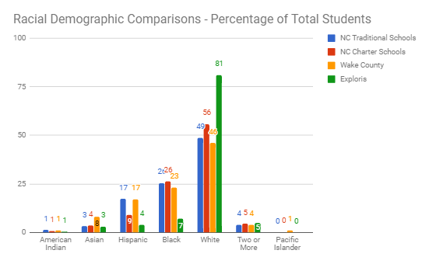

Socioeconomic Comparison Percentages:

|  |  |  |  |  |
| --- | --- | --- | --- | --- |
|  | NC Traditional Schools | NC Charter Schools | Wake County | Exploris |
| 2014-2015 | 55 | 36 | 34 | 6 |
| 2015-2016 | 50 | 30 | 36 | 7 |
| 2016-2017 | 50 | 31 | 34 | 9 |
| 2017-2018 | n/a | n/a | 31 | 7 |

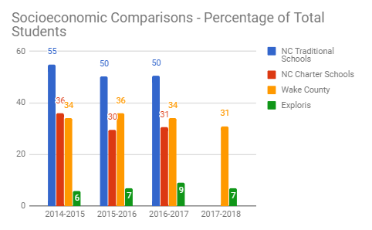

**Student Project Data**

*In January 2018, the Board heard from students and teaching faculty about their work uncovering racial and socioeconomic inequities. Here is some of the data from that work:*

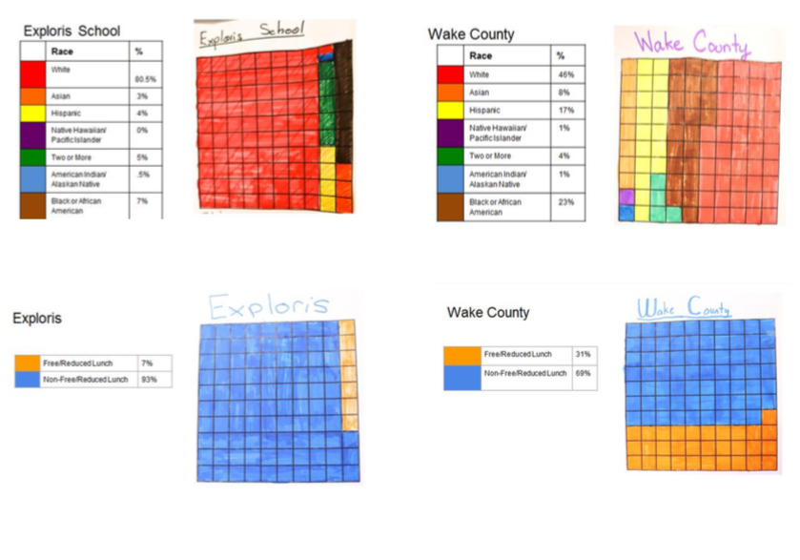

**Section 2 - Lottery Projections**

**Possible Scenarios for Use of Priority Seats in Lottery**

**Targets with “Delayed” New Building Opening**

**Slower increase**:

|  |  |  |  |  |
| --- | --- | --- | --- | --- |
| Lottery Target | Total Students | FRL #s | Resulting Actual FRL % |  |
| 2018-2019 | 0% | 456 | 37 | 8.1% |
| 2019-2020 | 10% | 456 | 42 | 9.3% |
| 2020-2021 | 15% | 570 | 78 | 13.7% |
| 2021-2022 | 20% | 684 | 128 | 18.8% |
| 2022-2023 | 25% | 684 | 163 | 23.8% |
| 2023-2024 | 25% | 684 | 168 | 24.6% |

**Faster increase**:

|  |  |  |  |  |
| --- | --- | --- | --- | --- |
|  | Lottery Target | Total Students | FRL #s | Resulting Actual FRL % |
| 2018-2019 | 0% | 456 | 37 | 8.1% |
| 2019-2020 | 15% | 456 | 58 | 12.6% |
| 2020-2021 | 20% | 570 | 103 | 18.1% |
| 2021-2022 | 25% | 684 | 163 | 23.8% |
| 2022-2023 | 25% | 684 | 169 | 24.7% |
| 2023-2024 | 25% | 684 | 171 | 25.0% |
|  |  |  |  |  |

**Fastest increase**:

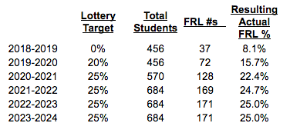

**Targets with “Expected” New Building Opening**

**Slower increase**:

|  |  |  |  |  |
| --- | --- | --- | --- | --- |
| Lottery Target | Total Students | FRL #s | Resulting Actual FRL % |  |
| 2018-2019 | 0% | 456 | 37 | 8.1% |
| 2019-2020 | 10% | 570 | 54 | 9.4% |
| 2020-2021 | 15% | 684 | 95 | 13.9% |
| 2021-2022 | 20% | 684 | 128 | 18.8% |
| 2022-2023 | 25% | 684 | 163 | 23.8% |
| 2023-2024 | 25% | 684 | 168 | 24.6% |

**Faster increase**:

|  |  |  |  |  |
| --- | --- | --- | --- | --- |
|  | Lottery Target | Total Students | FRL #s | Resulting Actual FRL % |
| 2018-2019 | 0% | 456 | 37 | 8.1% |
| 2019-2020 | 15% | 570 | 75 | 13.1% |
| 2020-2021 | 20% | 684 | 126 | 18.4% |
| 2021-2022 | 25% | 684 | 163 | 23.8% |
| 2022-2023 | 25% | 684 | 169 | 24.7% |
| 2023-2024 | 25% | 684 | 171 | 25.0% |

**Fastest increase**:*

|  |  |  |  |  |
| --- | --- | --- | --- | --- |
|  | **Lottery Target** | **Total Students** | **FRL #s** | **Resulting Actual FRL %** |
| 2018-2019 | 0% | 456 | 37 | 8.1% |
| 2019-2020 | 20% | 570 | 96 | 16.8% |
| 2020-2021 | 25% | 684 | 156 | 22.8% |
| 2021-2022 | 25% | 684 | 169 | 24.7% |
| 2022-2023 | 25% | 684 | 171 | 25.0% |

***\*One illustration of how the above scenario would affect enrollment at each grade level:***

Total School Population by Grade Level

|  |  |  |  |  |  |  |  |  |  |  |  |  |  |
| --- | --- | --- | --- | --- | --- | --- | --- | --- | --- | --- | --- | --- | --- |
|  | K | 1 | 2 | 3 | 4 | 5 | 6 | 7 | 8 | Total | FRL #s at 8% | FRL #s w/ Weights | Resulting Actual FRL |
| 2018-2019 | 38 | 38 | 38 | 38 | 38 | 38 | 76 | 76 | 76 | 456 | 37 | 37 | 8.1% |
| 2019-2020 | 57 | 57 | 57 | 57 | 57 | 57 | 76 | 76 | 76 | 570 | 46 | 96 | 16.8% |
| 2020-2021 | 76 | 76 | 76 | 76 | 76 | 76 | 76 | 76 | 76 | 684 | 56 | 156 | 22.8% |
| 2021-2022 | 76 | 76 | 76 | 76 | 76 | 76 | 76 | 76 | 76 | 684 | 56 | 169 | 24.7% |
| 2022-2023 | 76 | 76 | 76 | 76 | 76 | 76 | 76 | 76 | 76 | 684 | 56 | 171 | 25.0% |

Number of FRL Qualifiers by Grade Level

|  |  |  |  |  |  |  |  |  |  |  |
| --- | --- | --- | --- | --- | --- | --- | --- | --- | --- | --- |
|  | K | 1 | 2 | 3 | 4 | 5 | 6 | 7 | 8 | Total FRL #s |
| 2018-2019 | 4 | 4 | 4 | 3 | 3 | 4 | 5 | 5 | 5 | 37 |
| 2019-2020 | 11 | 11 | 11 | 11 | 11 | 11 | 15 | 6 | 6 | 96 |
| 2020-2021 | 19 | 19 | 19 | 19 | 19 | 19 | 19 | 16 | 7 | 156 |
| 2021-2022 | 19 | 19 | 19 | 19 | 19 | 19 | 19 | 19 | 17 | 169 |
| 2022-2023 | 19 | 19 | 19 | 19 | 19 | 19 | 19 | 19 | 19 | 171 |

*Above scenario - effect on total population over five years:*

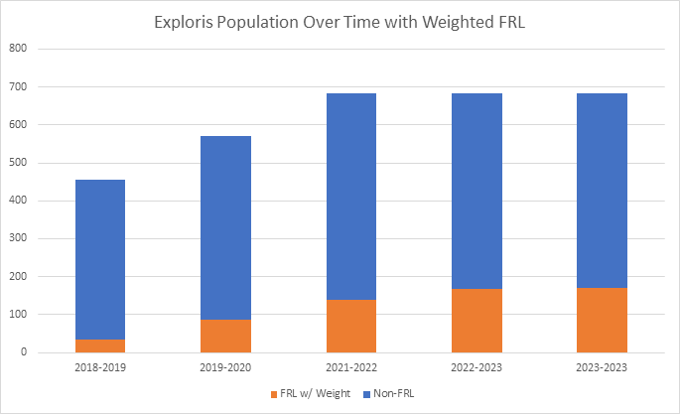

**Appendix B:** [**FAQs**](https://docs.google.com/document/d/1o3PXNJIVL7-3QewBk9IrnbV-HAPmdRr-84go9h_e4gU/edit)

**Diversity and Equity FAQ for Board**

**\***Board questions collected on 1/23

**General Questions:**

1. How will we define equity and diversity at Exploris? Where will this definition be published?
   * To be addressed by proposed language within core values and on website diversity and inclusion page
2. Why is it important for Exploris to improve our approach to supporting equity and diversity in our school community?
   * Strategy 4.4 under the school’s current strategic plan is to: *“Strengthen programming to maximize resources while ensuring a free and appropriate education for ALL students.”*
   * Exploris is the only school recognized as a “Model” STEM school in the state by NCDPI. According to the DPI recognition criteria, Exploris should be focused on *“outreach, support and focus on underserved, especially females, minorities, and economically disadvantaged”* students.
   * A diverse school population prepares students for life in a multicultural society. Research indicates that racial and ethnic diversity in the school environment offers students greater opportunity for cognitive growth and preparation for citizenship. For example:
     + [How Racially Diverse Schools and Classrooms Can Benefit All Students](https://tcf.org/content/report/how-racially-diverse-schools-and-classrooms-can-benefit-all-students/) (The Century Foundation, 2016)
     + [The Benefits of Diversity in Education for Democratic Citizenship](http://www-personal.umich.edu/~pgurin/benefits.html) (Gurin, Nagda, and Lopez, 2003)
     + [A meta-analytic test of intergroup contact theory](http://www.iaccp.org/sites/default/files/pettigrew_tropp_2006_contact_theory_0.pdf) (Pettigrew and Tropp, 2006)
     + [Effects of diversity experiences on socially responsible leadership over four years of college](http://psycnet.apa.org/record/2013-43360-001) (Parker and Pascarella, 2013)
     + [Racial and ethnic diversity in the classroom: Does it promote student learning?](https://eric.ed.gov/?id=EJ635281) (Terenzini, Cabrera, Colbeck, Bjorklund, and Parente, 2001)
   * Exploris is positioned to be a state and national model of high quality, innovative education that prepares students for high school, college, and life. However, the visible (and statistical) lack of diversity in the school allows naysayers to discredit the success of the school and the powerful model of education it has to share with others. Other innovative North Carolina charter schools (Central Park School, Girls Leadership Academy of Wilmington, and Raleigh Oak) have already taken a stance on this by implementing weighted lotteries.
   * The school has a powerful mission and vision statement. Exploris lives out this mission and vision in its approach to community building and in teaching students to affect change. However, there is a critical opportunity for the school to better model the mission and vision by taking a more proactive approach to recruiting and supporting a more diverse student population.
   * Preliminary results from the parent survey (55 responses) indicates that 84% of Exploris parents believe that a school culture that supports equity and diversity benefits all students. Yet only 56% feel that Exploris has a strong culture of equity and diversity.
3. How will we benchmark annual data on equity and diversity?
   * In order to track Exploris’s progress towards annual enrollment goals, we will track publically available data on racial and socioeconomic diversity.
   * We also recognize and celebrate that Exploris has many types of diversity that all students benefit from including religious and cultural diversity.

**Lottery Questions:**

1. What is the recommendation for implementing Exploris admissions policy adopted in 2015?
   * After extensive research, analysis of enrollment projects, and consultation with school staff, the Equity and Diversity Committee recommends that the board begin implementing the existing policy as written for the incoming class of fall 2019:
     + 20% of total school enrollment qualifying for FRL in 2019-2020
     + 25% of total school enrollment qualifying for FRLin 2020-2021
     + 25% of total school enrollment qualifying for FRL for each year following
   * The committee recommends that the policy be implemented such that the enrollment targets apply to total enrollment at each grade level. This will allow the school to maximize progress towards enrollment goals without overwhelming any single grade level with total FRL numbers that are disproportionate to the school’s overall targets.
2. What is the basis for these recommendations?
   * While the increase in lottery targets will now be spread over only two years, it will still take the school at least 3 years to get to the 25% target. The actual FRL growth numbers may vary slightly depending on how quickly the school grows the overall student population in the new building.
   * While the overall goal is to reflect the socioeconomic diversity of WCPSS (31%), setting the enrollment target at 25% allows room to account for underreporting of self-reported data from already enrolled families. It will also allow the school to study to what extent the lottery policy us succeeding in reaching targets without risking exceeding the overall goal in ways that would have additional implications on the school budget.
3. How will the lottery function?
   * Priority status for faculty, board members, and siblings will remain.
   * The overall enrollment target for a particular year will be applied at each grade level, not to the overall population of incoming students. This means some grade levels, particularly 7th and 8th grades, will take additional years to reach FRL enrollment goals (see projections)
   * To illustrate how grade level enrollment targets will work, consider the following two scenarios for the 20% FRL target for spring 2019:
     + Kindergarten will have 57 openings which means the target will be to have 12 students who qualify for FRL. After other priority seats are filled, let's say there are 30 seats remaining to be filled. 12 of these seats would be filled by qualifying FRL students and 18 would be filled by the general lottery population.
     + Seventh grade may only have 5 openings due to turnover and no increase in class size at 76 students overall. After staff and sibling seats are filled, there may only be 2 open seats remaining. The 20% target would be 15 qualifying FRL students. Assuming the class has approximately 5 qualifying FRL students moving up from 6th grade, the class would need 10 more FRL students to meet the enrollment goal. The two available seats would go to additional qualifying FRL students for a total of 7 FRL students in the class for the year.
4. How will the wait list function?
   * There will be a single waitlist generated for each grade level similar to the current process. FRL qualifying students will be tagged as such within that waitlist. When seats become available, they will be filled by students identified as FRL qualifiers according to the waitlist until the enrollment target is reached for the grade level. If enrollment targets have been reached, seats will be filled according to waitlist order.
5. What will be the process to have the policy approved by the state board?
   * It is recommended that school administration arrange to meet with the NC Office of Charter Schools and the attorney for the State Board of Education to vet the proposed admissions procedures before officially submitting the policy for consideration.
   * The goal would be to have the policy approved by the state board at the October 2-4, 2018 meeting (in time to update the Exploris application form by November 1, 2018).
   * Given that it may take 8-10 weeks for SBE approval, it is recommended that the policy should be vetted with the Office of Charter Schools prior to the June 2018 Exploris board meeting so revisions can be considered in time to submit to the SBE in July.
6. If our weighted lottery is designed to address our free lunch population, will we readdress the lottery in the future to reflect the current Wake County percentage?*
   * The lottery policy and procedures can be adjusted in the future with SBE approval. Exploris may want to consider adjusting after 3-5 years after seeing how well the proposed policy functions in meeting overall objectives.
7. If Wake County is 31%, are we targeting Wake County +/-5%, +/-10%, etc?*
   * While there will likely be fluctuation in actual numbers from year to year, the proposed policy is intended to approach the Wake County goal while allowing for underreporting of FRL numbers. Overall, the lottery should self-correct to some extent each year.
8. What does the data look like in terms of the past three years of applicants: all openings, number of siblings, actual openings? What is the current percentage of students from siblings, teachers, board, other?
   * Please see Appendix A for available data.
9. Where do Exploris students come from? What are current Exploris students’ base schools?
   * The school does not have this information available. The answer would likely vary significantly each year since students come from across Wake County and often from other counties.
10. What does comparison data look like for other charter schools vs. Exploris?*
    * Please see Appendix A for data comparing Exploris and Wake County schools to other NC charter schools.
11. What do we know about any correlation between socioeconomic and racial diversity?
    * While there may be some correlation, it will be important to keep in mind that the school is working to increase both types of diversity through a variety of strategies. Adding the lottery priority for FRL students and providing additional student supports are strategies specific to increasing socioeconomic diversity. Intentional recruitment to diversify the lottery pool will help address both types of diversity, as will additional training for staff. Additional strategies to support racial (and also cultural) diversity are expected to emerge from input from families and students over time beginning with the parent survey distributed in spring 2018.
12. How will the opening of the new building impact diversity efforts?
    * The opening of the new building, and corresponding graduated growth of grade level class sizes will allow the updated enrollment policy to increase socioeconomic diversity in the school at a manageable pace (in terms of school budget) while also meeting enrollment objectives within 2-3 years. If the building were not opening, it would likely take much longer to reach enrollment goals. Conversely, if the building were to open in 2019 at maximum capacity (without graduated class size growth), enrollment of FRL qualifiers would jump more significantly.
    * Location of the new building is also an important consideration. More investigation needs to be done into how the school can address transportation needs. In the meantime, it is recommended that the school conducts targeted recruitment within walking distance of the new building.

**Student Support Questions**

1. What are the barriers to access that need to be overcome to assure equity of access for economically disadvantaged students? What are the types of additional supports will need to be put in place to support these students?
   * Barriers to access include:
     + Lack of meal support
     + Lack of transportation
     + Cost of field experiences
     + Cost of before/after school care
     + Lack of access to information about the school (e.g. if families don’t have access to internet)
     + School culture - perception (e.g. if public perception of Exploris is negative around diversity, or if public perception is that Exploris staff and student body is homogenous).
   * While we have not done official exit surveys, it has been reported in the past that families have left Exploris because their families could not afford the related costs.
   * The Faculty Enrollment Team has been working to identify costs of providing additional supports and possible solutions.
2. Are we currently supporting students who qualify for free and reduced lunch? To what extent?
   * The school currently provides some support for meals and scholarships, however the current meal system is not scalable given the projected need, and the current scholarship budget also will not cover projected need. The Equity and Diversity Committee has been working closely with the Faculty Enrollment Team to develop possible short and long term solutions.
3. If we begin offering transportation and lunch support, is it possible that some families currently at Exploris might begin reporting existing need more accurately and start qualifying for supports?
   * It is likely that we would find that we have higher FRL numbers than currently reported if additional supports were offered. It will be important to collect additional data as new supports are implemented in the 2018-2019 school year so the 2019-2020 lottery is based on accurate enrollment data.
4. What are the options for providing transportation support?
   * More investigation needs to be done into how the school can address transportation needs. In the meantime, it is recommended that the school conducts targeted recruitment within walking distance of the new building.
5. Will we have more money for scholarship students so we can continue the great field trip learning experiences?
   * Field experiences are a core part of the Exploris instructional model. Identifying budget solutions to cover related costs is an important part of the long term solution to ensuring that Exploris can serve all students with its powerful instructional model.
6. The new building does not have a cafeteria, will this cause challenges in providing meal support?
   * Many schools run subsidized lunch programs without a school cafeteria. This should not be an issue.
7. How will the school address staffing needs for meal support and nutrition in the future?
   * It is recommended that the school partner with a provider who can provide logistical support and nutritious meal options. Some staff time will need to be accounted for to help coordinate with the provider.
8. Do we believe there is a correlation between greater diversity and Exceptional Children program (EC) costs?
   * Based on data collected from implementing a weighted lottery over 5 years, Central Park School for Children reported no significant increase in EC population relative to overall increase in FRL qualifiers.

**Appendix C: References for Further Reading**

Charter School Diversity

* [The Growing Segmentation of the Charter School Sector in North Carolina](http://www.nber.org/papers/w21078) (Ladd, Clotfelter, & Holbein, 2015)
* [North Carolina Charter Schools: Excellence and Equity through Collaboration](http://publicimpact.com/pi/wp-content/uploads/2014/07/NC_Charter_Schools_Excellence_and_Equity_through_Collaboration_Full-Report-Public_Impact.pdf) (Public Impact, 2014)
* [The barriers that make charter schools inaccessible to disadvantaged families](https://www.brookings.edu/blog/brown-center-chalkboard/2018/03/16/the-barriers-that-make-charter-schools-inaccessible-to-disadvantaged-families/) (Valant, Lincove, 2018)

Benefits of Diversity in the Classroom

* [How Racially Diverse Schools and Classrooms Can Benefit All Students](https://tcf.org/content/report/how-racially-diverse-schools-and-classrooms-can-benefit-all-students/) (The Century Foundation, 2016)
* [The Benefits of Diversity in Education for Democratic Citizenship](http://www-personal.umich.edu/~pgurin/benefits.html) (Gurin, Nagda, and Lopez, 2003)
* [A meta-analytic test of intergroup contact theory](http://www.iaccp.org/sites/default/files/pettigrew_tropp_2006_contact_theory_0.pdf) (Pettigrew and Tropp, 2006)
* [Effects of diversity experiences on socially responsible leadership over four years of college](http://psycnet.apa.org/record/2013-43360-001) (Parker and Pascarella, 2013)
* [Racial and ethnic diversity in the classroom: Does it promote student learning?](https://eric.ed.gov/?id=EJ635281) (Terenzini, Cabrera, Colbeck, Bjorklund, and Parente, 2001)