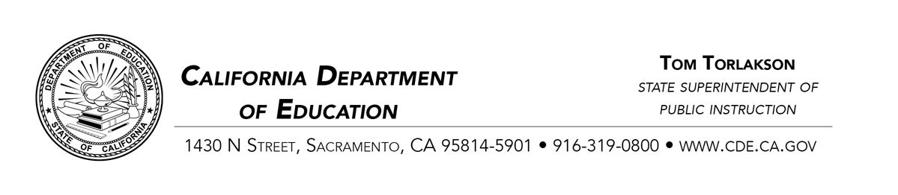
December 5, 2018
Dear County and District Superintendents and Charter School Administrators:

Low-Performing Students Block Grant
Governor Brown signed Assembly Bill 1808 into law on June 27, 2018. AB 1808 authorizes the allocation of a $300 million Low-Performing Students Block Grant (LPSBG) in the 2018–19 fiscal year to provide California’s low-performing students with additional supports to increase their academic achievement as defined in the California Education Code (EC), Section 41570(d).
The purpose of this letter is to notify eligible local educational agencies (LEAs) of the reporting requirements for this grant pursuant to EC Section 41570(f)(2). The LEA must submit two reports to the State Superintendent of Public Instruction using the California Department of Education’s (CDE’s) online reporting tool:
- Required Report Number One: On or before March 1, 2019, the LEA is required to report to the State Superintendent regarding the adopted plan to use the grant funds to increase the academic performance of pupils identified, pursuant to EC Section 41570(d).
Note: All eligible LEAs must complete Required Report Number One. If an eligible LEA chooses not to receive LPSBG funds, it still must complete Required Report Number One to formally document that choice.
- Required Report Number Two: On or before November 1, 2021, all eligible LEAs that have accepted LPSBG funds are required to report to the State Superintendent regarding the implementation of the plan, the strategies used, and whether those strategies increased the academic performance of the pupils identified, pursuant to EC Section 41570(d).

To access the online reporting tool, please follow the directions in the Reporting Requirements section of the CDE LPSBG web page located at https://www.cde.ca.gov/fg/aa/ca/lpsbgprginfo.asp#reportingreq.
For questions regarding the reporting requirements or the online reporting tool, please contact the School Improvement and Support Office by phone at 916-319-0833 or by email at LPSBG@cde.ca.gov.
Sincerely,
Melanie Greene, Director
Improvement and Accountability Division
California Department of Education

MG:ls
2018-07451

