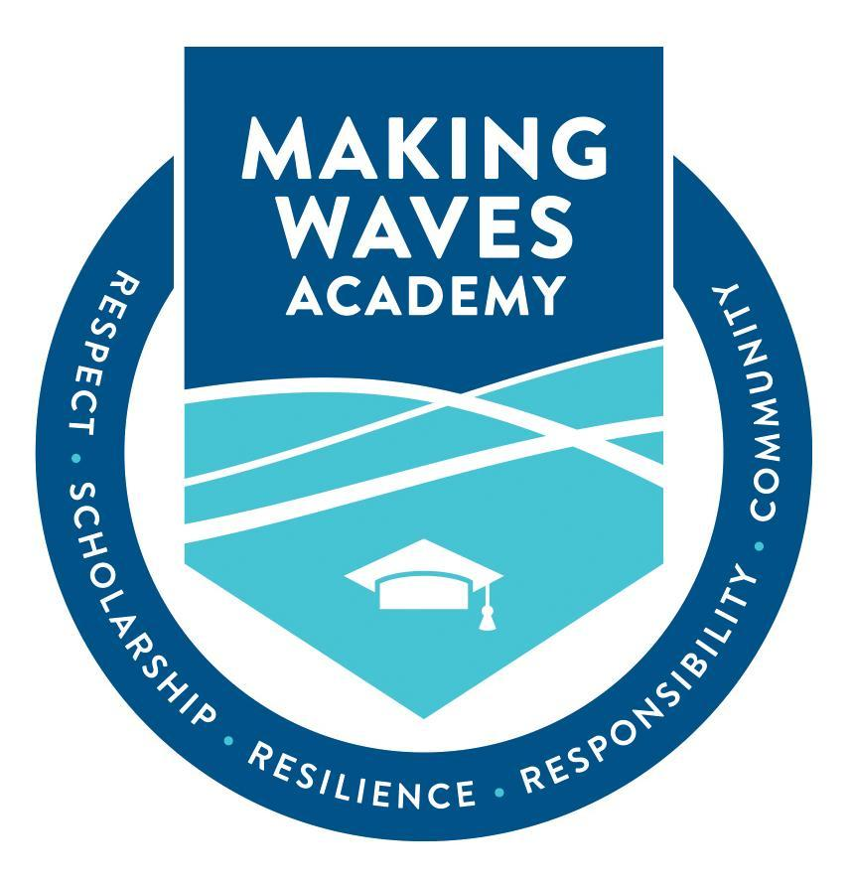

Board Report
School-Wide
(Talent Team Focus for May)

Talent Team

Lisa Dodson, Managing Director of Talent

Scott Pullman, Associate Director of Talent

Joanella Mendoza, Associate Director of Talent

Where We Have Been…
The Making Waves Academy Talent Team is committed to recruiting and retaining mission-aligned talent to serve our community. Every year brings a new surprise to the world of talent, and this year has certainly been dynamic, and full of surprises and uncertainty. This academic year has been unique with a constant decline in the workforce leading us to the “Great Resignation”. Educators leaving the classroom as well as staff turnover has once again challenged our team to become more creative, innovative, and embrace technology and various platforms while trying to maintain a personal touch.
This year we felt the impact of the pandemic both professionally and personally. We hired 50 new staff members from January 2021 to August 2021 while increasing the number of in-house substitute teachers. However, absenteeism and various leaves continued to impact our community. Despite our best efforts, eight teachers resigned from their positions in the summer of 2021 when the pool of available and qualified teachers was low. The academic year started with ten teacher vacancies which created instability and stress in the community. Turnover in leadership was unexpected, creating additional pain points. Partnerships remained strong but we felt the decline in candidates being referred to our school from various partners. Teach For America’s enrollment declined from 6,000 to 2,000 corps members throughout the United States, decreasing our number of corps members from 4 to 1 with a slight chance of securing 2.
We often ask ourselves: How did we get here? Did we fail to plan? How could this have been avoided? How do we move forward in this new climate? It remains to be seen whether this will persist as the pandemic continues presenting challenges for the 2022-2023 academic year.

Where We Are Now…
The Talent Team has expanded as we seek to move towards our goal of a fully staffed school for the 2022-23 school year. We have added a temporary employee, Ms. Melissa Wilson, an experienced HR professional in the role of Talent Team Associate. She is responsible for the coordination of interviews, panels, collecting data and scheduling reference checks. Ms. Joanella Mendoza has also joined the team in the role of Associate Director. She has a strong background in teaching, technology, and school operations.

In the fall, given the teaching shortage, Mr. Nelson authorized the Talent Team to hire on-site substitute teachers. At the end of last year, the school had two full-time, on-site substitute teachers. Currently we have twelve on-site substitute teachers employed by the school. Ms. Chinela Key-Baysinger also joined the staff as a Substitute Coordinator to assist the administration with supporting coverage for faculty absences. Some of these new, on-site substitute teachers are alumni of Making Waves Academy and their presence is inspirational to current Wave-Makers.

The current focus of the Talent Team is the hiring of teachers for the upcoming school year. Our first hire, Ms. Oznur Root, was hired in December as a middle school teacher. She is currently teaching at an International School in Cyprus. We found her through GetSelected.com, a website for teaching candidates. This site has also led us to find out-of-state teachers for hard-to-fill positions such as Ms. Susana Montoya, our incoming Chemistry Teacher and Mr. Ulicies Isorida, our incoming Math Teacher. Our referral process has also been quite useful as we were able to find two English Teachers, Mr. Alex Barkett and Ms. Amanda LaBerge, who started in the winter. Making Waves Academy employees can receive referral bonuses depending on the position their referral is hired for- $250 for contractor referrals, $1,000 for staff referrals, $2,000 for credential teacher or coordinator referrals, and $3,000 for Director-level referrals.
We have attended in-person career fairs throughout Northern, Central, and Southern California. We also attended virtual fairs with Puerto Rican universities and we are hopeful to continue this outreach. We have partnered with the Global Ambassador Program which attracts bilingual teachers from the Dominican Republic and other countries. We will continue to attend in-person and online fairs throughout the year.
Currently six teachers have accepted offers to join the community for the new school year and we are making offers to many additional candidates. In addition to these six, we hired four teachers in the middle of the school year with the understanding that they will return for the 2022-2023 school year. In addition to teachers, we have had success in filling leadership roles. Dr. Tierra Parker has started as the Senior Dean of Students. Ms. Alina Enoiu has joined us as a Literacy Intervention Coordinator. Mr. Darin Little joined our team as the English Language Development Coordinator. Ms. Arella Sidransky will start next month as an additional Dean of Students. We are continuing to look for mission-aligned educators and leaders in education, and have been authorized by Mr. Nelson to overhire teachers.

As we continue our search for talent, we look forward to utilizing our sources of hire including Indeed, our Making Waves Career Website (Powered by Jobvite), job fairs (both in-person and online), EdJoin, Teach For America and our Teacher Residency Program.

Where We Are Going…
The teacher recruitment climate remains ever-changing, exacerbated by a number of challenges- the unprecedented exodus of educators leaving the classroom, a nationwide decline in candidates entering the teaching profession, and attracting teachers to the Bay Area due to the high cost of living. Because of these challenges, the Talent Team continues to analyze and adjust how we utilize existing talent pipelines in order to further our reach and pinpoint high-quality candidates.
Widely used sourcing tools, such as Indeed, EdJoin, and GetSelected.Com, offer growing talent pools and filtering options that our team uses to discover candidates who fit what we’re looking for. Used in conjunction with professional networking powerhouses, such as LinkedIn Recruiter, we gain greater insight into the person behind the application by viewing more in-depth employment history, colleague endorsements, and skills assessments. We will continue to expand our number of education-affiliated connections on LinkedIn to increase engagement with our job postings with a wider range of candidates. In addition, we’ll continue to take advantage of LinkedIn’s messaging feature to connect and build relationships with potential candidates long before their first interview with us.

This year, our Teacher Residency Program successfully graduated three teacher residents who will be joining the staff as full-time faculty members. In partnership with Alder Graduate School of Education, we recruit mission-aligned candidates and cover 100% of the tuition costs of a credentialing and master’s program. Candidates are expected to teach at Making Waves upon completion of their program. This year, under the leadership of our Director of Teacher Residency, Ms. Kelly Le, we have accepted five teacher residents for the upcoming 2022-2023 school year.

While the “Great Resignation” has caused significant movement in and out of the workforce, our Talent Team has been fortunate to receive high-quality candidates thanks to MWA faculty and staff that directed this movement in our direction through referrals. We will continue to encourage existing faculty and staff to use their knowledge of MWA culture, experience, and expectations to refer candidates who they think would succeed at our school.

Lastly, as COVID mandates and restrictions continue to lift across the country, our Talent Team is looking forward to attending in-person hiring events to meet the next wave of MWA talent face-to-face. We will also continue to attend virtual hiring fairs to connect with candidates who are unable to attend in-person events, creating greater opportunity and equity among potential candidates to meet members of our Talent Team.

Our team remains resilient and committed to finishing the year strong.

Meet the Newest Faces at Making Waves Academy!

