A-G Completion Improvement Grant Program (EC 41590)
Plan for Making Waves Academy

What?
Making Waves Academy is projected to receive $291,377 pursuant to the A-G Completion Improvement Grant Program (EC 41590). The purpose of the grant is to help increase the number of high school students who graduate from high school with A-G eligibility. The funds will be available for use through the 2025-26 school year.

So what?
Making Waves Academy seeks to use this funding to expand access to coursework to satisfy A-G course requirements by establishing new partnerships with post-secondary educational institutions through a dual enrollment program. A dual enrollment program at Making Waves Academy would provide students the opportunity to earn up to two years of college credits while completing high school diploma requirements. Through a College and Career Access Partnership (CCAP) Agreement with a participating community college district, Making Waves Academy would be able to offer community college courses to participating high school students during the school day, while keeping enrollment closed to the general public (AB 288).

Community input collected at a public board meeting held on March 10, 2022 necessitated revisions to our original plan. A student survey was also conducted as a recommendation from the board meeting.

Now what?
Making Waves Academy recommends that the board approve our A-G Completion Improvement Grant plan to start a dual enrollment program. Fiscal impact: not to exceed $35,000 per year for the first three years, then approximately $140,000 annually thereafter.

Table 1. Revisions based on community input.
In order to ensure community and stakeholder input, the plan shall be discussed at a regularly scheduled meeting by the governing board of the school district, county board of education, or governing body of the charter school and adopted at a subsequent regularly scheduled meeting.
Community input collected at a public board meeting held on March 10, 2022 necessitated revisions to our original plan. A student survey was also conducted as a recommendation from the board meeting. The revised plan was completed on April 1, 2022.

Three essential questions emerged from the public discussion. The plan now reflects revisions in response to these questions, but are highlighted below for ease of reference.

- What is the value proposition for this particular dual enrollment program?
  - The primary value proposition of this dual enrollment program is to increase college completion rates among our college-bound graduates through early credit accumulation. A dual enrollment program at Making Waves Academy would provide students the opportunity to earn up to two years of college credits while completing high school diploma requirements.

- What does student interest look like for a dual enrollment program?
  - Based on a March 2022 survey, 86 upper school students – almost equivalent in size to the current graduating class at Making Waves Academy – have expressed interest in participating in an early college credit program.

- What are the ongoing projected expenses for continuing the dual enrollment program after the grant funding depletes?
  - The fiscal impact of a dual enrollment program is not to exceed $35,000 per year for the first three years, then approximately $140,000 annually thereafter.

The A-G Completion Improvement Grant plan is scheduled for vote and adoption at a subsequent public board meeting, scheduled on May 5, 2022.

If in its implementation a dual enrollment program becomes impossible or impractical to continue, or if unforeseen or unavoidable circumstances would result in insurmountable delay or expense, the grant would be used towards expanding options for credit recovery or elective courses to supplement, not supplant, current services.

Table 2. Description of use of funds.
A grant recipient shall develop a plan on or before April 1, 2022, describing how the funds received under this section will increase or improve services for unduplicated pupils to improve A–G eligibility, including information about the number of pupils identified for opportunities to retake courses pursuant to paragraph (2) of subdivision (e).
Making Waves Academy developed its original plan for the A-G Completion Improvement Grant Program on February 17, 2022. Following community input and discussion at a public board meeting, the revised plan was completed on April 1, 2022.

Making Waves Academy seeks to use this funding to expand access to coursework to satisfy A-G course requirements by establishing new partnerships with post-secondary educational institutions through a dual enrollment program.

The primary value proposition of a dual enrollment program is to increase college completion rates among our college-bound graduates through early credit accumulation. A dual enrollment program at Making Waves Academy would provide students the opportunity to earn up to two years of college credits while completing high school diploma requirements.

Through a College and Career Access Partnership (CCAP) Agreement with a participating community college district, Making Waves Academy would be able to offer community college courses to participating high school students during the school day, while keeping enrollment closed to the general public (AB 288).

All students will have the option to enroll in courses offered through the dual enrollment program, including 176 students currently identified as needing to retake courses.

If in its implementation a dual enrollment program becomes impossible or impractical to continue, or if unforeseen or unavoidable circumstances would result in insurmountable delay or expense, the grant would be used towards expanding options for credit recovery or elective courses to supplement, not supplant, current services.

Table 3. Student interest.
Based on a March 2022 survey, 86 upper school students – almost equivalent in size to the current graduating class – have expressed interest in participating in an early college credit program at Making Waves Academy.
When asked why, the top reasons were to help confirm their career pathway, to experience college-level rigor, and to save money on college tuition.
When asked what subjects they would study, business and science ranked highest, followed by arts and communication.
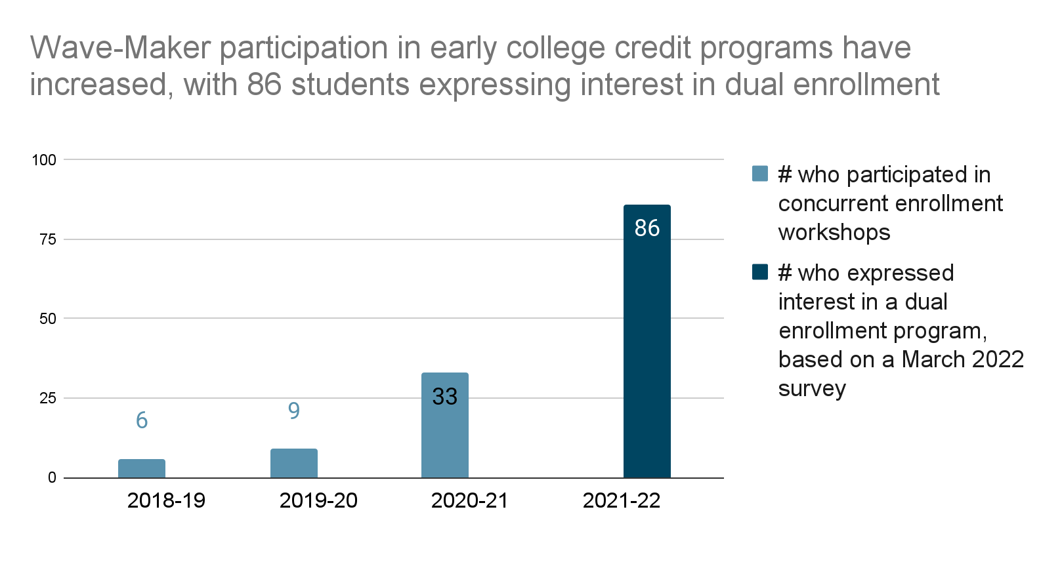

Table 4. Proposed budget.

To launch a dual enrollment program at Making Waves Academy, grant funding will be used towards instructional materials, professional development, and hiring a full-time administrator. The administrator will plan, organize, and provide oversight for all functions and activities related to dual enrollment, concurrent enrollment, and related initiatives. 2022-23 will be a planning year, with the first cohort of students beginning in 2023-24.

 | 2022-23 | 2023-24 | 2024-25 | 2025-26
 | Planning year | Year 1 | Year 2 | Year 3
Revenues
A-G Completion Improvement Grant | $97,125.66 | $97,125.66 | $97,125.66 | $0
Expenses
Certificated pupil support administrator salary, health and welfare benefits and insurance, and taxes | $115,154 | $118,608.62 | $122,166.88 | $125,831.89
Instructional materials | $5,000 | $5,000 | $5,000 | $5,000
Conferences and professional development | $4,000 | $4,000 | $4,000 | $4,000
Funds to be raised | ($27,028.34) | ($30,482.96) | ($34,041.22) | ($134,831.89)

Table 5. Supplement, not supplant.
The plan shall include information regarding how the plan and described services supplement, and do not supplant, those services identified in the school district’s local control and accountability plan required pursuant to Section 52060, the county superintendent of schools’ local control and accountability plan required pursuant to Section 52066, or the charter school’s local control and accountability plan required pursuant to Section 47605 or 47605.6 and Section 47606.5, and the local educational agency’s learning recovery program plan adopted pursuant to Section 43522.
Making Waves Academy does not currently offer a dual enrollment program, therefore use of this grant to develop such an opportunity would supplement, not supplant, our current services.

Table 6. Nondiscrimination policy.
The plan shall also include a description of the extent to which all pupils within the local educational agency, particularly unduplicated pupils, will have access to A–G courses approved by the University of California.
All students at Making Waves Academy may participate in our dual enrollment program, which, pursuant to Education Code Section 41590, is designed to help increase the number of high school students who graduate from high school with A-G eligibility.

In accordance with our institutional goals, the dual enrollment program at Making Waves Academy remains committed to using funding from the A-G Completion Improvement Grant to expand access to coursework to satisfy A-G course requirements by establishing new partnerships with post-secondary educational institutions.

Our dual enrollment program is compliant with our school nondiscrimination policy.

MWA does not discriminate against any student or employee on the basis of actual or perceived disability, gender, gender identity, gender expression, nationality, race or ethnicity, citizenship, immigration status, religion, religious affiliation, sexual orientation, or any other characteristic that is contained in the definition of hate crimes in the California Penal Code.

MWA adheres to all provisions of federal law related to students with disabilities, including, but not limited to, Section 504 of the Rehabilitation Act of 1973, Title II of the Americans with Disabilities Act of 1990 (“ADA”), and the Individuals with Disabilities Education Improvement Act of 2004 (“IDEIA”).

MWA is committed to providing a work and educational atmosphere that is free of unlawful harassment under Title IX of the Education Amendments of 1972 (sex); Titles IV, VI, and VII of the Civil Rights Act of 1964 (race, color, or national origin); The Age Discrimination in Employment Act of 1967; The Age Discrimination Act of 1975; the IDEIA; and Section 504 and Title II of the ADA (mental or physical disability). MWA also prohibits sexual harassment, including cyber sexual bullying, and harassment based upon pregnancy, childbirth or related medical conditions, race or ethnicity, religion, religious affiliation, creed, color, immigration status, gender, gender identity, gender expression, national origin or ancestry, physical or mental disability, medical condition, marital status, age, sexual orientation, or any other basis protected by federal, state, local law, ordinance or regulation. MWA does not condone or tolerate harassment of any type, including discrimination, intimidation, or bullying, including cyber sexual bullying, by any employee, independent contractor or other person with which MWA does business, or any other individual, student, or volunteer. This applies to all employees, students, or volunteers and relationships, regardless of position or gender. MWA will promptly and thoroughly investigate any complaint of harassment and take appropriate corrective action, if warranted. The lack of English language skills will not be a barrier to admission or participation in MWA’s programs or activities. MWA prohibits retaliation against anyone who files a complaint or who participates in a complaint investigation.

Any student who believes they have been subject to misconduct prohibited by this Policy or has witnessed such prohibited misconduct is encouraged to immediately report any act of such misconduct to the Coordinator: Dean of Students, 4123 Lakeside Drive Richmond, CA 94806 Ph. (510) 262-1511. Complaints regarding such misconduct may also be made to the U.S. Department of Education, Office for Civil Rights.

Table 7. Mid-cycle report.
A grant recipient shall report to the Superintendent on or before December 31, 2023, on how they are measuring the impact of the funds received under this section on their A–G completion rate, as identified within their plan, and the outcomes based on those measurements.
Making Waves Academy plans to prepare a mid-cycle report on the A-G completion rate, as identified within our plan, and the outcomes based on those measurements.

Table 8. Report to legislature.
The department shall compile the information reported pursuant to this subdivision and submit a report to the appropriate policy and fiscal committees of the Legislature on or before April 30, 2024, and shall update the state board on the contents of that report at a regularly scheduled meeting of the state board.
Not applicable to Making Waves Academy.

Table 9. Final report.
A grant recipient shall report to the Superintendent on or before August 31, 2026, on final outcomes that measure the impact of the funds received under this section on their A–G completion rate.
Making Waves Academy plans to prepare a report on the final outcomes related to our A-G completion rate.

Table 10. Examples of dual enrollment courses offered by Contra Costa College through neighboring high schools.

Date | Course | Secondary Course | High School | Type
Fall 2019 | CIS 166A | Basic Web Page Development | De Anza HS | Articulated
Fall 2019 | MEDIC 150 | Medical Terminology | De Anza HS | Dual Enrollment
Fall 2019 | ENGL 1A | Composition and Reading | Mare Island Tech | Dual Enrollment
Spring 2020 | COUNS 120 | Managing College Success | Aspire Academy
Spring 2020 | ADJUS 135 | Law and Democracy | De Anza HS | Dual Enrollment
Spring 2020 | CIS 166B | Advanced Webpage Development | De Anza HS | Dual Enrollment
Spring 2020 | MEDIC 206 | EHRs and Computer Applications | De Anza HS | Dual Enrollment
Spring 2020 | CIS 166A | Basic Web Page Development | El Cerrito HS | Dual Enrollment
Spring 2020 | CIS 166B | Advanced Webpage Development | El Cerrito HS | Dual Enrollment
Spring 2020 | Coun 140 | Job Strategies | Greenwood | Dual Enrollment
Spring 2020 | BOT 210A | Keyboard Skills through Word Processing | Kennedy HS | Dual Enrollment
Spring 2020 | CIS 166A | Basic Web Page Development | Kennedy HS | Articulated
Spring 2020 | CIS 166B | Advanced Webpage Development | Kennedy HS | Articulated
Spring 2020 | CIS 190B | Windows Fundamentals | Kennedy HS | Dual Enrollment
Spring 2020 | ENGL 1C | Critical Thinking and Advanced Composition | Mare Island Tech | Dual Enrollment
Spring 2020 | ENGIN 112 | Introduction to Engineering | Pinole Valley HS | Articulated
Spring 2021 | ADJUS 135 | Law and Democracy | Richmond HS | Dual Enrollment
Spring 2022 | ENGIN 112 | Introduction to Engineering | Richmond HS | Articulated
Summer 2019 | MATH 164 | Introduction to Probability and Statistics | Mare Island Tech
Summer 2019 | SPCH 120 | Public Speaking | Mare Island Tech

Table 11. A draft timeline for Year 1 (AY 2022-23).
Task | Owner | Due Date
Initial course inquiry for subsequent academic year | Early College Administrator | 07/01/2022
Utilize AY22 student survey to gauge interest in potential Dual Enrollment courses | Early College Administrator | 8/01/2022
Collaborate with DAIs to identify potential Dual Enrollment courses and begin planning on CCAP agreement | Early College Administrator | 9/01/2022
Develop Dual Enrollment Policy for students | Early College Administrator | 9/01/2022
First round – meet with Finance Team and Contra Costa College to discuss apportionment | Early College Administrator | 9/01/2022
Prepare a share-out for the Curriculum and Instruction Review Advisory Committee (CIRAC) | Early College Administrator | 10/01/2022
Finalize course requests for the subsequent academic year | Early College Administrator | 11/01/2022
Establish outreach and enrollment plan | Early College Administrator | 11/01/2022
Second round – meet with Finance Team and Contra Costa College to discuss apportionment | Early College Administrator | 11/01/2022
Complete draft of CCAP agreement | Early College Administrator | 11/01/2022
Convene content teams, DAIs, Contra Costa College to discuss curriculum alignment | Early College Administrator | 12/01/2022
Develop and deliver info sessions and marketing materials regarding Dual Enrollment opportunities | Early College Administrator | 12/01/2022
Work with Academic Advising Coordinator to include Dual Enrollment course on Course Selection form for AY 23-24 | Early College Administrator | 12/01/2022
Develop timeline/checkpoints of required elements students must complete to take part in Dual Enrollment. | Early College Administrator | 01/01/2023
Identify students that selected a Dual Enrollment course and prepare an in-depth Dual Enrollment workshop to provide overview of the opportunity, commitment, and process from registration to the first day of courses. | Early College Administrator | 01/01/2023
Submit student course requests to Contra Costa College | Early College Administrator | 02/01/2023
Making Waves Academy votes for approval of the CCAP agreement | Early College Administrator | 02/01/2023
Contra Costa College votes for approval of the CCAP agreement | Early College Administrator | 02/01/2023
Confirm teacher | Early College Administrator
Designee of Making Waves Academy signs the CCAP agreement | Early College Administrator | 05/01/2023
Designee of Contra Costa College countersigns the CCAP agreement | Early College Administrator | 05/01/2023
Plan curriculum and lessons for supplemental study classes to support Dual Enrollment students | Early College Administrator | 06/01 - 7/01/2023
First day of dual enrollment class at Making Waves Academy | Early College Administrator | 08/16/2023

A College and Career Access Partnership (CCAP) Agreement is an agreement or contract between a community college and K12 school district that documents how the partners will provide college and career pathways to students for the purpose of offering or expanding dual enrollment opportunities for students who may not already be college bound or who are underrepresented in higher education.
Assembly Bill 288 (2015) authorizes the governing board of a community college district to enter into a College and Career Access Pathways (CCAP) partnership with the governing board of a school district with the goal of developing seamless pathways from high school to community college for career technical education or preparation for transfer, improving high school graduation rates, or helping high school pupils achieve college and career readiness. The bill requires the partnership agreement to outline the terms of the partnership, as specified, and to establish protocols for information sharing, joint facilities use, and parental consent for high school pupils to enroll in community college courses.

