**MWA Talent Team Report**

Lisa Dodson, MWA Managing Director of Talent Acquisition

Scott Pullman, MWA Associate Director of Talent Acquisition

**Introduction**

The Making Waves Academy Talent Team is committed to recruiting and retaining mission- aligned talent to serve our community. Every year brings a new surprise to the world of talent, and this year has certainly been full of surprises and challenges, requiring our team to remain focused, resilient and diligent. This recruitment cycle has also required our team to become creative, innovative, and embrace technology while maintaining a personal touch. The intent of this report is to provide an update on: 1) hiring updates, 2) recruitment strategies, 3) an update on teacher credentialing, 4) staff diversity data, and 5) accomplishments and challenges.

**1. Hiring Data (Since January 1, 2020 – May 11, 2020)**

|  |  |  |
| --- | --- | --- |
| **Position Type** | **# Hired Positions** | **# Open Positions** |
| Faculty | **10** | **3** |
| Special Education Staffing | **4** | **1** |
| Leadership (Coordinators, Leads, Directors, etc.) | **2** | **6** |
| Staff (Exempt Positions) | **3** | **1** |
| Staff (Non-Exempt Positions) | **0** | **2** |
| **TOTALS** | **19** | **13** |

**2. Recruitment Events and Strategies**

Education and Career Fairs:

The Talent Team attended ***nineteen recruitment events*** between October 2019-March, 2020. We were also registered to attend ten education fairs that were cancelled because of COVID-19.

Fairs Attended:

Harvard University, UC Santa Cruz, Spelman College, Morehouse College, Georgetown University, Stanford University, University of Arizona, Teachers of Color Virtual Job Fair, CSU Fullerton, CSU Monterey Bay, UC Riverside, University of San Francisco, CSU East Bay, CSU Fresno, CSU San Luis Obispo, Alliant University, West Contra Costa Teacher Fair, CSU Sacramento, & Santa Clara Univ.

Fairs Cancelled:

Bay Education Summit, UC Berkeley, California Baptist University Loyola Marymount University, Pepperdine University, CSU San Marcos, CSU Sonoma, CSU Sacramento, Holy Names University, and the University of the Pacific. Each of these fairs were education fairs.

Upcoming Virtual Fairs:

Azusa Pacific University, Howard University, UC Berkeley, and Alliant University.

Direct Recruiting:

After learning of potential school closures and the number of pink slips issued by West Contra USD, we employed direct recruiting strategies to reach out to teachers at John Henry Charter, Manzanita Charter, and West Contra Costa USD. Our efforts resulted in two hires; one upper school science teacher and one upper school ELA teacher.

**3. Teacher Credentialing Updates:**

MWA teachers have made extensive progress towards becoming compliant. Several teachers who were non-compliant six months ago are now complaint. The new COVID extension outlined in this section will allow teachers additional time to complete their requirements. Our office will continue monitoring credentialing closely while providing faculty with the needed support to navigate the credentialing process and their options. MWAs goal is to become 100% compliant*.

***Updated by CA Commission on Teaching Credentialing (CCTC) 5/8/2020.***

***Extensions/Appeals*** - Hardships Related to COVID-19 as “Good Cause” for Extensions

***Basic Skills Deferment*** - The Commission voted to defer the California Basic Education Skills Test (CBEST) for applicants who were unable to complete the examination due to the health and safety restrictions related to COVID-19 between March 19, 2020 and September 1, 2020. This examination is used to meet the California Basic Skills Requirement (BSR), which is necessary for issuance of almost all credentials and permits. Per statute, this deferral cannot be granted to educators that have previously failed the CBEST examination

***STSP/PIP “Renewals”*** - As STSPs and PIPs are non-renewable, CTC has stated that they will allow a Variable-Term Waiver for those currently on Short Term Staff Permits (STSPs) or Provisional Intern Permits (PIPs) who are unable to qualify for the Intern credential *due to exams/classes not being available. This is a temporary solution due to COVID-19 issues.*

**4. Staff Diversity Data**

Making Waves Academy believes that diversity is as important among faculty as it is among students. The Talent Team has increasingly recruited and hired teachers from a range of backgrounds and ethnicities. This helps students identify and connect with faculty and staff who share the same culture.  Diversity in the workplace is vital for employees because it manifests itself in building a great reputation for the company, leading to increased profitability and opportunities for workers. We have hired nineteen new personnel and the following graphs reflects the diversity of our talent and various avenues of building our pipeline.

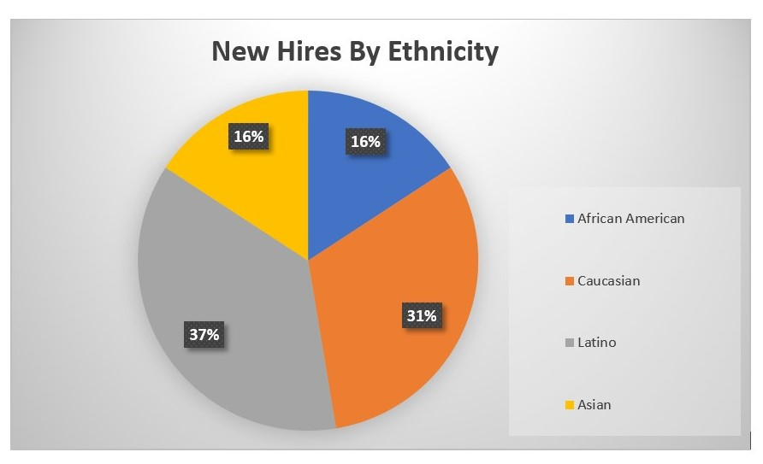

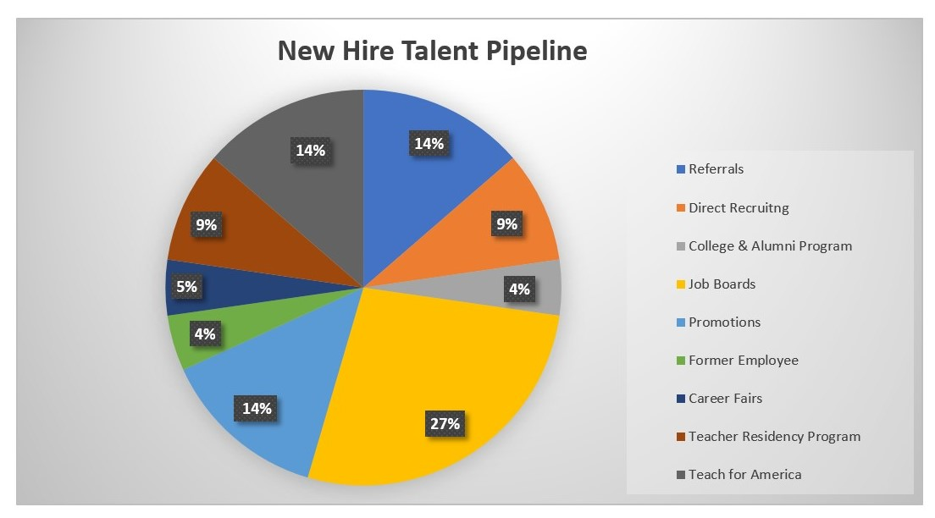

***\*The referral program is a huge asset to generating great talent.***

**5. Challenges and Accomplishments**

The Talent Team has faced a number of challenges – the state teacher shortage, a nationwide decline in candidates entering the teaching profession, attracting teachers to the Bay Area due to the high cost of living, AB 1505, and in some cases, we selected the wrong person for the job. We shared challenges with the Bellwether team during their School Review process, and other settings with our CEO and various stakeholders and we have listened attentively with the goal of overcoming these challenges. We are looking forward to continuing our work in collaboration with our CEO, Senior School Director, our HR department, and other stakeholders to attract, onboard, develop, and retain great talent for our Wave-Makers.

We are humbly celebrating our accomplishments as well. We have hired nineteen new personnel in preparation for the new year and we are making progress toward filling thirteen additional vacancies before our August start date. Of the thirteen remaining vacancies, it is important to note that we have six leadership positions and there are five high-quality internal candidates who are interested and preparing for the interview process. Please reference the chart on the first page to see which positions make up the remaining seven open positions. During these unprecedented times, we are remaining positive, focused and excited to continue this great work for our Wave-Makers and community.