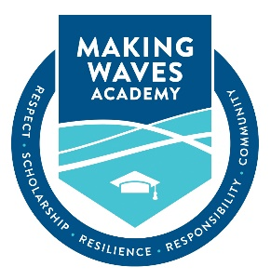

MATERIAL REVISION CHANGES TO THE MWA CHARTER

Executive Summary of Proposed Changes

Proposed Amendment Elements
Making Waves Academy requests the proposed amendment to the Charter Petition, dated July 1, 2017.
- 4th Grade Addition – Making Waves Academy requests to add one additional grade level, grade 4, to the current grade level span served (5th-12th grades).

- Instructional Approach – A Cored-Hybrid Interdisciplinary Model where students will have the same core teacher for 2 of their 4 core classes in English, humanities, math, and science.

- Daily Schedule Changes – The daily schedule will reflect fewer transitions for 4th graders as they will be with one teacher for:
  - English Language Arts & Humanities
  - Mathematics & Science
  - Health and Wellness
  - Encore or electives
The proposed changes of the material revision are provided to our charter authorizer with Track Changes in the most current version of the petition.

