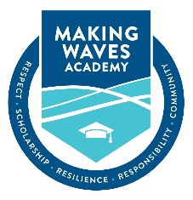

CEO Report

SEPTEMBER 2019

Mission Connection
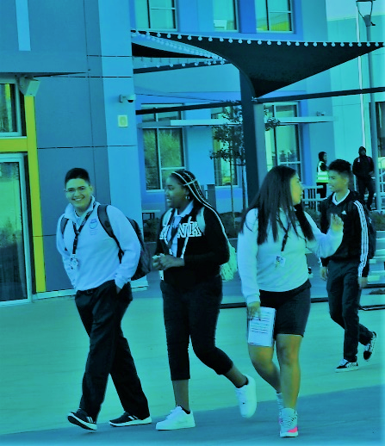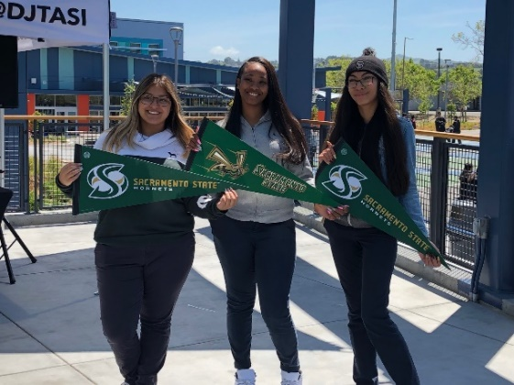
These two pictures represent two of three key parts of the journey of a Wave-Maker – their 5th-12th grade experience here at MWA and their college admissions and enrollment decision. The third phase, college success, is led by the CAP team and is fulfilled as Wave-Makers earn their BA degrees and consider career or graduate school options. The joy found on the faces of the students in these pictures is one of the immeasurable things we bring to our students and their families. The thought of the “impossible” now seeming not only possible and plausible, but achievable… with support.
The process for amending and updating charter legislation confirms what we already knew to be true – equitable, rigorous, and accessible public education for all – is conditional. The key condition being the perceived impact on the current, traditional public school system. The stakeholders with the least amount of political influence (our families) are the most vulnerable to the proposed changes. These changes make it harder, but not impossible, for public charter schools to succeed.
In this current climate, that mirrors a “Hunger Games” approach to education, it is important that we value, recognize, and appreciate a part of the current work of MWA (beyond college-readiness), is to protect and nurture the hopes and dreams our students have for themselves, educate them rigorously and holistically, and create moments of joy and safety, and care.

Focus Areas for 2019-20
- A recommitment to “teaching and learning” – 1) a focus on math instruction, 2) successful launch of our “NEW” SPED program, and 3) black student achievement.
- A commitment to stakeholder engagement and observation of practices throughout the year.
- Preparation for the WASC accreditation visit.

Objectives for the Quarter 1 (JUL – SEP)
- Create and launch a systemic approach to stakeholder engagement for executive leadership and school leaders.
- Create a small working group across the organization to look at math achievement at MWA.
- Consult with MWA leadership to create faculty awards for excellence in the areas of innovation, instructional practice efficacy, and growth mindset along with a service award for a staff member.
- Establish a systematic approach to prioritizing cost areas and expenses in the MWA budget.

Functional Area Spotlight – Executive Office – Chief of Staff, Liz Martinez
My office is focused on the following key areas for quarter one, this work expands the reach of the Executive Office exponentially.

Central Office Functional Areas of Support
-- Business Services -- Executive Office – Learning & Innovation – Operations --
-- Community Engagement & Growth --Talent – Human Resources – Talent --

Governance Practices: Over the summer, I collaborated with the Board President and the CEO to mine the learnings from AY 2018-19 and implement adjustments for AY 2019-20. The objective of these efforts is to preserve the essence of our governing board while ensuring that we are meeting all compliance and transparency requirements. To move beyond compliance to excellence:
- I reviewed our practices against the Brown Act and our By-Laws and as a result re-worked the planning and execution process leading up to Board Meetings.
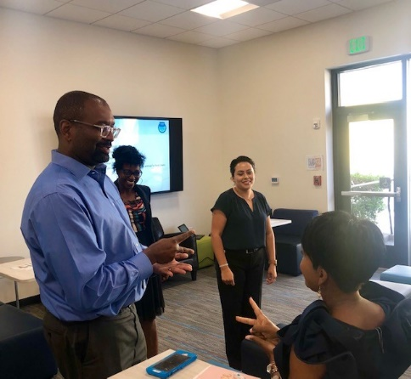
- I updating all Board policies to align with our approved By-Laws.
Office Culture and Climate: The Central Office (MWAS) moved to campus on July 27th and in the midst of our move, we welcomed our inaugural Office Manager, Ashley Yarbrough. We are collaborating to create a foundation for a high-functioning, organized, and efficient front office. In addition to managing the office, Ashley is supporting the Executive Office with a variety of projects that make room for me to focus on high-impact, strategic work such as culture and climate. I have more time to create intentional spaces for joy with our staff.
(Alton & Lisa playing extreme rock, paper, scissors)

Following the Staff Satisfaction Survey and the CEO’s listening campaign, I learned that within our larger community we have wide spectrum of climates and micro cultures beyond upper and middle school divisions. This year, I am leaning in to identify those climates and cultures and address challenges, patterns, and behaviors systematically. Leaning in will look like:
- Facilitating meetings to address larger themes or patterns that are creating tension
- Engaging in one-to-one conversations to explore organizational and interpersonal challenges
- Facilitating workshops, meetings, and/or circles to promote skill development in the areas of conflict resolution, cross-cultural communication, and collaborative problem solving
I look forward to reporting on our wins and challenges later in the year.

