*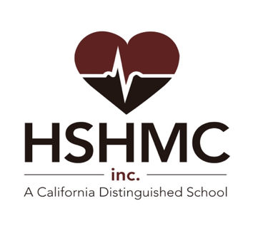*

*(Last board approval 12/2/2020)*

ENROLLMENT PROCESS FOR HSHMC, INC.

APPLICATIONS WILL BE ACCEPTED FOR THE 2023-2024 SCHOOL YEAR BEGINNING NOVEMBER 1, 2022. THE OPEN ENROLLMENT PERIOD IS NOVEMBER 1, 2022 THROUGH FEBRUARY 1, 2023. IF THE NUMBER OF APPLICATION EXCEEDS AVAILABLE SPACES, A LOTTERY WILL DETERMINE APPLICATION SELECTION. SIBLINGS OF CURRENT STUDENTS AND CHILDREN OF SHARP EMPLOYEES WILL BE GIVEN PRIORITY IN A LOTTERY. STUDENTS WILL BE NOTIFIED OF ACCEPTANCE BEGINNING IN FEBRUARY, 2023. STUDENTS WHO ARE NOT ACCEPTED FOR THE COMING SCHOOL YEAR WILL BE PLACED ON A WAITING LIST AND NOTIFIED AS SOON AS SPACE BECOMES AVAILABLE. PLEASE NOTE THAT STUDENTS AT HSHMC ARE UP TO DATE ON THEIR COVID VACCINATIONS.

IN ADDITION TO SUBMITTING AN APPLICATION, INTERESTED FAMILIES MUST ATTEND A “NEW STUDENT ORIENTATION” PRIOR TO FEBRUARY 1, 2023. IF YOU HAVE APPLIED OR WILL BE APPLYING, PLEASE PLAN TO ATTEND A VIRTUAL ORIENTATION AT HSHMC, INC. ON ONE OF THE FOLLOWING DATES:

THURSDAY, NOVEMBER 16, 2022 – 5:30 PM

THURSDAY, DECEMBER 15, 2022 – 5:30 PM

THURSDAY, JANUARY 12, 2023 – 5:30 PM

TUESDAY, JANUARY 26, 2023 – 5:30 PM