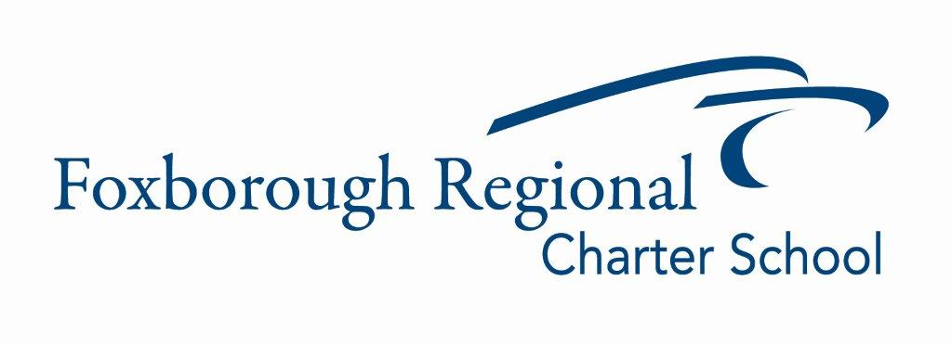

Operations Department Update
February 13, 2024

Elementary School Roof Project:

ES Roof Project Update

I am thrilled to share an encouraging update on the progress of our FRCS Project, which has shown remarkable advancements across various critical aspects. From significant milestones in contracts and budgeting to strategic phasing and scheduling, design and logistical progress, to stringent safety measures in hazmat handling and site visits, our team is demonstrating exceptional commitment and expertise. Each step we take is a testament to our dedication to not only meeting but exceeding our project goals. Let's delve into these exciting developments in more detail.

1. Contracts and Budget: The project has achieved a significant milestone with the approval of the Studio Umbra contract, marking a crucial step in collaboration and project development. The team's readiness to address additional budget requirements for the ES gym roof area reflects their commitment to quality and adaptability to evolving project needs. Anticipation of the comprehensive budget from TERVA represents a proactive approach to financial management.

2. Project Phasing and Scheduling: The team has shown remarkable flexibility in adapting the project phasing to align with a revised and more effective schedule. The detailed planning for Phase 1 and Phase 2, focusing on specific improvements and upgrades in the Elementary and High School, indicates a methodical and well-structured approach to managing the project's timeline. Adjusting deadlines for the schematic design and construction documents demonstrates an acute awareness of the project’s requirements and effective resource management.

3. Design and Logistics: Progress in the design phase, with the schematic design nearing completion and an upcoming cost reconciliation meeting, showcases the team’s dedication to maintaining momentum. The integration of design development with construction documentation is a strategic move, enhancing efficiency and focus on project goals.

4. Hazmat and Site Visits: The prompt identification and planned remediation of asbestos issues, along with the inclusion of these measures in the Summer 2024 budget, highlight the team's commitment to environmental safety and health standards. Conducted site visits emphasize a thorough and practical approach to understanding and addressing the structural and mechanical aspects of the project.

Overall, the FRCS Project Team is making solid progress. They're effectively managing the complexities of contracts, budgeting, and planning. Their careful approach to different project phases and their attention to safety, especially regarding asbestos, demonstrate their thoroughness and commitment. The project is moving forward steadily, with a clear focus on quality and safety.

Food Service Update

I am pleased to announce that our recent transition from Genuine Foods to City Fresh as our food service provider has been a resounding success. We heard and acknowledged the concerns and feedback regarding our previous vendor, and took decisive action to enhance our food service quality. This change is part of our ongoing commitment to providing the best possible experience for our students and staff.

In the few weeks since City Fresh began serving their meals, we have observed a notable increase in student engagement with our food service program. This uptick is not only a testament to the quality and appeal of the meals provided by City Fresh but also reflects our community's appreciation for our efforts to listen and respond to their needs.

We are excited to continue this partnership with City Fresh, and look forward to seeing more of our students enjoy the diverse and nutritious options available. As always, we welcome your feedback and suggestions as we strive to make our school's food service program a highlight of our students' day.

Thank you for your support during this transition and for your ongoing commitment to our school community.

