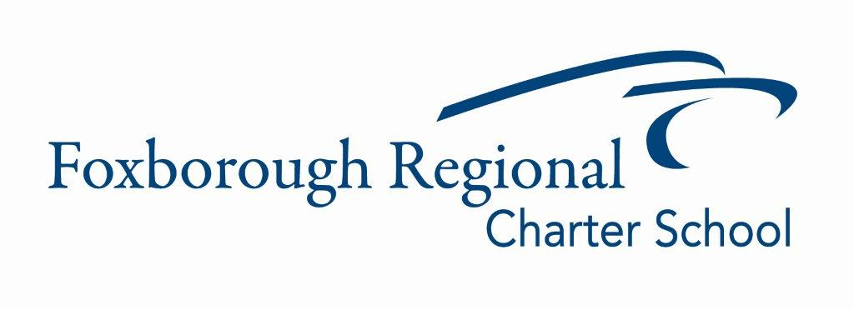

Operations Department Update
December 13, 2023

Elementary School Roof Project Initiation:

Request for Qualifications (RFQ) for a Design Team:
- We issued an RFQ to select a design team for the Elementary School Roof Project. Following the RFQ process, Studio Umbra, the architectural firm responsible for the Middle School Roof Project, achieved the highest score among the ten proposals received.

Next Steps:
- FRCS, in collaboration with our Owner's Project Manager (OPM), Terva, will negotiate a service fee agreement with Studio Umbra.
- The agreed-upon fee will first be reviewed and voted on by the finance committee, then presented to the board for final approval.

Urgent Decision Required:
- Prompt board approval of the design team fee is essential to adhere to the project's timeline once negotiations are concluded.

Attachments for Board Review:
1. Detailed timeline for the Elementary School Roof Project.

