Operations Department Update
September 12, 2023

MS Roof:
Last week's focus in roofing primarily revolved around completing the roof above the Middle School's main entrance. This marked the final significant roofing task within the project. Concurrently, the construction of new roof parapets and the installation of roof edge metal continued, along with the placement of metal scuppers and downspouts. Furthermore, masonry flashing and repointing have been successfully completed on the sloped roof along the west side of the Media Center. This progress now enables unimpeded access to this roof by the roofing team as they proceed with their work early next week. Importantly, this is the last roof above an area that will be occupied during school hours.

On Thursday, 8/24, our mechanical and electrical subcontractor deployed a substantial crew and crane to the site. They effectively hoisted and initiated the reinstallation of the mechanical equipment that was previously removed and stored, located on the Phase 2, 8th-grade roof.

Interior repairs at the Media Center have been successfully completed. The patched drywall has received fresh paint, and a rebuilt sill has been installed at the large window.

Additionally, I'm pleased to report that the demobilization of the site fence has taken place at the HS Main entry courtyard, extending all the way to the middle of the east side of the MS. The remaining fencing panels have been relocated across from Door I to create the new, smaller corral area.

Schedule:

Despite recent weather events, the roofing phase of the project continues to progress ahead of schedule.

Financial:

Projected expenses for the month of August 2023: $1,050,000

Issues/Risks:
We are actively monitoring the delivery of metal panels, collaborating closely with TERVA as they work directly with the manufacturer. Our aim is to potentially improve upon the mid/late October delivery date that was provided by the GC/subcontractor on 8/10. Once we have a confirmed delivery date for the materials on-site, we will develop a plan for their installation, ensuring minimal disruption during school hours.

Site Photos from Terva

Description: Workers continued roof edge parapet construction around the newly installed roof above the MS main entrance perimeter; laying wood framing with rigid insulation infill, and affixed plywood sheathing. (8/26)
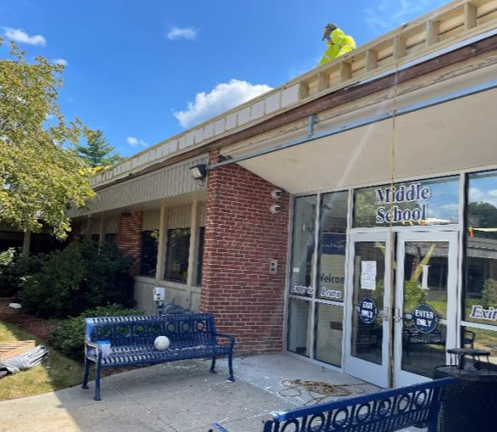
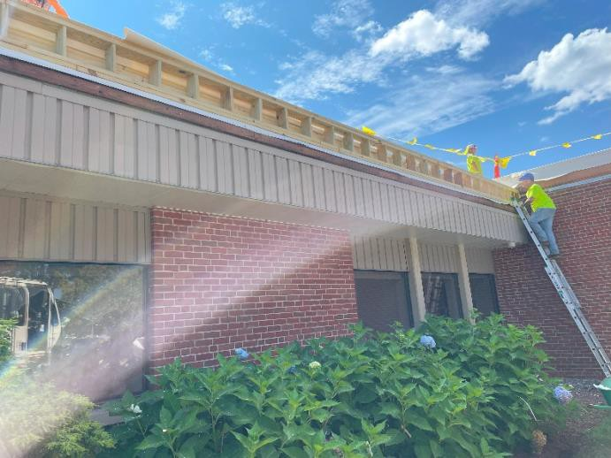

Description: As a precautionary measure, small metal gutter boxes with new downspouts were installed at the placed scupper openings cut into the roof parapets. This is part of the roof design and is intended as a backup system to handle rainwater in emergency situations, i.e, if drains become clogged, or in most extreme rain events if rain leader system becomes overwhelmed, etc. (8/22, 8/23, 8/26)
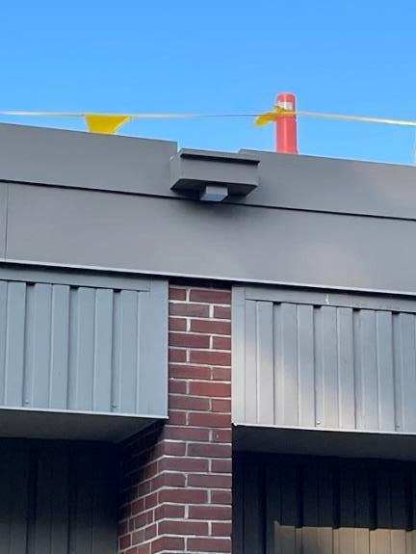
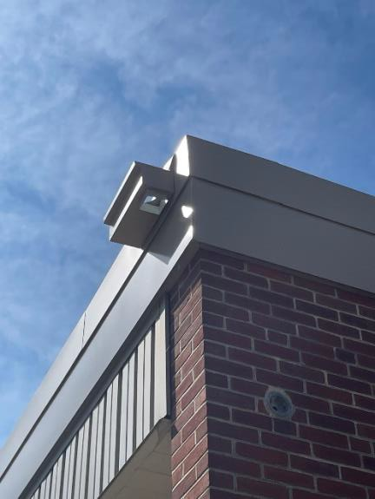
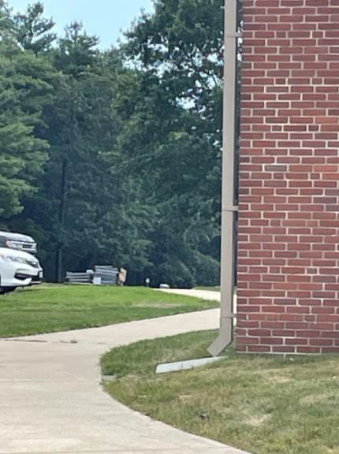

Description: Roofers continued to lay edge metal along the newly framed parapets on the 8th grade roof. (8/26) New metal gutters and edge metal installation began at the 6th/7th grade pop-up roofs. (8/21, 8/23)
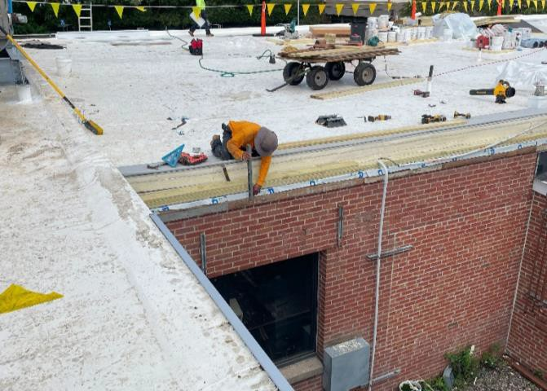
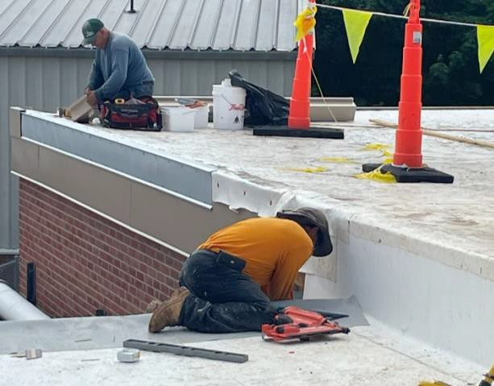
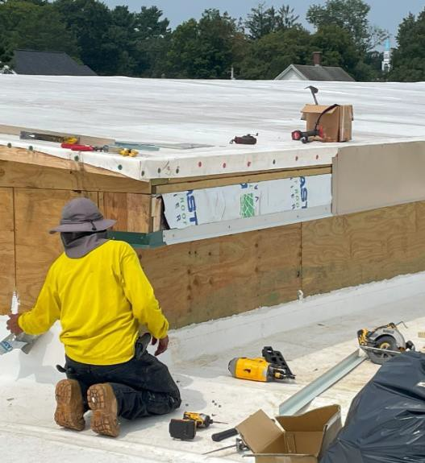
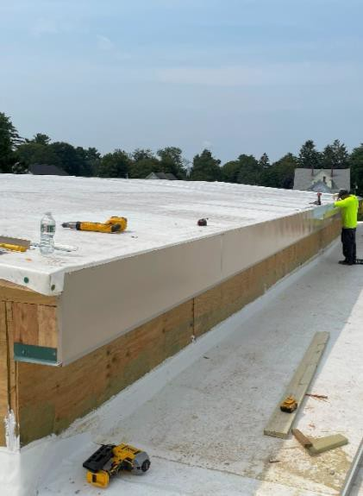
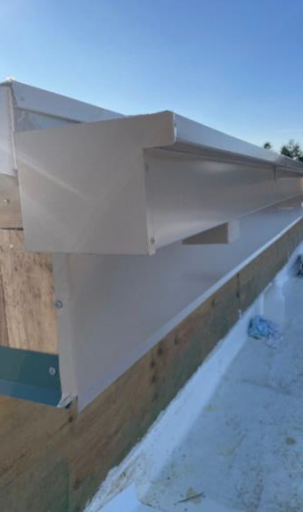

Description: On Tuesday, 8/22, the Middle School main entrance roof was prepped for replacement, beginning with the existing gravel being raked and removed from the roof, followed by screwing down an initial layer of cement board. (8/22, 8/23)
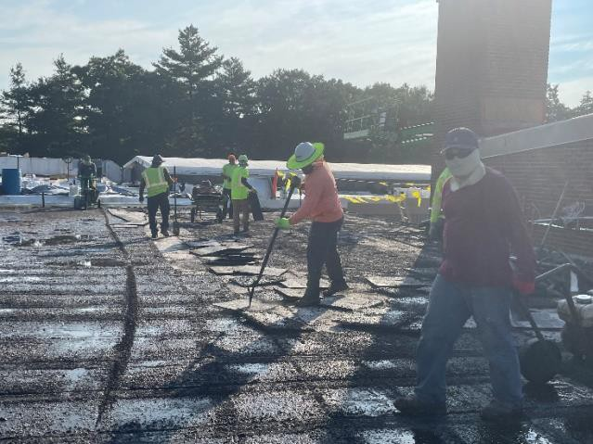
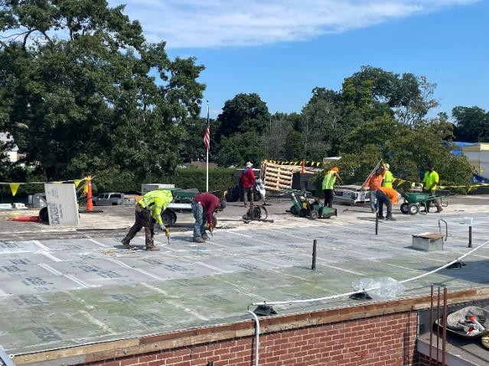
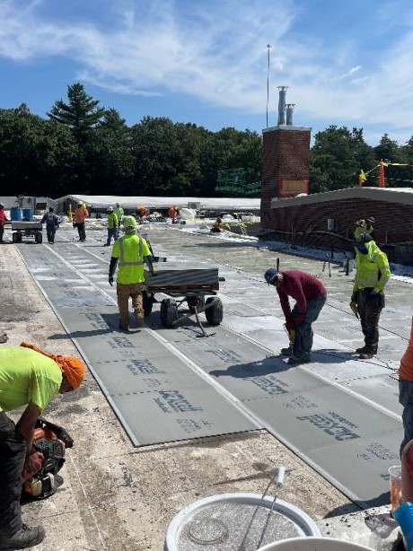
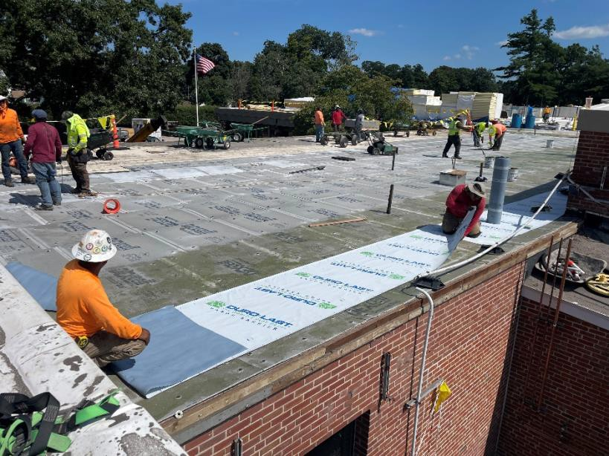

Description: Roofers lay down the initial layer of air vapor barrier, built-up layers of insulation, cement board, and the PVC membrane on the roof above the Middle School main entrance. This was the final large roof to be completed as part of the project. (8/22, 8/23)
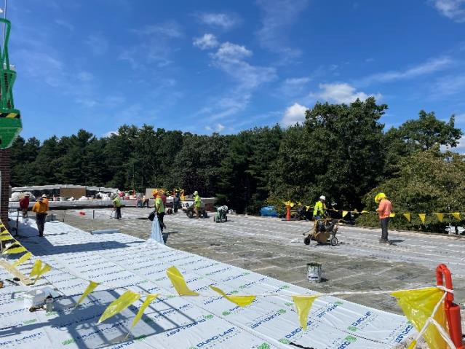
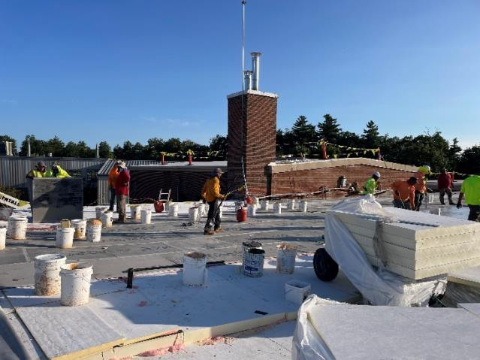
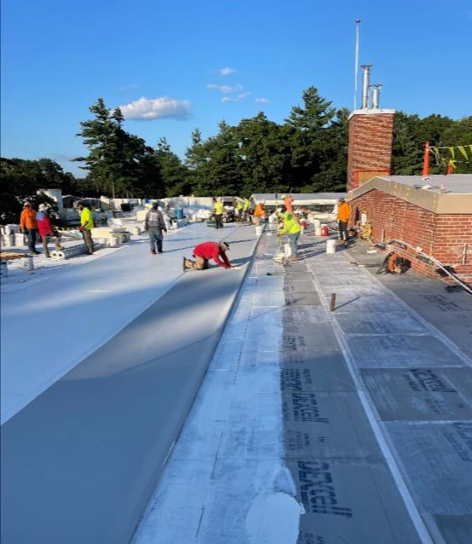
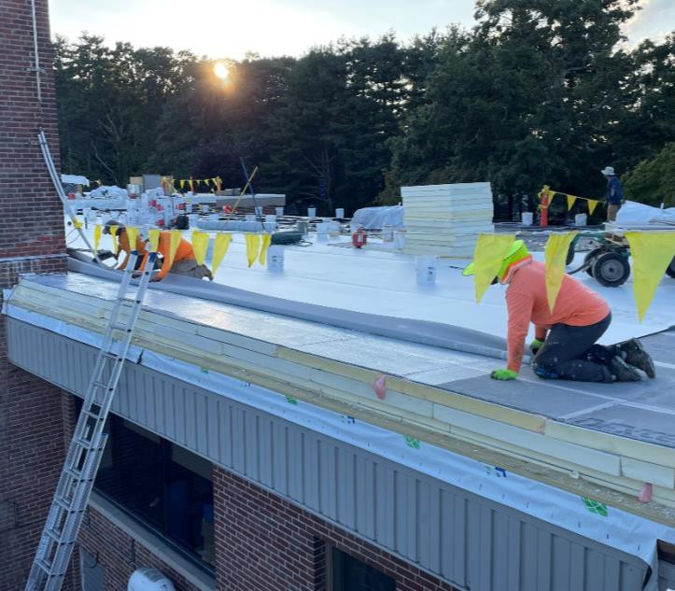

Description: The balance of the mechanical equipment and structural support extensions, which was being temporarily stored on the lawn while the new roofs were installed, was lifted off the ground by crane and placed back on the 8th grade new roof. Structural steel workers first installed the steel extensions prior to the placement of the steel frame and the mechanical equipment. Mechanical subcontractor is working to reconnect and recharge the mechanical equipment prior to the return of students. (8/24, 8/26)
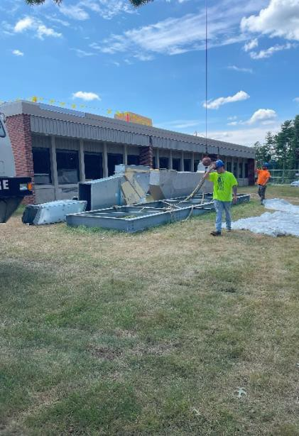
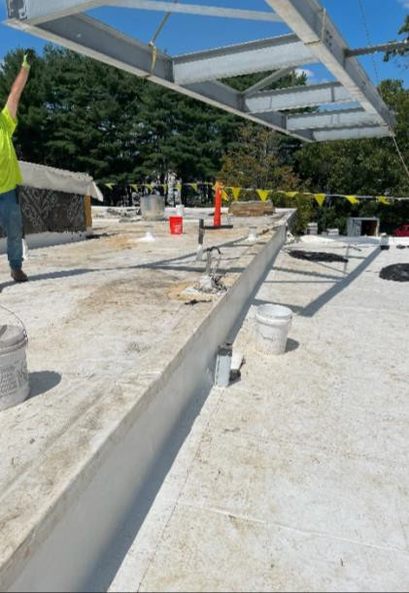
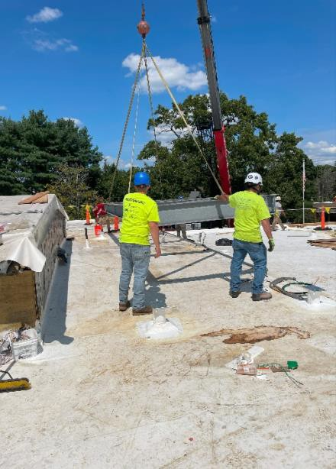
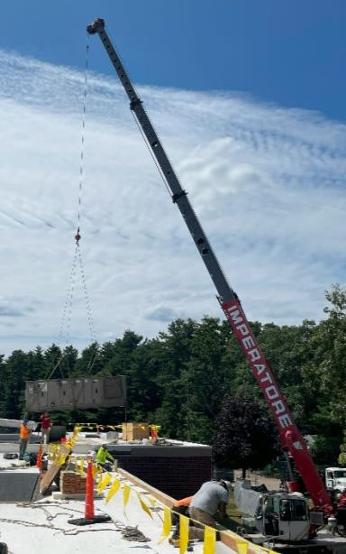
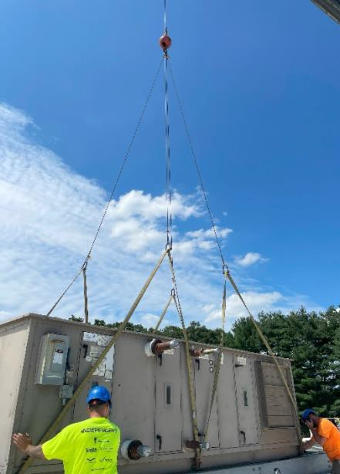
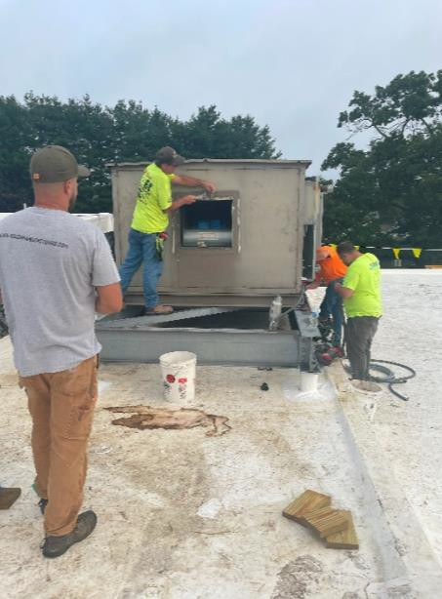

Description: Electricians work to reconnect the Phase 1 exhaust fans, following the reassemly of the existing ductwork on the 6th/7th grade roof by the sheetmetal workers. (8/24)
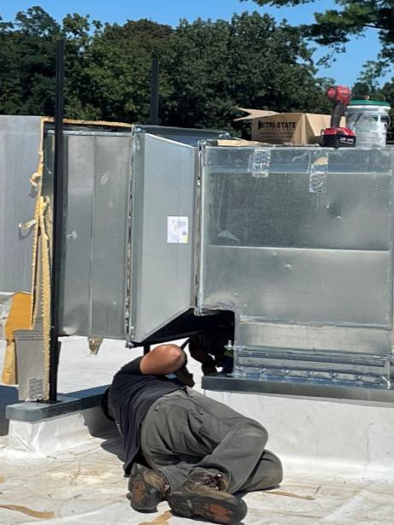
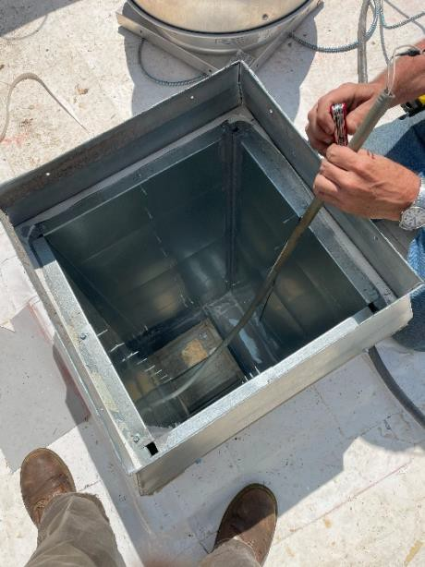
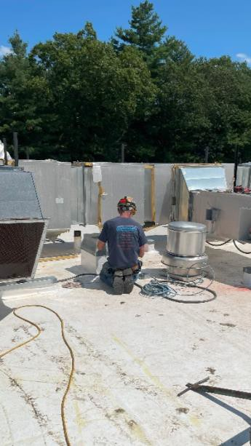

Description: Hanging piping along the Media Center gable wall. Prepping the run to the newly relocated ground-mounted chiller. Connection to the chiller will occur next week. (8/22)
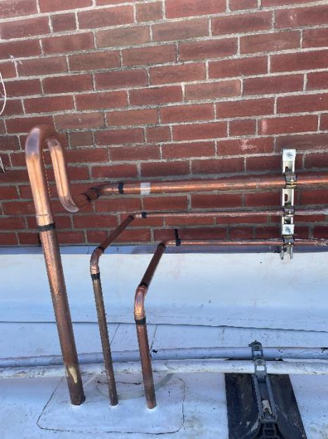
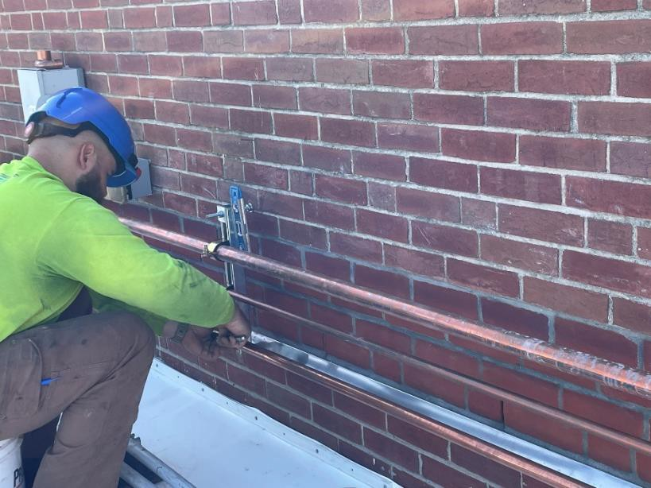

Description: Masonry work continues at the sloped roof between the Middle School entrance/offices and the low roof behind the Media Center. Chipping and removal of existing brick, installation of new through-wall flashing, and laying of new brick, to be followed by washing at the end of the week. (8/22, 8/23)
