Operations Department Update
August 8, 2023

MS Roof:
As in the last update, there are no major issues to report, and everything is moving according to schedule. Although, we’ve had a lot of rain this summer, the team has not only been able to keep the project on schedule, but we are also slightly ahead.
CORI
CORIs continue to be processed as needed and I would like to make a note of Mallory and the HR Department’s efforts in keeping up with the demand. If it were not for their efforts the project would not have started on time.

FINANCIALS
July invoices have not been finalized yet but are projected to be: $900,000
No change orders in the month of July

PROJECT SCHEDULE
The phases have been updated and will not reflect the original plans.
- Phase 1 (Heavy work that would have the most impact on the 5th,6th, & 7th grade wing low roof/AHU serving the Cafeteria, ) • Phase 1 has been completed. There continues to be work that needs to be done in that section of the building, such as masonry work, flashing and reinstalling the HVAC system, but the major work has been completed and the team feels comfortable with moving onto Phase 2.

- 8th grade wing and offices Phase 2 – Starts 7/31/23

- Media Center • Phase 3 – (TBD)

Site Photos
Description: Phase 1 – Stripping of existing roof and installation of new roof, southeast section of grades 6/7 roof.
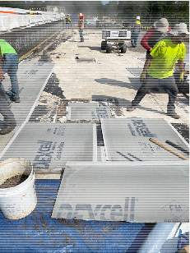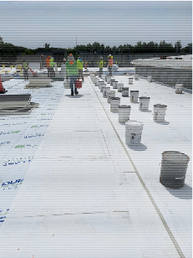

Description: Phase 1 - All of the tar and gravel has been removed and start of laying new cement board, followed with insulation, middle section of grades 6/7 roof.
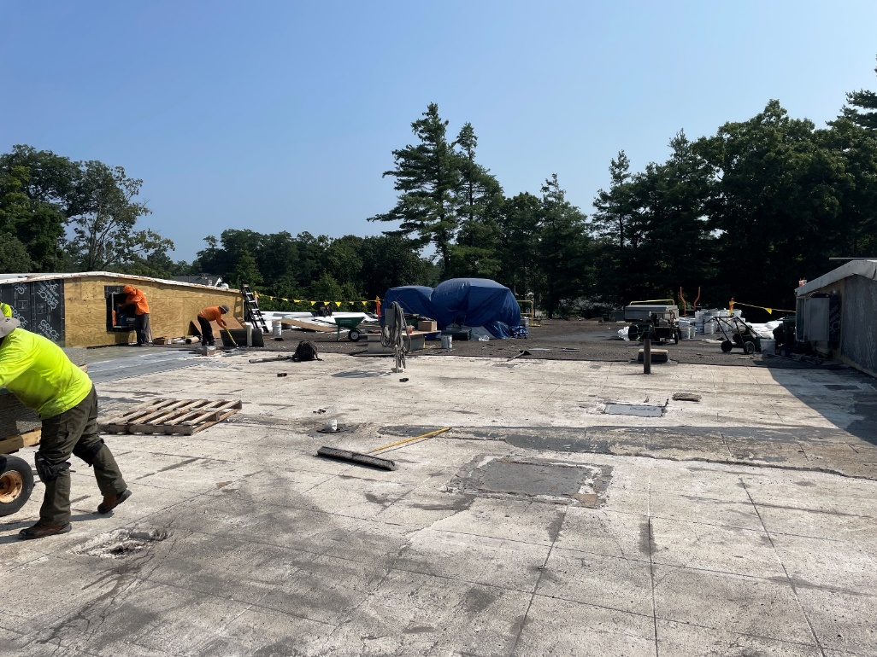

Description: Phase 1 - All of the AVB is installed and rolled, to be followed up with gluing down of insulation and the final cement board backer, middle section of grades 6/7 roof.

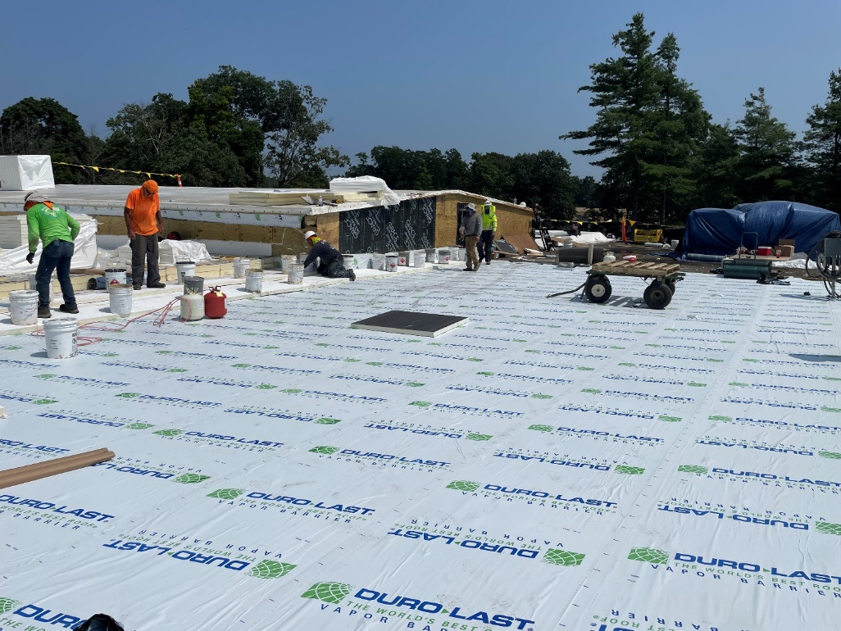
Description: Phase 1 - The membrane was laid down atop of the cement board, to be followed with welding the membrane together, middle section of grades 6/7 roof.
