The following information provides a snapshot of the data collected about PCM during the 2022-23 school year. The 2022-23 school year marked the second year of operation for PCM. According to NWEA MAP assessment data, over half of our students came in between 1 to 2.5 years below grade level. While many students realized significant academic growth, the needs of mental health and social-emotional growth were high and had more impact than in pre-pandemic years on students’ ability to make pre-pandemic projected academic growth. This year students in grades 3-5 participated in the statewide Smarter Balanced Assessment (SBA) for Reading and Math. The 5th grade participated in the Washington Comprehensive Assessment of Science (WCAS).

From reflections, data analysis, and feedback from last year, PCM’s staff will focus on the following for the 2022-23 school year:

- Amplify the emphasis on place-based and project-based learning for older elementary students, in anticipation of a shift towards a student demographic that supports a more authentic Montessori environment in the coming years. This period will focus on utilizing place-based project-based learning to equip students with the leadership skills necessary for success in the Adolescent Community Program, ensuring a seamless transition that aligns with Montessori principles.
- Fortify the special education inclusion model by increasing dedicated planning time for collaboration between special educators and classroom guides. This will ensure that all students receive the support they need within a fully inclusive environment.
- Establish a comprehensive and vertically integrated social and emotional learning (SEL) curriculum to foster a positive atmosphere within classrooms and throughout the school. This initiative aims to build a cohesive, supportive community for all students and staff.
- Initiate the formation of student, parent, and community councils, and enhance educational opportunities for parents. These councils will serve as platforms for active engagement, feedback, and collaboration, strengthening the school-community partnership.

If you have any questions about the data, please feel free to reach out to Laylah Bewick at laylahb@myPCM.org

Sincerely,
Laylah Bewick
Pullman Community Montessori - Head of School

PCM 2022-23 CORE DATA SUMMARY

2022-23 Demographic Data Comparisons

*PCM 2022-23 enrollment data is based off of 97 students.*
Key: EL = Elementary, PSD = Pullman School District

Social Emotional Learning

As PCM’s model is focused on whole-child development, elevating executive functioning and social-emotional skills development to that of academics, PCM measure growth in the area through an assessment called EFgoPro. The assessment is administered three times per year and focuses on measuring growth over time.

PCM students ranked in the 58th national percentile. With intensified efforts PCM expects to see more growth in future years.

2022-23 SEL Results
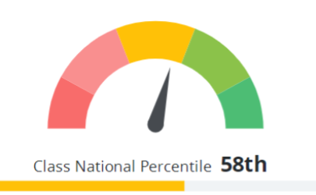

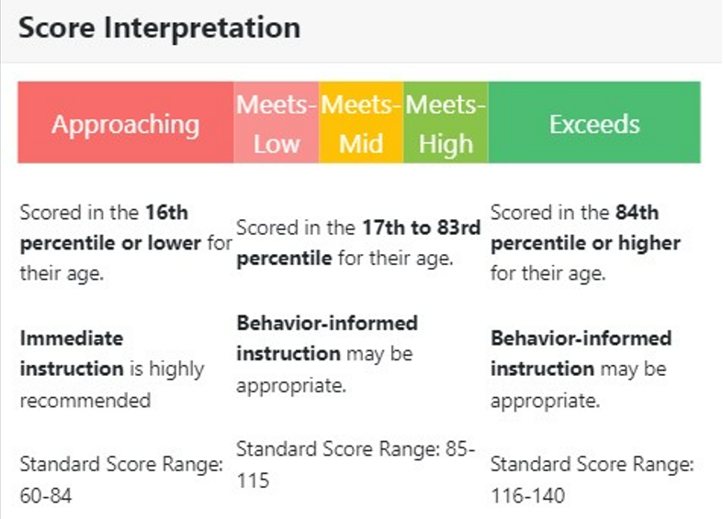

SEL Growth

The tables below were extracted from the one-pager created in collaboration with Reflection Sciences, creator and host of the EFGoPro Assessment System. To read more about how this assessment is used please read this one-pager.
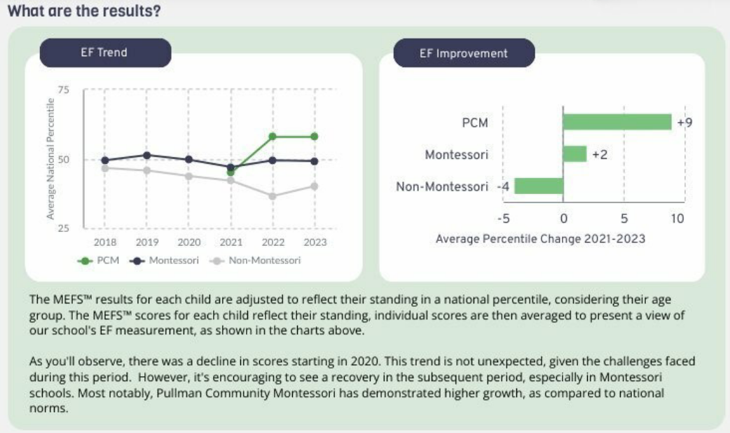

State Assessment Results
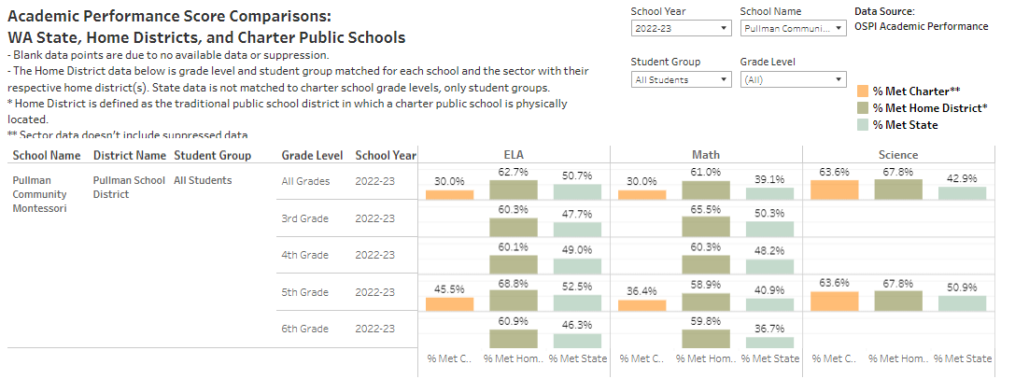

State Assessment Results by Skill Level

 | ELA | Math | Science
Percent Level 1 | 33.3% | 53.3% | 36.4%
Percent Level 2 | 36.7% | 16.7% | 0.0%
Percent Level 3 | 13.3% | 20.0% | 54.5%
Percent Level 4 | 16.7% | 10.0% | 9.1%
Percent Met Standard | 30.0% | 30.0% | 63.6%

While PCM intends to continue to focus and strengthen our support to increase student academic performance, perspective should be maintained when interpreting SBA scores keeping in mind the number of students coming in significantly below grade level and accounting for student growth within the academic year (according to NWEA MAP) that is not reflected in these summative scores. Additionally, our student population level in grades 3 through 6 can be significantly small (as low as 3 students in a grade level). An example of growth that would not be reflected in SBA scores is displayed below. A student with growth in the 80th percentile or above is making the maximum growth that can be expected while still learning other critical skills and retaining their love of learning.

MAP Growth & Achievement – Math

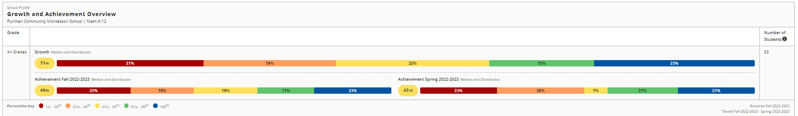

MAP Growth & Achievement – Reading

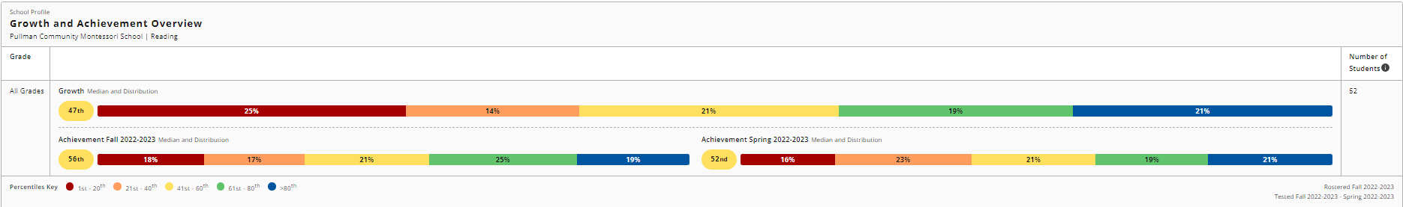

School Specific Goal Results

Annually, Washington charter schools are required to identify a minimum of two school specific goals, one operational and one academic. PCM’s academic school specific goal states: of the students who score Lo and LoAvg on their MAP Reading and
Math in Fall 2022, half of them will achieve their MAP Projected Growth goals by the Spring 2023 testing session.

For PCM’s Operational School Specific goal, PCM met our goal as assessed using the Essential Elements of Montessori in the Public Sector Rubric that was created by the National Center for Montessori in the Public Sector. The areas of significant struggle were securing and maintaining dual certificated Montessori Guides (aka Teachers) and securing a full-time qualified Montessori instructional coach who also serves as the Director of Academic Programs. It is hoped this will improve as our school grows and implications of COVID reduce over time.

For PCM’s Academic School Specific Goal, PCM exceeded our goal in Reading and met our goal in Math:

READING EXCEEDS: >60% of students scoring Lo/LoAvg meet their individual growth projection goals on Spring MAP
PCM = 76% of students classified as Lo or LoAvg on the fall 2022 assessment met or exceeded their projected growth on the Spring 2023 assessment.

MATH MEETS: 50-59% of students scoring Lo/LoAvg meet their individual growth projection goals on Spring MAP
PCM = 50% of students classified as Lo or LoAvg on the fall 2022 assessment met or exceeded their projected growth on the Spring 2023 assessment.

The school wide data for MAP Reading and Math are reflected in the tables below.

The percentages in column one shows the percentage of students who met or exceeded their growth targets as projected by the fall 2022 MAP assessment. The percentages in the second column, reflect the percentage of students whose achievement level was considered to be in the average or above quintile on the fall 2022 MAP assessment.

KEY
F-S = Fall 2022 to Spring 2023 growth
W-S = Winter 2022 to Spring 2023 growth

School Specific Goal – Reading Results

 | F-S Reading Growth | % with achievement AVE or above in F
Whole School | 52%
Younger Elementary (1, 2, 3) | 47% | 67%
Older Elementary (4, 5, 6) | 60% | 75%
K (W-S only) | 43% | 74%

School Specific Goal – Math Results

 | F-S Reading Growth | % with achievement AVE or above in F
Whole School | 55%
Younger Elementary (1, 2, 3) | 50% | 50%
Older Elementary (4, 5, 6) | 68% | 53%
K (W-S only) | 77% | 88%

*Kindergarten engages in the WaKIDS Inventory of Skills in the fall so kindergarten does not participate in the fall assessment. Kindergarten does participate in the winter and spring assessment to provide them opportunity to engage with computers and assessments prior to their first-grade year.

NWEA MAP (Northwest Evaluation Association - Measure of Academic Performance) is a widely used adaptive assessment for English Language Arts and Math performance that is taken three time per year at PCM. MAP is nationally normed and used to measure and support student growth.

