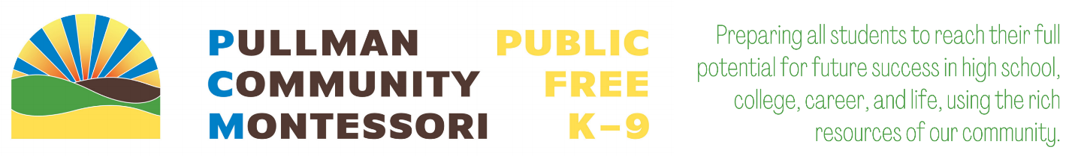

FAMILY & COMMUNITY
ENGAGEMENT HANDBOOK

PCM shall not discriminate in any programs or activities or against any student, employee, or any other person on the basis of age, sex, race, creed, belief system/religion, color, marital-partnership status, status as a victim of domestic violence, national origin, alienage or citizenship status, veteran or military status, sexual orientation, gender expression, gender identity, the presence of any sensory, mental, or physical disability, or the use of a trained dog guide or service animal, and provides equal access to the Boy Scouts and other designated youth groups. Furthermore, PCM shall not discriminate on any other ground that would be unlawful if done by any other public school. PCM shall take all steps necessary to ensure that discrimination does not occur, as required by state and federal civil rights, and anti-discrimination laws.

For any questions, concerns, or to report violations, please contact one of the following coordinators:
- Title IX/Sex Equity Officer & HIB Compliance Coordinator/Officer – Jared Kuhn – JaredK@myPCM.org
- Gender Inclusive School Coordinator - Laylah Sullivan - LSullivan@myPCM.org
- Civil Rights Compliance Coordinator - Jill Stansbury - JillS@myPCM.org
- Section 504 & IEP Program Manager - Emily Klein - EmilyK@myPCM.org
- Homeless/McKinney Vento Liaison – Michael Moll-Fuller – MichaelM@mypCM.org
- State Assessment Coordinator – Jill Stansbury - JillS@myPCM.org

Pullman Community Montessori | 115 NW State St, STE 212, Pullman, WA 99163 | (P)509-336-5909
TABLE OF CONTENTS
Section1: Introduction 3
Pullman Community Montessori 3
Pillars & Core Values 3
Charter School Basics 5
Section 3 Involving the Community and Families 8
Community Involvement 8
Parent Involvement 10
Section 3: Plan 12
Annual Meeting 12
School-Parent Compact 12
Title 1 Family Involvement Budget 12
Parent Involvement Workshops and Opportunities 13
Partner Programs 14
Accessibility 14
Communication 14
Annual Notifications 14
Section 3 Adoption 15

Section1: Introduction
At PCM we recognize that family and community engagement in our school’s activities, promotes student achievement. All students will benefit from increased family and community engagement that provides connections within our community in addition to positive educational and career opportunities for students.

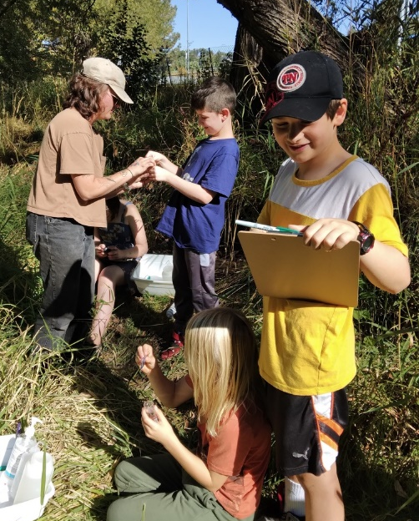
Pullman Community Montessori
PCM is a free public charter school for Kindergarten – 9th grade. Our education model is personalized to students’ needs and prepares them—through rigorous academics, a robust social-emotional program, and career and life skill development—to ensure every student has the opportunity, skills, and mindset to be successful in college, career, and life. We rely on a data-driven, high-quality, place-based Montessori program, deeply rooted in research, to achieve this goal and foster students’ love of learning. We are deeply committed to guiding students to be self-empowered lifelong learners, global citizens, environmental stewards, and compassionate and collaborative leaders, bringing positive changes to their communities and the world!

Pillars & Core Values
Our pillars reflect our commitments and beliefs around school, students, and families. Six pillars establish the foundation at PCM:
- Cultivating collaborative leaders
- Respecting the child
- Self-empowered lifelong learners
- Our place, Our Community
- Families as partners
- Teachers as leaders and change makers
Cultivating collaborative leaders: We guide students to find their inner leader as they are the change-makers of tomorrow. Students, staff, board and community members model our collaboratively developed core values. Students are well supported while engaging in opportunities to hone their LEADERS skills which are broadly defined in ways that empower them to find their personal leadership style.

Respecting the child: We see the power of the child and their innate ability as capable seekers of knowledge. Teachers work as Guides to help students cultivate agency, intrinsic motivation, and independence. Our diverse (racial, cultural, socioeconomic, gender, abilities, age and orientation) mixed-age environments are strategically prepared to aid in this development and provide authentic opportunities to grow. All are welcomed and included.
Self-empowered lifelong learners: Keeping respect for the child’s innate curiosity at the forefront, we guide student growth academically, socio-emotionally, culturally, creatively, and physically through adherence to the essentials of the Montessori ‘whole-child’ educational approach. Essentials include:
- a highly trained, dual certificated Montessori teacher accompanied by a trained classroom assistant/interventionalist in each classroom
- extended blocks of uninterrupted but highly supported work time
- integrated curriculum
- specially designed, hands-on materials to build understanding from concrete to abstract
- strategically prepared classroom spaces
- authentic engagement opportunities and materials
- a mixed-age community environment; and
- a deep commitment to nurturing student agency, intrinsic motivation, and independence through a learner-centered approach.

Our place, Our Community: We engage students with their community’s local and natural resources through place-based projects to build real-world connections. This strengthens students’ sense of place and identity. We expand our concept of our classroom beyond our school walls to include our local community with wider application to the nation and the globe. Current and future careers require systems thinking, cultural humility, creativity, perseverance, and the ability to apply knowledge in diverse situations. The expansion of our classroom beyond our facility walls not only improves student engagement but positions students as self-knowing innovators and change-makes who understand their interconnection with their local, regional, national, and global communities.

Families as partners: Parent involvement is crucial to helping a student reach their full potential. We engage with families as partners so all feel vested and equipped with the tools necessary to make a positive contribution to the student’s development. Additionally, we expand our ‘family’ network beyond parents of students. PCM actively works to build relationships and opportunities for involvement and input with our local community partners to increase the support for each of our students. This expanded culture creates a strong and supportive educational ecosystem which supports student thriving.

Teachers as leaders and change makers: Relying on over 100 years of accumulating best practices, Montessori-trained teachers act as learning guides while classroom assistants support classroom culture. Our classroom assistants are trained interventionists. Our guides are educational scientists, empowered to shape curriculum and school culture and contribute to ongoing developments in the field of education through research and the dissemination of knowledge. To achieve this goal, staff and classroom assistants form professional learning communities and are supported with over 30 days of annual professional development and collaboration time.

PCM’s success is grounded in our approach to building culture within our classrooms, facility, and outside through our expanded definition of community.
PCM’s core values, We are LEADERS, serves as a blueprint of actions to create and reinforce the habits and language that support an environment of diversity, equity, and inclusion, where differences are valued and accountability, integrity, character, and a growth mindset are fostered. Our expectations that all participants of PCM’s community—students, teachers, staff, and parents—uphold and support our core values, display our high standards for all and our intent to expand community beyond our classroom walls.
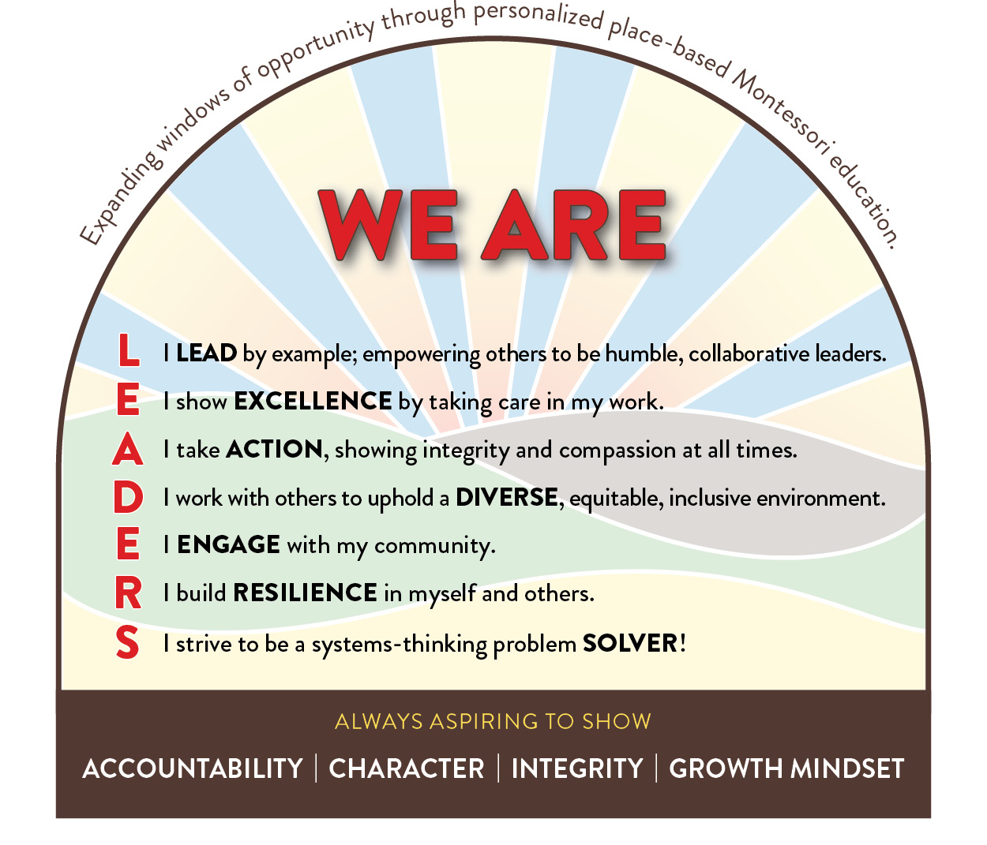

Charter School Basics

What is a charter school?
Charter schools are free public schools open to all students. Sometimes charter schools are perceived as private schools because they are not run by an elected district school board. Instead, they are managed by a Board of Trustees. Charter schools are therefore exempt from many public school regulations for curriculum development, staffing and budgeting. Charter schools commit to the same academic goals set for all public schools in Washington, then make their own decisions about how to achieve them.

What makes charter schools different from traditional district schools?
Since charter schools are independent from the district system, charter schools have greater flexibility in the way they operate. Charter schools are free to develop their own academic program, choose staff, set educational goals, offer a longer school day and school year, and establish their own standards for student behavior. Charter schools are required to raise student achievement. If they do not meet their performance goals they can be closed.

Who holds charter schools accountable for student performance?
Many checks and balances ensure that charter public schools provide quality education. Just like any other Washington public school, charter schools are overseen by the Office of Superintendent of Public Instruction (OSPI) and the State Board of Education. As with every public school, charter schools must comply with the same state and federal laws regarding health, safety, civil rights, and nondiscrimination. Charter schools must meet the same academic standards as any public school in Washington, teachers have to meet the same certification requirements as other public school teachers, and students take the same standardized tests. Charter schools must comply with the open public meetings act and public records act. Additionally, PCM receives additional oversight from the Washington State Charter School Commission and charter contracts are renewed based on school performance.
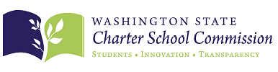
The PCM Board of Trustees oversee PCM are subject to state and non-profit financial audits and have to answer to the community. Since families choose to attend PCM, the school is directly accountable to parents and must ensure it is meeting parents’ standards and expectations.

Who can attend charter schools?
Charter schools are free and open to all students. If more students apply to a school than seats are available, students are enrolled based upon a random lottery system.

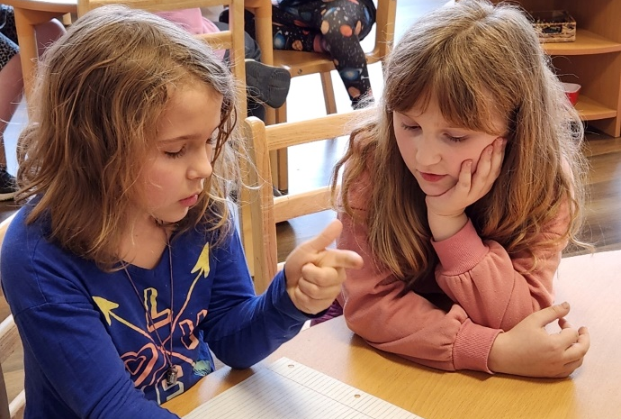
How does the lottery system work?
When more students apply for a charter school than seats are available, State law requires that a random public lottery be held by which to admit students. Within this lottery sibling preferences is followed, similar to other public schools. Charters schools are eligible to apply for other preferences as well. PCM applied and was granted a preference to increase the opportunity for students who qualify as economically disadvantaged, as well as a preference for staff children. All lottery preferences other than those required by law were approved by the Washington State Charter School Commission.

PCM uses Transparent Classroom to manage applications and conduct the lottery. If a lottery is necessary, it is random and conducted publicly with a nonaffiliated third-party observer present. Students who are not granted a seat are added to the waitlist for the given grade level. Their order is based on the selection order determined by the lottery. Families who register after the lottery has been conducted are added to the waitlist in the order their applications are received.
For further detail around PCM’s Enrollment Policies and Procedures you can visit our website.

Section 3 Involving the Community and Families

Community Involvement

What role does the Board of Trustees serve?
While the board has numerous responsibilities, its chief objective is ensuring PCM’s financial, organizational, and academic success through high quality governance. The ultimate governance role of PCM’s Board of Trustees includes the following:

- Safeguard PCM’s mission and vision and secure sufficient resources to fulfill it.
- Assess its own performance regularly.
- Ensure transparent, strategic, and effective resource allocation.
- Hire, support, and assess the performance of PCM’s head of school.
- Serve as ambassadors for the organization.
- Set clear policies and procedures.
- Use SMART goals to create a clear track for success and compliance.
- Monitor and ensure legal and regulatory compliance.

Who can apply?
Anyone may apply for an open board seat or board committee position. The PCM founding board is committed to expanding our board to reflect the ethnically and professionally diverse community we serve. While we take our stewardship role of public funds seriously, we are also committed to giving our community voice in that management. Therefore, while the PCM Board may consider a few members outside our community, the majority of seats will be filled by our local community members. For a candidate outside of our community to be considered, they must hold exceptional expertise that align to PCM’s mission, vision, and goals. If a candidate is elected by a majority vote of the Board of Trustees, they must submit to background check.

What are the required qualifications for board and committee service?
- Belief in the Washington Charters School Sector and in the mission of PCM.
- Passion and commitment to high-quality education and serving the needs of ALL students.
- Capacity to give time and energy and a willingness to provide access to resources, both financial and in-kind, to support and strengthen the school.
- Professionalism, entrepreneurialism, resourcefulness, and critical thinking.
- Ability to work effectively on a diverse team.
- Acceptance and support of decisions made in accordance with the bylaws;
- Willingness to leverage personal and professional networks and resources on behalf of the school.
- Committed to self-reflection and personal growth.
- Open to expanding cultural competence and personal understanding of Diversity, Equity, and Inclusion.
- Commitment to anti-racist governance.
- Eager to contribute personally while honoring the full board commitment to the community and the PCM’s mission and vision.

What are the board committees and what do they do?
​
The Governance Committee is responsible for ongoing review and recommendations to enhance the quality and future viability of the Board of Trustees.

The Finance Committee coordinates the Board’s financial oversight responsibilities by recommending policy to the Board, interpreting it for the Trustees, and monitoring its implementation. All members of the finance committee will work together
to make certain that all financial matters of the organization are addressed with care, integrity, and in the best interest of PCM.

The Development Committee leads the Board’s participation in resource development and fundraising. The committee is the Board’s central source of information about the fundraising climate in general, and about the status of the school’s larger scale fundraising activities in particular. It also plays a strong role in identifying, cultivating, and approaching major donors.
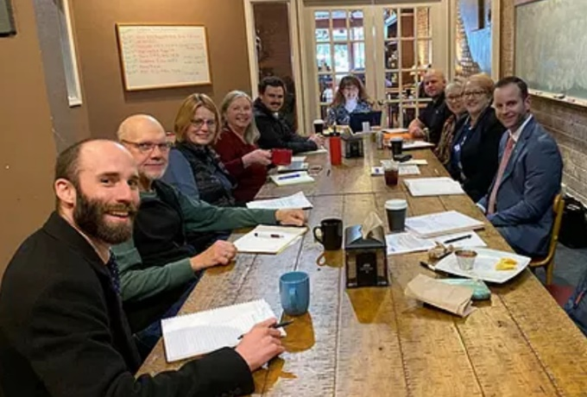
The Leadership Evaluation and Support Committee is commissioned by and responsible to the board of trustees to assume the primary responsibility for developing and implementing a year-round process to strengthen the board’s support, evaluation, and partnership with the Head of School.

The Academic Excellence Committee is responsible to the board of trustees to assume the primary responsibility for working with the school leadership team (Head of School and Montessori Coach –Director of Academic Programs) to define academic excellence, ensure that all board members know the charter promises that were made to the community and the authorizer and to devise clear and consistent measures to monitor these goals.
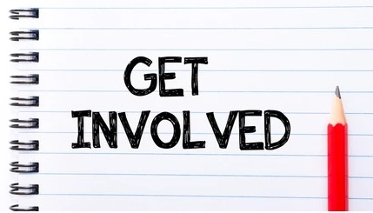
​

Committee meetings are open to the public. If you are interested, a great way to learn more is to attend one of our meetings. If you find you are interested, please contact PCMs main office and they will connect you with the respective committee chair and will follow up with you.

Parent Involvement

PCM recognizes the vital role that families play in a child’s life and education. It is important for parents and families to be engaged their child’s school lives and build strong partnerships with educators and schools. Community is one of the core components of PCM’s model and the Montessori philosophy in general. PCM extends its definition of community to include not only members of the school, but also the broader Pullman community that we frequently engage with through place-based learning, which includes walkabouts, project and service-learning projects, and field trips. PCM recognizes that people within our community may be unfamiliar with the Montessori model of education. We are committed to promoting PCM’s model throughout our community to not only ignite more support, but to also generate awareness of Montessori education. Additionally, our outreach materials and marketing plan is designed to provide information on child development to expand our role as educators beyond our walls. This commitment aligns with our vision to serve as an instrument of change and is one way we can give back to our community.

Participate on PCM Advisory Councils
The Community Advisory Council is composed of family and community members who are attuned to identify community perceptions and needs specific to communication, service, and family education.

The Special Support Council is composed of families of children currently in special populations with unique services. These special populations include those with 504 plans, IEPs, multilingual support and participation in the highly capable program. This committee helps PCM ensure that parents of special populations feel like they have a place to advocate for their children’s needs.

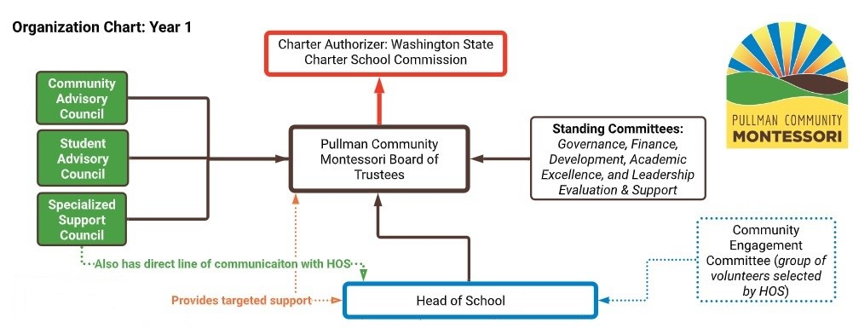
The Student Advisory Council is composed of students who are willing to identifying and sharing ideas to strengthen PCM’s program and provides students with an authentic opportunity to participate and make their voice heard in the adult world.
PCM’s organization chart illustrates how the Board of Trustees, board committees, councils and the Head of School are positioned to assist each other.

Communicate with teachers
Communication between schools and parents is a two-way street. PCM strives to communicate with parents about programs and student progress, and encourages parents to reach out to school staff to discuss their child’s work and progress. Our goal is to establish a relationship with parents and families your child’s by having a consistent and open dialogue.

Volunteer at your child’s school
We encourage you to reach out to your child’s teacher or the main office to learn about the various volunteer opportunities. Volunteering is a great way to connect with other parents and create a community of other parents committed to the success of PCM’s students.

Be a part of the decision-making process PCM creates ways for parents to weigh in on key decisions concerning the school. When these opportunities arise – get involved!

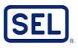
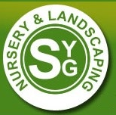
Collaborate with the community
PCM parents are well connected in our local community and can assist in connecting PCM to local businesses, cultural and civic organizations and contacts at WSU as potential partners. In addition, PCM encourages parents and community organization to participate in our “Community Experts” classroom activities where relevant learning takes place with students.

Grow your skills
PCM strives to provide supports and resources that assist families with parenting techniques, family support, and understanding child and adolescent development. Being involved with other school families will provide you with a place
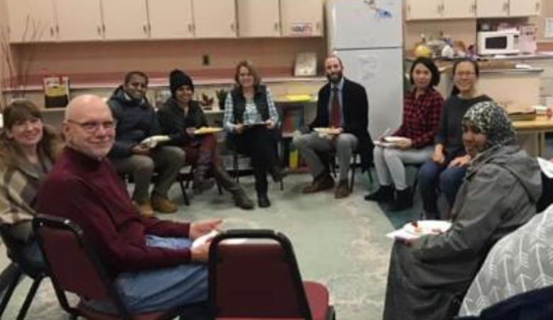
to gain practical advice from others.

Section 3: Plan

Annual Meeting

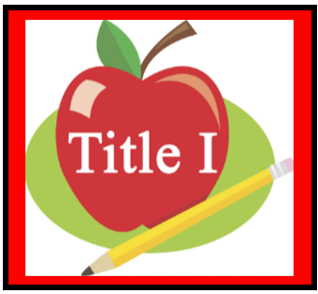
Families are invited to attend our annual family and community engagement meeting at Curriculum Night on September 1st and 2nd. There will be two sessions from 4-5 pm and 5-6 pm on each night.
This meeting provides families with the opportunity to learn about PCM’s Title 1 programs and requirements. Families will be able to review and provide feedback in the following areas:
- Title 1 School Status
- Rights of Title 1 Parents
- How to Interpret School Data
- Overall Title Budget
- Overview of Parent Involvement Plan

School-Parent Compact

The School-Parent Compact is a communication tool to support achievement for parents, students, and PCM staff. The Compact is an agreement on how PCM, families and students will support each other in ensuring that the student is successful. We will provide an opportunity to review the Compact during Curriculum Night on September 1st and 2nd.

If you can’t make one of the meetings above, be sure to review and sign your Compact when it comes home in October.

Title 1 Family Involvement Budget

As part of our school’s Title 1 program, we receive a set amount of money each year to implement our Parent Involvement Plan.
All parents are invited annually to provide input on how these dollars will be spent.
The following is a list of typical activities that could be included in PCM’s Family Involvement budget.
- Consumables such as paper, glue, and scissors for make and take projects at home that promote academic learning.
- Instructional kits, workbooks, reading materials.
- Books for loan programs or check out system.
- Transportation and childcare costs for Title I, Part A family engagement
- Meals or refreshments to encourage attendance when parent and family engagement meetings and trainings conflict with family meals or schedules. Refreshments can only be provided to increase participation.
- Registration and travel costs for family representatives or committee members to attend instate workshops and conferences that support family education and engagement. The expectation is that family participants will share new knowledge with other families.
- Translation and interpretation services translation and interpretation resources to make it possible for families to attend meetings and training sessions.
- Facility rental and usage costs related to the facility in which PCM conducts family engagement activities.

Parent Involvement Workshops and Opportunities

Parent and Family Engagement workshops through Family Universities provide professional development to build skills among families and PCM staff related to outreach and communication. These opportunities encourage families and staff to work together as equal partners. These are workshops and learning opportunities provided by family universities for our families and community members. We will continue to this list based on feedback from families and community members.
- Present philosophy of Montessori education and discuss how the model supports PCM’s schedule and school decisions.
- Special Education and 504 Workshop – What is an IEP and related services? How is academic progress of students measured and reported to families. What is a 504? How can the accommodations of 504 benefit children?
- Family Savings Workshop – How can you start saving for advanced education for your child beyond public schools?
- Learning strategies to help students at home, such as literacy, math and science suggestions and use of technology (including education about the harms of copyright piracy).
- Ways for families monitor a child’s progress and how to effectively work with educators.
- Help parents understand state academic standards. • Parent and Family Engagement professional development to raise awareness and build skills among teachers, pupil services personnel, principals, and staff related to outreach and communication, and ways to work with parents as equal partners.
- Review curriculum and resources used at PCM in all grade levels and subjects.

Additionally, PCM will provide professional development to teachers, specialized instructional personnel, and other staff on the value of engaging parents and their communities to increase academic achievement.

A strong focus will be maintained on parent satisfaction as the founding families will become the ambassadors of PCM and will rapidly spread word of their experience throughout our small community.

Partner Programs

Please join us in supporting the activities of our community partners.
- YMCA of the Palouse

PCM will continue to develop community partners throughout the year.

Accessibility

We will accommodate all families by providing:
- Childcare and refreshments at workshops and events when possible.
- Transportation option available.
- Interpreters and translated documents available upon request with advance notice.
- Multiple meeting dates and times when possible
- Meeting minutes distributed and made available to all.
- Surveys to track the successfulness of our plan.

Communication

PCM will communicate with families and community members through:
- Timely and relevant communication through Bloomz during the school year and Transparent Classroom during the enrollment and registration process
- Notice of upcoming events through flyers, phone calls, newsletters and school website
- Parent/Teacher Conferences
- Schoolwide Family Events
- Parent and Community Meetings
- Email/Text Messages
- Events posted on bulletin boards throughout the building

PCM will provide time for families, community members, teachers and PCM staff to connect at potlucks and school feasts.

Annual Notifications

PCM will provide specific annual notifications to families.
- Annual school report card that includes student achievement disaggregated by category.
- Individual student achievement reports will be provided to families that clearly identity academic progress and students areas of need.
- PCM Board policy regarding family engagement (Board Policy #4130).
- PCM will provide families with information regarding teacher and assistants qualifications on a yearly basis.
- State and local assessment information will be clearly communicated to families.
- PCM will provide families with the process to understand and access OSPI’s complaint procedures.

Section 3 Adoption

The Pullman Community Montessori Family and Community Engagement Procedures have been developed jointly with input from families. The plan will be agreed upon and revised as necessary with input from parents of children participating in PCM’s Title I program, as evidenced by meeting minutes and family feedback.

The Family and Community Engagement Procedures were developed by Pullman Community Montessori on 07/20/2023 and will be in effect for the 2023-24 school year. PCM will distribute the Family and Community Engagement Procedures to all parents of participating Title I children and make it available to the community on or before 09/30/2023.

_____________
Signature of Title I Authorized Representative

Date

