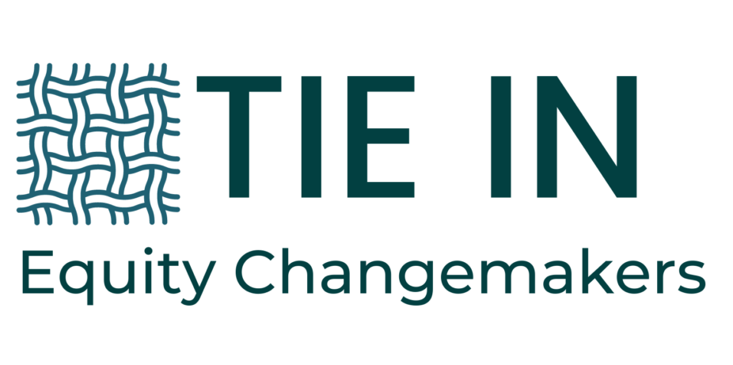

Laylah Sullivan
November 17, 2022

Dear Laylah,

Congratulations on your acceptance to TIE IN!

It is an honor to have you be a part of our inaugural cohort. The journey ahead for this coming year holds limitless possibilities for Changemakers like you to impact the culture and climate of your school community in the fight for racial equity and social justice.

Please email confirmation of your acceptance to the program by Friday, December 2, 2022. Your payment of $2,400 per team is due by Friday, January 13, 2022.

We will have our first gathering Wednesday, January 18, 2023 at 7pm EST where you will also meet your mentors. Expect our monthly convenings to last 1.5 hours.

In the coming weeks you will receive a schedule that will include meeting dates and times, topics, links to reading and media, and our permanent Zoom link for each meeting.

If you notice topics/content that don't seem relevant to your needs, please let me know ahead of time and I will adjust to meet your needs. Some topics cannot and will not be changed because they are fundamental to our understanding and working for racial equity and social justice.

Congratulations yet again and I look forward to hearing from you soon.

peace and justice,

Jazz

