Pre-opening monthly meeting FORM

School: PCM | Date: 6/10/21 |  | Time: 1:00 PM
Meeting Logistics
Meeting Location: ZOOM https://washington.zoom.us/j/4997536321
School Attendees: Laylah Sullivan (HOS) |  | WACSC Staff:
Objective
To provide pre-opening charter school with a status update regarding compliance reporting and Commission updates, and engage in a dialogue regarding general pre-opening school updates (i.e. facilities, staffing, prospective enrollment, etc.), pre-opening progress of calendar items, and school specific updates.
Monthly Submission Review
Items Due: (JUNE)
15th Employee Handbook
31st Student Handbook
31st School Calendar
Upcoming Items: (JULY)
1st Authorization to Expend Funds
1st Curricular Scope and Sequence and Detailed Unit/Project, Lesson Plans
1st Evidence of 80% Enrollment
1st Evidence of MTSS
1st Safe School Plan
1st School Complaint Process
10th F-203, F-195, F-195F Forms
15th Annual Budget
15th Preopening Site Visit Scheduled
15th Special Education Policies and Procedures
15th State Assessment Schedule
Compliance Notes:
Topics for Discussion
Hiring/Staffing Updates
Notes: We have hired 3 Classroom Assistants (I turned down at last minute), 1 Younger Elementary Teacher, 1 Older Elementary Teacher, 2 Kindergarten teachers, and our Special Educator – Director of Specialized Programs. We are having to reopen our assistant position, and find a SPED para for a student who needs a 1:1. 0.25 Nurse position was posted and recruited locally, haven’t found anyone. PSD said they’ve had a Nurse position posted since November 2020 and still can’t fill it. We are looking into cooperative relationship with Spokane Charters. Circling back with ESD 101 Nurse Corps with new legislative changes.
School Facility/ Physical Plant Update
Facility: Work going well. Moving into offices today. No big surprises. No asbestos.
Food Services: Partnering with Pullman School District on breakfast and lunch service (they are drafting contract…supposed to provide draft end of next week).
Transportation: Know need 2 buses (# of buses, rout map, RFP)…smaller size. Still working on contracting.
Curriculum Development
Notes: Met with NCMPS about cross maps and still on track for July 1. TSS will upload standards into Transparent Classroom at that point. MC is wrapping up sample pace-based lesson examples for teachers. Received updated Essential Elements of Montessori in the Public Sector Rubric (school wide reflective practice tool)….fully revamped with DEI lens on all.
Professional Development
Notes:
COMPLETED
BES (Build Excel Sustain) Effective Professional Development and Live Coaching
Racial Equity Workgroup (WA Charters)--ongoing but major conflicts with schedule.
Child Study Course – now towards end
ONGOING
TSS Project Planning Workshops
Haring Foundation as needed meetings (PBIS & MTSS support).
TSS semi-monthly meetings
NCPMS semi-monthly meetings
Commission-OSPI sessions
FUTURE (MC will join)
NCMPS DEI trainings (currently not recalling name) & strong potential for invited fellowship around DEI with NCMPS in January.
Montessori Coaches Training (summer & during school year)
Will be visiting SIA to observe MAP assessment and other processes (MAY)
*Summer PD will be done onsite not yet called out in list. Starts July 6th PD. School starts 18th. Student orientation Aug. 11-13 half day.
Prospective Enrollment
Notes:
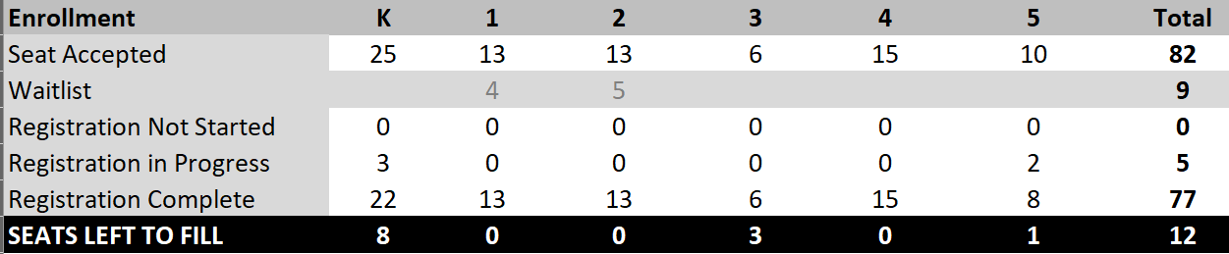

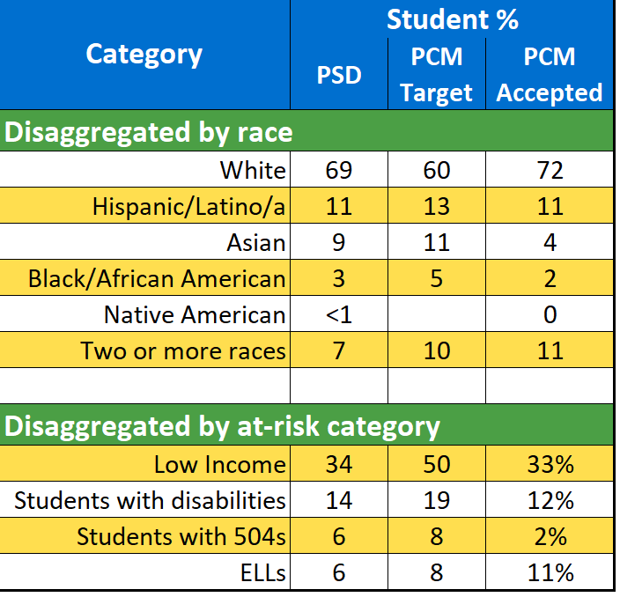

Family and Community Engagement
Notes:
Have scheduled Family Orientation with Q&A for June 23 (K), 24(YE), 25(OE) 5-6PM w/ remote and recorded option.

Visiting Child Cares, boosting Social Media engagement. Listed on Pullman Chamber website as Public school under PSD. Restocking flyers and other marketing materials.

Board Updates
Notes: New board members may be added at June 22 Meeting. Will have 1 member moving off in June. We made minor updates to our Bylaws at the June 22 Meeting.
Policy Development
Notes: We adopted a 2nd batch at our Special Meeting on June 8th (in yellow in this FILE). Pink will be adopted at the June 22 board meeting.
Fundraising Updates
Notes: no updates from last time.
Conditional Approval/Heightened Oversight Updates (If Applicable)
Notes:
Miscellaneous
Notes:
Next Steps

