Pre-opening monthly meeting FORM

School: PCM | Date: 5/20/21 |  | Time: 1:00 PM
Meeting Logistics
Meeting Location: ZOOM https://washington.zoom.us/j/4997536321
School Attendees: Laylah Sullivan (HOS) |  | WACSC Staff:
Objective
To provide pre-opening charter school with a status update regarding compliance reporting and Commission updates, and engage in a dialogue regarding general pre-opening school updates (i.e. facilities, staffing, prospective enrollment, etc.), pre-opening progress of calendar items, and school specific updates.
Monthly Submission Review
Items Due: Items done Laylah will submit
31st Building Capacity
31st Emergency Contact Information
31st Enrollment Wait List by Grade
Upcoming Items: (JUNE)
15th Employee Handbook
31st Student Handbook
31st School Calendar
Compliance Notes:
Topics for Discussion
Hiring/Staffing Updates
Notes: We have hired 2 Classroom Assistants, 1 Younger Elementary Teacher, 1 Older Elementary Teacher. Were are in final stages with the 2 other assistant positions, and the 2 Stand-alone K positions (not to offer status yet). In Stage 2 process for our SPED teacher/director applications. 0.25 Nurse position being posted and recruited locally.
School Facility/Physical Plant Update
Notes:
Facility: Loan closed. Work going fast and furious. Pause for asbestos testing of 1 wall in 205-207 rooms. All contractors moving quickly. Adapted timeline - Certificate of Occupancy by end of July for some rooms, others beginning of August.
Food Services: Partnering with Pullman School District on breakfast and lunch service (they are drafting contract).
Transportation: Making progress on transportation plan (# of buses, rout map, RFP). Chris Jose put me in contact with 2 Spokane schools with this software and expertise that are willing to help. Hoping to contract with Harlow for transportation.
Curriculum Development
Notes: No updates from last time besides continuous progress towards goals.
NCMPS will have all cross maps updated and completed for K-5th by the July 1 deadline.
Professional Development
Notes:
COMPLETED
BES (Build Excel Sustain) Effective Professional Development and Live Coaching
ONGOING
Racial Equity Workgroup (WA Charters)--ongoing but major conflicts with schedule.
TSS Project Planning Workshops
Haring Foundation as needed meetings (PBIS & MTSS support).
TSS semi-monthly meetings
NCPMS semi-monthly meetings
Child Study Course – now towards end
Commission-OSPI sessions
FUTURE (MC will join)
NCMPS DEI trainings (currently not recalling name) & strong potential for invited fellowship around DEI with NCMPS in January.
Montessori Coaches Training (summer & during school year)
Will be visiting SIA to observe MAP assessment and other processes (MAY)
*Summer PD will be done onsite not yet called out in list. Starts July 6th PD. School starts 18th. Student orientation Aug. 11-13 half day.
Prospective Enrollment
Notes:
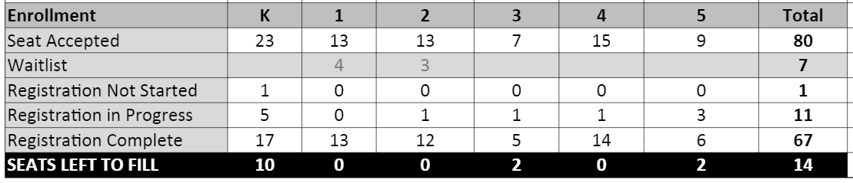
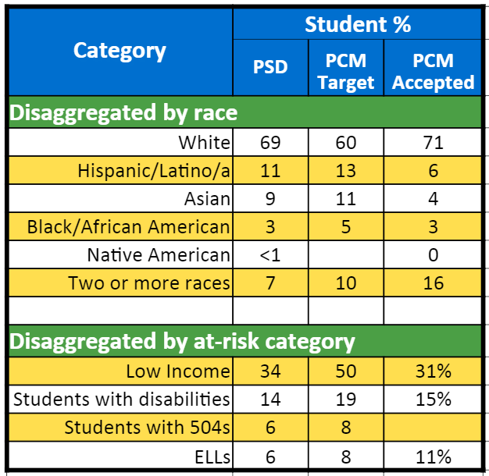
Had 3rd and 5th full but one family with multiples moved and one family with multiples is no longer moving to Pullman. Still slow progress over time. Have had a lot of interest of families with multiple kids but many overlapped with grades that were already full (apprehensive about putting on the waiting list).

Rapid changes in community so strategizing for more in person ops. Following up with childcare centers and local support services 1 on 1.
Family and Community Engagement
Notes: nothing new just progress from last notes. Gearing up for input sessions around Family & Community Engagement Handbook and Equity Plan. Starting up in June
Board Updates
Notes: Complete last WA Charters training (2nd part of fiduciary responsibility) this month, full board DEI training with Dr. Scott was April 22. Potential new trustee being groomed. Hoping to add new board member June 8th.
Policy Development
Notes: we are following these recs for policy development. We have approved the ones in green. Most others will be approved at this board meeting. Working on ESSER compliance application that must be voted on at this meeting to meet June 1 deadline.
Fundraising Updates
Notes: Were notified we did not receive NSVF, they did not get moved on to the next step. Donor Door campaign progressing – in person asks will improve.
Conditional Approval/Heightened Oversight Updates (If Applicable)
Notes:
Miscellaneous
Notes: School Questions:
- The time frame of when EDS and Skyward are activated for new schools makes progress really slow on a number of fronts. Commission as noted the concern. Mike Sando is the individual that I would refer the schools and Matt. P to discuss issues with. The tension is occurring because schools are not entered into a system until their first day of school. Current ESSER system is old and difficult to make additions/changes too. Therefore new schools will not be able to complete applications and meet the deadlines for funding that are currently in place. OSPI is aware of the issue. Per discussions with Mike S. of OSPI New Schools will get their funding. There will just be lag in accessing for the opening year.
Next Steps
- Kara to send over Board Observations to Laylah
- July 26-August 6th would be best.
- Krystal to provide Laylah more information around possible EEK.

