Pre-opening monthly meeting FORM

School: PCM | Date: 5/6/21 |  | Time: 1:00 PM
Meeting Logistics
Meeting Location: ZOOM https://washington.zoom.us/j/4997536321
School Attendees: Laylah Sullivan (HOS) |  | WACSC Staff:
Objective
To provide pre-opening charter school with a status update regarding compliance reporting and Commission updates, and engage in a dialogue regarding general pre-opening school updates (i.e. facilities, staffing, prospective enrollment, etc.), pre-opening progress of calendar items, and school specific updates.
Monthly Submission Review
Items Due: (APRIL) --- ALL HAVE BEEN SUBMITTED
14th Evidence of Uniform Accounting Systems that Comply with Generally Accepted Accounting Principles (GAAP)
15th F1 Personal Financial Disclosure Statement for Board Members
30th Charter/Nonprofit Agreements (YMCA is only one)
30th Evidence of 50% Enrollment
Upcoming Items: (MAY)
31st Building Capacity
31st Emergency Contact Information
31st Enrollment Wait List by Grade
Compliance Notes:
Topics for Discussion
Hiring/Staffing Updates
Notes: We have hired 2 Classroom Assistants, 1 Younger Elementary Teacher, and have a pending offer for 1 Older Elementary Teacher. All others are in process.
School Facility/Physical Plant Update
Notes: Loan closing - last week of April. We possess stamped plans form city. All contractors moving quickly. Adapted timeline targets acquisition of - Certificate of Occupancy by end of July at latest (remember, will take place room by room as stated in Charter Application).
Curriculum Development
Notes: No updates from last time besides continuous progress towards goals.
NCMPS will have all cross maps updated and completed for K-5th by the July 1 deadline.
Professional Development
Notes:
COMPLETED
BES (Build Excel Sustain) Effective Professional Development and Live Coaching
ONGOING
Racial Equity Workgroup (WA Charters)--ongoing but major conflicts with schedule.
TSS Project Planning Workshops
Haring Foundation as needed meetings (PBIS & MTSS support).
TSS semi-monthly meetings
NCPMS semi-monthly meetings
Child Study Course
Commission-OSPI sessions
FUTURE (MC will join)
Montessori Coaches Training (summer & during school year)
Will be visiting SIA to observe MAP assessment and other processes (MAY)
*Summer PD will be done onsite not yet called out in list.
Prospective Enrollment
Notes: 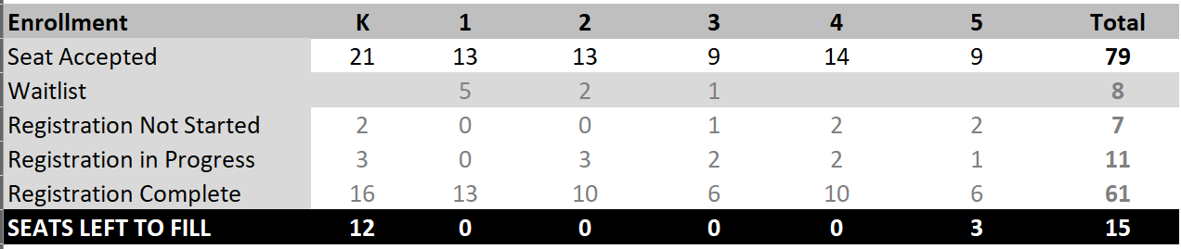
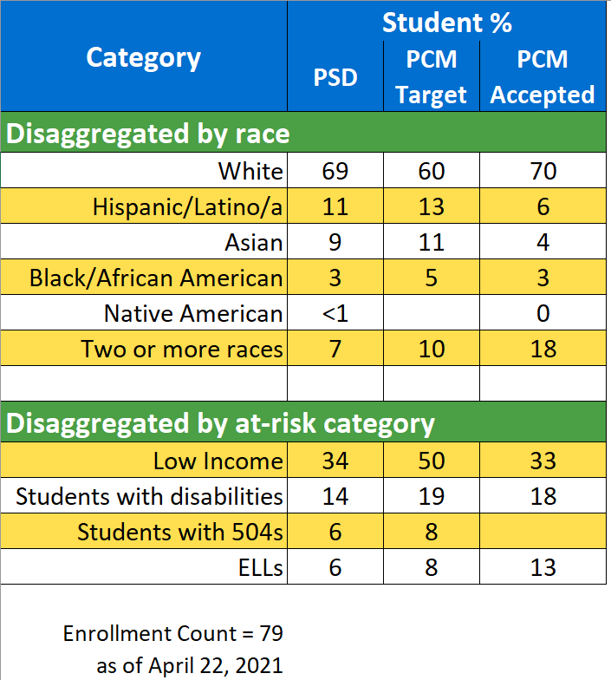

Most places in our community are not allowing tabling. Following up with child care centers and local support services 1 on 1.
Family and Community Engagement
Notes: noting new just progress from last notes.
Board Updates
Notes: Completed last WA Charters training (2nd part of fiduciary responsibility), full board DEI training with Dr. Scott on April 22 was really good. Potential new trustee being groomed. All trustees completed F1 submission a week before the deadline.
Policy Development
Notes: we are following these recs for policy development. We have approved
Policies have been modified from WSSDA and are under final review. Vote will occur at May board meeting (moved from April to conduct final review and make room for loan and non-profit YMCA agreements)
Fundraising Updates
Notes: Applied for NSVF grant (no news yet). Donor Door campaign progressing slowly but reinvigorating campaign.
Conditional Approval/Heightened Oversight Updates (If Applicable)
Notes:
Miscellaneous
Notes:
School Questions:

Next Steps

